
Design and Access Statement

Title: 250 Grays Inn Road, London WC1X 8JR
Date: 05/04/2019
Project number: J9648
Site: 250 Grays Inn Road, London, WC1X 88JR
Applicant: KMK Ltd
Agent: Property Tectonics, Titan Court, 2nd Floor, 3 Bishop Square, Hatfield, AL10 9NA
Application: Listed Building Consent

Contents

1.0 Existing Site 3
2.0 Proposed Development 4
3.0 Proposed Materials 5
4.0 Scale……………………………………………………………………………………………………………………………………..5
5.0 Access 5
6.0 Environment 5

Existing Site

The subject property comprises a four-storey mid-terrace period property of traditional construction, situated to the west facing side of Grays Inn Road, a very short distance from the junction with Wren Street.
The property is provided with solid load-bearing brick external walls, with a timber framed, typical London centre valley main roof, with flat and mono-pitch ground floor rear extension roofs, that are provided with a variety of different weatherings, including glass and slate.
Accommodation within the property comprises lower ground and ground floor retail unit, with two self-contained flats at first and second floor level.
The retail unit comprises a ground floor kitchen and public seating area, with WC and storage at lower ground floor level.

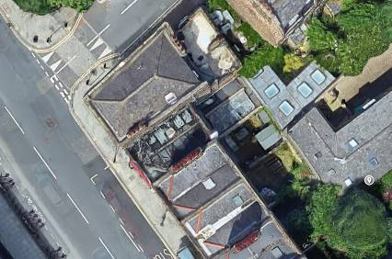

Photo No. 1 – Satellite View of Property

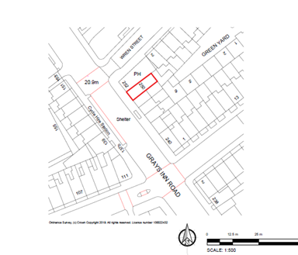

Fig. No. 1 – Site Plan

Proposed Development

The proposed works to be undertaken are as follows:-
- Renewal of rear ground floor extension glazed roof.
- Redecoration of ground floor shopfront.
- Repair of GF to LGF staircase

- Renewal of Rear Ground Floor Extension Glazed Roof
The existing mono-pitched glazed roof above the ground floor retail area is in a poor condition causing issues with water ingress into the ground floor retail area. Various attempts to remedy the water ingress have failed. The glazed mono-pitched roof has now reached the end of its design life and needs to be replaced.
The existing mono-pitched glazing, glazing bars and associated cover flashings are to be removed. Adjacent existing parapet works and roof coverings will not be affected by the works. No other works externally within the vicinity of the glazed roof are proposed.
A proprietary double-glazed roof system incorporating metal powder coated glazing bars is to be installed to match existing. New Code 4 lead flashings to be installed to weather the junction between the glazing and adjacent existing walls.

Mono-pitch roof to be replaced.

Photo No. 2 – GF Mono Pitched Roof

- Redecoration of Ground Floor Shopfront
The existing painted finishes to the ground floor front elevation shopfront are in a poor and deteriorating condition. In order to ensure the timber shopfront is not adversely affected by rot or decay, it is necessary to redecorate the shopfront’s previously painted timber.

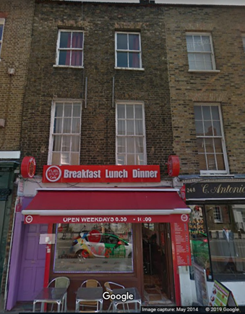

Photo No. 3 – GF Shopfront

- Repairs to GF to LGF Staircase
The existing GF to LGF staircase is of traditional timber construction. The existing treads are heavily worn and are a H&S risk to both members of staff and the public. The staircase is to be repaired, with the existing badly dished treads being replaced.

Proposed Materials
The shopfront will be redecorated RAL 3020, to match existing.



Fig. No. 2 – RAL 3020 Sample

The rear mono-pitched roof will comprise metal powder coated RAL 9017 glazing bar system with double-glazed 6/12/6.4 laminated glass between glazing bars. Perimeter Code 4 lead flashings to weather between glazing and existing enclosing walls.

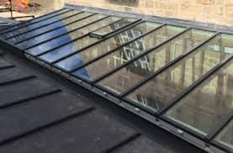

Fig. No. 3 – Example of Type of Roof Glazing To Be Provided

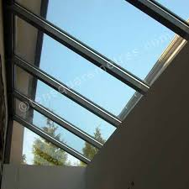

Fig. No. 4 – Example of Type of Roof Glazing To Be Provided (Internal View)

Fig. No. 5 – Example of Type of Roof Glazing Section To Be Provided

The existing timber stair treads will be replaced with matching timber treads.

- Scale
The proposed works will not have any impact with regards to the existing mass or scale of the property.

5.0 Access
The proposed works do not have any impact on access to the property.

6.0 Environment
The proposed works do not have any impact upon any existing trees to the site.
The proposed works do not have any other environmental implications.
Working hours will be Monday to Friday 8.00am to 6.00pm and 9.00am to 1.00pm Saturday. There will be no Sunday working.

