**20 Chalcot Square NW1 8YA**

Design and Access Statement to Accompany Planning Application by PTA.

**Prepared by**

**Powell Tuck Associates Ltd**

**6 Stamford Brook Road**

**London W6 0XH**

**Tel no 020 8749 7700**

**email gmorgan@powelltuck.co.uk**

13th December 2018 – Revision P

19th December 2018 – Revision P1

15th April 2019 – Revision P2

**Contents**

1. Description of Area

2. Heritage Asset Status

3. Significance

4. Policy and impact

5. Description of works

6. Summary list of restoration works

6. Design features

7. Landscape statement

1. **Description of Area and building**

Chalcot Square is a significant feature of the Conservation Area and is surrounded by a large number of mid 19th century listed buildings, 20 included. The main road in Chalcot Square is a continuation of Chalcot Road and is of a generous width. On the south side of the road is a listed terrace of mid 19th century houses with front garden areas. These buildings are three storeys high with attics, or mansard roofs, and are grand in character with stucco decoration to the main facades, decorative window surrounds, prominent cornices and projecting porches. On the north side of the road is a grassed public open space, which is bounded by railings and contains a number of mature trees and a play area. All of the mid 19th century terrace houses surrounding Chalcot Square are particularly distinctive due to the use of paint colours on their stucco facades. The majority of these properties are painted in muted pastel shades, which afford each property an individual character and adds vibrancy to the square

This is an early Victorian end of terraced house built, we understand, circa 1855-1860 on lower ground, ground and two upper floors with mansard rooms at third floor level. It is of traditional 18” (460mm), 14” (350mm) or 9” (230mm) solid stock brickwork with a painted stucco façade dressed and designed in the Italianate style.

20 Chalcot Square is a single ownership dwelling designated heritage asset, listed Grade 2. The owners are the freeholders and the current basement is a self contained unit accessed via it’s own front door in the lightwell, the original internal staircase has been removed.

The property is situated in the eastern corner of Chalcot Square with west facing views overlooking the attractive communal Chalcot Square Gardens. The Square is bounded on all sides by Grade II Listed early Victorian buildings of similar design. Being a “corner” house No 20 Chalcot Square lies at right angles to No.19.

This front frontage is set back from Chalcot Square behind an angled sunken lightwell area and a bridging platform leading to the main front door at raised ground level. Original cast- iron “area” railings protect the front platform. A cast iron gate gives access to solid steps that lead down into the lightwell to the original tradesman’s entrance. The lightwell area has been split in half with No.19 Chalcot Square and is therefore angled at 45 degrees, this item of metal work is non-original. The dividing wall is of solid brick and therefore reduces daylight into the front basement room. A meter cupboard is located below the upper step platform. A small storage vault is located below the pavement with access from the internal w.c. The void below the bridging platform contains the entrance hall and meter cupboard to the basement flat. The adjoining metal casement window is barred for security reasons.

The façade is flat-fronted and has a rusticated painted stucco finish at lower levels. The upper walls are stucco rendered and also painted. The main entrance portico and door are located at raised ground level and abut the north side party wall. The door is of timberwork with opaque glass panels below a glazed fanlight. The façade is dominated by the Prostyle Doric columned entrance portico supporting balustraded stucco balconies continuing across first floor windows – all to match the neighbouring buildings. Tripartite timber framed and double-hung box sash windows light the front Dining room at raised ground level. Three full height timber framed and double-hung box windows light the Drawing Room at first floor level. These are joined by a continuous cornice (with keystones above windows) and console brackets between, and pediments over central windows. The three sash windows at second floor level have stucco architraves and surrounds with sills over brackets.

The main flank wall is of solid stock brickwork with a gable end at high level. It has been altered over the years to accommodate extensions at ground and lower-ground levels. The side extension roof is of mixed flat timber and felted design with double-glazed roof panels over the kitchen area. It drains into a box gutter and then to the rear. A door in the back wall of the kitchen leads onto a timber platform and then timber steps down to the back patio garden.

A new opening was also created some years ago at third floor level (within the chimney breast) to allow access onto a metal framed and timber decked balcony.

The main rear and three storey back addition walls are also of solid stock brickwork (part rendered and painted). Windows at most levels are of original timber framed and double- hung box sash design below segmental brick arches and above stone sills. Landing windows are part stained glass.

The rear patio is approximately 26’ x 30’ and is “split-level” and bounded by adjoining gardens and brick boundary walls. The east side boundary wall to the modern redevelopment at No 8 Fitzroy Road rises up to second floor level next to the main flank wall of No. 20 Chalcot Square.

A timber platform and steps lead from the kitchen at raised ground level down to the garden.

French doors lead from the rear living room at basement level onto the patio.

The roof over the three-storey back addition is of flat timber asphalted design.

The main mansard roof is set back behind a painted brick parapet wall dressed with a cornice and blocking course at high level.

The main roof is of the original timber pitched “mansard” design. It is set back from the front façade behind an asphalt lined parapet gutter (with plastic mesh protectors). The parapet wall is stucco rendered overlaid with concrete copings and a lead lined lower-blocked cornice. The upper and lower slopes are overlaid with original Welsh quarry slates. Two lead lined dormers (with sash windows) are located in the front slope.

The front gutter also takes rainwater from the adjoining roof at No.21 Chalcot Square. The gutter drains into a hidden gulley and then into a rain pipe that runs down the front wall, through the portico to basement level. The rear slope has a single pitch that drains down into a lead lined parapet gutter. This drains into a hopper and then down the rear wall.

Two tall brick chimney stacks run up above the flank side gable wall. The mansard at third floor level contains a large “through” bedroom/living room. A doorway in the rear flank side wall/chimney stack gives access onto a metal framed and timber decked south east facing balcony. The current attic room can only be accessed via a timber step ladder.

1. **Heritage Asset Status**

The property is part of listing No.1258098 for 20-28, initially listed on 14

May 1974, the entry being revised on 11 January 1999:

*TQ2884SW CHALCOT SQUARE 798-1/64/190 (East side) 14/05/74 Nos.20-28 (Consecutive) and attached railings (Formerly Listed as: CHALCOT SQUARE Nos.1-33 AND 33A (Consecutive))  
GV II*

Terrace of 9 houses forming east side of Chalcot Square. 1855-60, altered. Stucco with rusticated ground floors, mostly painted. Nos 20, 23-25 & 28, slate mansard roofs with dormers.

EXTERIOR: 3 storeys, attics and basements except Nos 21 & 22 and 26 & 27, slightly projecting, with 4 storeys and basements. (Nos 22 & 26 with C20 penthouses). 3 windows each. Prostyle Doric porticoes supporting balustraded stucco balconies continuing across 1st floor windows. Doorways with cornice-heads, fanlights, side lights and panelled doors (some part glazed). Tripartite sashes to ground floors. Projecting houses with panelled pilasters at angles rising from 1st floor level to support the main entablature with modillion cornice (which continues across other houses) below attic storey. Upper floors, lugged architrave sashes with margin glazing; 1st floors joined by continuous cornice with keystones above windows and console-brackets between and pediments over central windows (projecting houses, segmental). 2nd floors with keystones; central windows having large keystone projecting into the architrave above. Attic storeys with pilaster strips at angles, cornice and blocking course.

*INTERIORS: not inspected.*

SUBSIDIARY FEATURES: attached cast-iron railings to areas.

12-14, 15-19 and 29-33-33A are similarly listed, in the 1999 splitting of the original 1974 listing for the various terraces in Chalcot Square.

Chalcot Square is part of the Primrose Hill Conservation Area designated on 1 October 1971

1. **Significance**

The primary architectural significance of each building is in the aesthetic and architectural quality of the terrace of which they are part, their contribution to Group Value of Chalcot Square and to the wider Primrose Hill Conservation Area

Primary historic significance is the buildings' evidence as part of the mid 19thC expansion of middle-class London.

The buildings are characteristic of their age and the regional type, the London terrace house, and are significant because of that typicality, not because of singularity.

The typicality of the London terrace house plan form and surviving historic fabric confers significance on the interiors but this has been substantially diminished at lower ground floor level in each by serial alterations of layout and replacement of original fabric.

Grant of listed building consent for the Basement floor extensions would be taken as acknowledgement that those extensions were not harmful to the significance of the building, or to their setting.

1. **Policy impact**

**The Camden Local Plan 2017**

G1 Delivery and location of growth  
A1 Managing the impact of development  
A5 Basement  
D1 Design  
D2 Heritage  
CC1 Climate change mitigation  
CC2 Adapting to climate change  
T4 Sustainable movement of goods and materials DM1 Delivery and monitoring

1. **Description of Works**

The proposal includes reuniting the house with the basement flat, adding an extension onto the rear of the house, remodelling the current infilled area at the side of the house to accommodate ancillary spaces and the extensive restoration of the historic fabric of the building.

Reuniting the house with the basement

The proposal allows for the internal layout of the property to be altered advantageously with no visual impact. Absorbing the basement flat back into the original single dwelling configuration by reinstating the basement staircase under the existing staircase.

Rear extension

The depth of the proposed rear extension would align with the existing rear structure of the building, only the doors would slide beyond the building line to articulate the separate nature of the new building to the old.

Lowering the floor level of the extension beyond the outline of the building will enhance the quality and usability of the space. Steps in the landscaping will deal with the level change outside.

Side infill

The side infill building already exists at basement and ground level as well as a balcony on the third floor. The proposal includes a metal mesh screen set back from the building edge that masks the existing void space behind and visually connects the ground floor with the balcony above.

Restoration of historic fabric

The scheme proposes the removal of all non-original fixtures on the principle floors as indicated on the drawings. Including the bathroom and fitted wardrobes on the second floor. The existing (dangerous) ladder on the third floor to be replaces with a building control compliant staircase and new arrangement of joinery to conceal the stair, and W.C. and storage, separating it from the existing building fabric. Restructuring the roof and adding insulation at the same time.

Extension and infill additions are in keeping with the contemporary nature of all new works and provide a scheme of greater design and construction quality within the volume of the space already occupied.

1. **Summary list of restoration works to the historic fabric of the building**

Remove flat and reunite house

Unifying the original house by integrating the basement flat, with the addition of a new traditional style staircase to connect the floors internally.

Basement window

Adjusting the basement level front window position to align with the window above. New sash window type and details to match.

Doorway to Utility room- ground floor

We propose to replace this existing doorway to the utility room with a jib door, reducing visual impact of this non original insertion.

Remove bathroom on second floor

Removing non original bathroom from the second floor of the building and restore existing room.

Roof

Add structural reinforcement and insulation internally to form an appropriately habitable space, retain and reuse exact external historical materials.

Remove all non-original fitted furniture

All non original fitted furniture will be removed from the ground, first and second floors of the house. Where missing architectural details will be replicated to fill any gaps.

Window and casement restoration

All window frames to be stripped of paint and refinished to a high standard.

Restoration of flooring + woodwork

Removal of all floor coverings and restoration of the existing timber boards. As well as all doors, architraves, skirting boards, window sills and associated original woodwork.

Restoration of fan light above front door

Replacing the fan light above the entrance door to match the original design, as seen on other buildings.

New Shutters on Ground floor

Currently no shutters exist. New shutters to be based on the design and material of those on the first floor.

Front hand rail

Replacing the front railing down to the basement. This item will be replaced with a design to match original design.

Removal of flue pipe

Removal of the unsightly stainless steel flue pipe from the rear elevation.

Removal of boiler room

Removal of the boiler room from outside the rear elevation to a new location within the side extension.

1. **Design features**

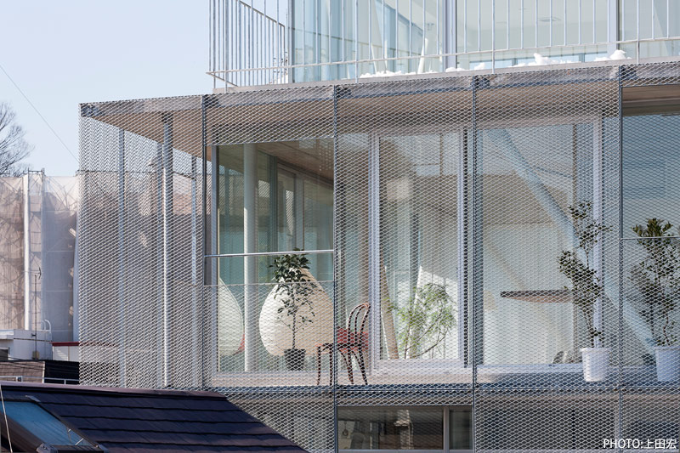

*Example of light weight steel mesh screenc*

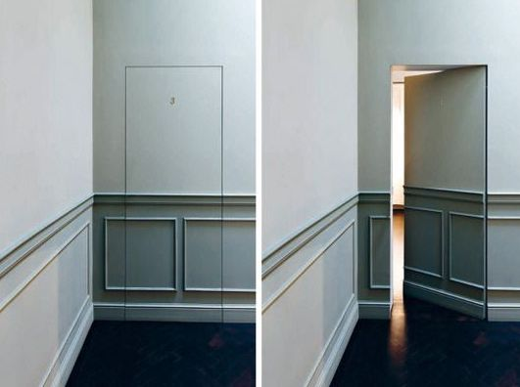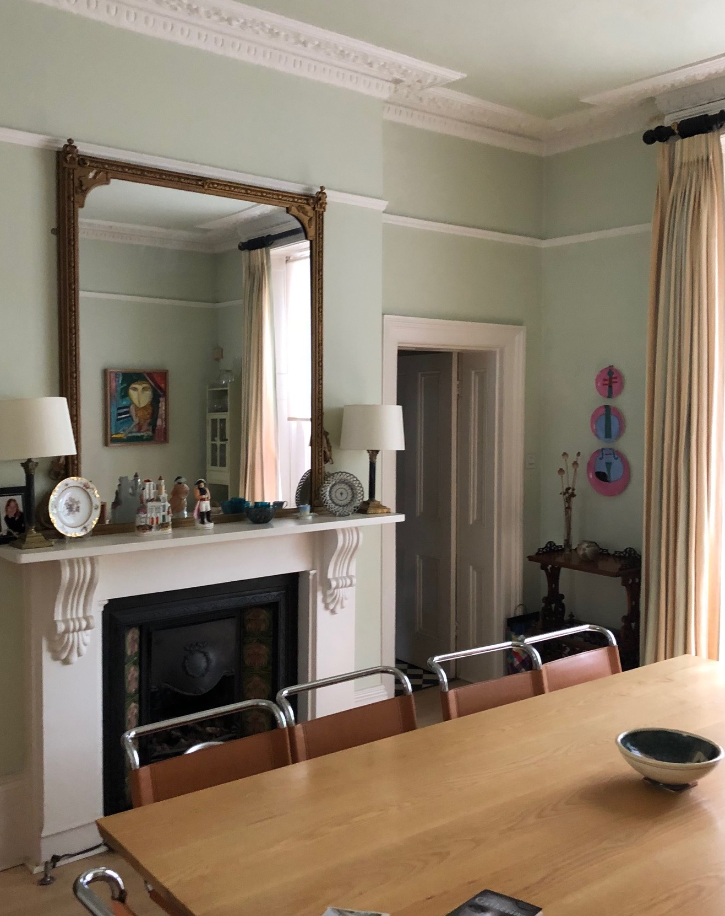

*Example jib door replacement to utility room on the ground floor / existing doorway to utility room.*

1. **Landscaping statement**

As per the drawings the newly created lower floor level will be contained by a short retaining wall structure with heavily planted area beyond for privacy. Exact design TBC.