**Construction Management**

**Plan**

**pro forma** v2.2

**Contents**

**Revisions 3**

**Introduction 4**

**Timeframe 6**

**Contact** **7**

**Site** **9**

**Community liaison** **12**

**Transport** **15**

**Environment** **25**

**Agreement**  **30**

# Revisions & additional material

Please list all iterations here:

|  |  |  |
| --- | --- | --- |
| **Date** | **Version** | **Produced by** |
|  |  |  |

**Additional sheets**

Please note – the review process will be quicker if these are submitted as Word documents or searchable PDFs.

|  |  |  |
| --- | --- | --- |
| **Date** | **Version** | **Produced by** |
|  |  |  |

# Introduction

The purpose of the **Construction Management Plan (CMP)** is to help developers to minimise construction impacts, and relates to both on site activity and the transport arrangements for vehicles servicing the site.

It is intended to be a live document whereby different stages will be completed and submitted for application as the development progresses.

The completed and signed CMP must address the way in which any impacts associated with the proposed works, and any **cumulative impacts of other nearby construction sites**, will be mitigated and managed. The level of detail required in a CMP will depend on the scale and kind of development. Further policy guidance is set out in Camden Planning Guidance [**(CPG)** 6: Amenity](http://www.camden.gov.uk/ccm/content/environment/planning-and-built-environment/two/planning-policy/supplementary-planning-documents/camden-planning-guidance.en) and [**(CPG)** 8: Planning Obligations](http://www.camden.gov.uk/ccm/content/environment/planning-and-built-environment/two/planning-policy/supplementary-planning-documents/camden-planning-guidance.en).

This CMP follows the best practice guidelines as described in [Transport for London’s](https://www.tfl.gov.uk/info-for/freight/safety-and-the-environment/improving-construction-safety) (TfL’s Standard for [Construction Logistics and Community Safety](http://www.clocs.org.uk/standard-for-clocs/) (**CLOCS**) scheme) and [Camden’s Minimum Requirements for Building Construction](http://www.camden.gov.uk/ccm/cms-service/download/asset?asset_id=3257318) **(CMRBC)**.

The approved contents of this CMP must be complied with unless otherwise agreed with the Council in writing. The project manager shall work with the Council to review this CMP if problems arise in relation to the construction of the development. Any future revised plan must also be approved by the Council and complied with thereafter.

It should be noted that any agreed CMPdoes not prejudice or override the need to obtain any separate consents or approvals such as for road closures or hoarding licences.

If your scheme involves any demolition, you need to make an application to the Council’s Building Control Service. Please complete the “[**Demolition Notice**](http://www.camden.gov.uk/ccm/content/environment/building-control/file-storage-items/demolition-notice---the-building-act-1984-section-80-notice-bc104-.en)**.**”

Please complete the questions below with additional sheets, drawings and plans as required. The boxes will expand to accommodate the information provided, so please provide as much information as is necessary. **It is preferable if this document, and all additional documents, are completed electronically and submitted as Word files to allow comments to be easily documented. These should be clearly referenced/linked to from the CMP.**

Please notify that council when you intend to start work on site. Please also notify the council when works are approximately **3 months from completion.**

(Note the term 'vehicles' used in this document refers to all vehicles associated with the implementation of the development, e.g. demolition, site clearance, delivery of plant & materials, construction, etc.)

Revisions to this document may take place periodically.Timeframe

**DEVELOPER ACTIONS**

**COUNCIL ACTIONS**

**Post app submission**

**0ommunity liaison**

**Appoint principal contractor**

**Requirement to submit CMP**

**Begin community liaison**

**Council response to second draft**

**Work can commence if draft CMP is approved**

**Resubmission of CMP if first draft refused**

**2ommunity liaison**

**3ommunity liaison**

**1ommunity liaison**

INDICATIVE TIMEFRAME (MONTHS)

**4ommunity liaison**

**Council response to draft**

**Submit draft CMP**

# Contact

1. Please provide the full postal address of the site and the planning reference relating to the construction works.

Address: 24 Heath Drive, London NW3 7SB

Planning no 2018/0914/P

2. Please provide contact details for the person responsible for submitting the CMP.

Name: Hugh Lennon

Address: Unit 5 Sayer House, Oxgate Lane, London NW2 7JN

Email: hugh@myconstruction.co.uk

Phone: 0208 4505747

3. Please provide full contact details of the site project manager responsible for day-to-day management of the works and dealing with any complaints from local residents and businesses.

Name: Alex Kotsis

Address: Unit 5 Sayer House, Oxgate Lane, London NW2 7JN

Email: Ervin@myconstruction.co.uk

Phone: 07901 209060

4. Please provide full contact details of the person responsible for community liaison and dealing with any complaints from local residents and businesses if different from question 3. In the case of [**Community Investment Programme (CIP)**](http://www.camden.gov.uk/ccm/content/environment/planning-and-built-environment/two/placeshaping/twocolumn/the-community-investment-programme.en), please provide contact details of the Camden officer responsible.

Name: AS SECTION 3

Address:

Email:

Phone:

5. Please provide full contact details including the address where the main contractor accepts receipt of legal documents for the person responsible for the implementation of the CMP.

Name: Hugh Lennon

Address: Unit 5 , Sayer House , Oxgate Lane , London NW2 7JN

Email: hugh@myconstruction.co.uk

Phone: 0208 4505747

# Site

6. Please provide a site location plan and a brief description of the site, surrounding area and development proposals for which the CMP applies.

Heath Drive is situated in the Hampstead area of the London Borough of Camden. It is a residential street and runs north east from Finchley Road towards Hampstead Heath.

The property - No. 24 Heath Drive - is a double-fronted, three-storey house (with basement, attics and garden) built in 1907 in the Neo-Georgian style. It is situated in the Redington/Frognal Conservation Area and is Grade II

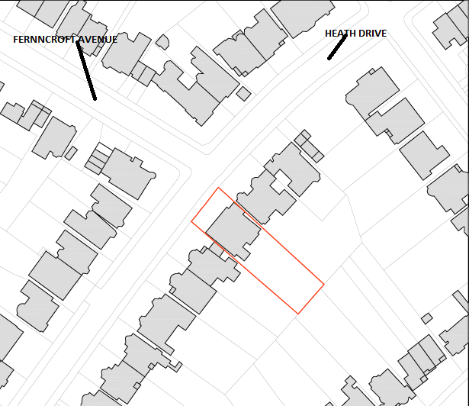

7. Please provide a very brief description of the construction works including the size and nature of the development and details of the main issues and challenges (e.g. narrow streets, close proximity to residential dwellings etc).

The construction work includes demolition to the existing garage and side extensions, new basement extension and a refurbishment of the exiting building to a new modern layout. The site is in close proximity to neighbouring properties and has a number of trees to the rear and front of the property. Due to the constraints the basement works are to be carried out in a systematic and controlled method to ensure that the integrity of the building is maintained as well as the trees being managed by arborculturalist during the contract period .

8. Please identify the nearest potential receptors (dwellings, business, etc.) likely to be affected by the activities on site (i.e. noise, vibration, dust, fumes, lighting etc.).

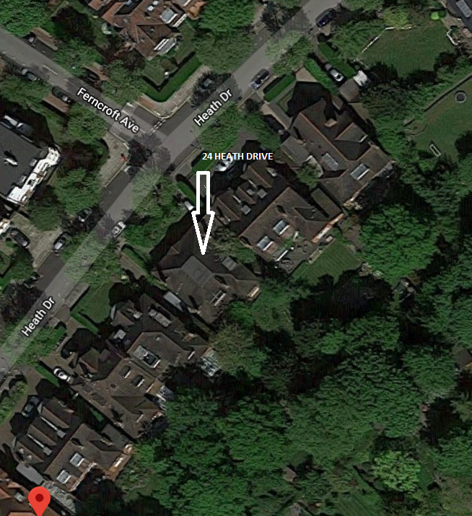

The nearest receptors are 23 and 25 Heath Drive, and due to the large rear garden we do not envisage any impact on the properties on Oakhill Avenue .The procedures in this CMP will seek to mitigate the impact including dust, noise, vibration lighting etc on these local buildings all the neighbouring properties will be made fully aware of the construction activities and programme of works .The site construction team will deal with any queries and provide a immediate response to any issues raised .The site and scaffold will be appropriately screened to mitigate any noise or dust and the boundary hoarding will be maintained and checked on a regular basis maintained and checked on a daily basis.

9. Please provide a scaled plan detailing the local highway network layout in the vicinity of the site. This should include details of on-street parking bay locations, cycle lanes, footway extents and proposed site access locations.

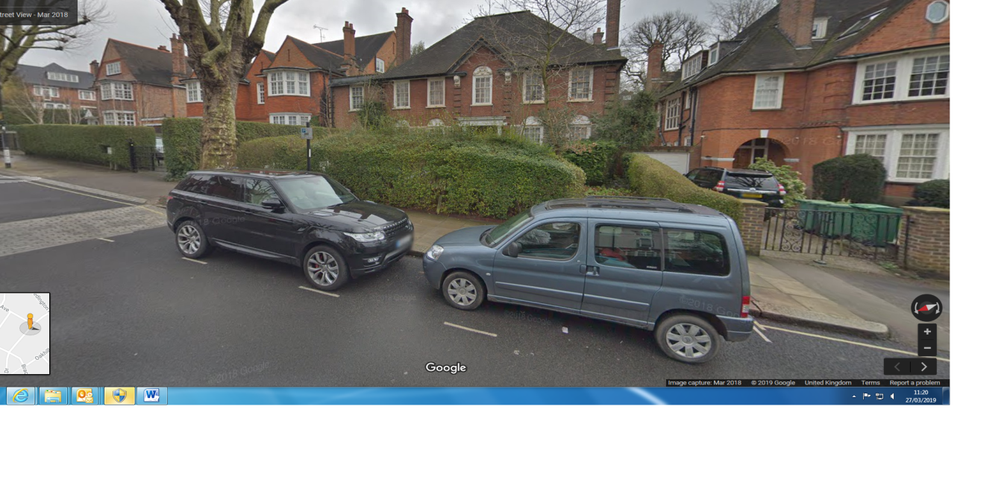

here are 2 bays directly outside the property but after reviewing the site access plan and after further investigation we will access and egress the site from 1 gate and manage this accordingly as set out below, we at this stage do not anticipate having to suspend any parking bays as this is preferable but this will have to be reviewed on an on-going basis.

.

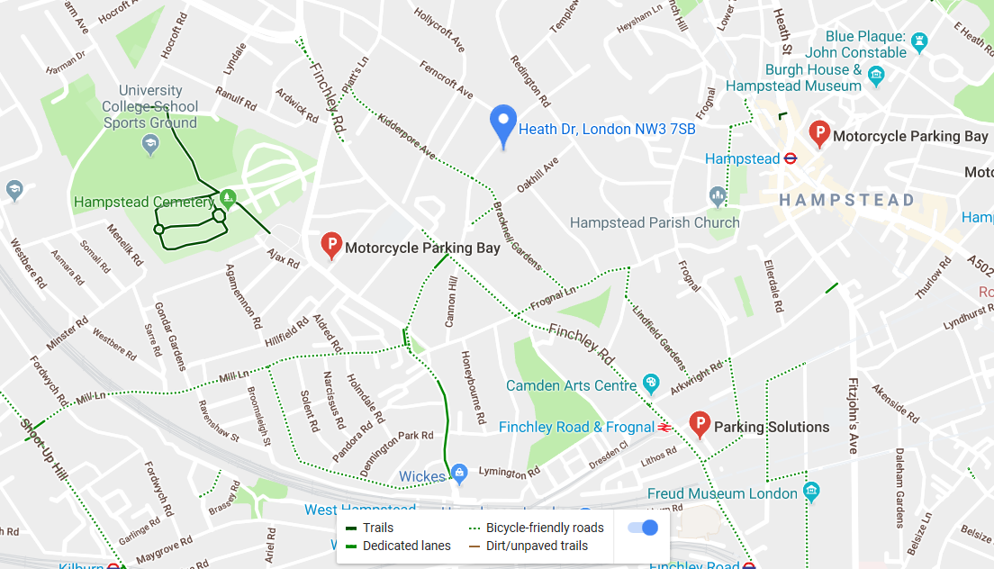

Site access locations are indicated in the site set up there is permit parking around all local roads.

10. Please provide the proposed start and end dates for each phase of construction as well as an overall programme timescale. A Gantt chart with key tasks, durations and milestones would be ideal. (See attached addendum1)

11. Please confirm the standard working hours for the site, noting that the standard working hours for construction sites in Camden are as follows:

* 8.00am to 6pm on Monday to Friday
* 8.00am to 1.00pm on Saturdays
* No working on Sundays or Public Holidays

The standard working hours will be from 8.00am -6.00pm Monday to Fridays and 8.00am to 1.00pm on Saturdays there will be no working on Sundays and Public Holidays, we will restrict some operations on Saturdays to ensure they are low impact to keep any disruption to the surrounding area to a minimum.

12. Please indicate if any changes to services are proposed to be carried out that would be linked to the site during the works (i.e. connections to public utilities and/or statutory undertakers’ plant). Larger developments may require new utility services. If so, a strategy and programme for coordinating the connection of services will be required. If new utility services are required, please confirm which utility companies have been contacted (e.g. Thames Water, National Grid, EDF Energy, BT etc.) You must explore options for the utility companies to share the same excavations and traffic management proposals. Please supply details of your discussions.

If multiple incoming services are required under the purposed scheme, it will be our intentions, where possible to use the same excavation and traffic management proposal for all the service connection needed. This will reduce the impact on the works to the public highway. A strategy for coordinating the connecting the services will be developed and submitted to the council for approval. We will have a new water and electrical connection which we anticipate having a small Impact to the local footpath in a very short time frame 2-3 days maximum.

# Community Liaison

**A neighbourhood consultation process must have been undertaken prior to submission of the CMP first draft. This consultation must relate to construction impacts, and should take place following the granting of planning permission in the lead up to the submission of the CMP. A consultation process specifically relating to construction impacts must take place regardless of any prior consultations relating to planning matters. This consultation must include all of those individuals that stand to be affected by the proposed construction works. These individuals should be provided with a copy of the draft CMP, or a link to an online document. They should be given adequate time with which to respond to the draft CMP, and any subsequent amended drafts. Contact details which include a phone number and email address of the site manager should also be provided.**

Significant time savings can be made by running an effective neighbourhood consultation process. This must be undertaken in the spirit of cooperation rather than one that is dictatorial and unsympathetic to the wellbeing of local residents and businesses.

These are most effective when initiated as early as possible and conducted in a manner that involves the local community. Involving locals in the discussion and decision making process helps with their understanding of what is being proposed in terms of the development process. **The consultation and discussion process should have already started, with the results incorporated into the CMP first draft submitted to the Council for discussion and sign off.**This communication should then be ongoing during the works, with neighbours and any community liaison groups being regularly updated with programmed works and any changes that may occur due to unforeseen circumstances through newsletters, emails and meetings.

Please note that for larger sites, details of a construction working group may be required as a separate S106 obligation. If this is necessary, it will be set out in the S106 Agreement as a separate requirement on the developer.

**Cumulative impact**

Sites located within high concentrations of construction activity that will attract large numbers of vehicle movements and/or generate significant sustained noise levels should consider establishing contact with other sites in the vicinity in order to manage these impacts.

**The Council can advise on this if necessary.**

**13. Consultation**

Contact with neighbouring residents and local representatives has taken place with the form of a letter drop, on the 1/4/19 which outline the works with a time frame and contact details should they wish to contact anyone regards the project, it l also contain detail should they wish to view the CMP, we have received no feed back to date positive or negative , we are hoping to start on the 20th of May but this is subject to 3rd parties so TBC. Three weeks prior to starting on site we will again inform local residents and representatives ,of the confirmed start date, key construction dates within the programme of works, pending works this will be maintained throughout the contract period, and be posted on the site notice board .To this date the neighbouring properties of 23,25 Heath drive have been contacted. (See letter attached to e mail )

**14. Construction Working Group**

Please provide details of community liaison proposals including any Construction Working Group that will be set up, addressing the concerns of the community affected by the works, the way in which the contact details of the person responsible for community liaison will be advertised to the local community, and how the community will be updated on the upcoming works i.e. in the form of a newsletter/letter drop, or weekly drop in sessions for residents.

We have letter dropped all the local residents on the 1/5/ 19 and have no feed back to date positive or negative this explain to the local residents of the nature of the works , outline programme of the works and contact detail, of the site manager, contracts manager as well as an alternative contact at out head office familiar with the contract. It also provide an out of hours contact within this information, and residents will be informed of any changes to circumstances as and when it may occur. There will be a site notice board displaying all the relevant information fixed to the site hoarding fully accessible. Should any complaints be received pertaining the works the works will be halted and reviewed until the matter has been reasonable resolved by all parties, which may mean changing working practices.

**15. Schemes**

Please provide details of your ‘Considerate Constructors Scheme’ registration, and details of any other similar relevant schemes as appropriate. Contractors will also be required to follow the “[Guide for Contractors Working in Camden](http://www.camden.gov.uk/ccm/cms-service/download/asset?asset_id=799001)” also referred to as “[Camden’s Considerate Contractors Manual](http://www.camden.gov.uk/ccm/cms-service/download/asset?asset_id=799001)”.

We have registered with the ‘Considerate Constructor Scheme’ which is the national initiative, set up by the construction industry to improve its image. Registration details are as follows:

Registration ID: 69945

Subsequent reports from CCS will be forwarded when carried out and received.

Works will also be carried out in conjunction CHAS and with the “guide for Contractors Working in Camden” and “Camden’s Considerate Constructors Manual.”

**16. Neighbouring sites**

Please provide a plan of existing or anticipated construction sites in the local area and please state how your CMP takes into consideration and mitigates the cumulative impacts of construction in the vicinity of the site. The council can advise on this if necessary.

We have a number of sites in around the area and we will were possible pool our deliveries to reduce traffic movement , we will of course be using the same suppliers, the contracts are as follows.

59 Redington Road NW3 7RP

24-26 Redington Gardens NW3 7RX

36 Heath Drive NW3 7SB

# Transport

**This section must be completed in conjunction with your principal contractor. If one is not yet assigned, please leave the relevant sections blank until such time when one has been appointed.**

Camden is a CLOCS Champion, and is committed to maximising road safety for Vulnerable Road Users (VRUs) as well as minimising negative environmental impacts created by motorised road traffic. As such, all vehicles and their drivers servicing construction sites within the borough are bound by the conditions laid out in the [CLOCS Standard.](http://www.clocs.org.uk/)

This section requires details of the way in which you intend to manage traffic servicing your site, including your road safety obligations with regard to VRU safety. It is your responsibility to ensure that your principal contractor is fully compliant with the terms laid out in the CLOCS Standard. It is your principal contractor’s responsibility to ensure that all contractors and sub-contractors attending site are compliant with the terms laid out in the CLOCS Standard.

Checks of the proposed measures will be carried out by the council to ensure compliance. Please refer to the CLOCS Standard when completing this section. Guidance material which details CLOCS requirements can be accessed [here](http://www.camden.gov.uk/ccm/cms-service/stream/asset?asset_id=3550016&), details of the monitoring process are available [here](http://www.camden.gov.uk/ccm/cms-service/stream/asset?asset_id=3550014&).

Please contact [CLOCS@camden.gov.uk](mailto:CLOCS@camden.gov.uk) for further advice or guidance on any aspect of this section.

**Please refer to the CLOCS Overview and Monitoring Overview documents referenced above which give a breakdown of requirements.**

**CLOCS Contractual Considerations**

17. Name of Principal contractor:

My Construction ,

Unit 5 Sayer House, Oxgate Lane,

London NW2 7JN

18. Please submit the proposed method for checking operational, vehicle and driver compliance with the CLOCS Standard throughout the duration of the contract (please refer to our [CLOCS Overview document](http://www.camden.gov.uk/ccm/cms-service/stream/asset?asset_id=3550016&) and [Q18 example response](http://www.camden.gov.uk/ccm/cms-service/stream/asset?asset_id=3550015&)).

There will be 3 accredited traffic Marshalls that will be responsible for all traffic movement for ingress and egress to the site, the site will be contacted by the driver when he nearing the site in preparation for the delivery, at this stage they will be deployed to help manoeuvre the vehicle safety onto the site in reverse so that it will always be able to drive out, priority will all ways be given to pedestrians during the delivery to and from site. All operators shall ensure their vehicles will meet the requirements as described as silver in the FORS standard, addressing the issue of management, vehicle, drivers and operations, and provide evidence of this. This will be constantly reviewed and updated accordingly to improve and monitor the CLP.

19. Please confirm that you as the client/developer and your principal contractor have read and understood the [CLOCS Standard](http://www.clocs.org.uk/wp-content/uploads/2015/05/CLOCS-Standard-v1.2-APRIL_15.pdf) and included it in your contracts. Please sign-up to join the [CLOCS Community](http://www.clocs.org.uk/links-to-partners/) to receive up to date information on the standard by expressing an interest online.

I confirm that I have included the requirement to abide by the CLOCS Standard in my contracts to my contractors and suppliers:

We can confirm that that we understand and have included the requirements to abide by CLOCS Standard within our appraisal of the works at 24 Heath Drive.

Please contact [CLOCS@camden.gov.uk](mailto:CLOCS@camden.gov.uk) for further advice or guidance on any aspect of this section.

**Site Traffic**

**Sections below shown in blue directly reference the CLOCS Standard requirements. The CLOCS Standard should be read in conjunction with this section.**

**20. Traffic routing**: *“Clients shall ensure that a suitable, risk assessed vehicle route to the site is specified and that the route is communicated to all contractors and drivers. Clients shall make contractors and any other service suppliers aware that they are to use these routes at all times unless unavoidable diversions occur.”* (P19, 3.4.5)

Routes should be carefully considered and risk assessed, taking into account the need to avoid where possible any major cycle routes and trip generators such as schools, offices, public buildings,museums etc. Where appropriate, on routes that use high risk junctions (i.e. those that attract high volumes of cycling traffic) installing Trixi mirrors to aid driver visibility should be considered.

Consideration should also be given to weight restrictions, low bridges and cumulative impacts of construction (including neighbouring construction sites) on the public highway network. The route(s) to and from the site should be suitable for the size of vehicles that are to be used.

a. Please indicate routes on a drawing or diagram showing the public highway network in the vicinity of the site including details of how vehicles will be routed to the [Transport for London Road Network](http://www.lscp.org.uk/lrsu/engineering_tlrn.html) (TLRN) on approach and departure from the site.

The site is situated just off the Finchley Road (A41) this will be the main route to the site turning into Heath Drive, the deliveries will then be reversed on to site by the traffic marshalls on to the site and off loaded on to the site footprint, the vehicles will then drive out leaving the site, then turn back on to heath Drive and back onto the Finchley Road. Heath Drive is a residential road with residential parking restrictions but we do not envisage any significant impact on parking or the surround roads while deliveries are taking place due to the access arrangement stated above. 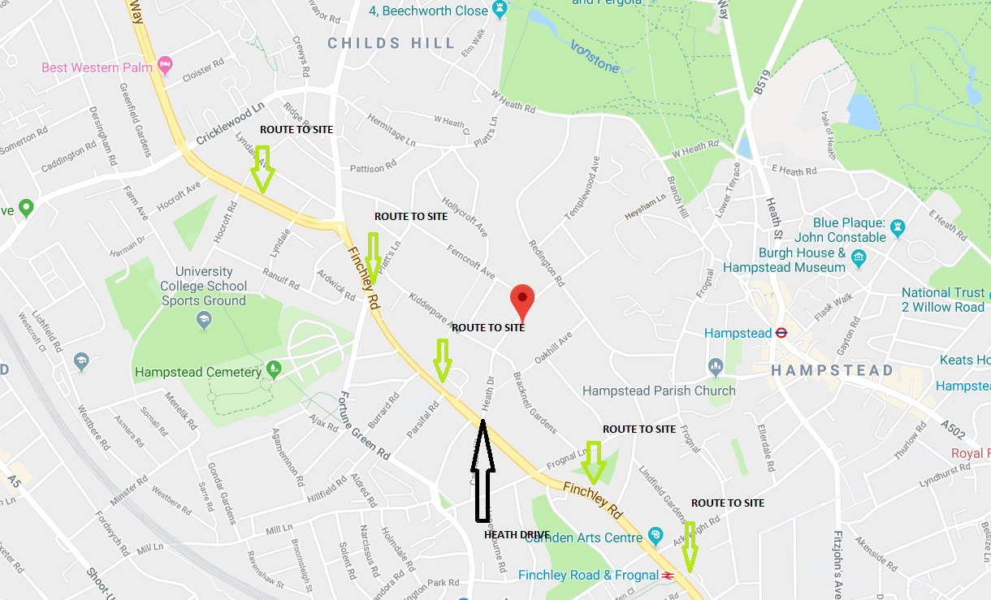

b. Please confirm how contractors, delivery companies and visitors will be made aware of the route (to and from the site) and of any on-site restrictions, prior to undertaking journeys.

All subcontractors and operatives will be made aware of the delivery arrangements in the site induction when they arrive on site, it will also be posted on the site notice board, all delivery arrangements and procedures will be sent to our local suppliers in line with our existing practices, any order over and above these will be sent when placing the order of the goods, a very large percentage of our deliveries will be sourced locally, and are suppliers that we are familiar with. When the drive calls the site 20 minutes before he arrives he will be reminded of the route and arrangements, the area will be readied for his arrival, if the loading area is not available he will be asked to reschedule his delivery or told to park in a suitable area in the local vicinity avoiding any disruption to traffic in the area. They will ask to turn off their engine once they arrive on site or if having to be held up.

**21. Control of site traffic, particularly at peak hours**: “*Clients shall consider other options to plan and control vehicles and reduce peak hour deliveries”* (P20, 3.4.6)

Construction vehicle movements are restricted between 9.30am to 3.00pm on weekdays (During term time) and between 8.00am and 1.00pm on Saturdays)As there is a school in the vicinity of the site or on the proposed access and/or egress routes.(Refer to the [*Guide for Contractors Working in Camden*](http://www.camden.gov.uk/ccm/cms-service/download/asset?asset_id=799001)).

A delivery plan should ensure that deliveries arrive at the correct part of site at the correct time. Instructions explaining such a plan should be sent to all suppliers and contractors**.** Consideration should be given to the location of any necessary holding areas for large sites with high volumes of traffic. Vehicles must not wait or circulate on the public highway. Whilst deliveries should be given set times to arrive, dwell and depart, no undue time pressures should be placed upon the driver at any time.

a. Please provide details of the typical sizes of all vehicles and the approximate frequency and times of day when they will need access to the site, for each phase of construction.You should estimate the average daily number of vehicles during each major phase of the work, including their dwell time at the site. High numbers of vehicles per day and/or long dwell times may require vehicle holding procedures.

Skip lorry 4 wheels 20 tonnes L 6.27X W 2.5 2 X Times per week Muck Away /Tippers 32 tonnes l9.1X W2.6 Average 3 X Per day during the early stages of the contract 20-25 weeks Delivery Vehicles L 12m X 2.55 W 0n Average 2 times per day during the contract period Concrete Lorries L 9.2 X2.9 W On Average 2 times per day during the early stages the contract 15-18 weeks .

The estimated dwell time for skip exchanges is approximately 15minute Tippers 20 minutes and deliveries dependant on material up to 45 minutes these will be within the site foot print so will not affect the neighbouring area. Engines will be switch off while stationary. Deliveries will be scheduled to be between 9.30AM and 3pm during term times as to avoid the school traffic we will also try to ensure they do not deliver at the same time.

b. Please provide details of other developments in the local area or on the route.

There are no significant projects in the local area or on route that will impact on deliveries to site.

c. Please outline the system that is to be used to ensure that the correct vehicle attends the correct part of site at the correct time.

All deliveries will be planned as set out previously and will delivered when required due to the site constrains, we also have an off-site storage facility that we can utilise if necessary. The delivery will be advised of site location when he calls site 20 minutes before as this is a small site it will be managed by the traffic marshalls

d. Please identify the locations of any off-site holding areas (an appropriate location outside the borough may need to be identified, particularly if a large number of delivery vehicles are expected) and any measures that will be taken to ensure the prompt admission of vehicles to site in light of time required for any vehicle/driver compliance checks. Please refer to question 24 if any parking bay suspensions will be required for the holding area.

This is not anticipated

e. Please provide details of any other measures designed to reduce the impact of associated traffic (such as the use of [construction material consolidation centres](https://www.google.co.uk/url?sa=t&rct=j&q=&esrc=s&source=web&cd=2&cad=rja&uact=8&ved=0ahUKEwi5hKjPiLjRAhVqLcAKHQduC_gQFggkMAE&url=http%3A%2F%2Fcontent.tfl.gov.uk%2Fdirectory-london-construction-consolidation-centres.pdf&usg=AFQjCNFhB34aaqw3M3fmDpJYUUBw_PjbdA&sig2=KXhGnTR3slzf0kN4XMOcQg&bvm=bv.143423383,d.ZWM)).

As set out above we will were possible use local suppliers for general building material and other materials this will be the case .We will also recycle any materials where possible but in this case will be minimal.

**22. Site access and egress:** “*Clients shall ensure that access to and egress from the site is appropriately managed, clearly marked, understood and clear of obstacles.”* (P18, 3.4.3)

Vehicles entering and leaving the site should be carefully managed, using gate that is clearly marked and free from obstacles. Traffic marshalls must ensure the safe passage of all traffic on the public highway, in particular pedestrians and cyclists, when vehicles are entering and leaving site, particularly if reversing.

Traffic marshals, or site staff acting as traffic marshals, should hold the relevant qualifications required for directing large vehicles when reversing. Marshals should be equipped with ‘STOP – WORKS’ signs (not STOP/GO signs) if control of traffic on the public highway is required. Marshals should have radio contact with one another where necessary.

a. Please detail the proposed access and egress routes to and from the site

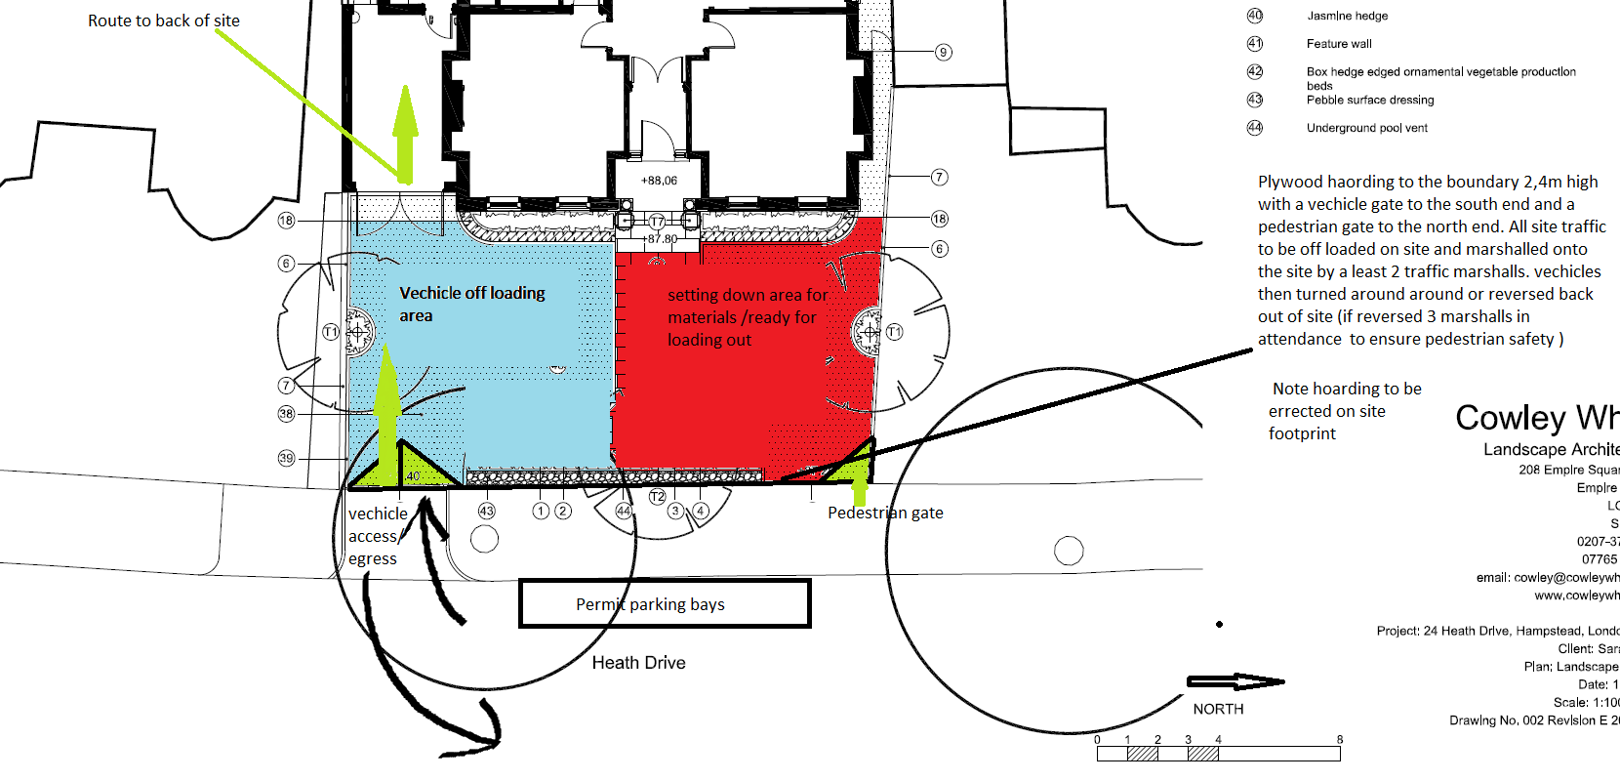

b. Please describe how the access and egress arrangements for construction vehicles will be managed.

There will be 3 Traffic Marshalls to manage the ingress and egress to the site and maintain the access areas ,the vehicle will always be backed in and driven forward out.

c. Please provide swept path drawings for any tight manoeuvres on vehicle routes to and from the site including proposed access and egress arrangements at the site boundary (if necessary).

No tight manoeuvres anticipated.

d. Provision of wheel washing facilities should be considered if necessary. If so, please provide details of how this will be managed and any run-off controlled.

Wheel washing may be required at the initial stages of the works and will be carried out by jet washing the wheel on the site footprint , all run off from the wheel cleaning will be contain within the site boundary . A regular inspection of the public highway will be maintained during these works.

**23. Vehicle loading and unloading:** *“Clients shall ensure that vehicles are loaded and unloaded on-site as far as is practicable.”* (P19, 3.4.4)

If this is not possible, Traffic Marshalls must ensure the safe passage of pedestrians, cyclists and motor traffic in the street when vehicles are being loaded or unloaded.

Please provide details of the parking and loading arrangements for construction vehicles with regard to servicing and deliveries associated with the site (e.g. delivery of materials and plant, removal of excavated material). This is required as a scaled site plan, showing all points of access and where materials, skips and plant will be stored, and how vehicles will access and egress the site. If loading is to take place off site, please identify where this is due to take place and outline the measures you will take to ensure that loading/unloading is carried out safely. Please outline in question 24 if any parking bay suspensions will be required.

**Please note all Vehicles to be reversed in and driven out.**

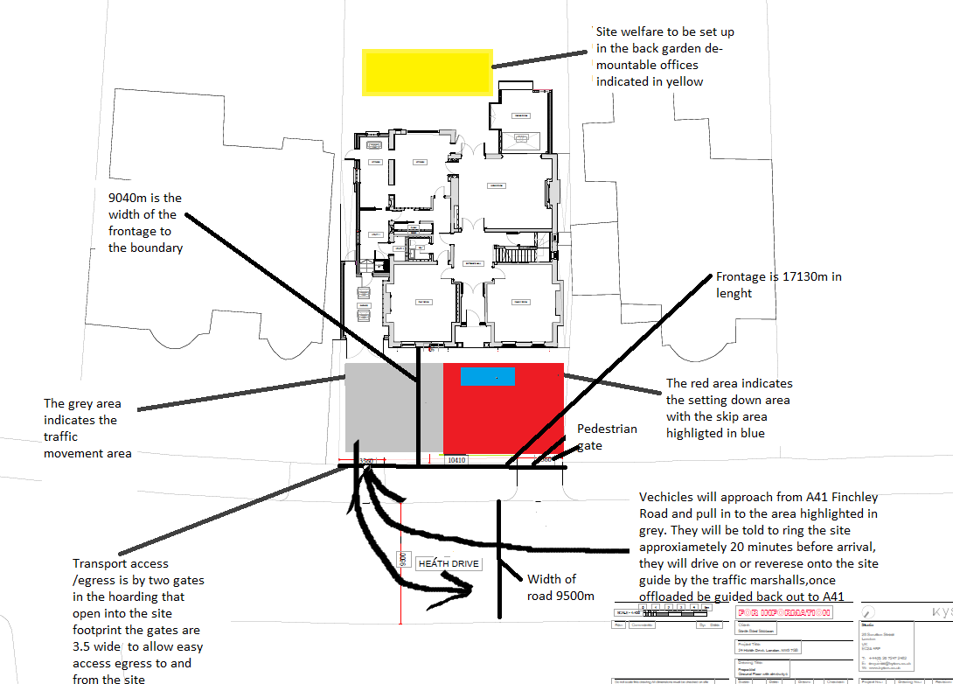

**No deliveries to be schedule before 9.30 and after 3.30 during term times to avoid school traffic**

**Highway interventions**

**Please note that Temporary Traffic Orders (TTOs) and hoarding/scaffolding licenses may be applied for prior to CMP submission but won’t be granted until the CMP is signed-off.**

**If the site is on or adjacent to the TLRN, please provide details of preliminary discussions with Transport for London in the relevant sections below.**

**24. Parking bay suspensions and temporary traffic orders**

Please note, parking bay suspensions should only be requested where absolutely necessary. Parking bay suspensions are permitted for a maximum of 6 months, requirement of exclusive access to a bay for longer than 6 months you will be required to obtain [Temporary Traffic Order (TTO)](http://camden.gov.uk/ccm/content/transport-and-streets/traffic-management/temporary-road-restrictions/) for which there is a separate cost.

Please provide details of any proposed parking bay suspensions and TTO’s which would be required to facilitate construction. **Building materials and equipment must not cause obstructions on the highway as per your Considerate Contractors obligations unless the requisite permissions are secured.**

Information regarding parking suspensions can be found [here.](http://www.camden.gov.uk/ccm/navigation/transport-and-streets/parking/parking-bay-suspensions/)

We do not envisage any parking suspensions.

**25. Scaled drawings of highway works**

Please note that use of the public highway for storage, site accommodation or welfare facilities is at the discretion of the Council and is generally not permitted. If you propose such use you must supply full justification, setting out why it is impossible to allocate space on-site. You must submit a detailed (to-scale) plan showing the impact on the public highway that includes the extent of any hoarding, pedestrian routes, parking bay suspensions and remaining road width for vehicle movements. We prefer not to close footways but if this is unavoidable, you should submit a scaled plan of the proposed diversion route showing key dimensions.

a. Please provide accurate scaled drawings of any highway works necessary to enable construction to take place (e.g. construction of temporary vehicular accesses).



As also attached above and as indicated on the scaled drawing attached we anticipate no effect on the public highway during the contract period only apart from the services to be connected by the appropriate service provider.

b.Please provide details of all safety signage, barriers and accessibility measures such as ramps and lighting etc.

Mandatory safety signage will be fixed to hoarding to ensure public safety. Deliveries to be unloaded on site in to the loading bays indicated in the above illustrations. Travel marshalls will be in attendance for ingress and egress to and from the site.

**26. Diversions**

Where applicable, please supply details of any diversion, disruption or other anticipated use of the public highway during the construction period (alternatively a plan may be submitted).

No diversion or disruption is anticipated during the contract period.

**27. VRU and pedestrian diversions, scaffolding and hoarding**

Pedestrians and/or cyclist safety must be maintained if diversions are put in place. Vulnerable footway users should also be considered. These include wheelchair users, the elderly, those with walking difficulties, young children, those with prams, the blind and partially sighted. Appropriate ramping must be used if cables, hoses, etc. are run across the footway.

Any work above ground floor level may require a covered walkway adjacent to the site. A licence must be obtained for scaffolding and gantries. The adjoining public highway must be kept clean and free from obstructions. Lighting and signage should be used on temporary structures/skips/hoardings etc.

A secure hoarding will generally be required at the site boundary with a lockable access.

a. Please provide details describing how pedestrian and cyclist safety will be maintained, including any proposed alternative routes (if necessary), and any Traffic Marshall arrangements.

Full time trained traffic marshals will be on site to ensure safety for venerable road users, pedestrians and cyclists during delivery and waste collection appointments. Ramps and pedestrian barriers will be fitted if required to ensure safe access is maintained.

Where reversing is required, assistance will be made available by trained and competent persons / banksman.

b. Please provide details of any temporary structures which would overhang the public highway (e.g. scaffolding, gantries, cranes etc.) and details of hoarding requirements or any other occupation of the public highway.

This does not apply

SYMBOL IS FOR INTERNAL USE

# Environment

To answer these sections please refer to the relevant sections of **Camden’s Minimum Requirements for Building Construction (**[**CMRBC**](http://www.camden.gov.uk/ccm/cms-service/download/asset?asset_id=3257318)**).**

28. Please list all [noisy operations](http://www.camden.gov.uk/ccm/content/environment/environmental-health--consumer-protection/noise/reducing-noise/noise-from-construction-sites.en?page=2)  and the construction method used, and provide details of the times that each of these are due to be carried out.

Works will only be carried out during 08:00 and 18:00 Mon to Fri and 08:00 to 13:00 Saturdays only (if required).

Consideration will be applied to the adjacent neighbours and we will seek to not carry out particularly noisy works such as the breaking and drilling of concrete on Saturday mornings (if worked).

Where possible hand held tools will be used to minimise noise.

Noisy works operations are anticipated to include use of:

Breakers, drills, 1x mini excavator, electric table saws.

29. Please confirm when the most recent noise survey was carried out (before any works were carried out) and provide a copy. If a noise survey has not taken place please indicate the date (before any works are being carried out) that the noise survey will be taking place, and agree to provide a copy.

A noise survey will be carried out during the start of work to ensure accurate measurements are recorded prior to enabling works commencing to establish existing baselines. We confirm a copy will be provided on completion.

30. Please provide predictions for [noise](http://www.camden.gov.uk/ccm/content/environment/environmental-health--consumer-protection/noise/reducing-noise/noise-from-construction-sites.en?page=2) and vibration levels throughout the proposed works.

Over the 10 hour day the average noise levels are anticipated to be in the region of or less than 75dB

Noise levels are predicted to peak at 80dB but these will only be short duration activities.

Vibration levels are anticipated to be no more than 10mm/s and considerably less on average throughout the day.

31. Please provide details describing mitigation measures to be incorporated during the construction/[demolition](http://www.camden.gov.uk/ccm/navigation/environment/building-control/demolition/) works to prevent noise and vibration disturbances from the activities on the site, including the actions to be taken in cases where these exceed the predicted levels.

Regular monitoring will be carried out by the site manager. If exceeded readings are experienced the source of the excess noise/ vibration levels will be established then the work process / methodology will be reviewed if required.

2.4m hoardings to the boundary will help contain noise as well as an additional sheeting at high level if required localised screens will be used as as and when required to mitigate the noise and dust .

Modern tools will be used to ensure vibration/noise levels are reduced to the minimum.

32. Please provide evidence that staff have been trained on BS 5228:2009

All personnel will receive an induction including training in BS 5228:2009 code of practice and guidance on noise reduction and nuisance.

The site manager will hold current SMSTS certification.

All supervisors including sub-contractors will have as a minimum SSSTS certification.

All other operatives will have the relevant CSCS or job specific CITB approved certification.

33. Please provide details on how dust nuisance arising from dusty activities, on site, will be prevented.

Damping down will be carried out in accordance with BS 6187: 2011

Works will be carried out in accordance with:

Control of Pollution Act 1974

Environmental Act 1990 (ss79-82)

BS 5228:1997 Code of Practice on Construction and Open Site.

Regularly sweeping and damp cleaning of surrounding areas and hoardings will be carried out .

34. Please provide details describing how any significant amounts of dirt or dust that may be spread onto the public highway will be prevented and/or cleaned.

All dust will be supressed with irrigation or a Hepa filter dust extraction systems (Class L & Class M dependant on type of dust being produced).

Designated operatives will regularly check and clean the site boundaries exits / entrances of the hoarding to the pavements and highway to ensure no dust or dirt is present.

If necessary a mechanical road sweeper type electric machine will be used on and as and when required basis but not envisaged.

35. Please provide details describing arrangements for monitoring of [noise](http://www.camden.gov.uk/ccm/content/environment/environmental-health--consumer-protection/noise/reducing-noise/noise-from-construction-sites.en?page=2), vibration and dust levels.

All noise produced by plant will be reduced by the use of mufflers, baffles or silencers and where possible using pre-fabricated components and by strictly adhering to site working hours, vibration will be minimised by phased ground impacting operations . Nuisance dust levels will be eliminated by employing extractors with Hepa filters and by using irrigation reservoirs fitted to cutting equipment etc.

36. Please confirm that a Risk Assessment has been undertaken at planning application stage in line with the GLA policy. [The Control of Dust and Emissions During Demolition and Construction 2104 (SPG)](https://www.london.gov.uk/file/18750/download?token=zV3ZKTpP), that the risk level that has been identified, and that the appropriate measures within the GLA mitigation measures checklist have been applied. Please attach the risk assessment and mitigation checklist as an appendix.

The risk assessment will form part of the Site safety file and be included in all RAMS that cover relevant activities and will incorporate the appropriate measures as identified in the Supplementary Planning Guidance.

37. Please confirm that all of the GLA’s ‘highly recommended’ measures from the [SPG](https://www.london.gov.uk/file/18750/download?token=zV3ZKTpP) document relative to the level of risk identified in question 36 have been addressed by completing the [GLA mitigation measures checklist.](https://www.london.gov.uk/what-we-do/planning/implementing-london-plan/supplementary-planning-guidance/control-dust-and)

Confirmed

38. If the site is a ‘High Risk Site’, 4 real time dust monitors will be required. If the site is a ‘Medium Risk Site’, 2 real time dust monitors will be required. The risk assessment must take account of proximity to sensitive receptors (e.g. schools, care homes etc), as detailed in the [SPG](https://www.london.gov.uk/file/18750/download?token=zV3ZKTpP). Please confirm the location, number and specification of the monitors in line with the SPG and confirm that these will be installed 3 months prior to the commencement of works, and that real time data and quarterly reports will be provided to the Council detailing any exceedances of the threshold and measures that were implemented to address these.

Due to the size and type of works being carried out real time monitors are not deemed necessary however regular monitoring will be carried out by the site manager and records kept within the site office.

39. Please provide details about how rodents, including [rats](http://www.camden.gov.uk/ccm/content/environment/environmental-health--consumer-protection/pest-control/about-the-pest-control-service.en), will be prevented from spreading out from the site. You are required to provide information about site inspections carried out and present copies of receipts (if work undertaken).

The site will be kept clean and tidy, and site rules include the consumption of food only being permitted within the canteen. Waste produced from this area will be disposed of in euro bins with lids not bags, which will be collected and disposed of in accordance with our waste management plan to prevent rodents spreading from the site.

A site survey will be carried out by an approved Pest Control specialist before commencement of actual construction. A Method Statement for pest control will be prepared and implemented by the specialist, in accordance with Camden's Minimum Requirements. Any redundant drains will be removed and any connections sealed with concrete.

During the works the monitoring of the evidence of rodent activity will continue.

40. Please confirm when an asbestos survey was carried out at the site and include the key findings.

Asbestos survey will be carried out in line with our Health and Safety procedures and as a duty of care before work commences.

41. Complaints often arise from the conduct of builders in an area. Please confirm steps being taken to minimise this e.g. provision of a suitable smoking area, tackling bad language and unnecessary shouting.

All site personnel will receive a site specific induction highlighting that bad behaviour and bad language is not permitted and may result in immediate dismissal.

Unnecessary shouting will be monitored by advice from site supervisory staff.

Smoking will not be permitted within the building footprint. Any operatives who wish to smoke must smoke within the allocated area within the site boundary cigarette bins will be provided to ensure they are not inappropriately discarded, and fire safety measures will be readily available, this will form part of the site induction.

There will be disciplinary action when site rules are not adhered to, in order to prevent bad site culture development, or a negative impact on the community.

42. If you will be using non-road mobile machinery (NRMM) on site with net power between 37kW and 560kW it will be required to meet the standards set out below. The standards are applicable to both variable and constant speed engines and apply for both PM and NOx emissions.

**From 1st September 2015**

**(i) Major Development Sites** – NRMM used on the site of any major development will be required to meet Stage IIIA of EU Directive 97/68/EC

**(ii) Any development site within the Central Activity Zone -** NRMM used on any site within the Central Activity Zone will be required to meet Stage IIIB of EU Directive 97/68/EC

**From 1st September 2020**

**(iii) Any development site -** NRMM used on any site within Greater London will be required to meet Stage IIIB of EU Directive 97/68/EC

**(iv) Any development site within the Central Activity Zone -** NRMM used on any site within the Central Activity Zone will be required to meet Stage IV of EU Directive 97/68/EC

Please provide evidence demonstrating the above requirements will be met by answering the following questions:

1. BB Construction time period (8 weeks Pre construction /72 weeks Construction:
2. Is the development within the CAZ? (N):NO
3. Will the NRMM with net power between 37kW and 560kW meet the standards outlined above? (Y):YES
4. Please provide evidence to demonstrate that all relevant machinery will be registered on the NRMM Register, including the site name under which it has been registered:
5. Any NRMM required for the project (possibly only 1 x No. 130 CFM compressor @ 44kW and 1x 200kva generator) will be hired in from a reputable hire company such as 1st Response Site Services or Speedy Hire Services. Items will be registered to the site and from commencement.
6. Please confirm that an inventory of all NRMM will be kept on site and that all machinery will be regularly serviced and service logs kept on site for inspection:
7. An inventory and service record for any NRMM required will be available for inspection
8. Please confirm that records will be kept on site which details proof of emission limits, including legible photographs of individual engine plates for all equipment, and that this documentation will be made available to local authority officers as required:
9. All relevant documentation regarding the above will be maintained on site should it be require for inspection .

SYMBOL IS FOR INTERNAL USE

# Agreement

The agreed contents of this Construction Management Plan must be complied with unless otherwise agreed in writing by the Council. This may require the CMP to be revised by the Developer and reapproved by the Council. The project manager shall work with the Council to review this Construction Management Plan if problems arise in relation to the construction of the development. Any future revised plan must be approved by the Council in writing and complied with thereafter.

It should be noted that any agreed Construction Management Plan does not prejudice further agreements that may be required such as road closures or hoarding licences.

**Please notify that council when you intend to start work on site. Please also notify the council when works are approximately 3 months from completion.**

**Signed:** …………………………………………………………………

**Date:** 13/03/2019……………………………………………..

**Print Name:** Hugh Lennon ……………………………………………………..….

**Position: Project Manager** …………………………………………

Please submit to: [planningobligations@camden.gov.uk](mailto:planningobligations@camden.gov.uk)

End of form.