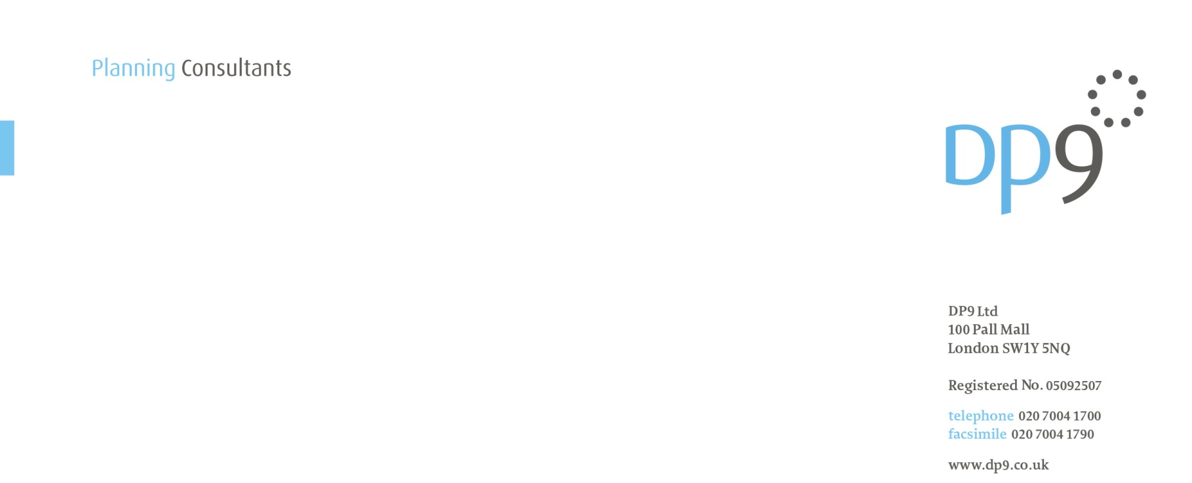DP4129

4 April 2019

Mr David Peres da Costa

London Borough of Camden

Regeneration and Planning  
Culture and Environment

2nd Floor, 5 Pancras Square

c/o Town Hall

Judd Street

London

WC1H 9JE

Dear David

**1 TRITON SQUARE & sT ANNES CHURCH (rEF: 2016/6069/p) – cONDITION 4 PART B) (rESIDENTIAL ELEMENT PILING STATEMENT0: APPROVAL OF DETAILS APPLICATION**

We write on behalf of our client, British Land Property Management Limited, to submit details to discharge Condition 4 part B) attached to the above planning permission. The submission comprises of a ‘Piling Strategy Statement – Residential Element’ prepared by M3 dated 1st April 2019.

The submission is made in accordance with the amended condition wording as approved under Non Material Amendment application ref. 2017/6573/P. Condition 4 reads as follows:

*‘No impact piling within:*

*A) the commercial element; or*

*B) the residential element of the development*

*shall commence until a piling method statement, prepared in consultation with ThamesWater or the relevant statutory undertaker, detailing the depth and type of piling to be undertaken within that element and the methodology by which such piling will be carried out including measures to prevent and minimise the potential for damage to subsurface water infrastructure, and the programme of works for the relevant element, has been submitted to and approved in writing by the local planning authority. Any piling within the relevant element must be undertaken in accordance with the terms of the approved piling method statement for that element.*

*Reason: To safeguard existing below ground public utility infrastructure and controlled waters in accordance with the requirements of policy CC3 of the London Borough of Camden Local Plan 2017.’*

The submitted statement provides the required piling details for the Residential Element in accordance with the condition. The statement concludes that no impact piling is planned during the development works and that the continuous flight auger (CFA) piling proposed for the Residential Element is not anticipated to impact on Thames Water Assets.

We look forward to receiving confirmation of receipt and would ask you to contact Dan Fyall or Georgina Redpath at the above office if you require any further information.

Yours sincerely



**Georgina** **Redpath**

**Planner**