**38-46, JAMESTOWN ROAD, 24, 26 AND 28, OVAL ROAD**

[Be the first to contribute](https://historicengland.org.uk/listing/the-list/list-entry/1113236#contributions)

**Overview**

Heritage Category: Listed Building

Grade: II

List Entry Number: 1113236

Date first listed: 06-Jul-1981

Statutory Address: 24, 26 AND 28, OVAL ROAD

Statutory Address: 38-46, JAMESTOWN ROAD

**Map**

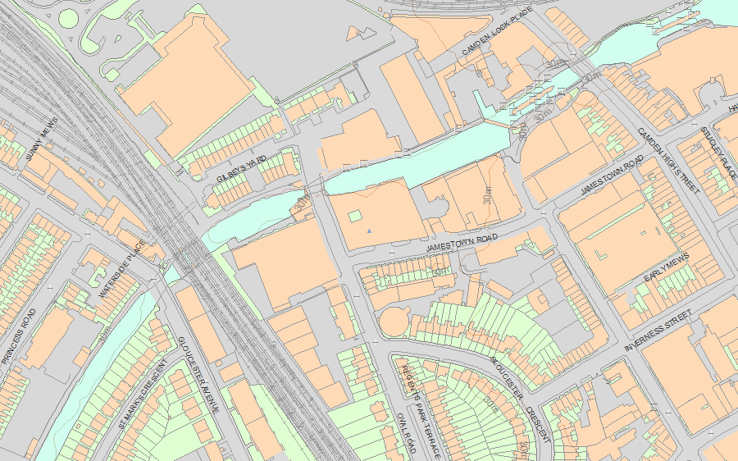© Crown Copyright and database right 2019. All rights reserved. Ordnance Survey Licence number 100024900.  
© British Crown and SeaZone Solutions Limited 2019. All rights reserved. Licence number 102006.006.  
Use of this data is subject to [Terms and Conditions](https://historicengland.org.uk/terms/website-terms-conditions/).

The above map is for quick reference purposes only and may not be to scale. For a copy of the full scale map, please see the attached PDF - [1113236 .pdf](http://mapservices.historicengland.org.uk/printwebservicehle/StatutoryPrint.svc/109665/HLE_A4L_Grade%7CHLE_A3L_Grade.pdf)

The PDF will be generated from our live systems and may take a few minutes to download depending on how busy our servers are. We apologise for this delay.

This copy shows the entry on 26-Mar-2019 at 14:44:39.

**Location**

Statutory Address: 24, 26 AND 28, OVAL ROAD

Statutory Address: 38-46, JAMESTOWN ROAD

The building or site itself may lie within the boundary of more than one authority.

County: Greater London Authority

District: Camden (London Borough)

National Grid Reference: TQ 28560 83989

**Details**

CAMDEN  
  
TQ2883NE JAMESTOWN ROAD 798-1/76/1258 Nos.38-46 (Even) 06/07/81   
  
GV II  
  
See under: Nos.24, 26 AND 28 OVAL ROAD.   
  
  
  
CAMDEN  
  
TQ2883NE OVAL ROAD 798-1/76/1258 (East side) 06/07/81 Nos.24, 26 AND 28   
  
GV II  
  
Formerly known as: Gilbey House OVAL ROAD. Includes: Nos.38-46 JAMESTOWN ROAD. Factory, store and offices. 1894 by William Hucks with addition of 1937 by Mendelsohn and Chermayeff; for wine importers and gin distillers Gilbey's. Original block to south-east: of concrete reinforced with hoop iron. Exterior rendered; channelled rustication to ground floor and channelled pilaster strips rising from 1st to 4th floor. 5 storeys plus attic and basement. 10 bays to Jamestown Road. Plain, square-headed entrances to ground floor including 2 vehicle entrances to left. Square-headed, recessed metal framed windows, most with small panes. Subsidiary cornice above 3rd floor, main cornice above 4th floor. INTERIOR: not inspected. HISTORICAL NOTE: an early example of reinforced concrete construction. 1937 block: of reinforced concrete frame filled with concrete panels; ground floor brown glazed tiles, upper floors rendered. Corner site; 7 storeys, with 6 bays to Oval Road and 7 bays to slightly concave Jamestown Road facade. International Modern idiom. Recessed main entrance to left of Oval Road facade with full height projecting square-sided bay window above with floor to ceiling glazing (emphasising the position of executive offices). Other windows form horizontal strips separated by vertical mullions. Teak 2-light window frames, plate glass. To Jamestown Road, the 6th floor rooms are recessed to incorporate a loggia with cast-iron railings. Projecting cornice above 6th floor. INTERIOR: not inspected. HISTORICAL NOTE: the building incorporates technical innovations by consulting engineer Felix Samuely, e.g. the foundations are floated on cork insulation to protect the wine from the vibration of nearby trains. Air conditioning too was incorporated. Until recent years known as Gilbey House. Gilbey's, formed in 1857, by 1914 occupied 20 acres in Camden.  
  
  
  
  
  
Listing NGR: TQ2856083989

**Legacy**

The contents of this record have been generated from a legacy data system.

Legacy System number: 477686

Legacy System: LBS

**Legal**

This building is listed under the Planning (Listed Buildings and Conservation Areas) Act 1990 as amended for its special architectural or historic interest.

End of official listing