**40, COLLEGE CRESCENT**

[2 contributions](https://historicengland.org.uk/listing/the-list/list-entry/1386727#contributions)

**Overview**

Heritage Category: Listed Building

Grade: II

List Entry Number: 1386727

Date first listed: 11-Jan-1999

Statutory Address: 40, COLLEGE CRESCENT

**Map**

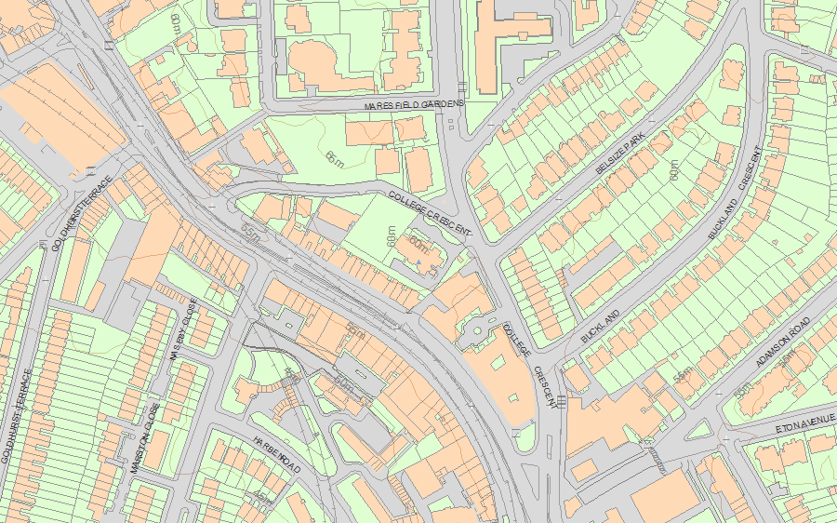© Crown Copyright and database right 2019. All rights reserved. Ordnance Survey Licence number 100024900.  
© British Crown and SeaZone Solutions Limited 2019. All rights reserved. Licence number 102006.006.  
Use of this data is subject to [Terms and Conditions](https://historicengland.org.uk/terms/website-terms-conditions/).

The above map is for quick reference purposes only and may not be to scale. For a copy of the full scale map, please see the attached PDF - [1386727 .pdf](http://mapservices.historicengland.org.uk/printwebservicehle/StatutoryPrint.svc/348671/HLE_A4L_Grade%7CHLE_A3L_Grade.pdf)

The PDF will be generated from our live systems and may take a few minutes to download depending on how busy our servers are. We apologise for this delay.

This copy shows the entry on 26-Mar-2019 at 12:11:48.

**Location**

Statutory Address: 40, COLLEGE CRESCENT

The building or site itself may lie within the boundary of more than one authority.

County: Greater London Authority

District: Camden (London Borough)

National Grid Reference: TQ 26566 84516

**Details**

TQ2584NE CAMDEN COLLEGE CRESCENT 798-1/50/266 (West side) 11.1.99 No.40   
  
GV II  
  
Detached house. c1880-1. By Morris and Stallwood of Reading. For Samuel Palmer. Grey and red Reading bricks with terracotta enrichment and continuous dentil cornices at floor level. Tiled hipped roofs with tall brick slab chimney-stacks. EXTERIOR: 3 and 2 storeys and basement. 5 bays; irregular windows. Asymmetrical design in Queen Anne style. Central projecting porch of pilasters flanking a round-arched entrance with keystone and supporting an enriched parapet with ball finials; panelled part-glazed double doors with patterned fanlight. To left a window with radial patterned head; 1st and 2nd floor sashes have keystones and shaped aprons. To left, a Flemish gabled bay of grey bricks with red brick pilaster strips rising through the floors to form round-arched blind arcading with keystones on the 2nd floor; single central sashes with shaped and enriched aprons; enriched plaque in pediment. Ground floor window flanked by cartouches. Left hand outer bay of 2 storeys forming a canted bay on the return. To right of entrance a pedimented oriel window with large round-arched window having patterned glazing above. Right hand outer bay of 2 sashes to each floor flanked by red brick pilasters; central enriched plaques. The rear elevation is less significant and the main architectural interest of the exterior resides in the front elevation. INTERIOR: Front portion of house, up to rear wall of axial corridor, has very fine original internal features. Central hall and staircase has dado panelling, moulded arches on turned columns, original doors and windows with stained glass. Moulded ceiling, wooden fireplace and fine panelled doors in elaborate wooden surrounds. The main staircase rises through 3 storeys with all its decoration intact. The rooms to the rear of the axial corridor throughout the house are plainer and more altered than those at the front. The main rooms on the front ground floor retain very fine fireplaces and elaborate doors and door surrounds, they also have contemporary plaster ceilings and deep coving. On the upper floors many of the rooms have been sub-divided but those at the front in particular still retain most of their original late Victorian fittings including fireplaces, doors, door surrounds, coving, skirting boards, dado panelling and fitted cupboards. This high quality late Victorian house survives very well with remarkably good quality contemporary internal features in the front rooms. HISTORICAL NOTE: Samuel Palmer of Huntley and Palmer's biscuits, Reading, built his house in a style and materials popular in the Reading area. Originally called Northcourt the house then became a Children's Hospital. Palmer's family presented the drinking fountain, (qv), at the corner with Fitzjohn's Avenue, to his memory in 1904.   
  
  
  
Listing NGR: TQ2656684516

**Legacy**

The contents of this record have been generated from a legacy data system.

Legacy System number: 474123

Legacy System: LBS

**Legal**

This building is listed under the Planning (Listed Buildings and Conservation Areas) Act 1990 as amended for its special architectural or historic interest.

End of official listing