**NUMBERS 12-19 AND ATTACHED RAILINGS**

[2 contributions](https://historicengland.org.uk/listing/the-list/list-entry/1379288#contributions)

**Overview**

Heritage Category: Listed Building

Grade: II

List Entry Number: 1379288

Date first listed: 14-May-1974

Date of most recent amendment: 11-Jan-1999

Statutory Address: NUMBERS 12-19 AND ATTACHED RAILINGS, 12-19, LEIGH STREET

**Map**

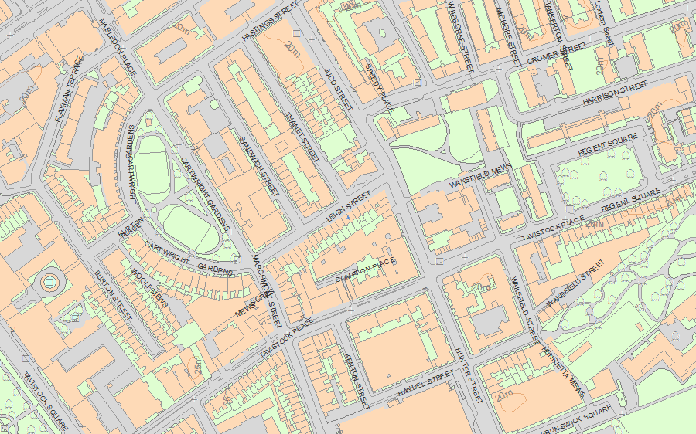© Crown Copyright and database right 2019. All rights reserved. Ordnance Survey Licence number 100024900.  
© British Crown and SeaZone Solutions Limited 2019. All rights reserved. Licence number 102006.006.  
Use of this data is subject to [Terms and Conditions](https://historicengland.org.uk/terms/website-terms-conditions/).

The above map is for quick reference purposes only and may not be to scale. For a copy of the full scale map, please see the attached PDF - [1379288 .pdf](http://mapservices.historicengland.org.uk/printwebservicehle/StatutoryPrint.svc/448885/HLE_A4L_Grade%7CHLE_A3L_Grade.pdf)

The PDF will be generated from our live systems and may take a few minutes to download depending on how busy our servers are. We apologise for this delay.

This copy shows the entry on 25-Mar-2019 at 15:13:09.

**Location**

Statutory Address: NUMBERS 12-19 AND ATTACHED RAILINGS, 12-19, LEIGH STREET

The building or site itself may lie within the boundary of more than one authority.

County: Greater London Authority

District: Camden (London Borough)

National Grid Reference: TQ 30186 82519

**Details**

CAMDEN  
  
TQ3082NW LEIGH STREET 798-1/90/1022 (South side) 14/05/74 Nos.12-19 (Consecutive) and attached railings (Formerly Listed as: LEIGH STREET Nos.1-19 (Consecutive))  
  
GV II  
  
8 terraced houses with later shops. 1810-13. By James Burton. Built by T Jennings. Darkened stock brick with some later patching. 4 storeys and cellars. 2 windows each. Nos 12, 13 & 19, early C19 wooden projecting shopfronts with entablatures and large window panes; No.19 with reeded pilasters carrying fascia; round-arched doorways with cornice-heads, patterned fanlights and panelled doors. No.14, C20 reproduction C19 shopfront. Nos 15-18, altered mid-later C19 shopfronts with entablatures flanked by consoles. Gauged brick flat arches to recessed sash windows, 1st floor Nos 12-14 with cast-iron balconies. No.18 with stucco architraves and 1st floor console bracketed cornices. Nos 14-19 with plain stucco 3rd floor sill band. Parapets. INTERIORS: not inspected. (Survey of London: Vol. XXIV, King's Cross Neighbourhood, Parish of St Pancras IV: London: -1952: 88).   
  
  
  
  
  
  
  
Listing NGR: TQ3018482516

**Legacy**

The contents of this record have been generated from a legacy data system.

Legacy System number: 478656

Legacy System: LBS

**Sources**

Books and journals  
'Survey of London' in Survey of London - Kings Cross neighbourhood The Parish of St Pancras Part 4: Volume 24 , (1951), 88

**Legal**

This building is listed under the Planning (Listed Buildings and Conservation Areas) Act 1990 as amended for its special architectural or historic interest.

End of official listing