DECISION

Planning (Listed Building and Conservation Areas) Act 1990

Listed Building Consent Refused

Address:
23-24 Montague Street
London
WC1B 5BH

Proposal:
Removal and replacement of the 2nd-3rd floor staircase at No 24 Montague Street, pursuant to listed building consent ref 2017/0044/L granted on 22/05/2017 for replacement windows to front elevation and associated internal alterations in association with change of use from hotel to 6 flats.
Drawing Nos: Site Location Plan; 333_01_08; 333_500_08; 333_500_10; 333_500_11; Design and Access & Heritage Statement.

The Council has considered your application and decided to refuse listed building consent for the following reason(s):

Reason(s) for Refusal

1 | The proposed demolition and replacement of the historic 2nd to 3rd floor staircase to No 24 Montague Street is considered to cause harm to the special architectural and historic interest of the grade II listed building, and therefore contrary to policy D1 (Design) and policy D2 (Heritage) of the Camden Local Plan 2017.

Informative(s):

In dealing with the application, the Council has sought to work with the applicant in a positive and proactive way in accordance with paragraph 38 of the National Planning Policy Framework 2019.

You can find advice about your rights of appeal at:

http://www.planningportal.gov.uk/planning/appeals/guidance/guidancecontent

Yours faithfully

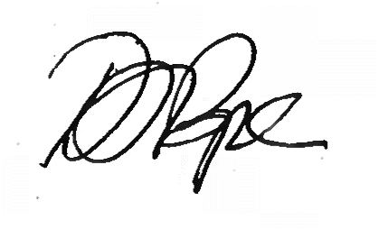
Daniel Pope
Chief Planning Officer

