**THE ROUNDHOUSE**

[6 contributions](https://historicengland.org.uk/listing/the-list/list-entry/1258103#contributions)

**Overview**

Heritage Category: Listed Building

Grade: II*

List Entry Number: 1258103

Date first listed: 10-Jun-1954

Date of most recent amendment: 11-Jan-1999

Statutory Address: THE ROUNDHOUSE, CHALK FARM ROAD

**Map**

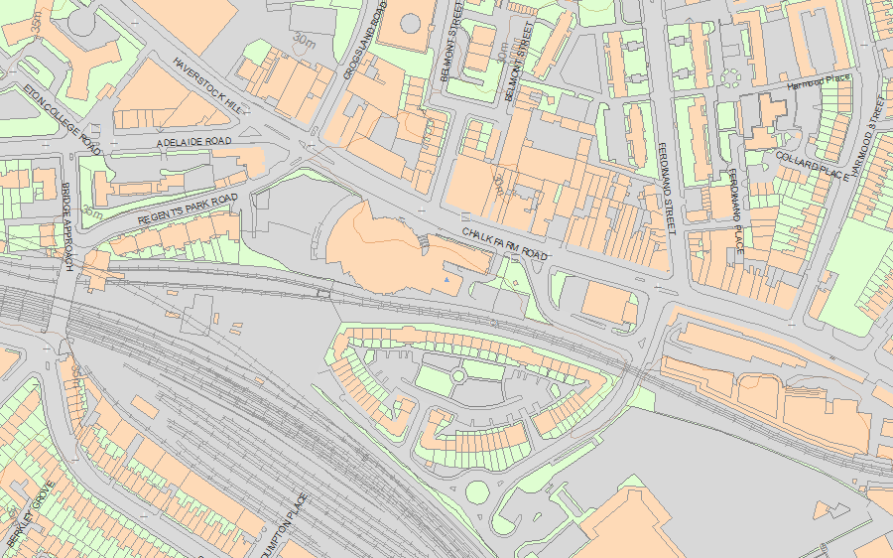© Crown Copyright and database right 2019. All rights reserved. Ordnance Survey Licence number 100024900.  
© British Crown and SeaZone Solutions Limited 2019. All rights reserved. Licence number 102006.006.  
Use of this data is subject to [Terms and Conditions](https://historicengland.org.uk/terms/website-terms-conditions/).

The above map is for quick reference purposes only and may not be to scale. For a copy of the full scale map, please see the attached PDF - [1258103 .pdf](http://mapservices.historicengland.org.uk/printwebservicehle/StatutoryPrint.svc/418399/HLE_A4L_Grade%7CHLE_A3L_Grade.pdf)

The PDF will be generated from our live systems and may take a few minutes to download depending on how busy our servers are. We apologise for this delay.

This copy shows the entry on 14-Mar-2019 at 12:45:02.

**Location**

Statutory Address: THE ROUNDHOUSE, CHALK FARM ROAD

The building or site itself may lie within the boundary of more than one authority.

County: Greater London Authority

District: Camden (London Borough)

National Grid Reference: TQ 28297 84302

**Details**

CAMDEN  
  
TQ2884SW CHALK FARM ROAD 798-1/64/194 (South West side) 10/06/54 The Roundhouse (Formerly Listed as: CHALK FARM ROAD The Round House Theatre)  
  
GV II*  
  
Formerly known as: Warehouse of W & A Gilbey Ltd CHALK FARM ROAD. Goods locomotive shed, now theatre. 1846-7. By Robert B Dockray. For the London and North Western Railway. Built by Branson & Gwyther. Converted for use as a theatre 1967 and 1985. Yellow stock brick. Low pitched conical slate roof having a central smoke louvre, now glazed, and bracketed eaves. Circular plan 48m in diameter. Buttresses with offsets mark bays each having a shallow, recessed rectangular panel. Former entrances and windows with round-arched heads. INTERIOR: roof carried on 24 cast-iron Doric columns (defining original locomotive spurs) and a framework of curved ribs. Believed to retain original flooring, turn table and fragments of early railway lines. Wooden gallery probably added by Gilbeys, late C19. HISTORICAL NOTE: the building did not last long as an engine shed; by the 1860s the engines had become too long to be turned and stored there so it was leased to W & A Gilbey Ltd as a liquor store until converted to a theatre in the 1960s. (Survey of London: Vol. XXI, Tottenham Court Road and Neighbourhood, St Pancras III: London: -1949: 114).   
  
  
  
  
  
Listing NGR: TQ2829784302

**Legacy**

The contents of this record have been generated from a legacy data system.

Legacy System number: 476873

Legacy System: LBS

**Sources**

Books and journals  
'Survey of London' in Survey of London - Tottenham Court Road and Neighbourhood St Pancras Part 3: Volume 21, (1949), 114

**Legal**

This building is listed under the Planning (Listed Buildings and Conservation Areas) Act 1990 as amended for its special architectural or historic interest.

End of official listing