**28-38, LAMBS CONDUIT STREET**

[4 contributions](https://historicengland.org.uk/listing/the-list/list-entry/1379267#contributions)

**Overview**

Heritage Category: Listed Building

Grade: II

List Entry Number: 1379267

Date first listed: 02-Apr-1981

Statutory Address: 28-38, LAMBS CONDUIT STREET

**Map**

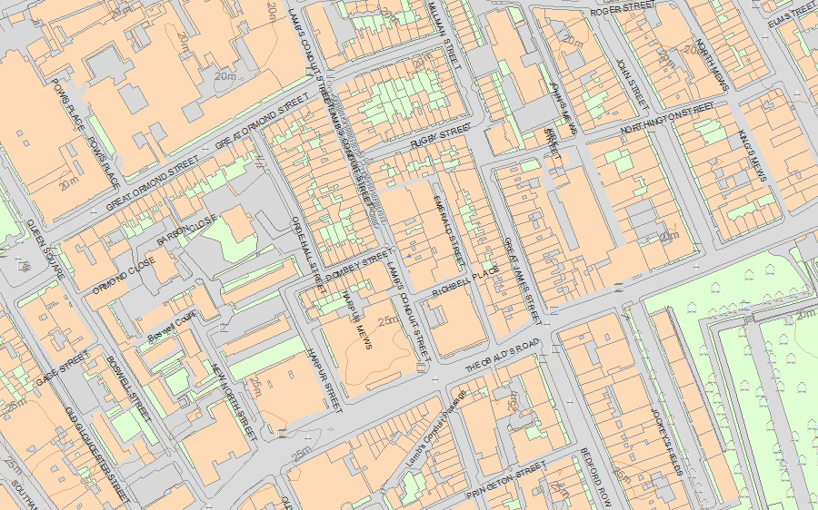© Crown Copyright and database right 2019. All rights reserved. Ordnance Survey Licence number 100024900.  
© British Crown and SeaZone Solutions Limited 2019. All rights reserved. Licence number 102006.006.  
Use of this data is subject to [Terms and Conditions](https://historicengland.org.uk/terms/website-terms-conditions/).

The above map is for quick reference purposes only and may not be to scale. For a copy of the full scale map, please see the attached PDF - [1379267 .pdf](http://mapservices.historicengland.org.uk/printwebservicehle/StatutoryPrint.svc/342201/HLE_A4L_Grade%7CHLE_A3L_Grade.pdf)

The PDF will be generated from our live systems and may take a few minutes to download depending on how busy our servers are. We apologise for this delay.

This copy shows the entry on 14-Mar-2019 at 10:41:39.

**Location**

Statutory Address: 28-38, LAMBS CONDUIT STREET

The building or site itself may lie within the boundary of more than one authority.

County: Greater London Authority

District: Camden (London Borough)

National Grid Reference: TQ 30674 81934

**Details**

CAMDEN  
  
TQ3081NE LAMB'S CONDUIT STREET 798-1/101/1002 (East side) 02/04/81 Nos.28-38 (Even)   
  
GV II  
  
Terrace of 5 houses. Nos 30 & 32 are one building. 1690-1700, No.28 built under a lease granted to Nicholas Barbon in 1686. Refronted early C19. No.38 rebuilt C20 above ground floor level but included for group value. Yellow stock brick with stone coped parapets. 4 storeys. 2 windows except Nos 28 & 38 with three. No.28 with C19 shopfront, the rest altered to various degrees in C20. Gauged brick flat arches to recessed sash windows, the 1st floor of Nos 34 & 36 in shallow round-arched recesses. Rear elevations of plum stocks with bands and flush framed ash windows. INTERIORS: not inspected but Nos 28 & 36 noted to retain original staircases, that of No.28 possibly late C17 with heavy turned balusters and closed string; No.36 with twist balusters and carved tread ends. Some panelled rooms.   
  
  
  
  
  
Listing NGR: TQ3066881956

**Legacy**

The contents of this record have been generated from a legacy data system.

Legacy System number: 478635

Legacy System: LBS

**Legal**

This building is listed under the Planning (Listed Buildings and Conservation Areas) Act 1990 as amended for its special architectural or historic interest.

End of official listing