**Design & Heritage Statement**

**29 Crediton Hill, London NW6**

**For:**

**Mr and Mrs Russell**

**29 Crediton Hill,**

**London NW6**

**Janka & Tony Mobbs Architects**

**7 Willcott Road**

**London W3 9QX**

**Tel: 020 8992 3443**

**7th March 2019**

**Design & Heritage Statement**

**29 Crediton Hill, London NW6**

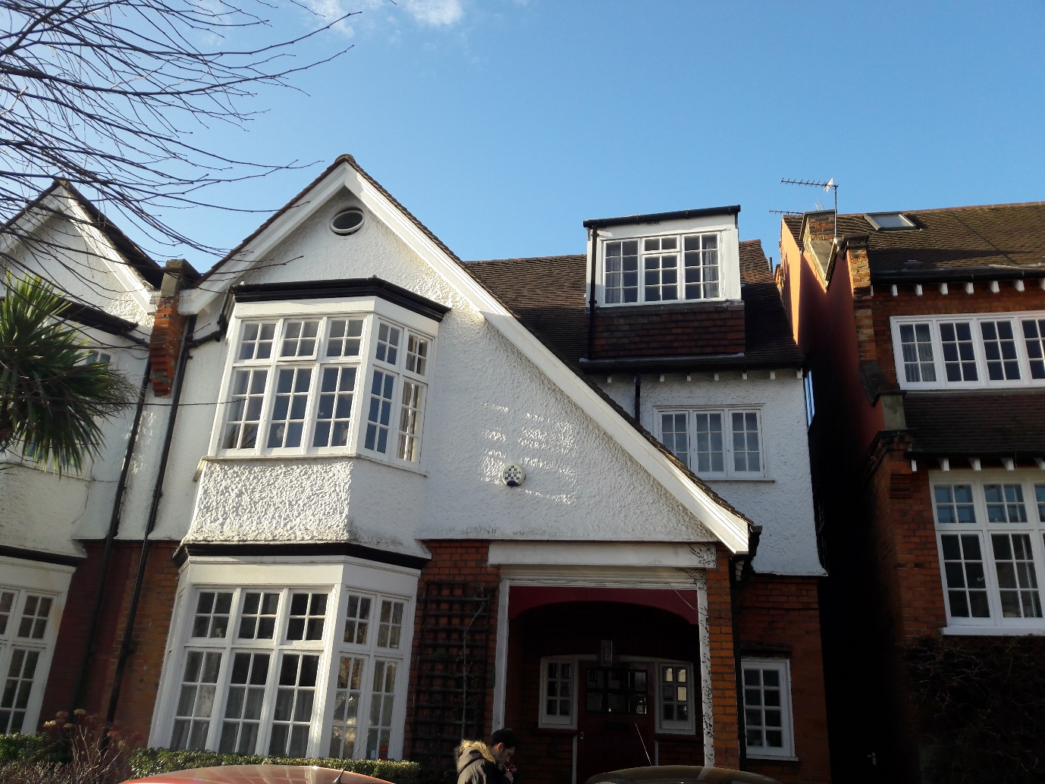

Fig 1 - Front of the house.

The property is located in the West End Green Conservation Area in the Ward of Camden. This Conservation Area was first designated on the 1st March 1993. The houses on Crediton Hill, which is a relatively quiet street, are substantial Edwardian properties, detached and semi-detached, built for families of the professional classes in an Arts and Crafts style.

No 29 Crediton Hill is a semi-detached, three storey house with dormer windows at the front and rear. The original windows were painted timber although some have been replaced with uPVC. The external walls are in red brick, and in pebbledash render painted white. At the rear most of the brickwork has been painted white. The roof is of clay, plain tiles. There is a single storey extension at the rear which we consider to be original as it is shown on the 1905 plan attached to the deeds. See fig 2 below. There is a large rear garden with substantial trees at the far end, a significant distance from the house.

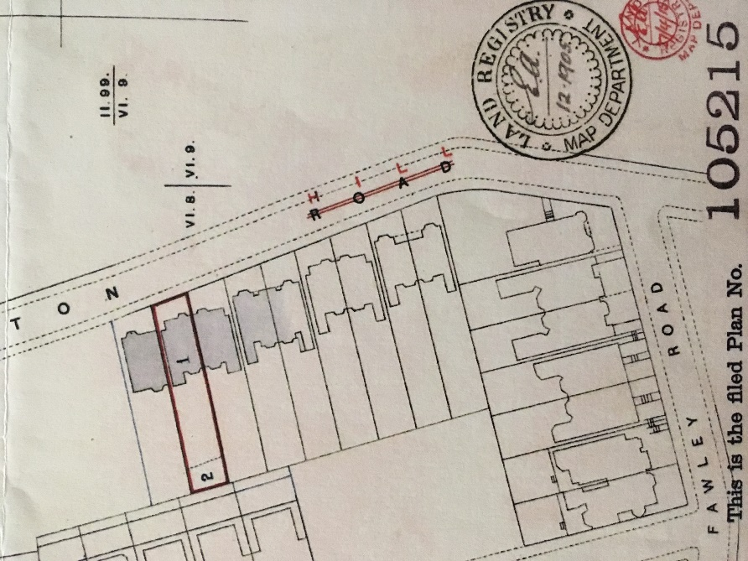

Fig 2 - Plan attached to the deeds of the house dated 1905.

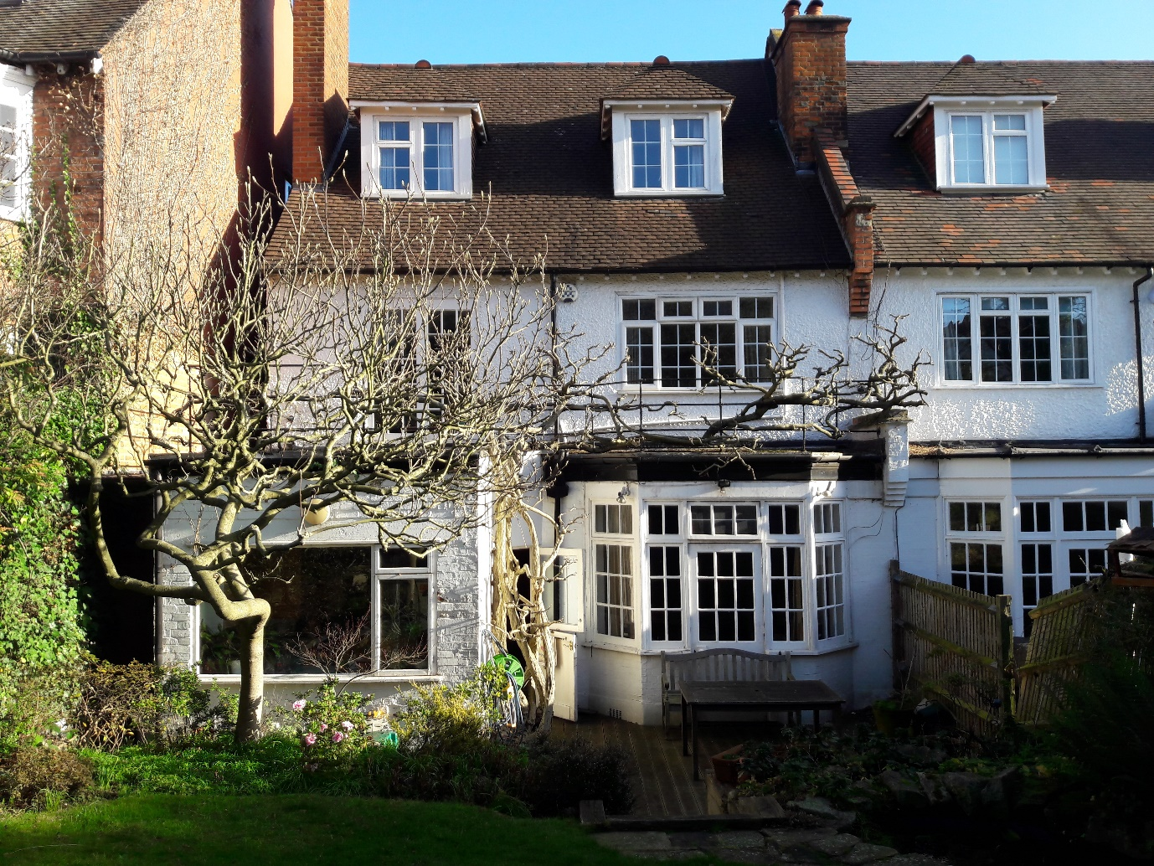

Fig 3 - Rear of the house

**Design proposals**

The ground floor is deep and the central and rear parts of the interior are rather dark despite the large windows. It is proposed to improve the current (original) rear extension by widening it to the south side to provide a better shaped space. To the west a small extension in traditional style is proposed in in the form of a bay window. Together with the proposed flat rooflights this would allow natural light to flood into the centre and rear of the house.

The existing roof terrace is to be retained, widened to the south. The handrails are to be replaced with new to meet the requirements of the building regulations. The railings proposed are to be metal with a timber handrail as shown on fig 4 below. They are a simplified version of the original railings to neighbouring properties – 50, 52 and 54 Crediton Hill, and to properties in Fawley Road. See photograph of 50 Crediton Hill - fig 5 below.

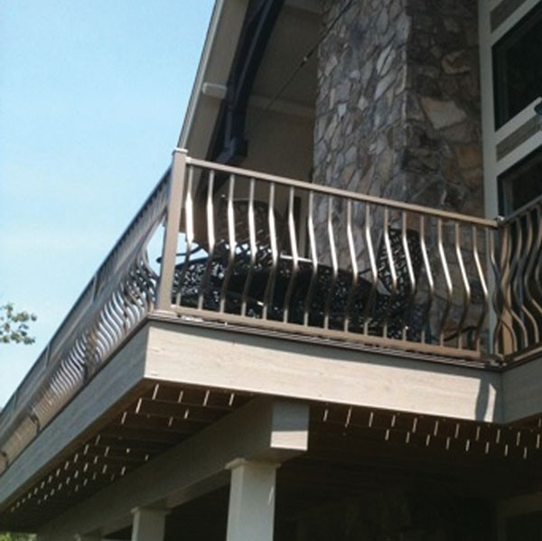

Fig 4 - Railings to terrace.

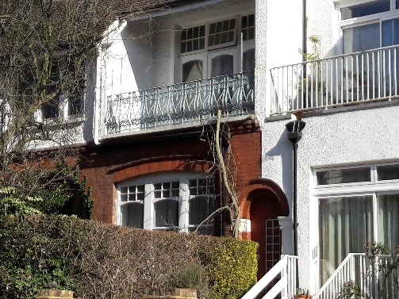

Fig 5 - Railings at 50 Crediton Hill

**The effect on the amenity of the neighbours**

The ground floor at no. 29 Crediton Hill is approximately 1.7m below the ground floor of no. 31. The height of the ground floor extension of no. 29 therefore has no impact on no. 31 and there is no loss of amenity. See fig 6

The proposed extensions to no. 29 are over 4m from the boundary with no. 27 Crediton Hill (see fig 7) and will therefore have no effect on the amenity of the occupiers of 27.

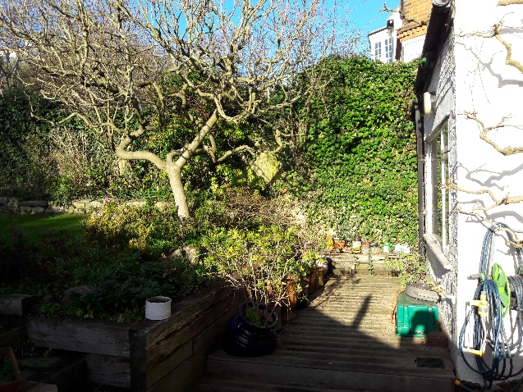 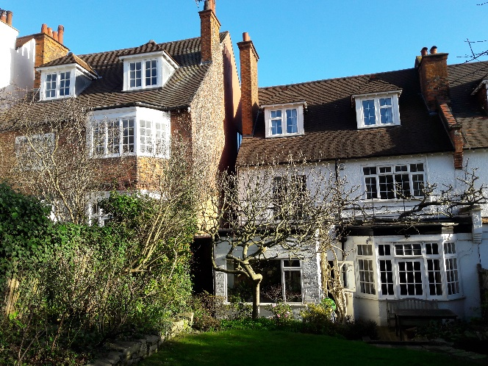

Fig 6 Fig 7

**Character and Appearance**

The proposed works are at the rear of the property and will not be visible from the street. Our approach is for a traditional design to be sympathetic to the existing building.

**Access**

No changes are proposed to the current access arrangements.

**Pre-application Meeting**

A pre-application meeting was held on 14th February 2019, when a number of proposals were discussed. See Planning Officer’s report dated 28th February 2019, a copy of which is attached. This concludes that *“the proposed enlargement of the existing ground floor extension would not have a significant design or amenity impact and is considered acceptable. The revised ground floor extension would not cause harm to neighbouring amenity in terms of loss of light, outlook or privacy”*.

7th March 2019