Site Name: | Suncheck Centre | ATM Location  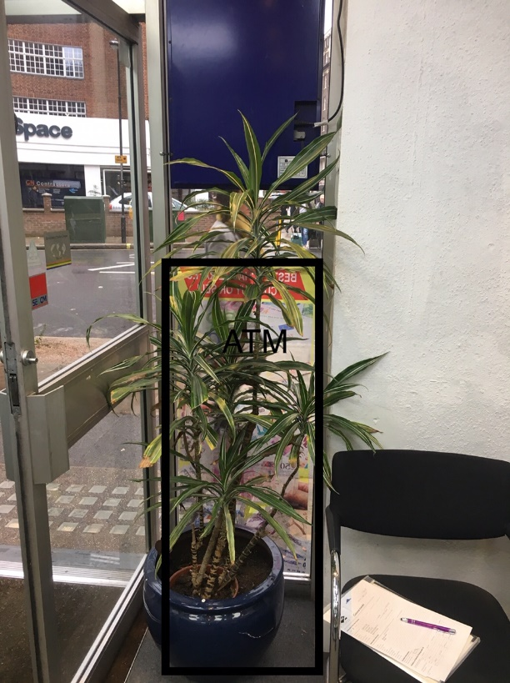  Front of Shop & Side View  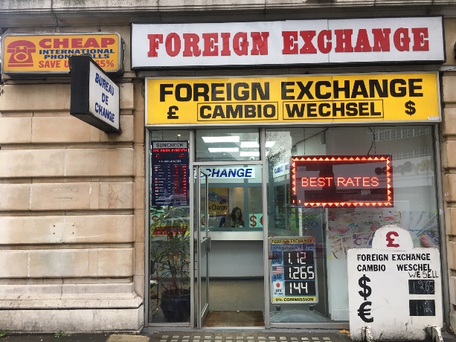  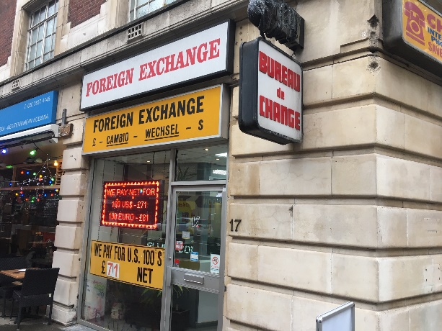
Address: | 17 Woburn Place, Bloomsbury, London, WC1H 0LN
Site Contact: | Mrs Neelam Anand
Phone: | T: 0207 278 5709 M: 07931 168438
Email: | Anandneelam@gmail.com
ATM Type: | NCR SS26
Opening Hours: | Mon-Sun 08.30am – 18.30 hrs. (G4S Access Hours)
Signage: | ATM Euronet Standard, Plus Light Box (X2)
Notes: This site is located a short walk from Russell Square station, and located on a busy road between two large hotels used by the tourist trade. Merchant used to have a TTW 3 years ago but removed, merchant currently sends all customers to the Travelex ATMs 4 minutes’ walk away from their branch as this is the only nearest Atm in the area.
ATM Location:
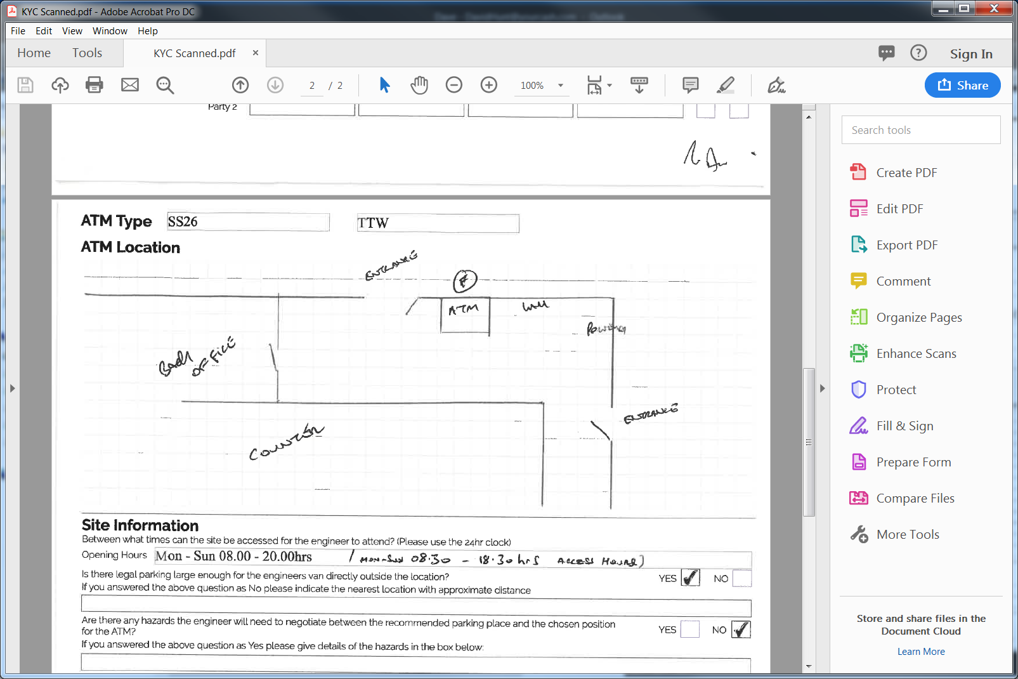

Wall Sign: - Replace inserts on current lightbox location, there are two light boxes in total, one on either side of the shop.

