* [Menu](https://historicengland.org.uk/listing/the-list/list-entry/1393968)
* [Search](https://historicengland.org.uk/sitesearch)

Top of Form

What are you looking for?



Searching...

Click anywhere to close (ESC)

Bottom of Form

* [Listing](https://historicengland.org.uk/listing/)
  + [Search the List](https://historicengland.org.uk/listing/the-list/)
  + [Enrich the List](https://historicengland.org.uk/listing/enrich-the-list/)
  + [Apply for Listing](https://historicengland.org.uk/listing/apply-for-listing/)
  + [What is Listing?](https://historicengland.org.uk/listing/what-is-designation/)
  + [Listing Guidance](https://historicengland.org.uk/listing/selection-criteria/)
  + [Latest Listings](https://historicengland.org.uk/whats-new/listing/)
* [Advice](https://historicengland.org.uk/advice/)
  + [Advice Finder](https://historicengland.org.uk/advice/find/)
  + [Heritage at Risk](https://historicengland.org.uk/advice/heritage-at-risk/)
  + [Your Home](https://historicengland.org.uk/advice/your-home/)
  + [Technical Guidance](https://historicengland.org.uk/advice/technical-advice/)
  + [Planning](https://historicengland.org.uk/advice/planning/)
  + [Caring for Heritage](https://historicengland.org.uk/advice/caring-for-heritage/)
  + [Constructive Conservation](https://historicengland.org.uk/advice/constructive-conservation/)
  + [Heritage Protection Guide](https://historicengland.org.uk/advice/hpg/)
* [Research](https://historicengland.org.uk/research/)
  + [Our Research Strategy and Agenda](https://historicengland.org.uk/research/agenda/)
  + [Research Methods](https://historicengland.org.uk/research/methods/)
  + [Current Research](https://historicengland.org.uk/research/current/)
  + [Research Results](https://historicengland.org.uk/research/research-results/)
  + [Support & Collaboration](https://historicengland.org.uk/research/support-and-collaboration/)
  + [Inclusive Heritage](https://historicengland.org.uk/research/inclusive-heritage/)
  + [Latest Research](https://historicengland.org.uk/whats-new/research/)
  + [Heritage Counts](https://historicengland.org.uk/research/heritage-counts/)
* [Images & Books](https://historicengland.org.uk/images-books/)
  + [Find Photos](https://historicengland.org.uk/images-books/photos/)
  + [Search All Publications](https://historicengland.org.uk/images-books/publications/)
  + [Buy Books](https://historicengland.org.uk/images-books/books/)
  + [The Historic England Archive](https://historicengland.org.uk/images-books/archive/)
  + [Be an Archive Detective](https://historicengland.org.uk/images-books/archive-mysteries/)
* [Services & Skills](https://historicengland.org.uk/services-skills/)
  + [Education](https://historicengland.org.uk/services-skills/education/)
  + [Grants](https://historicengland.org.uk/services-skills/grants/)
  + [Our Planning Services](https://historicengland.org.uk/services-skills/our-planning-services/)
  + [Training & Skills](https://historicengland.org.uk/services-skills/training-skills/)
  + [Archive Services](https://historicengland.org.uk/services-skills/archive-services/)
  + [Heritage Action Zones](https://historicengland.org.uk/services-skills/heritage-action-zones/)
* [Get Involved](https://historicengland.org.uk/get-involved/)
  + [100 Places](https://historicengland.org.uk/get-involved/100-places/)
  + [Immortalised](https://historicengland.org.uk/get-involved/help-write-history/immortalised/)
  + [HerStories](https://historicengland.org.uk/get-involved/help-write-history/herstories/)
  + [Support Us](https://historicengland.org.uk/get-involved/support-us/)
  + [Volunteer in Heritage](https://historicengland.org.uk/get-involved/volunteer/)
  + [Visit Your Heritage](https://historicengland.org.uk/get-involved/visit/)
  + [Protect Your Heritage](https://historicengland.org.uk/get-involved/protect/)
  + [Help Write History](https://historicengland.org.uk/get-involved/help-write-history/)
  + [Angel Awards](https://historicengland.org.uk/get-involved/angel-awards/)
* [What's New](https://historicengland.org.uk/whats-new/)
  + [News](https://historicengland.org.uk/whats-new/news/)
  + [In Your Area](https://historicengland.org.uk/whats-new/in-your-area/)
  + [Love Letters to Buildings](https://historicengland.org.uk/whats-new/features/love-letters-to-buildings/)
  + [Latest Listings](https://historicengland.org.uk/whats-new/listing/)
  + [Latest Research](https://historicengland.org.uk/whats-new/research/)
  + [Heritage Online Debate](https://historicengland.org.uk/whats-new/debate/)
  + [Statements](https://historicengland.org.uk/whats-new/statements/)
  + [Stay Up To Date](https://historicengland.org.uk/whats-new/stay-up-to-date/)
  + [First World War Centenary](https://historicengland.org.uk/whats-new/first-world-war-home-front/)

We use cookies to give you the best possible experience online. By using this website, you consent to cookies being used in accordance with our [Cookie Policy](https://historicengland.org.uk/terms/).

* [Home](https://historicengland.org.uk/)
* [...](https://historicengland.org.uk/listing/the-list/list-entry/1393968)
* [Listing](https://historicengland.org.uk/listing/)
* [Search the List](https://historicengland.org.uk/listing/the-list/)
* List Entry
* [Section Navigation](https://historicengland.org.uk/listing/the-list/list-entry/1393968)
  + [Map Search](https://historicengland.org.uk/listing/the-list/map/)
  + [Advanced Search](https://historicengland.org.uk/listing/the-list/advanced-search/)
  + [Minor Amendments](https://historicengland.org.uk/listing/the-list/minor-amendments/)
  + [Download Listing Data](https://historicengland.org.uk/listing/the-list/data-downloads/)
  + [Non-Listed Sites](https://historicengland.org.uk/listing/the-list/non-listed-sites/)
  + [About The List](https://historicengland.org.uk/listing/the-list/about-the-list/)
  + [Enrich the List](https://historicengland.org.uk/listing/the-list/enrich/)
  + [Understanding List Entries](https://historicengland.org.uk/listing/the-list/understanding-list-entries/)

**NO. 21 JOHN STREET, THE DUKE OF YORK PUBLIC HOUSE ON ROGER STREET, AND NOS. 1-4 MYTRE COURT ON JOHN MEWS**

[4 contributions](https://historicengland.org.uk/listing/the-list/list-entry/1393968#contributions)

**Overview**

Heritage Category: Listed Building

Grade: II

List Entry Number: 1393968

Date first listed: 17-Sep-2010

Statutory Address: NO. 21 JOHN STREET, THE DUKE OF YORK PUBLIC HOUSE ON ROGER STREET, AND NOS. 1-4 MYTRE COURT ON JOHN MEWS, JOHN STREET

**Map**

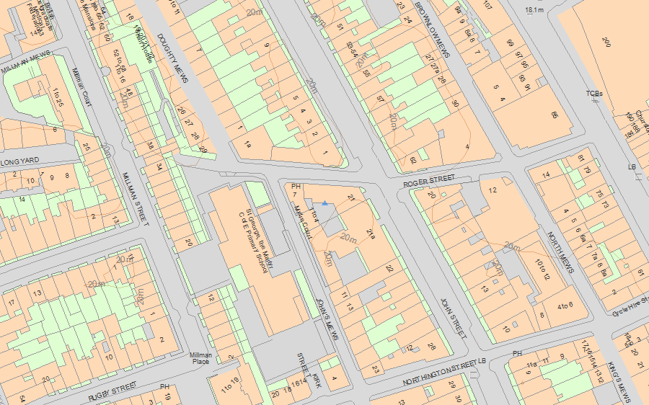© Crown Copyright and database right 2019. All rights reserved. Ordnance Survey Licence number 100024900.  
© British Crown and SeaZone Solutions Limited 2019. All rights reserved. Licence number 102006.006.  
Use of this data is subject to [Terms and Conditions](https://historicengland.org.uk/terms/website-terms-conditions/).

The above map is for quick reference purposes only and may not be to scale. For a copy of the full scale map, please see the attached PDF - [1393968 .pdf](http://mapservices.historicengland.org.uk/printwebservicehle/StatutoryPrint.svc/355007/HLE_A4L_Grade%7CHLE_A3L_Grade.pdf)

The PDF will be generated from our live systems and may take a few minutes to download depending on how busy our servers are. We apologise for this delay.

This copy shows the entry on 06-Mar-2019 at 11:25:52.

**Location**

Statutory Address: NO. 21 JOHN STREET, THE DUKE OF YORK PUBLIC HOUSE ON ROGER STREET, AND NOS. 1-4 MYTRE COURT ON JOHN MEWS, JOHN STREET

The building or site itself may lie within the boundary of more than one authority.

County: Greater London Authority

District: Camden (London Borough)

National Grid Reference: TQ 30782 82105

**Reasons for Designation**

Mytre House, the Duke of York Public House and Mytre Court, a development of 1937 by DE Harrington, should be listed at Grade II for the following principal reasons: * architectural: a stylish design characteristic of the 1930s, which responds in scale and materials to the existing streetscape of Georgian Bloomsbury * sculptural embellishment: two engaged pylons with sculpted tops flanking the main entrance * materials and detailing: good brickwork and careful detailing on the pub and flats * intactness: an unusual degree of surviving original fabric in the Duke of York public house * planning interest: a mixed use development combining commercial offices with a block of flats and a public house, and therefore particularly forward-looking for its time

**Details**

798/0/10236 JOHN STREET 17-SEP-10 Holborn No. 21 John Street, the Duke of York p ublic house on Roger Street, and Nos. 1-4 Mytre Court on John Mews   
  
II Offices, flats and the Duke (of York) Public House, designed in 1937 by Denis Edmund Harrington and completed by 1938. Minor later alterations.   
  
EXTERIOR: The complex is located at the northernmost end of the block bound by John Street, Roger Street and John Mews. On the corner of John Street and Roger Street is the eight-storey office block. This is a steel-framed building with artificial stone facing to the ground and first floor, red brick above, and metal casement windows. The third floor is accentuated by stone banding which forms a continuous sill and lintel to the windows which are separated by panels of fluted brickwork. The set-back top storey has banded rustication in the brickwork between the windows and an artificial stone cornice. The set-back is particularly deep on the John Street elevation and here the cornice forms a projecting canopy, inset with glass blocks. The offices are entered from John Street where the original glazed hardwood door is flanked by two tall, engaged pylons with sculpted tops. Each depicts a woman, in the stylised fashion of the 1930s and reminiscent of the work of Eric Gill.   
  
In keeping with the scale of the back streets and mews, the building height drops to three storeys half way along Roger Street. The elevations are treated in the same way as the office block, with the ground and first floor in artificial stone and the third floor in brick. On the canted corner of the building between Roger Street and John Mews is the entrance to the Duke PH which occupies the ground floor, with a restaurant with separate entrance further along John Mews. The pub windows have marginal glazing bars and painted lettering giving the name of the brewery IND COOPE. The pub's double entrance doors are original as is the restaurant door with its surround of tiles laid end-on. Also facing John Mews is the four-storey block of flats. The frontage is symmetrical with curved brick balconies with concrete bases and coping either side of a canted bay window. The ground floor has banded brick rustication and a central door under a concrete canopy. The flat roof is bounded by iron railings.   
  
INTERIOR: In the OFFICES, the entrance lobby has fluted pilasters, a slender decorative frieze and a coved cornice to the ceiling, which has stepped shallow mouldings. The main stair wraps around a central lift shaft and has terrazzo treads and skirting, now largely covered by carpet; the lift is modern. The arrangement of rooms on each floor varies, some are open plan, some have partitioned offices, but all the features and finishes are recent in date. The fire escape stairs and doors are original.   
  
The PUBLIC HOUSE has a strong period character and it is very likely that most of its fabric is original. A basic floor plan of the pub interior was published as part of the architects' designs for the building and shows the two main rooms, labelled 'Saloon Bar' (now the restaurant) and 'Public Bar' (now the main bar), with a small 'Private Bar' partitioned off from the public bar in between the two. A door now closed off by the booths in the main bar indicates where this private bar was originally located. The bar counter in the basic plan curves sinously in the main bar, and differs from the current arrangement. It is not unlikely that that the inclusion of a bar counter in the plan was intended to give an indication of the room's function, however, rather than being a detailed design. Indeed, the fabric evidence in the public house suggests a different arrangement was created when the pub was fitted out, perhaps under the direction of the first landlord. The jazzy pink, white and black-patterned lino is in a design and condition that suggests it is original to the building. The lino follows the profile of the current bar counter in both rooms, suggesting it too is original. The joinery of the bar counter and bar front in both parts of the pub is also consistent with a 1930s date. Booths and panelling in the saloon bar are likely to be original too: they are in a design of the period (stained timber with darker raised bands) and form a coherent ensemble that appears purpose-fitted in this room. One partition has a fluted glass transom, another convincing period detail. The saloon bar also has an original fireplace, shown on the architects' plan, with a brick surround and timber mantelpiece. The booths in the public bar are known to be late-C20 sympathetic additions, but the panelling here matches that in the saloon bar and so may be original. The fabric evidence of the interior strongly suggests the current fixtures and fittings are original to the building.   
  
The interior of the FLATS were not inspected.  
  
HISTORY: Mytre House was built speculatively and among the first tenants of the offices were Linotype & Machinery Ltd, a printing engineering company, whose large advertising board can be seen on a 1950s photograph of the building; also in the building, according to 1946 Directory was a chartered surveyors and a trade association. The first landlord of the Duke was one Hyman Lipman. Denis Edmund Harrington was an Associate of the RIBA from 1928 and a Fellow from 1941. Having studied at the School of Architecture, Northern Polytechnic in London he was assistant to Mewes and Davis for two years and then Chief Assistant at TP Bennett and Sons for nine. Both were major early C0 commercial practices, the former the designers of the Ritz Hotel in London the latter renowned for sleek, Moderne blocks of mansion flats. Harrington established his own practice in December 1936 and Mytre House was one of his first independent commissions. After the Second World War, Harrington continued to design mainly offices and flats, but was also architect of the rebuilt Painters Hall for the Painter Stainers Company at Little Trinity Lane, City of London in 1961.   
  
REASONS FOR DESIGNATION: Mytre House, the Duke of York Public House and Mytre Court, a development of 1937 by DE Harrington, is listed at Grade II for the following principal reasons: * architectural: a stylish design characteristic of the 1930s, which responds in scale and materials to the existing streetscape of Georgian Bloomsbury * sculptural embellishment: two engaged pylons with sculpted tops flanking the main entrance * materials and detailing: good brickwork and careful detailing on the pub and flats * intactness: an unusual degree of surviving original fabric in the Duke of York public house * planning interest: a mixed use development combining commercial offices with a block of flats and a public house, and therefore particularly forward-looking for its time

**Legacy**

The contents of this record have been generated from a legacy data system.

Legacy System number: 507898

Legacy System: LBS

**Legal**

This building is listed under the Planning (Listed Buildings and Conservation Areas) Act 1990 as amended for its special architectural or historic interest.

End of official listing