Our ref: 141218

14 December 2018

Development Management
Regeneration and Planning
London Borough of Camden
Town Hall
Judd Street
London
WC1H 9JE

Dear Sir/Madam,

THE HONOURABLE SOCIETY OF GRAY’S INN, 1 GRAY’S INN SQUARE, LONDON, WC1R 5AA

Please find enclosed a listed building application for repairs and refurbishment to the cellar stores on the lower ground floor of the above property. The works can be described as follows:

* Necessary excavation to allow for new damp proof system;
* Insert new concrete slab to area of wine cellar stores and corridors on lower ground floor allowing for new perimeter drainage channels and sump pump voids;
* Insert drained cavity damp proof system, to include affixing cavity membrane to walls and sump pump outlet;
* Remove existing lathe and plaster ceilings to enable inspection of ground floor joists and timbers from below for decay/damage by wood boring insects etc, treat as necessary and re-plaster in lathe and plaster to match existing finish;
* Remove timber panelling by hand (set aside storing carefully for re-instatement) to enable repair of rotten beam end to cellar store – see plan;
* General redecoration i.e. painting internal walls, timberwork and make good any brickwork; and
* Insertion of new brick/slate free standing wine storage units.

DESIGN & ACCESS STATEMENT

The cellar rooms are used to store wine served at various functions carried out by the Honourable Society of Gray’s Inn. At present, wine is generally stacked within the stores in cases and boxes with no racking system. The Inn wish to install a racking system to provide a more orderly and secure method of storage, however, the stores and the small corridor serving them have been subject for some time to water penetration and this has lead to significant damp issues within these areas. As part of a general refurbishment, the Inn have been advised that it is necessary to first tackle the water ingress to prevent longer term damage to the wall fabric and floors and provide a dry area for storage purposes.

2.

The cause of the damp has been investigated by specialists and is due to lateral penetration of ground water, with ground levels being higher than the internal floor levels, thus creating an earth retaining situation.

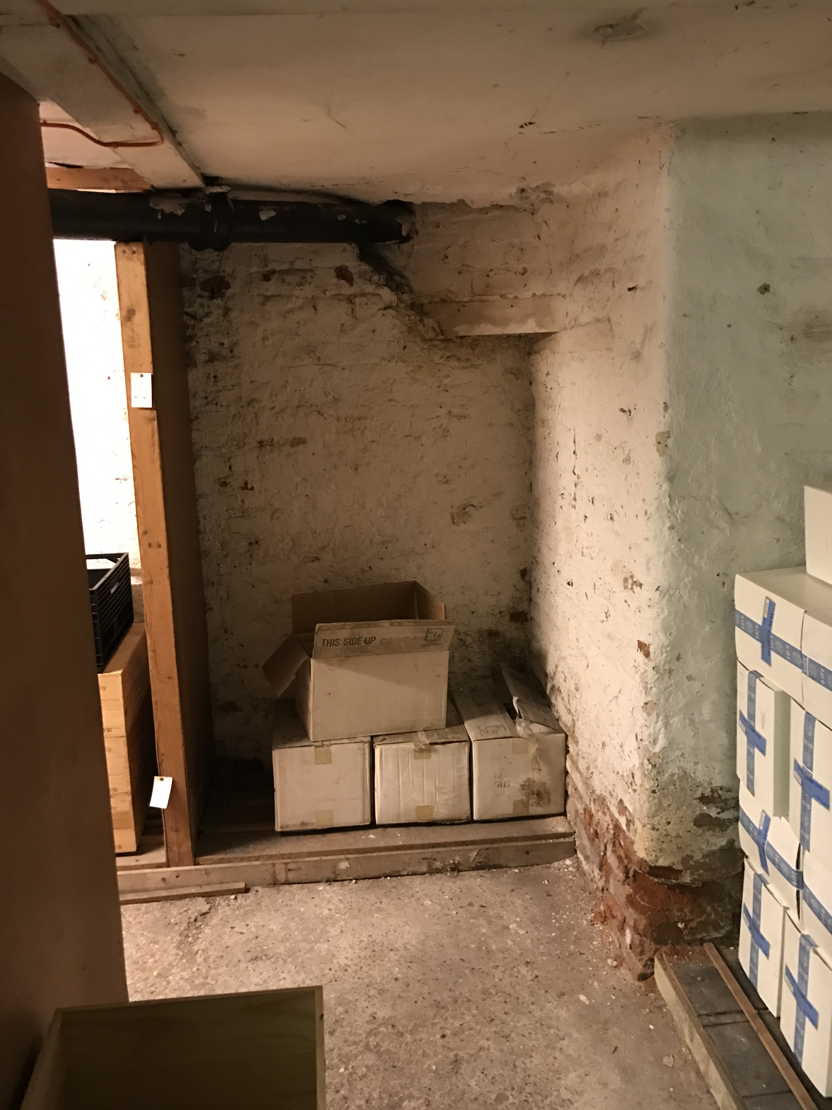
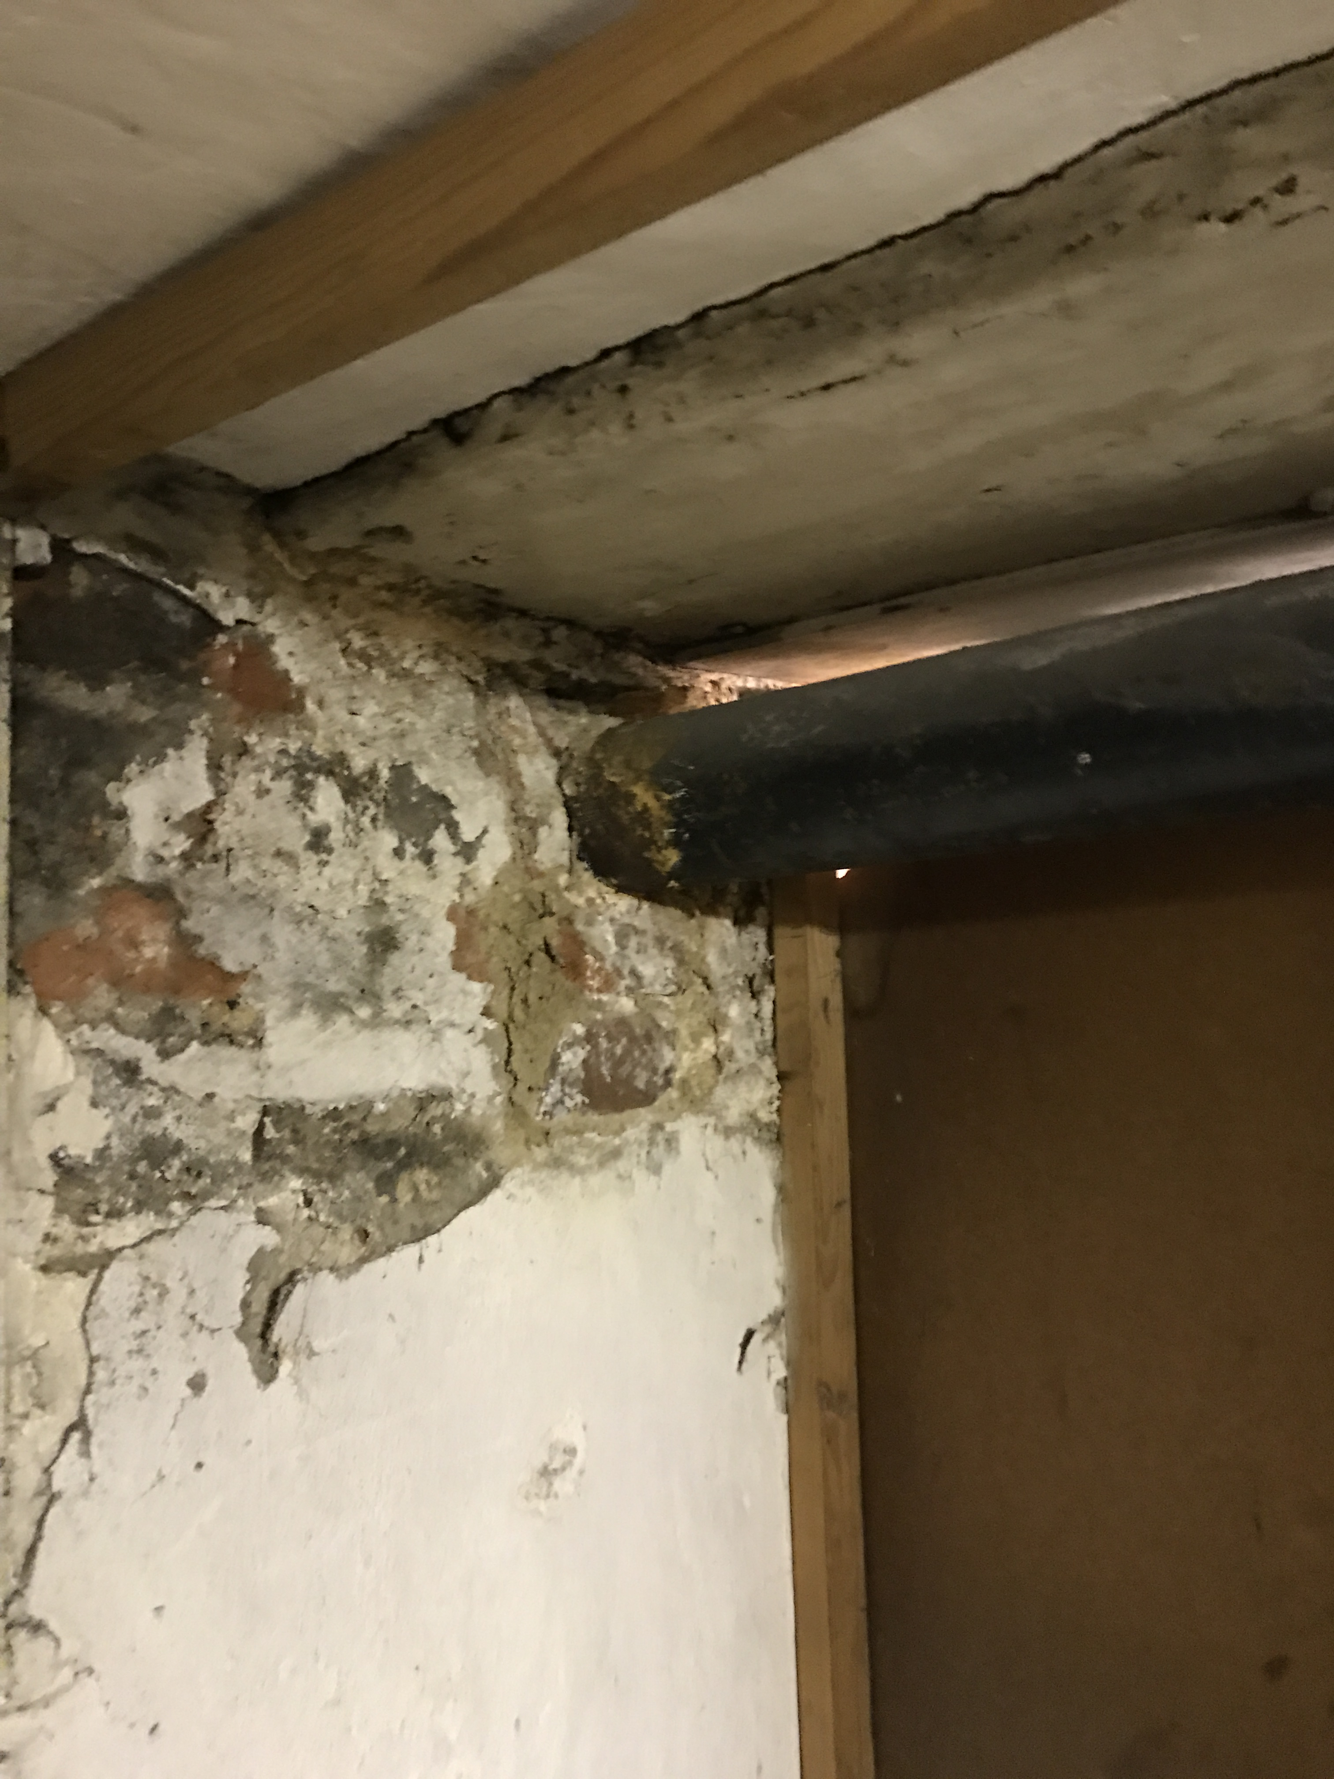

The cellar rooms are to the lower ground floor of No. 1 Gray’s Inn Square, a Grade II* listed building. No external alterations are proposed to the listed building, therefore only listed building approval is sought for these works. A heritage statement is provided as part of this covering letter, see below.

A detailed plan showing the proposed works has been provided as part of this application, along with separate details provided by the contractor Renderseal Ltd showing the make up and fixing of the proposed wall and floor membranes, the perimeter drainage channels and sump pump location/outlet pipe.

Access to the cellar is via an internal steps. No changes are proposed to existing access arrangements.

HERITAGE STATEMENT & PLANNING POLICY BACKGROUND

No. 1 Gray’s Inn Square is a designated Grade II* listed building and therefore constitutes a ‘Heritage Asset’ as described in the National Planning Policy Framework, 2018 (NPPF).

The NPPF states that any application affecting a heritage asset should be accompanied by a description of the significance of the asset and any contribution made by their setting. The level of detail provided should be proportionate to the assets’ importance and no more than is sufficient to understand the potential impact of the proposal on their significance (para. 189).

The NPPF requires local planning authorities to assess the nature of any harm to/loss of assets. Where this concerns assets of the highest significance it should be permitted in wholly exceptional circumstances (para 194).

3.

The Camden Local Plan was adopted in July 2017 and sets out the planning policy at local level, of relevance to this application is Policy D2 ‘Heritage’. Policy D2 states that the Council will preserve and, where appropriate, enhance Camden’s rich and diverse heritage assets and their settings, including conservation areas and listed buildings.

The Policy advises that the Council will not permit the loss or substantial harm to a designated heritage asset, unless it can be demonstrated that the substantial harm or loss is necessary to achieve a substantial public benefit that would outweigh the harm or loss.

The listing description for the application property is as follows:

TQ3181NW 798-1/102/632
CAMDEN GRAY'S INN (West side) Gray's Inn Square No.1 and attached railings 24/10/51 GV II* Terraced chambers. c1676, restored c1948. Brown brick with red brick dressings. Brick bands between floors. Tiled roof. Four storeys and cellar. Double-fronted with eight windows. Stone doorcase with consoles and broken segmental pediment with ball in centre. Gauged red brick flat arches and dressings to flush frame windows with boxing and glazing bars. Wood block bracketed eaves cornice.
INTERIOR: panelled with wood cornice and turned balusters with square newels to dog-leg stairs.
SUBSIDIARY FEATURES: attached cast-iron railings with torch flambe finials to rear.
Listing NGR: TQ3100581737

The application building forms part of the estate belonging to the Honourable Society of Gray’s Inn, one of four Inns of Court in London, situated to the north of High Holborn. The Estate comprises of a number of buildings (many listed) generally arranged around open squares and gardens.

The Inn is a professional association for barristers and judges, whose function is to support their qualified barrister members and educate and provide support to their student members. The Estate provides a library, chapel, dining and banqueting services and educational facilities.

The Estate is located within The London Borough of Camden Bloomsbury Conservation Area. The works under this application are, however, of an internal nature only. NO EXTERNAL WORKS/ALTERATIONS ARE PROPOSED. Therefore, there would be no impact upon the character and appearance of the Conservation Area, nor the external facade of the listed building as a result of these proposals.

The proposed works specifically relate to an area used for storing wine on the lower ground floor of No. 1 Gray’s Inn Square.

4.

The stores and corridor at this level have been subject for some time to water ingress and this has lead to significant, ongoing damage to wall fabric and issues with the use of these rooms for storage. It is necessary to address the penetration of ground water to preserve the long term historic fabric of the building and allow the functional use of these areas to continue.

A specialist contractor, Renderseal Ltd, have been called in by the Inn to advise on the options available to deal with the penetration of water. It is not possible to treat the problem externally due to ground levels. The recommendation was to alleviate the damp penetration issues with a cavity drainage system, as now applied for. The cavity drainage system is deemed to be more effective and less damaging to any historic fabric than the alternative of mechanically preparing the historic walls to receive a waterproof render. The cavity drainage system requires the installation of an inner membrane fixed to, but offset from, the internal walls to provide a false cavity into which any water can drain and collect into an excavated perimeter drainage channel. Water from the channels will flow into a sump pump, set into a void within the new concrete slab/screed, this is then discharged externally via a pipe in the wall. There would be no harm to the historic fabric with the insertion of this system – the wall treatment could be removed at some future point without having a lasting impact upon the area concerned. The existing floor is not of any special construction/interest, but consists of an existing ground bearing slab.

The application also includes a resin repair to the end of one existing timber beam. The surrounding brickwork would be carefully removed where the bearing end enters the wall to the enable the repair and the brickwork would be made good after the resin repair has been carried out. The beam has decayed due to fungal attack (dry rot) and without the repair work could become unstable. As part of maintaining the building, whilst these works are taking place in the cellar, the ceiling will be removed in localised areas to inspect for the spread of fungal attack in the ground floor joists and floor boards, any areas would be treated for attack/repaired and the ceiling replaced on a like for like basis.

Without the works and the repairs/inspections of the beams and roof timbers, neglect could lead to damage to historic fabric resulting in the need for more intrusive works/repairs at a later stage. No change of use is proposed, the work would not be visible from the outside and the purpose of the work is to keep the building in a good state of repair.

If the work is not carried out, it would also result in this part of the building being unused and it is acknowledged that the best way of ensuring proper care is taken of listed buildings is a viable use.

A similar treatment was permitted to the basement vaults at nos. 5 and 6 Raymond Buildings which also falls within the estate belonging to the Inn, your reference 2017/5361/L.

None of the works would have any external impact, or be visible to anyone except those accessing the cellar. There would be no loss or destruction of any historic fabric or any harm to the heritage asset as a result of these works. The works would not therefore contravene national, or local planning policy relating to listed buildings.

5.

Should you require any further information regarding the proposal or wish to carry out a visit to inspect the cellar rooms (Gray’s Inn will need to be advised of any site visit in advance to ensure access is available), please do not hesitate to contact us.

Yours faithfully

ABIGAIL SNOOK (MRS)

