31st January 2019

Dear Occupier,

I am writing to inform you about upcoming construction works we are planning to undertake at 38 Regents Park Road, London, NW1 7SX. Planning consent has already been granted for these works and as part of our preparation for starting construction works, we have prepared this CMP for the planning department.

The scheme comprises the retention and enhancement of original features to the existing front elevation, the replacement of the existing glazed link to the communal staircase with masonry construction and an extension at the rear of the property.

The inconsequential additions to the building mass do not have any adverse effect on the local amenities and are in keeping with the density of this and neighbouring properties.

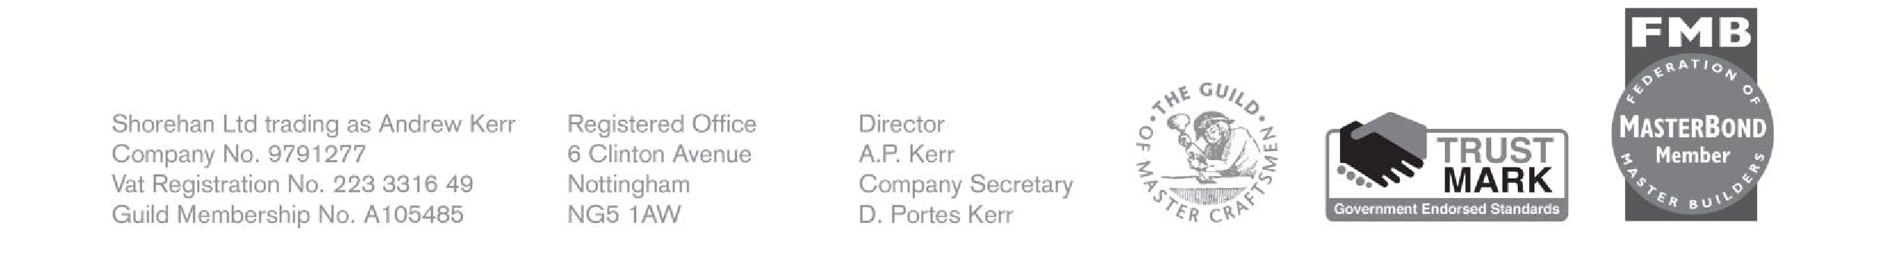

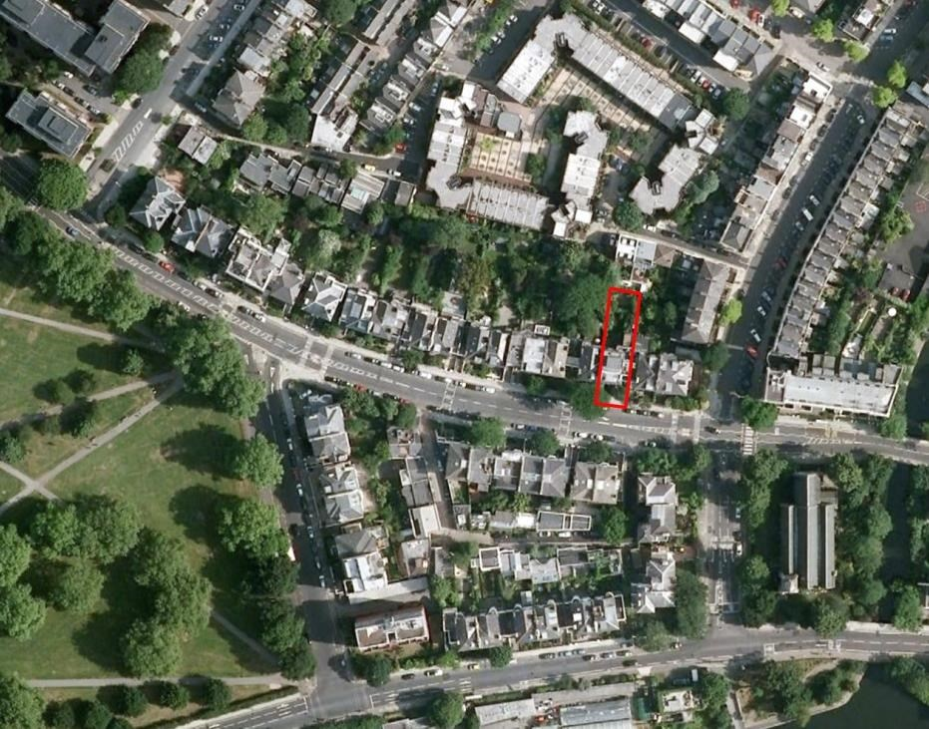

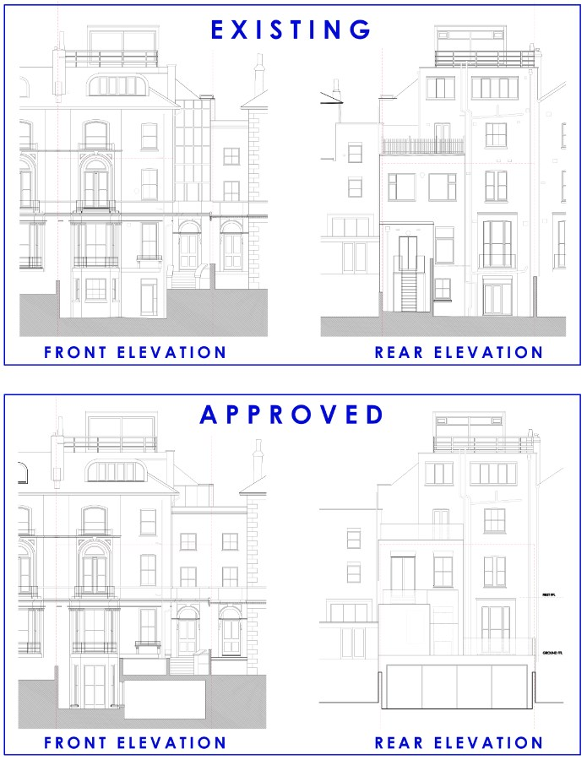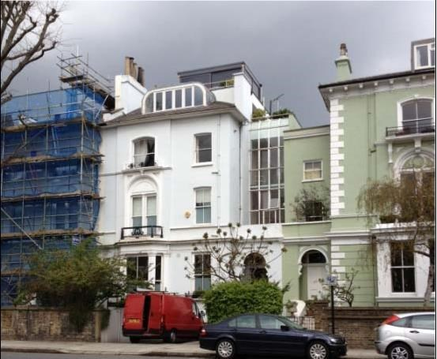

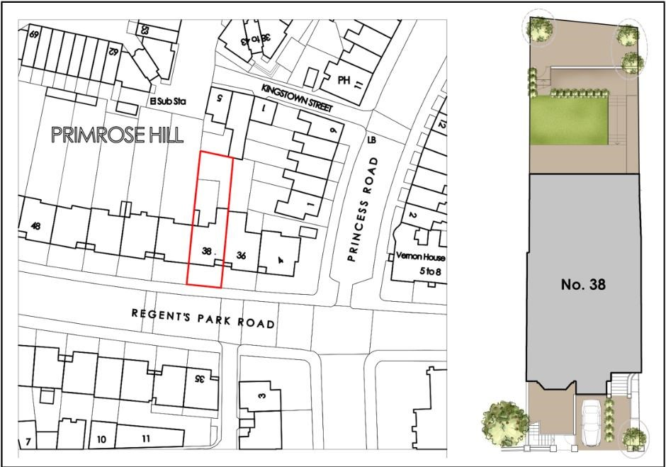

We would like to inform you that your safety is our top priority. To that end, we have issued a construction management plan to the council that covers how we will carry out these works to meet the requirements of current health and safety legislation and impact your daily lives as little as possible.

Please respond within 14 days from the date of the letter should you have any comments or concerns.

If you have any further questions, please do not hesitate to contact me.

Yours faithfully,

Andrew Kerr