* [Menu](https://historicengland.org.uk/listing/the-list/list-entry/1067409)
* [Search](https://historicengland.org.uk/sitesearch)

Top of Form

What are you looking for?



Searching...

Click anywhere to close (ESC)

Bottom of Form

* [Listing](https://historicengland.org.uk/listing/)
  + [Search the List](https://historicengland.org.uk/listing/the-list/)
  + [Enrich the List](https://historicengland.org.uk/listing/enrich-the-list/)
  + [Apply for Listing](https://historicengland.org.uk/listing/apply-for-listing/)
  + [What is Listing?](https://historicengland.org.uk/listing/what-is-designation/)
  + [Listing Guidance](https://historicengland.org.uk/listing/selection-criteria/)
  + [Latest Listings](https://historicengland.org.uk/whats-new/listing/)
* [Advice](https://historicengland.org.uk/advice/)
  + [Advice Finder](https://historicengland.org.uk/advice/find/)
  + [Heritage at Risk](https://historicengland.org.uk/advice/heritage-at-risk/)
  + [Your Home](https://historicengland.org.uk/advice/your-home/)
  + [Technical Guidance](https://historicengland.org.uk/advice/technical-advice/)
  + [Planning](https://historicengland.org.uk/advice/planning/)
  + [Caring for Heritage](https://historicengland.org.uk/advice/caring-for-heritage/)
  + [Constructive Conservation](https://historicengland.org.uk/advice/constructive-conservation/)
  + [Heritage Protection Guide](https://historicengland.org.uk/advice/hpg/)
* [Research](https://historicengland.org.uk/research/)
  + [Our Research Strategy and Agenda](https://historicengland.org.uk/research/agenda/)
  + [Research Methods](https://historicengland.org.uk/research/methods/)
  + [Current Research](https://historicengland.org.uk/research/current/)
  + [Research Results](https://historicengland.org.uk/research/research-results/)
  + [Support & Collaboration](https://historicengland.org.uk/research/support-and-collaboration/)
  + [Inclusive Heritage](https://historicengland.org.uk/research/inclusive-heritage/)
  + [Latest Research](https://historicengland.org.uk/whats-new/research/)
  + [Heritage Counts](https://historicengland.org.uk/research/heritage-counts/)
* [Images & Books](https://historicengland.org.uk/images-books/)
  + [Find Photos](https://historicengland.org.uk/images-books/photos/)
  + [Search All Publications](https://historicengland.org.uk/images-books/publications/)
  + [Buy Books](https://historicengland.org.uk/images-books/books/)
  + [The Historic England Archive](https://historicengland.org.uk/images-books/archive/)
  + [Be an Archive Detective](https://historicengland.org.uk/images-books/archive-mysteries/)
* [Services & Skills](https://historicengland.org.uk/services-skills/)
  + [Education](https://historicengland.org.uk/services-skills/education/)
  + [Grants](https://historicengland.org.uk/services-skills/grants/)
  + [Our Planning Services](https://historicengland.org.uk/services-skills/our-planning-services/)
  + [Training & Skills](https://historicengland.org.uk/services-skills/training-skills/)
  + [Archive Services](https://historicengland.org.uk/services-skills/archive-services/)
  + [Heritage Action Zones](https://historicengland.org.uk/services-skills/heritage-action-zones/)
* [Get Involved](https://historicengland.org.uk/get-involved/)
  + [100 Places](https://historicengland.org.uk/get-involved/100-places/)
  + [Immortalised](https://historicengland.org.uk/get-involved/help-write-history/immortalised/)
  + [HerStories](https://historicengland.org.uk/get-involved/help-write-history/herstories/)
  + [Support Us](https://historicengland.org.uk/get-involved/support-us/)
  + [Volunteer in Heritage](https://historicengland.org.uk/get-involved/volunteer/)
  + [Visit Your Heritage](https://historicengland.org.uk/get-involved/visit/)
  + [Protect Your Heritage](https://historicengland.org.uk/get-involved/protect/)
  + [Help Write History](https://historicengland.org.uk/get-involved/help-write-history/)
  + [Angel Awards](https://historicengland.org.uk/get-involved/angel-awards/)
* [What's New](https://historicengland.org.uk/whats-new/)
  + [News](https://historicengland.org.uk/whats-new/news/)
  + [In Your Area](https://historicengland.org.uk/whats-new/in-your-area/)
  + [Love Letters to Buildings](https://historicengland.org.uk/whats-new/features/love-letters-to-buildings/)
  + [Latest Listings](https://historicengland.org.uk/whats-new/listing/)
  + [Latest Research](https://historicengland.org.uk/whats-new/research/)
  + [Heritage Online Debate](https://historicengland.org.uk/whats-new/debate/)
  + [Statements](https://historicengland.org.uk/whats-new/statements/)
  + [Stay Up To Date](https://historicengland.org.uk/whats-new/stay-up-to-date/)
  + [First World War Centenary](https://historicengland.org.uk/whats-new/first-world-war-home-front/)

We use cookies to give you the best possible experience online. By using this website, you consent to cookies being used in accordance with our [Cookie Policy](https://historicengland.org.uk/terms/).

* [Home](https://historicengland.org.uk/)
* [...](https://historicengland.org.uk/listing/the-list/list-entry/1067409)
* [Listing](https://historicengland.org.uk/listing/)
* [Search the List](https://historicengland.org.uk/listing/the-list/)
* List Entry
* [Section Navigation](https://historicengland.org.uk/listing/the-list/list-entry/1067409)
  + [Map Search](https://historicengland.org.uk/listing/the-list/map/)
  + [Advanced Search](https://historicengland.org.uk/listing/the-list/advanced-search/)
  + [Minor Amendments](https://historicengland.org.uk/listing/the-list/minor-amendments/)
  + [Download Listing Data](https://historicengland.org.uk/listing/the-list/data-downloads/)
  + [Non-Listed Sites](https://historicengland.org.uk/listing/the-list/non-listed-sites/)
  + [About The List](https://historicengland.org.uk/listing/the-list/about-the-list/)
  + [Enrich the List](https://historicengland.org.uk/listing/the-list/enrich/)
  + [Understanding List Entries](https://historicengland.org.uk/listing/the-list/understanding-list-entries/)

**31, DOWNSHIRE HILL**

[1 contribution](https://historicengland.org.uk/listing/the-list/list-entry/1067409#contributions)

**Overview**

Heritage Category: Listed Building

Grade: II

List Entry Number: 1067409

Date first listed: 14-May-1974

Statutory Address: 31, DOWNSHIRE HILL

**Map**

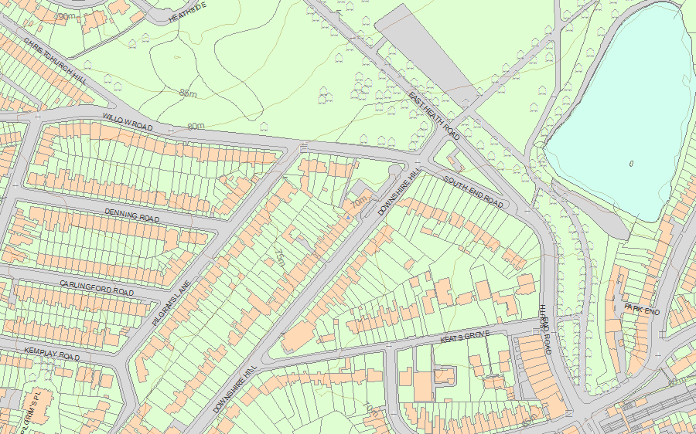© Crown Copyright and database right 2019. All rights reserved. Ordnance Survey Licence number 100024900.  
© British Crown and SeaZone Solutions Limited 2019. All rights reserved. Licence number 102006.006.  
Use of this data is subject to [Terms and Conditions](https://historicengland.org.uk/terms/website-terms-conditions/).

The above map is for quick reference purposes only and may not be to scale. For a copy of the full scale map, please see the attached PDF - [1067409 .pdf](http://mapservices.historicengland.org.uk/printwebservicehle/StatutoryPrint.svc/365191/HLE_A4L_Grade%7CHLE_A3L_Grade.pdf)

The PDF will be generated from our live systems and may take a few minutes to download depending on how busy our servers are. We apologise for this delay.

This copy shows the entry on 05-Mar-2019 at 15:06:05.

**Location**

Statutory Address: 31, DOWNSHIRE HILL

The building or site itself may lie within the boundary of more than one authority.

County: Greater London Authority

District: Camden (London Borough)

National Grid Reference: TQ 27025 85800

**Details**

CAMDEN  
  
TQ2785NW DOWNSHIRE HILL 798-1/28/330 (North side) 14/05/74 No.31   
  
GV II  
  
Terraced house. Early C19. Stucco. Slated mansard roof. 2 storeys and basement. 2 windows. Round-arched doorway with C20 radial fanlight and panelled door. Recessed sashes. Parapet. INTERIOR: not inspected.   
  
  
  
Listing NGR: TQ2702685801

**Legacy**

The contents of this record have been generated from a legacy data system.

Legacy System number: 477098

Legacy System: LBS

**Legal**

This building is listed under the Planning (Listed Buildings and Conservation Areas) Act 1990 as amended for its special architectural or historic interest.

End of official listing