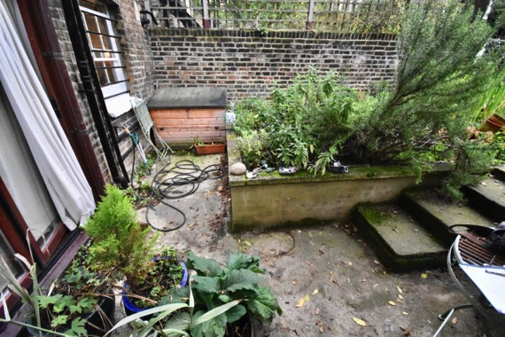

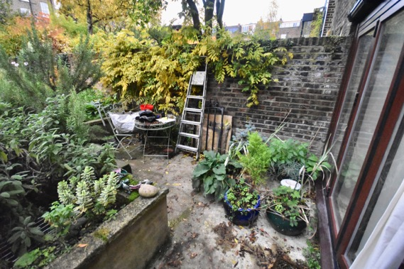

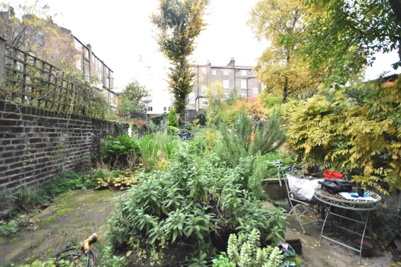 Flat 20A, Lower Ground, Fitzroy Rd, NW1 8TX

Paul Way RIBA Dec.2018