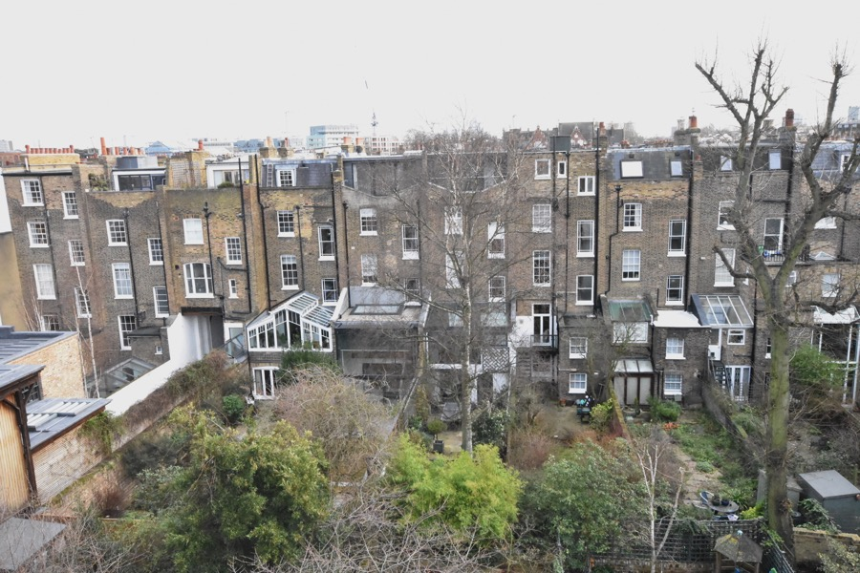

No.20A

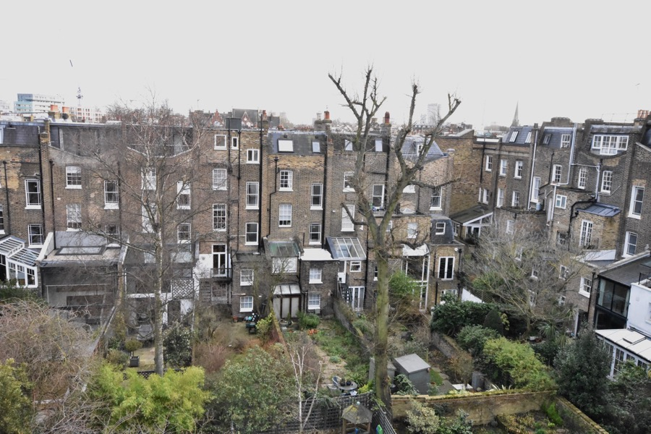

No.20A

View on rear of Fitzroy Road. NW1 8TX

Paul Way RIBA Feb.2019