**1A KEMPLAY ROAD, LONDON NW3 1TA**

BLOCK/SITE PLAN

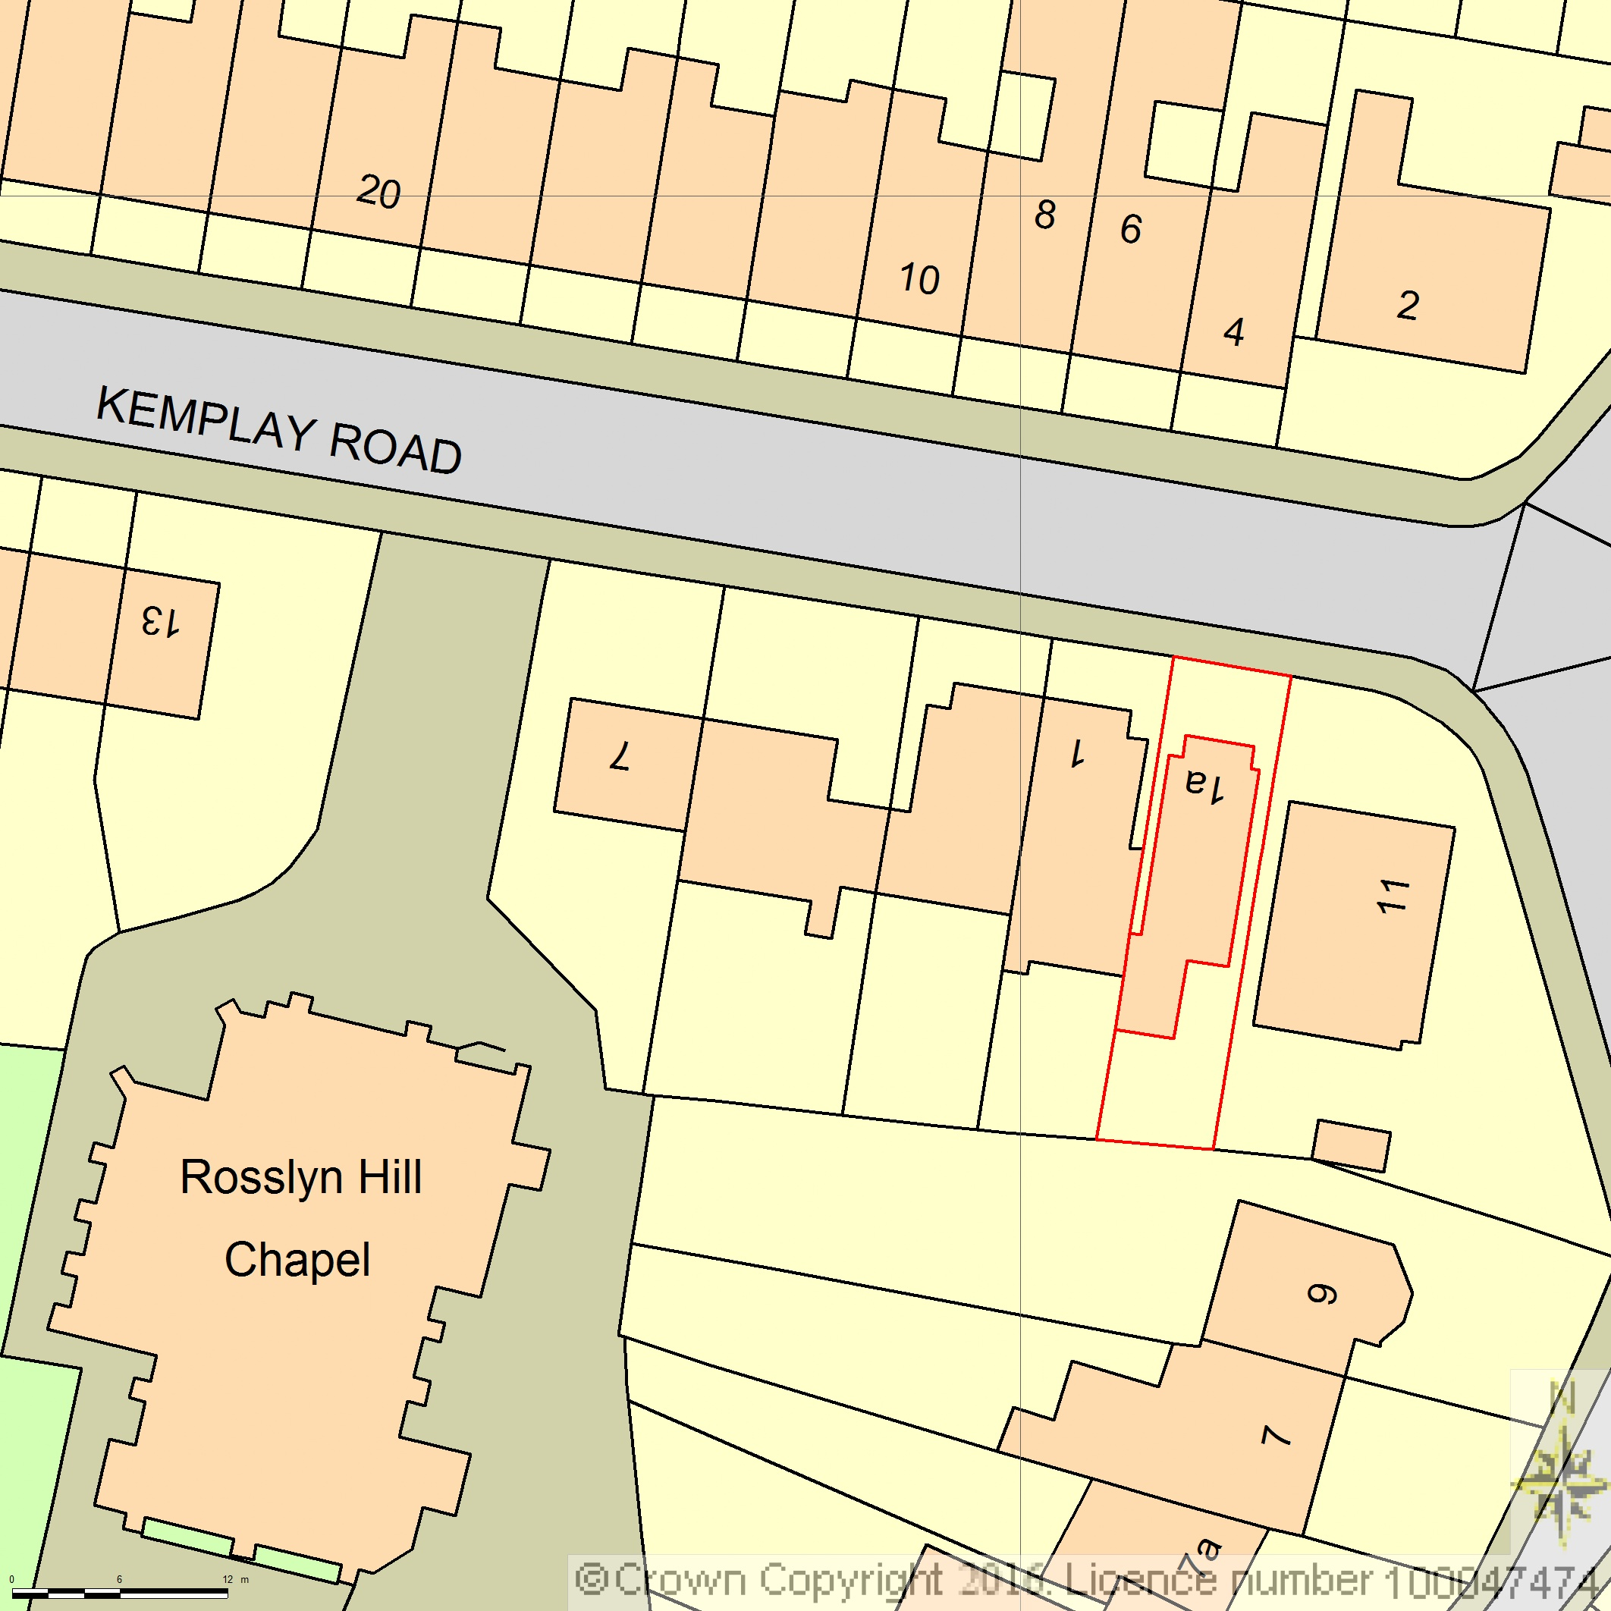

AREA 90m x 90m

SCALE 1:500 on A4

CENTRE COORDINATES: 526788, 185666



Supplied by Streetwise Maps Ltd

www.streetwise.net

Licence No: 100047474

17/03/2017 15:22:52