**Design, Access & Heritage Statement**

**Address:** 24 Brocas Close, London, NW3 3LD

**Proposal:**

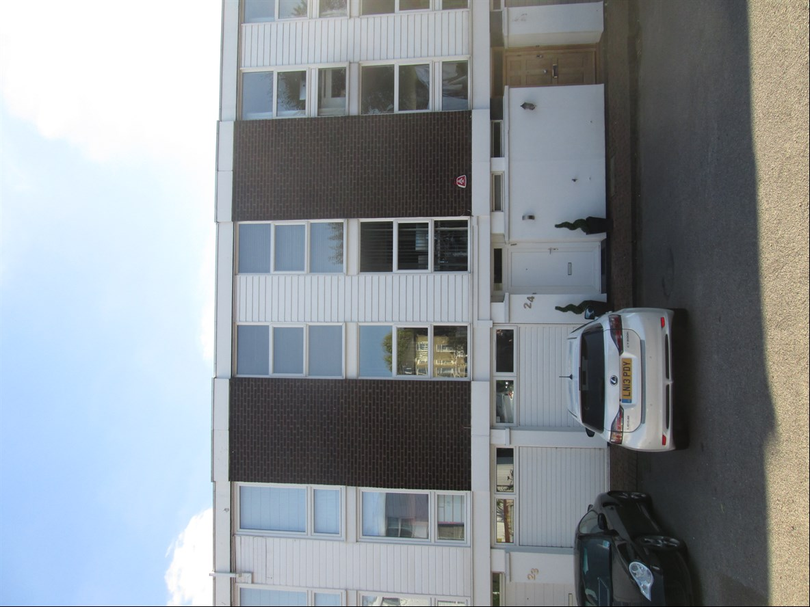Erection of a conservatory to the rear of the existing property

**Existing property:**

24 Brocas Close is part of a collection of properties located in the Camden area of London.

The existing property and surrounding properties are constructed of a combination of exposed brick, painted render to the front and white cladding to both front and rear. The property has a flat roof in style and windows are white PVCu which is consistent with this building type in this area.

**Design and use:**

The proposed conservatory will be constructed of two gable walls which will constructed of exposed brick to match the brick work of the existing property.

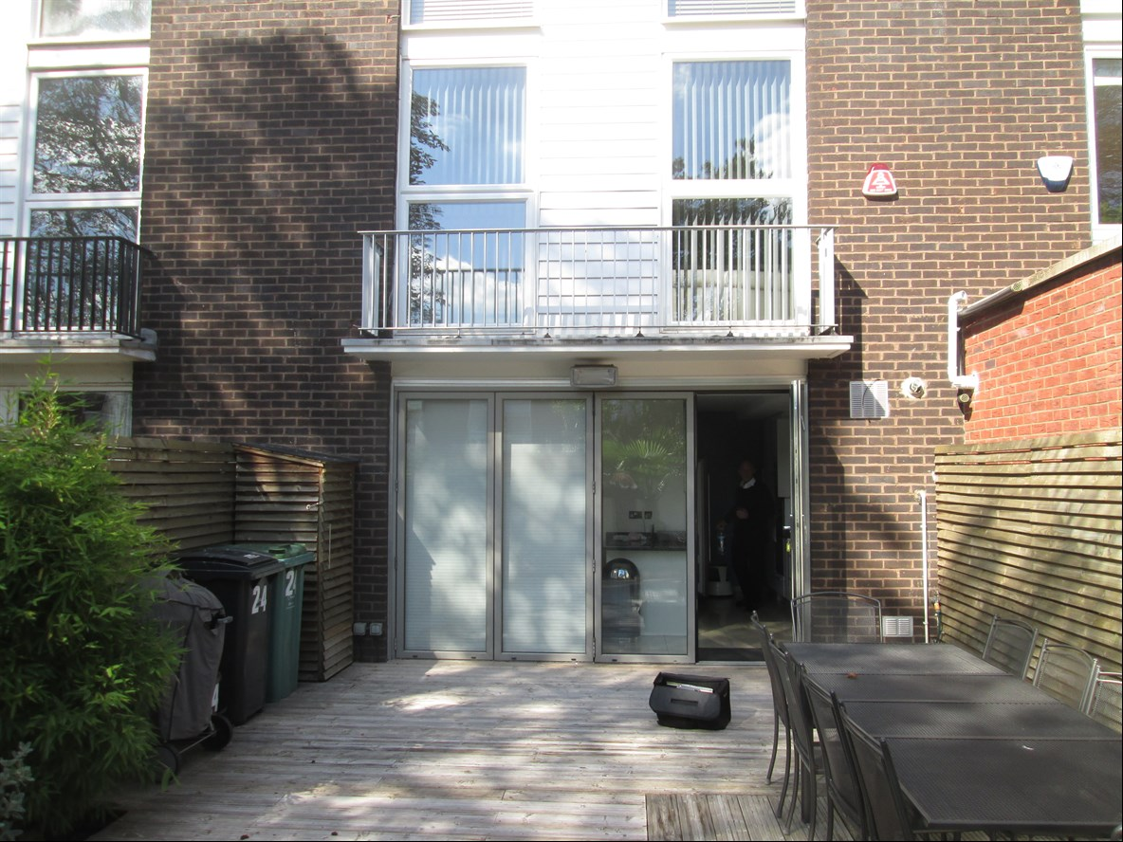The roof will be constructed of aluminium rafters with white PVCu capping’s to match the white PVCu of the existing property and tinted, toughened, solar controlled glass roof sheets. The bi-fold doors to the front of the proposed will be white aluminium.

All works are to the rear of the property and will now affect the surrounding area as the proposal seeks to use materials which are already in use within the area to ensure consistency within the area.

Council have recently approved application at No. 20 for the removal of a garage door to be replaced with a PVCu window facing the front of the property.

**Size:**

Position on property: rear elevation

Projection: 3m

Width: 5.6m

**Access & Parking:**

Access into the existing property will remain the same. There will also be no changes to existing parking.

**Landscaping:**

The proposed works will not require any alteration to the existing rear garden or front garden.