**From:** Cawley, Thomas <tcawley@bam.co.uk>   
**Sent:** 30 October 2018 14:25  
**To:** Berry-Khan, Gabriel <Gabriel.Berry-Khan@camden.gov.uk>; McDonald, Neil <Neil.McDonald@camden.gov.uk>  
**Cc:** O'Donohoe, Mike <modonohoe@bam.co.uk>; McCormack, Jim <jmccormack@bam.co.uk>; Mitchell, Simon <smitchell@bam.co.uk>  
**Subject:** FW: Regent High School - Energy

Hi Gabriel,

RE: Regent High School Planning Conditions 22 & 24

Please note the email below and attached from Buro Happold (David Kingstone) in response to your queries, relating to the above.

Best regards

Tom

**Thomas Cawley |**Senior Design Manager – London **|** BAM Construction Ltd

Kings Cross S4 Offices, 3rd Floor S4 Cabins, Handyside Street, Off York Way, Kings Cross, London, N1C 4AB

T 020 7XXX XXXX | DD 020 7XXX XXXX |  M 07810 557983 | E [tcawley@bam.co.uk](mailto:tcawley@bam.co.uk) | [www.bam.co.uk](https://protect-eu.mimecast.com/s/5UuRCJyp3IBMQ16fGlvG8?domain=bam.co.uk)

**From:** David Kingstone [<mailto:David.Kingstone@BuroHappold.com>]   
**Sent:** 30 October 2018 13:03  
**To:** Cawley, Thomas  
**Cc:** O'Donohoe, Mike; McCormack, Jim; Mitchell, Simon; 025901 CAMDEN BSF  
**Subject:** RE: Regent High School - Energy

Tom

Please find our response to the remaining questions:

1.      The as built SEER and SCOP have been based on the installed water source heat pump and the heating/cooling demands as calculated in the building regulations compliance model. Based on the expected heating and cooling demands the SCOP was calculated to be 5.24 and the SEER at 7.91 taking account of heat recovery from simultaneous heating and cooling and borehole free cooling. The design COP for the heat pump was 5.04 and the EER 4.04 at the system LTHW and CHW temperatures. The manufacturers literature is attached for more information.

2.      The source of the regulated emissions for the notional building was reported as 30.9 in the response to ITSFB volume 1 D-24.2 question g. An image of the page from the document is shown below.

3.      The % contribution of renewables to the emissions has been calculated as Cell H37/ the sum of cells G22 to G28

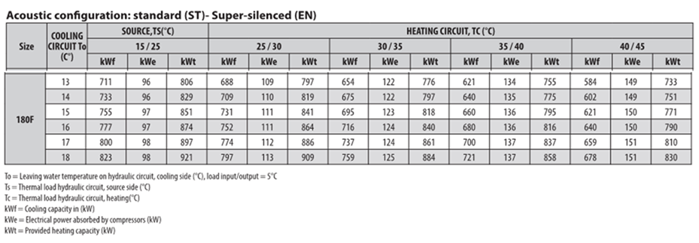

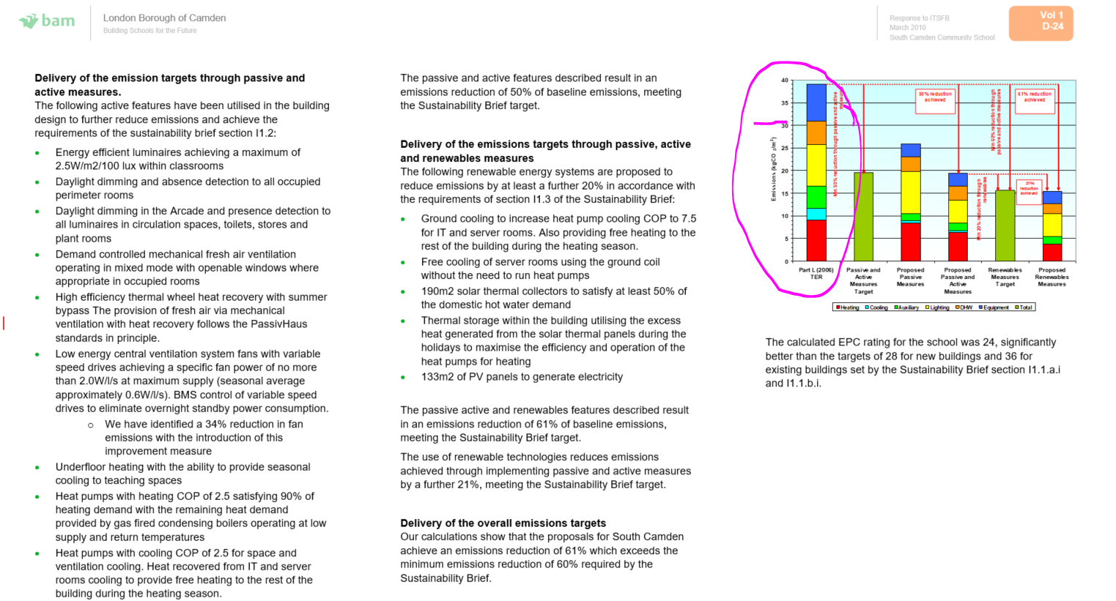

Regards

David Kingstone  
Associate Director  
BuroHappold Engineering | Building Environment  
T: +44 (0)113 2042200  
M: +44 (0)7753 829637  
[www.burohappold.com](https://protect-eu.mimecast.com/s/SwWJCL7r3Ik8YmGhmf2yW?domain=burohappold.com)   | [@burohappold](https://protect-eu.mimecast.com/s/LQ2qCMwv3U2m6RwcQC7vU?domain=twitter.com)

This transmission is confidential and intended solely for the person or organisation to whom it is correctly addressed. If you are not the intended recipient of this transmission, you should not take any action in reliance on it. Further, this transmission may contain confidential design and other information owned by Buro Happold Ltd. You should not copy, distribute, use, offer for sale or hire such information or in any way infringe the design and intellectual property rights of Buro Happold Ltd. It is intended that communication by email from Buro Happold Ltd or its employees is limited to communications connected to the services provided by Buro Happold Ltd. Buro Happold Ltd accepts no liability for any communications not connected to the services it provides. Computer viruses may be transmitted or downloaded onto your computer system via email communication. It is the recipient's responsibility to take any action necessary to prevent computer viruses being transmitted in this way. Accordingly, Buro Happold Ltd disclaims all responsibility which arises directly or indirectly from such transmission of computer viruses. Buro Happold Ltd. Registered in England: 2049511. Registered Office: Camden Mill Lower Bristol Road Bath BA2 3DQ

**From:** Cawley, Thomas <[tcawley@bam.co.uk](mailto:tcawley@bam.co.uk)>   
**Sent:** 10 October 2018 11:36  
**To:** David Kingstone <[David.Kingstone@BuroHappold.com](mailto:David.Kingstone@BuroHappold.com)>  
**Cc:** O'Donohoe, Mike <[modonohoe@bam.co.uk](mailto:modonohoe@bam.co.uk)>; McCormack, Jim <[jmccormack@bam.co.uk](mailto:jmccormack@bam.co.uk)>; Mitchell, Simon <[smitchell@bam.co.uk](mailto:smitchell@bam.co.uk)>  
**Subject:** FW: Regent High School - Energy

**\*\* External Email \*\***

Hi David,

Gabriel has responded further today with additional comments as below. Your earliest response to those would be appreciated.

Many thanks

Tom

**Thomas Cawley |**Senior Design Manager – London **|** BAM Construction Ltd

Kings Cross S4 Offices, 3rd Floor S4 Cabins, Handyside Street, Off York Way, Kings Cross, London, N1C 4AB

T 020 7XXX XXXX | DD 020 7XXX XXXX |  M 07810 557983 | E [tcawley@bam.co.uk](mailto:tcawley@bam.co.uk) | [www.bam.co.uk](https://protect-eu.mimecast.com/s/5UuRCJyp3IBMQ16fGlvG8?domain=bam.co.uk)

**From:** Berry-Khan, Gabriel [<mailto:Gabriel.Berry-Khan@camden.gov.uk>]   
**Sent:** 10 October 2018 11:15  
**To:** O'Donohoe, Mike  
**Cc:** McDonald, Neil; Cawley, Thomas  
**Subject:** RE: Regent High School - Energy

Dear Mike

As per below, thank you for your revised calculations sheet and the helpful explanations in your email.

I have the following queries outstanding:

-       Input ‘SEER’ for heat pump energy. The Energy & Sustainability Statement dated 2010 proposed a COP of 4.0; we would seasonal COP expect a lower to be lower than this and certainly lower than the 4.45 used here. Kindly clarify the as-designed/as-built figures for the COP and sCOP/sEER.

-       Source of regulated emissions figure for notional building/TER. I could not find 30.90 kgCO2/m2 in the original planning submissions – please could you point me to it?

-       Method used to calculate percentage renewables contribution. Adding back the renewables contribution of 2.34 kgCO2/m2 to the total (reg+unreg) emissions of 16.19, gives a pre-renewables emission rate of 18.53. Hence percentage contribution would be 12.6% and not your figure of 13.8% (which I cannot reproduce). What have I missed out here, please?

Best regards

Gabriel

--   
Gabriel Berry-Khan   
Senior Sustainability Officer (Planning)   
  
Telephone: 020 7974 4550  
  
[cid:image001.png@01D4702D.4547CE40](https://protect-eu.mimecast.com/s/Z4HqCNLw3UZyMEOh0pEDF?domain=emea01.safelinks.protection.outlook.com) [cid:image002.png@01D4702D.4547CE40](https://protect-eu.mimecast.com/s/zenvCOMx3UNQ207FAlrst?domain=emea01.safelinks.protection.outlook.com) [cid:image003.png@01D4702D.4547CE40](https://protect-eu.mimecast.com/s/2YEPCP7y3I0V5ojhZS5Ny?domain=emea01.safelinks.protection.outlook.com) [cid:image004.jpg@01D4702D.4547CE40](callto:tel:020%207974%204550)

**From:** Cawley, Thomas <[tcawley@bam.co.uk](mailto:tcawley@bam.co.uk)>   
**Sent:** 10 October 2018 09:32  
**To:** Berry-Khan, Gabriel <[Gabriel.Berry-Khan@camden.gov.uk](mailto:Gabriel.Berry-Khan@camden.gov.uk)>; McDonald, Neil <[Neil.McDonald@camden.gov.uk](mailto:Neil.McDonald@camden.gov.uk)>  
**Cc:** McCormack, Jim <[jmccormack@bam.co.uk](mailto:jmccormack@bam.co.uk)>; Mitchell, Simon <[smitchell@bam.co.uk](mailto:smitchell@bam.co.uk)>; O'Donohoe, Mike <[modonohoe@bam.co.uk](mailto:modonohoe@bam.co.uk)>  
**Subject:** RE: Regent High School - Energy

Hi Gabriel, Neil,

RE: Regent High School Planning Conditions 22 & 24

Just a note regarding the above and whether you have had a chance to review the additional information Mike sent over on 19/09/2018 (Below & attached). Your update would be appreciated.

Best regards

Tom

**Thomas Cawley |**Senior Design Manager – London **|** BAM Construction Ltd

Kings Cross S4 Offices, 3rd Floor S4 Cabins, Handyside Street, Off York Way, Kings Cross, London, N1C 4AB

T 020 7XXX XXXX | DD 020 7XXX XXXX |  M 07810 557983 | E [tcawley@bam.co.uk](mailto:tcawley@bam.co.uk) | [www.bam.co.uk](https://protect-eu.mimecast.com/s/8iwcCQnz9HXZN32tGQNE6?domain=emea01.safelinks.protection.outlook.com)

**From:** O'Donohoe, Mike   
**Sent:** 19 September 2018 11:26  
**To:** Berry-Khan, Gabriel  
**Cc:** McCormack, Jim; Cawley, Thomas; [neil.mcdonald@camden.gov.uk](mailto:neil.mcdonald@camden.gov.uk); Mitchell, Simon  
**Subject:** RE: Regent High School - Energy

Dear Gabriel,

My colleague (Tom Cawley) is presently on AL. Please see below and attached in response to your email to Tom dated 14 August 18. This has now been reviewed and we can respond as follows.

The as constructed BRUKL and EPC have been completed using the 2010 version of the National Calculation Methodology and as the approved DSM software utilised for the as constructed building is not backwards compatible to the 2006 National Calculation Methodology, it is not possible to provide the 2006 baseline.

To overcome this our method to show the 60% emissions reduction was as follows:

•        The 2006 baseline for the regulated emissions as that originally calculated in the Sustainability Statement of 30.9kgCO2/m2

•        The unregulated energy consumption of 25.66kWh/m2 for the baseline from the 2010 calculations has been used as this is based on the room activities for the building and is identical in the notional and proposed buildings

•        The Sustainability Statement identified the adoption of an energy efficient ICT strategy delivering an unregulated energy consumption of 8kWh/m2 for the constructed building

•        2006 emission factors for gas and electricity have been used because the 2010 emission factors changed significantly

We have updated the calculations to include the unregulated emissions; corrected the emissions from auxiliary, lighting and DHW to show a regulated and unregulated reduction of 61.19%.

Please note the PV contribution has not been double counted in the emissions table, however the renewables contribution used the total emissions with the PV contribution. The renewables contribution has now been amended to correct this and to include the unregulated emissions to give a 13.8% renewables contribution.

The BRUKL does include the electrical energy consumption associated with the GSHP installation. The renewable contribution from the GSHP has been calculated as the heat delivered by the GSHP less the electricity consumption of the GSHP based on its seasonal efficiency. The Element heading has been amended from Electric Heating to GSHP Heating for clarity.

In respect of the “further action required”

•        We are unable to submit the BRUKL for the 2006 baseline building because the as constructed BRUKL is based on the 2010 NCM and the approved software is not backwards compatible to the 2006 NCM. We have used our best endeavour to provide an equivalent calculation

•        We have corrected the calculations where omissions were found.

We trust this meets with your approval such that the conditions can be discharged.

Kind Regards

**Mike O'Donohoe** I Regional Design Manager - London I BAM Construction Ltd

24 Chiswell Street, London EC1Y 4TY

T 0207 374 3624 I F 0207 374 3603 I M 07860 387 796 I [www.bam.co.uk](https://protect-eu.mimecast.com/s/--ftCROA3cGZgRMIWpJC5?domain=emea01.safelinks.protection.outlook.com)

**From:** Berry-Khan, Gabriel <[Gabriel.Berry-Khan@camden.gov.uk](mailto:Gabriel.Berry-Khan@camden.gov.uk)>   
**Sent:** 14 August 2018 09:15  
**To:** Cawley, Thomas <[tcawley@bam.co.uk](mailto:tcawley@bam.co.uk)>; McDonald, Neil <[Neil.McDonald@camden.gov.uk](mailto:Neil.McDonald@camden.gov.uk)>  
**Cc:** McCormack, Jim <[jmccormack@bam.co.uk](mailto:jmccormack@bam.co.uk)>; O'Donohoe, Mike <[modonohoe@bam.co.uk](mailto:modonohoe@bam.co.uk)>  
**Subject:** RE: Regent High School - Energy

Dear Tom

I have sent my comments to Neil, stating in detail the items of outstanding information and clarifications needed prior to discharge. Please see a copy attached here in case not provided by Neil.

Given the delay and in order to help expedite matters, I am happy to discuss directly with Buro Happold if at all necessary, once they have had a chance to review my comments. Feel free to pass them my details.

Best wishes,

Gabriel

--   
Gabriel Berry-Khan   
Senior Sustainability Officer (Planning)   
  
Telephone: 020 7974 4550  
  
[cid:image001.png@01D44C26.81971F20](https://protect-eu.mimecast.com/s/TTMFCVAG3F2QP5WcxOJC_?domain=emea01.safelinks.protection.outlook.com) [cid:image002.png@01D44C26.81971F20](https://protect-eu.mimecast.com/s/RG_4CWLJ3U6oyPMcz9Pw8?domain=emea01.safelinks.protection.outlook.com) [cid:image003.png@01D44C26.81971F20](https://protect-eu.mimecast.com/s/ZJlKCXLK8U4rMq8fLVTpq?domain=emea01.safelinks.protection.outlook.com) [cid:image004.jpg@01D44C26.81971F20](callto:tel:020%207974%204550)

**From:** Cawley, Thomas <[tcawley@bam.co.uk](mailto:tcawley@bam.co.uk)>   
**Sent:** 13 August 2018 11:56  
**To:** McDonald, Neil <[Neil.McDonald@camden.gov.uk](mailto:Neil.McDonald@camden.gov.uk)>; Berry-Khan, Gabriel <[Gabriel.Berry-Khan@camden.gov.uk](mailto:Gabriel.Berry-Khan@camden.gov.uk)>  
**Cc:** McCormack, Jim <[jmccormack@bam.co.uk](mailto:jmccormack@bam.co.uk)>; O'Donohoe, Mike <[modonohoe@bam.co.uk](mailto:modonohoe@bam.co.uk)>  
**Subject:** RE: Regent High School -Details of energy efficiency performance and renewable energy technologies (ref 2014/4775/P)

Hi Neil,

RE: Regent High School Planning Conditions 22 & 24

Just a quick note regarding the above and whether your team have had a chance to review the attached.

Best regards

Tom

**Thomas Cawley |**Senior Design Manager – London **|** BAM Construction Ltd

Kings Cross S4 Offices, 3rd Floor S4 Cabins, Handyside Street, Off York Way, Kings Cross, London, N1C 4AB

T 020 7XXX XXXX | DD 020 7XXX XXXX |  M 07810 557983 | E [tcawley@bam.co.uk](mailto:tcawley@bam.co.uk) | [www.bam.co.uk](https://protect-eu.mimecast.com/s/IrUQCYWL3HDB6Nnfx8aL0?domain=emea01.safelinks.protection.outlook.com)

**From:** Cawley, Thomas   
**Sent:** 18 June 2018 11:28  
**To:** 'McDonald, Neil'; 'Berry-Khan, Gabriel'  
**Cc:** McCormack, Jim  
**Subject:** RE: Regent High School -Details of energy efficiency performance and renewable energy technologies (ref 2014/4775/P)

Hi Neil,

RE: Regent High School Planning Conditions 22 & 24

Just a quick note regarding the above and whether your team have had a chance to review the attached.

Best regards

Tom

**Thomas Cawley |**Senior Design Manager – London **|** BAM Construction Ltd

Kings Cross S4 Offices, 3rd Floor S4 Cabins, Handyside Street, Off York Way, Kings Cross, London, N1C 4AB

T 020 7XXX XXXX | DD 020 7XXX XXXX |  M 07810 557983 | E [tcawley@bam.co.uk](mailto:tcawley@bam.co.uk) | [www.bam.co.uk](https://protect-eu.mimecast.com/s/IrUQCYWL3HDB6Nnfx8aL0?domain=emea01.safelinks.protection.outlook.com)

This e-mail may contain information which is confidential, legally privileged and/or copyright protected. This e-mail is intended for the addressee only. If you receive this in error, please contact the sender and delete the material from your computer. See our new Privacy Notice [here](https://protect-eu.mimecast.com/s/z1I4CZYM7C7BoDkhQfmTK?domain=emea01.safelinks.protection.outlook.com) which tells you how we store and process the data we hold about you and residents.