Heritage Statement

Creation of a 3 bedroom flat in the loft space of 59 Greenfield Gardens, prepared by Proficiency on behalf of the property owners at;

**59 Greencroft Gardens**

**London**

**NW6 3LL**

Planning application reference – 2018/5581/NEW

INTRODUCTION

The purpose of this heritage report is to support the planning application at 59 Greencroft Gardens London NW6 3LL. The specific details of the proposed development can be seen in the architectural plans submitted with this application.

In the National Policy Planning Framework Section 12. Conserving and enhancing the historic environment, there is a requirement for applicants to include a heritage statement as part of their application for works affecting a heritage asset.

SYNOPSIS

The proposed development involves the creation of an additional flat conversion of a mezzanine flat, the flat is at the rear of a Victorian terraced house in a residential street within South Hampstead (formerly swiss cottage) conservation area in the London borough of Camden. The proposed development involves the creation of a dormer at the rear of the property, like that of both neighboring properties.

This statement details the History and character of the area, the specific architectural features and characteristics that the conservation area is in place to protect. It also briefly describes the reason for, and nature of the proposed development to provide context for the specific details of the proposed development contained in the accompanying plans.

HISTORICAL OVERVIEW

The History and character of 59 Greencroft gardens:

59 Greencroft gardens, is a large 3 story property faced with red brick and many original Victorian features. The house is situated within South Hampstead residential area and was built late 19th Century. The street scene boasts prominent mature trees, and original features such as ironwork porch canopies, patterned footpaths, baroque style pediments and gothic revival arches and arcading.

FRONTAGE

The image to the left shows the well managed frontage of 59 Greencroft Gardens. With original iron work porch and patterned walkway and sash windows.

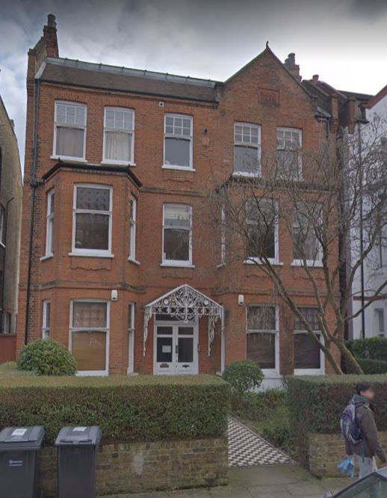

PROPOSED WORKS

All works proposed will not alter the frontage of the building and respects the building and its features. The proposal aims to convert the existing unused loft space to a 3 bedroom flat with dormer windows and a balcony to the rear, and conservation roof lights to the front.

The proposal aims to mirror that of the neighboring property, 61 Greencroft Gardens, with roof lights and inset terrace balcony.

REAR

The image above shows the rear of 59 Greencroft Gardens and the neighboring properties, with approved dormer windows and roof terraces. The application pertaining to 59 Greencroft uses these examples as inspiration for the design.

59 Greencroft Gardens

61 Greencroft Gardens

57 Greencroft Gardens

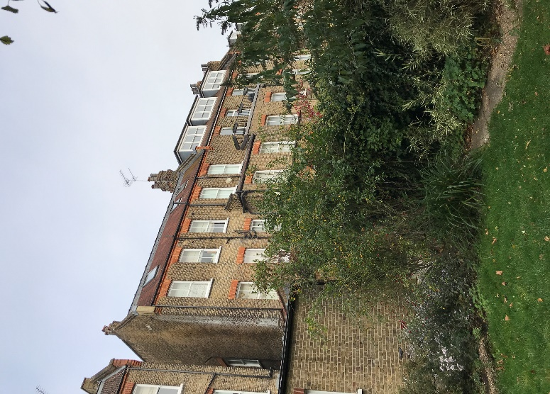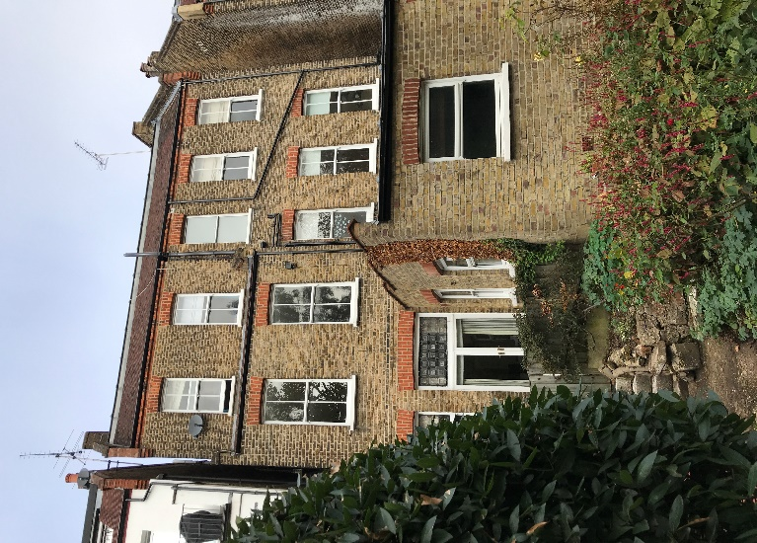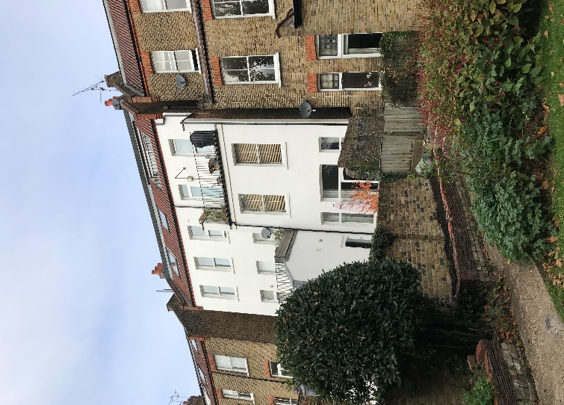

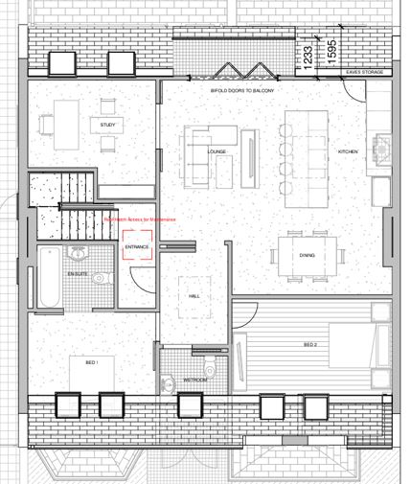 The plans show the new flat to include:

* New Staircase into flat, to match existing staircase
* 2 Bedrooms
* 2 bathrooms
* Study
* Generous open plan living space, kitchen/ living area
* Inset balcony to the rear of the house.

The plans show minimal disruption to the frontage of the house, which new additions are to include conservation roof lights.

CONCLUSION

The proposed works to add a 3 bedroom Flat in the loft space acknowledge the importance of the street scene of Greencroft Gardens and are sympathetic to the character of the house. There will be minimal disruption to the street scene and frontage of the house, due to the use of conservation roof lights. The design uses precedents from neighbors, 61 Greencroft gardens and alters the rear, to include a small inset balcony.

Proposed Frontage with Conservation Roof lights

Proposed Rear with roof lights and inset balcony to match 61 Greencroft Gardens

