Heritage Statement& Design and Access Statement

SITE ADDRESS: 10B Lady Somerset Road London NW5 1UP

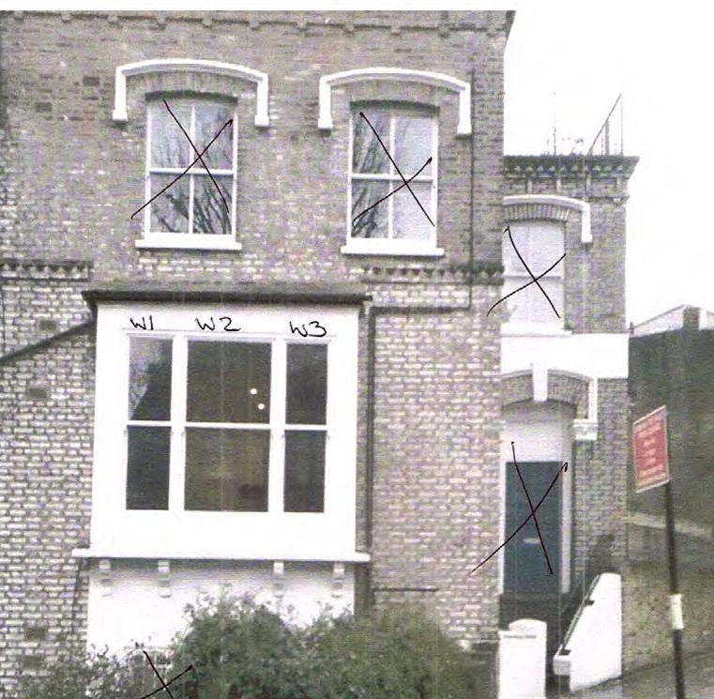
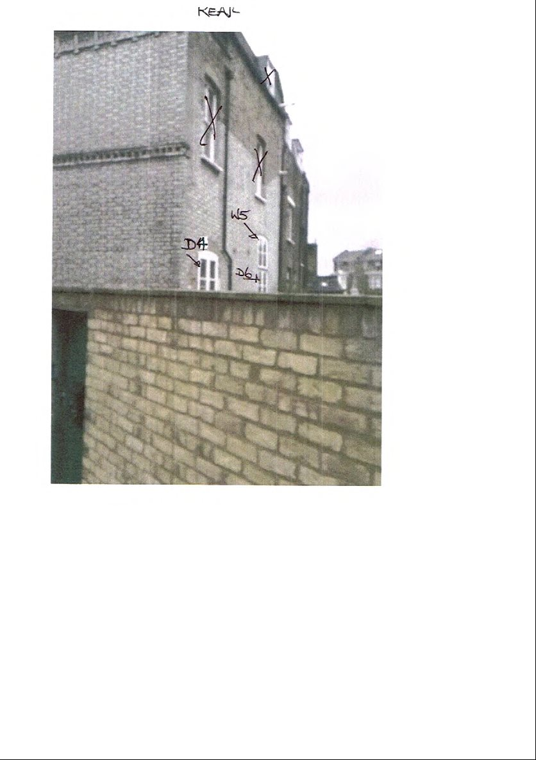

Use: Anglian Home Improvements have been contracted to replace the existing
bay window to the front and to French doors to the rear at the above site address.

Surrounding Area:

The local area consists of predominantly terraced properties many of which have been converted into flats. We do not believe the replacement windows and doors proposed will have a detrimental impact on the surrounding area.

Heritage/History

The property lies within the local conservation area. The property was originally a terrace house which has since been converted into flats.

Constraints: The property is Conservation Area for which we have been advised has an Article 4 Direction in place restricting permitted development hence the requirement of the application.

Design Principles/Justification: The applicant has chosen our white timber sash window, white flush fit timber window (above once set of French doors to the rear) and 2 sets of white timber French doors to replace the existing windows and doors as indicated on the accompanying CAD plans. The scale and visual appearance and material will be unchanged and will therefore be in keeping within the conservation area and the property. The existing windows and doors are in a poor condition and as such the new proposed windows will provide better weather proofing and thermal efficiency. This improvement will therefore will protect the internal and external fabric of the property.

In addition draught proofing, sound insulation and security measures will all be improved upon to the benefit of the quality of the life of the homeowners.

.
Access: No change to the property to the existing access.

Landscaping: N/A

To conclude with the above in mind we trust the windows proposed will be considered favourably by the council as we do not believe they will have any detrimental impact on the conservation area. We look forward to your reply and positive co-operation.

