**Design and access statement :**

**19 Prince Albert Road, London, NW1 7ST**

The proposal is to remove the existing flue pipes shown in image 1 and replace with a new flue that resembles the picture labelled image 2. The positioning and size of the new flue is displayed within the planning drawings accompanying this application.

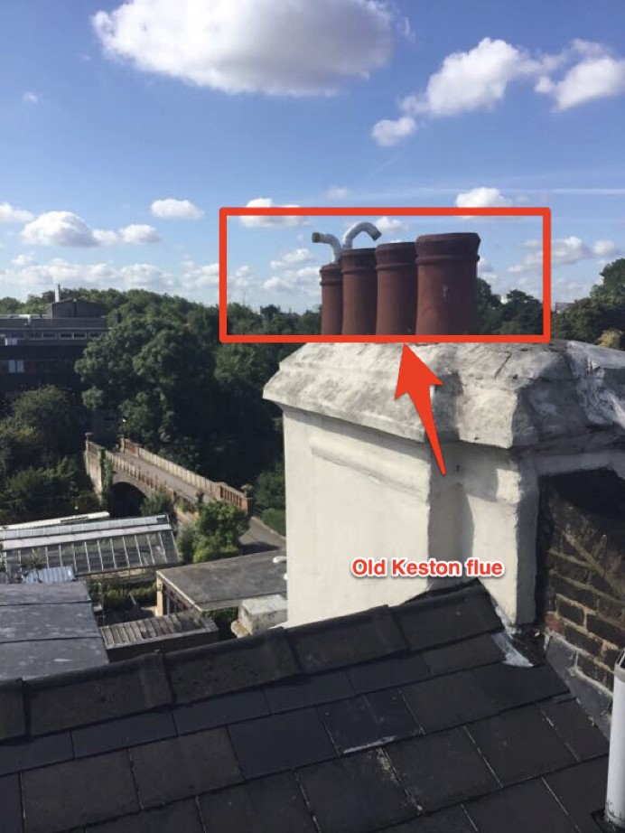

Image 1.

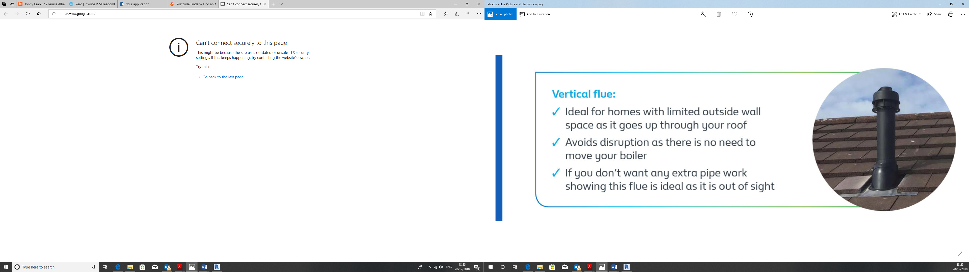

Image 2.