**DESIGN & ACCESS STATEMENT**

**SITE ADDRESS: 54a ELSWORTHY ROAD, LONDON, NW3 3BU.**

**CONTEXT AND STATEMENT OF HISTORIC SIGNIFICANCE** Anglian Home Improvements have been contracted to replace 3 of the windows to the front, 2 windows to the side and 4 windows to the rear. There is also a high level window at the front of the property situated behind the front which is hard to view and one behind the front left window which faces the adjacent property which is not visible from the front.

The property falls within a conservation area so the changing of these windows must fit in with the current property as the overall look of the house and its surrounding area is important.

**Front of property – 3 windows to second floor level to be changed. 6, 7 & 8 on plans**

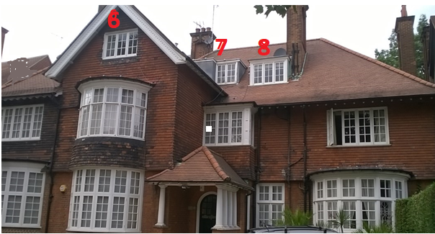

**AMOUNT:** There will be 11 new windows in total.

**LAYOUT**: The windows will replace the ones in situ and there will be no change in the style of opening of the main windows as they will remain side opening casements.

**SCALE**: The windows will be in proportion to the house as they will be in the original openings. The front windows will be side opening casements and will be in the same break sizes as the current ones.

**LANDSCAPING**: Our proposal will not require any landscaping as these are replacement windows only.

**APPEARANCE:** The windows a will be white Timber and will be flush fitting. They will have cottage style bars to the frames to copy the current ones. The windows replaced to the front are the attic style ones which are quite hard to view from ground level so any changes to the

front should not be noticeable from that distance. The remaining windows to the side and front will not be visible from the road so again changes here will not be under such scrutiny,

**Side Windows –one on 1st floor and Front back windows 11, 12 & 13 &**

**one on 2nd Floor Windows 9 & 10 Windows behind roof facing left**

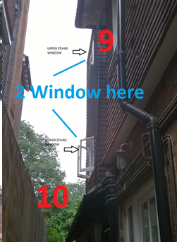 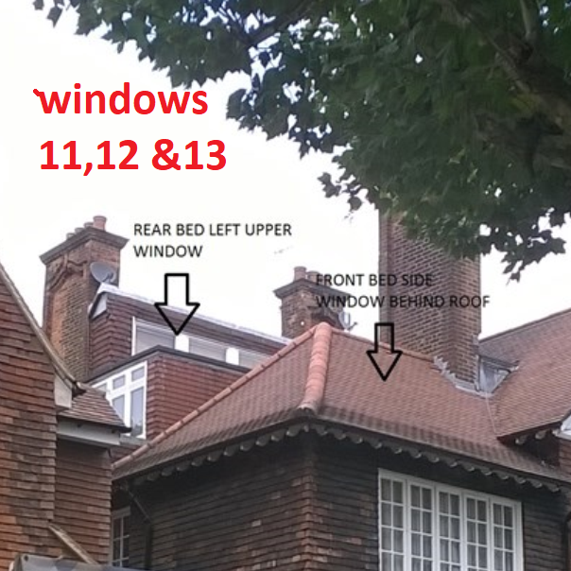

**ACCESS:** Access will be gained by entering the property via the main entrance. There are no changes to the parking arrangements or access onto the property. There are no special measures needed with highways to install the windows or bring materials to site.

**DEVELOPMENTS WITHIN OR AFFECTING CONSERVATION AREA, LISTED BUILDING OR ITS SETTING.** We have considered carefully the proposed changes to the property and feel that the new windows should not have a detrimental effect on the property as a whole and its surrounding area or setting.

**Rear Elevation – 4 windows to be changed at 2nd floor level.**

