**Construction Management**

**Plan**

**pro forma** v2.1

**Contents**

**Revisions 3**

**Introduction 4**

**Timeframe 6**

**Contact 7**

**Site 9**

**Community liaison 12**

**Transport 15**

**Environment 25**

**Agreement 30**

**Revisions & additional material**

Please list all iterations here:

|  |  |  |
| --- | --- | --- |
| **Date** | **Version** | **Produced by** |
|  |  |  |

**Additional sheets**

Please note – the review process will be quicker if these are submitted as Word documents or searchable PDFs.

|  |  |  |
| --- | --- | --- |
| **Date** | **Version** | **Produced by** |
|  |  |  |

**Introduction**

The purpose of the **Construction Management Plan (CMP)** is to help developers to minimise construction impacts, and relates to both on site activity and the transport arrangements for vehicles servicing the site.

It is intended to be a live document whereby different stages will be completed and submitted for application as the development progresses.

The completed and signed CMP must address the way in which any impacts associated with the proposed works, and any **cumulative impacts of other nearby construction sites**, will be mitigated and managed. The level of detail required in a CMP will depend on the scale and kind of development. Further policy guidance is set out in Camden Planning Guidance [**(CPG)** 6: Amenity](http://www.camden.gov.uk/ccm/content/environment/planning-and-built-environment/two/planning-policy/supplementary-planning-documents/camden-planning-guidance.en) and [**(CPG)** 8: Planning Obligations](http://www.camden.gov.uk/ccm/content/environment/planning-and-built-environment/two/planning-policy/supplementary-planning-documents/camden-planning-guidance.en).

This CMP follows the best practice guidelines as described in [Transport for London’s](https://www.tfl.gov.uk/info-for/freight/safety-and-the-environment/improving-construction-safety) (TfL’s Standard for [Construction Logistics and Cyclist Safety](http://www.clocs.org.uk/standard-for-clocs/) (**CLOCS**) scheme) and [Camden’s Minimum Requirements for Building Construction](http://www.camden.gov.uk/ccm/cms-service/download/asset?asset_id=3257318) **(CMRBC)**.

The approved contents of this CMP must be complied with unless otherwise agreed with the Council in writing. The project manager shall work with the Council to review this CMP if problems arise in relation to the construction of the development. Any future revised plan must also be approved by the Council and complied with thereafter.

It should be noted that any agreed CMPdoes not prejudice or override the need to obtain any separate consents or approvals such as for road closures or hoarding licences.

If your scheme involves any demolition, you need to make an application to the Council’s Building Control Service. Please complete the “[**Demolition Notice**](http://www.camden.gov.uk/ccm/content/environment/building-control/file-storage-items/demolition-notice---the-building-act-1984-section-80-notice-bc104-.en)**.**”

Please complete the questions below with additional sheets, drawings and plans as required. The boxes will expand to accommodate the information provided, so please provide as much information as is necessary. **It is preferable if this document, and all additional documents, are completed electronically and submitted as Word files to allow comments to be easily documented. These should be clearly referenced/linked to from the CMP.**

Please notify that council when you intend to start work on site. Please also notify the council when works are approximately **3 months from completion.**

(Note the term 'vehicles' used in this document refers to all vehicles associated with the implementation of the development, e.g. demolition, site clearance, delivery of plant & materials, construction, etc.)

Revisions to this document may take place periodically. **Timeframe**

**DEVELOPER ACTIONS**

**COUNCIL ACTIONS**

**Post app submission**

**0ommunity liaison**

**Appoint principal contractor**

**Requirement to submit CMP**

**Begin community liaison**

**Work can commence if draft CMP is approved**

**Council response to second draft**

**Resubmission of CMP if first draft refused**

**2ommunity liaison**

**3ommunity liaison**

**1ommunity liaison**

INDICATIVE TIMEFRAME (MONTHS)

**4ommunity liaison**

**Council response to draft**

**Submit draft CMP**

**Contact**

1. Please provide the full postal address of the site and the planning reference relating to the construction works.

Address: 246-248 Kilburn High Road, London, NW6 2BS.

Planning ref:

Type of CMP - Section 106 planning obligation/Major sites framework:

2. Please provide contact details for the person responsible for submitting the CMP.

Name: Paul Slaughter

Address: GPS Projects Ltd, Unit 10 Victory Park, Trident Close, Medway City Estate, Rochester, Kent, ME2 4ER

Email: pauls@gpsprojectsltd.co.uk

Phone: 01634 299880

3. Please provide full contact details of the site project manager responsible for day-to-day management of the works and dealing with any complaints from local residents and businesses.

Name: Tulio Novruzov

Address: GPS Projects Ltd, Unit 10 Victory Park, Trident Close, Medway City Estate, Rochester, Kent, ME2 4ER

Email: tulion@gpsprojectsltd.co.uk

Phone: 07702 562828

4. Please provide full contact details of the person responsible for community liaison and dealing with any complaints from local residents and businesses if different from question 3. In the case of [**Community Investment Programme (CIP)**](http://www.camden.gov.uk/ccm/content/environment/planning-and-built-environment/two/placeshaping/twocolumn/the-community-investment-programme.en), please provide contact details of the Camden officer responsible.

Name: Tulio Novruzov

Address: GPS Projects Ltd, Unit 10 Victory Park, Trident Close, Medway City Estate, Rochester, Kent, ME2 4ER

Email: tulion@gpsprojectsltd.co.uk

Phone: 07702 562828

5. Please provide full contact details including the address where the main contractor accepts receipt of legal documents for the person responsible for the implementation of the CMP.

Name: Paul Slaughter

Address: GPS Projects Ltd, Unit 10 Victory Park, Trident Close, Medway City Estate, Rochester, Kent, ME2 4ER

Email: pauls@gpsprojectsltd.co.uk

Phone: 01634 299880

**Site**

6. Please provide a site location plan and a brief description of the site, surrounding area and development proposals for which the CMP applies.





The site is located on the (A5) Kilburn High Road within the London Borough of Camden, approximately 200m south of Brondesbury Railway Station, 300m south of Kilburn Tube Station and 400m north of Kilburn High Road Railway

The surrounding area is mainly a mix of commercial (retail) and residential; however Kingsgate Primary School is located to the east on Kingsgate Road. The Site Manager will liaise with the school’s Management Team to ensure that normal school operations are not unduly disrupted and also confirm busy periods. Traffic will be coordinated to ensure that deliveries and waste removal takes place outside of the school’s busy periods.

The existing street where the site is located is a busy A-road (A5), a main route through Kilburn with a high concentration of traffic. Traffic periods will be monitored by the site manager to determine busy periods and therefore coordinate deliveries and waste removal for quieter periods throughout the day.

7. Please provide a very brief description of the construction works including the size and nature of the development and details of the main issues and challenges (e.g. narrow streets, close proximity to residential dwellings etc).

The project comprises the demolition of the existing building and the construction of two blocks to provide 27 residential units over 5 storeys (Block A0 and six storeys (Block B). The works will include demolition, piling, concrete frame construction, curtain walls, fit out and landscaping works.

The main issues associated with the development will be working in close proximity to the existing residential dwellings/commercial buildings whilst the sub-structure and superstructure construction works are undertaken. This however can be managed by the implementation and adherence to Safe Systems of Work.

8. Please identify the nearest potential receptors (dwellings, business, etc.) likely to be affected by the activities on site (i.e. noise, vibration, dust, fumes, lighting etc.).

The surrounding area is mainly a mix of commercial (retail) and residential; however Kingsgate Primary School is located to the east on Kingsgate Road. The Site Manager will liaise with the school’s Management Team to ensure that normal school operations are not unduly disrupted and also confirm busy periods. Traffic will be coordinated to ensure that deliveries and waste removal takes place outside of the school’s busy periods. Traffic will be coordinated to ensure that deliveries and waste removal takes place outside of the school’s busy periods. The neighbouring properties will require unhindered access at all times. The works are to be conducted in such a manner to ensure that neighbouring residents, visitors and the general public are not unduly disturbed. Deliveries and waste removals will be planned to ensure that they do not coincide with busy periods throughout the day.

9. Please provide a scaled plan detailing the local highway network layout in the vicinity of the site. This should include details of on-street parking bay locations, cycle lanes, footway extents and proposed site access locations.

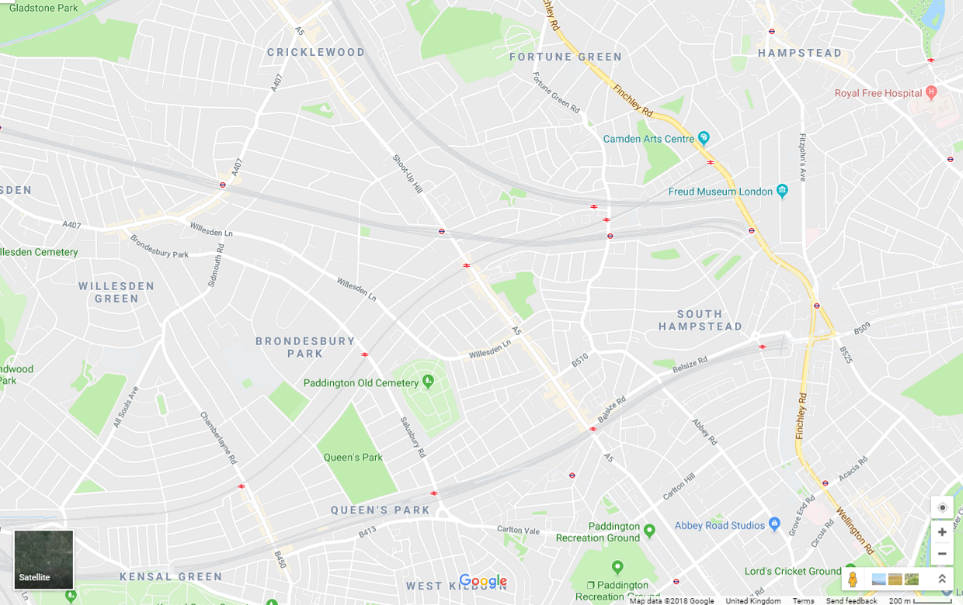

Site Location

100m

Route in Route out Scale

200m

Vehicles will travel to site via the ‘A’ roads and major roads in the borough, wherever possible, to enter and leave site, ensuring that where possible, residential streets are avoided. Unless where/when it is absolutely unavoidable, the use of residential streets by construction lorries are not tolerated. The site is located and surrounded by a number of ‘A’ roads and therefore the use of residential streets is unlikely.

Access from the north will take place from the A406 (North Circular Road), south onto the A5 Edgeware Road. Vehicles will travel approximately 2.5 miles through Shoot-Up Hill onto Kilburn High Road, where the site entrance will be located to the left opposite Buckley Road.

Access from the south will take place from the A40 Westway / A501 Marylebone Road and turn north onto A5 Edgeware Road. Vehicles will travel approximately 2 miles through Maida Vale onto Kilburn High Road, where the site entrance will be located to the right opposite Buckley Road.

10. Please provide the proposed start and end dates for each phase of construction as well as an overall programme timescale. (A Gantt chart with key tasks, durations and milestones would be ideal).

Commencement Date 12/11/2018

Completion Date 17/06/2020

11. Please confirm the standard working hours for the site, noting that the standard working hours for construction sites in Camden are as follows:

* 8.00am to 6pm on Monday to Friday
* 8.00am to 1.00pm on Saturdays
* No working on Sundays or Public Holidays

The standard working hours will be as above

12. Please indicate if any changes to services are proposed to be carried out that would be linked to the site during the works (i.e. connections to public utilities and/or statutory undertakers’ plant). Larger developments may require new utility services. If so, a strategy and programme for coordinating the connection of services will be required. If new utility services are required, please confirm which utility companies have been contacted (e.g. Thames Water, National Grid, EDF Energy, BT etc.) You must explore options for the utility companies to share the same excavations and traffic management proposals. Please supply details of your discussions.

UKPN, THAMES WATER

**Community Liaison**

**A neighbourhood consultation process must have been undertaken prior to submission of the CMP first draft. This consultation must relate to construction impacts, and should take place following the grant of planning permission in the lead up to the submission of the CMP. A consultation process specifically relating to construction impacts must take place regardless of any prior consultations relating to planning matters. This consultation must include all of those individuals that stand to be affected by the proposed construction works. These individuals should be provided with a copy of the draft CMP, or a link to an online document. They should be given adequate time with which to respond to the draft CMP, and any subsequent amended drafts. Contact details which include a phone number and email address of the site manager should also be provided.**

Significant time savings can be made by running an effective neighbourhood consultation process. This must be undertaken in the spirit of cooperation rather than one that is dictatorial and unsympathetic to the wellbeing of local residents and businesses.

These are most effective when initiated as early as possible and conducted in a manner that involves the local community. Involving locals in the discussion and decision making process helps with their understanding of what is being proposed in terms of the development process. **The consultation and discussion process should have already started, with the results incorporated into the CMP first draft submitted to the Council for discussion and sign off.**This communication should then be ongoing during the works, with neighbours and any community liaison groups being regularly updated with programmed works and any changes that may occur due to unforeseen circumstances through newsletters, emails and meetings.

Please note that for larger sites, details of a construction working group may be required as a separate S106 obligation. If this is necessary, it will be set out in the S106 Agreement as a separate requirement on the developer.

**Cumulative impact**

Sites located within high concentrations of construction activity that will attract large numbers of vehicle movements should consider establishing contact with other sites in the vicinity in order to manage traffic routeing and volumes. Developers in the Tottenham Court Road area have done this to great effect.

**The Council can advise on this if necessary.**

**13. Consultation**

The Council expects meaningful consultation. For large sites, this may mean two or more meetings with local residents **prior to submission of the first draft CMP**.

Evidence of who was consulted, how the consultation was conducted and a summary of the comments received in response to the consultation. Details of meetings including minutes, lists of attendees etc. must be included.

In response to the comments received, the CMP should then be amended where appropriate and, where not appropriate, a reason should be given. The revised CMP should also include a list of all the comments received. Developers are advised to check proposed approaches to consultation with the Council before carrying them out. If your site is on the boundary between boroughs then we would recommend contacting the relevant neighbouring planning authority.

Please provide details of consultation of draft CMP with local residents, businesses, local groups (e.g. residents/tenants and business associations) and Ward Councillors.

There was no responses from any of the below. Letters to the residents and local business were sent on 26.10.18 and the emails to the ward councillors

Residents:

254 Kilburn High Rd, London NW6 2BS

252 Kilburn High Rd, London NW6 2BS

250 Kilburn High Rd, Kilburn NW6 2BS

Local Business:

Ariana: 241 Kilburn High Road, London NW6 7JN

Starboy Barbers, 256 Kilburn High Rd, London, NW6 2BY

Charcoal Grill Kebab House, 249 Kilburn High Rd, London, NW6 7JN

Paddy Power, 251-255 Kilburn High Rd, London NW6 7JN

Ward Councillors:

Doug Beattie

Maryam Eslamdoust

Thomas Gardiner

**14. Construction Working Group**

Please provide details of community liaison proposals including any Construction Working Group that will be set up, addressing the concerns of the community affected by the works, the way in which the contact details of the person responsible for community liaison will be advertised to the local community, and how the community will be updated on the upcoming works i.e. in the form of a newsletter/letter drop, or weekly drop in sessions for residents.

GPS Projects will implement the following in regard to community liaison and consultation in connection with the development and seek regular improvement and upkeep of the CMP.

The residents will be kept informed about unavoidable disturbance such as unavoidable noise, dust, or traffic disruption. Clean information will be given well in advance and in writing.

Continuous liaison will be maintained with the local community, before works

commence, during the works and in particular in case of exceedances and/or change of techniques and/or methodology of the undertaken of the works and complaints /

concerns. This will be via the methods as detailed below.

Communication will be via:

* An initial letter drop which will introduce the site construction team management and community liaison officer. Head office details will also be provided.
* A monthly newsletter will be published and delivered to the residents and business owners of Kilburn High Road, Grangeway and surrounding properties. The newsletter will also be displayed on a fixed notice board that will be erected on notice boards displayed on the site Hoarding. The newsletter will include details on the stage of the works as well as the upcoming works etc.
* Our site manager will be our first point of contact for any liaison with the local community including addressing any complaints or concerns. The site manager will also be supported by the community liaison officer.
* A contact board will be displayed prominently on the site with the following information being made available.

1. The Title ‘Contact Board’

2. GPS Projects’ name, address and the person to whom correspondence

should be addressed.

3. Name of the site manager.

4. Month and year of completion of the works,

5. Name and telephone numbers of staff who can take immediate action, so that contact can be made at any time.

Occupiers in the vicinity who may be affected by noise from the works shall be notified of the nature of the works, a contact name, telephone number (including that to be used outside normal working hours), and address to which any enquiries should be directed.

Such notification will take place, where possible, 2 weeks but, in any event, at least a week

prior to the works commencing.

A staffed telephone enquiry line will be maintained at all times when site works are in

progress to deal with enquiries and complaints from the local community. The telephone

number will be publicised and also notified to the Noise and Licensing Enforcement Team

on 0207 974 4444. Both the Site Manager and Contracts Manager will be contactable 24/7.

Should noise/vibration/dust complaints arise from the building works, these complaints will

be recorded in a complaints register and made available to LB Camden, if requested. The

complaint register will provide information on day, time, details of complaint, details of

monitoring carried out and any additional mitigation works.

Should complaints be received concerning works/activities, then all works/activities being

the cause of the complaint will cease until such time the complaint is dealt with. Our site manager will maintain a log of all site visits to the site by the residents, neighbours and public where they wish to make any comments. Should any complaints be received these will be acted upon and reported at the working group.

We propose that the working group be held bi-monthly but the site manager will be available to address any concerns or questions from the residents on a day-to-day basis.

Consultation and communication will also be sought throughout the project via a

construction working group (CWG) where we can report on our progress and key

construction activities but at the same time seek feedback and comment from the group

with a view maintaining communication lines open at all times. The CWG will meet on a

monthly basis initially with this then changing to a quarterly basis following the completion

of the demolition and substructure works. The CWG may include but not limited to:

• The immediate residents who are neighbours to the site;

• Estate Managers;

• The local ward member for which the site falls within; and

• Camden Project Manager

GPS Projects’ CWG Schedule of Monthly Meeting Dates

• 1st Wednesday of each month

**15. Schemes**

Please provide details of any schemes such as the ‘Considerate Constructors Scheme’, such details should form part of the consultation and be notified to the Council. Contractors will also be required to follow the “[Guide for Contractors Working in Camden](http://www.camden.gov.uk/ccm/cms-service/download/asset?asset_id=799001)” also referred to as “[Camden’s Considerate Contractors Manual](http://www.camden.gov.uk/ccm/cms-service/download/asset?asset_id=799001)”.

**Order ID is 68378**

The project will be registered with Considerate Contractors scheme. Particular initiatives will be:

* Control of the works so that dust and waste from the construction activities cannot blow into surrounding areas;
* Noise minimisation consistent with good construction practice;
* Clean and neat front of house site presentation;
* Courteous approach to the local residents and general public by the site personnel;
* Carefully scheduled deliveries so that lorries do not back up and cause congestion in the surrounding areas;
* Provide local employment opportunities;
* Provide local procurement opportunities;
* A local newsletter will be made available to local residents; and
* Road cleaning vehicle as necessary

GPS Projects will set itself a target of achieving a minimum score for each CCS inspection

criteria of “very good”.

GPS Projects are in possession of a copy of Camden’s “Guide for Contractors” and will

adhere to this.

**16. Neighbouring sites**

Please provide a plan of existing or anticipated construction sites in the local area and please state how your CMP takes into consideration and mitigates the cumulative impacts of construction in the vicinity of the site. The council can advise on this if necessary.

GPS Projects are not aware of any large construction sites in the immediate vicinity of this site. There are always small renovation projects in such a large town This project will

increase heavy traffic at certain times but there are no other similarly sized projects. As

a result, the traffic increase will be as a result of this project and will not form a

cumulative effect due to other sites in the locale. Scheduled deliveries avoiding school pick up and drop off times will be put in place

from the beginning of the project.

There are no other sites of comparable size due to start within this projects time frame

that we are currently aware of.

The Site Manager will liaise with the Construction Project Managers of these consented developments and any consented developments to ensure that all deliveries are coordinated where possible.

**Transport**

**This section must be completed in conjunction with your principal contractor. If one is not yet assigned, please leave the relevant sections blank until such time when one has been appointed.**

Camden is a CLOCS Champion, and is committed to maximising road safety for Vulnerable Road Users (VRUs) as well as minimising negative environmental impacts created by motorised road traffic. As such, all vehicles and their drivers servicing construction sites within the borough are bound by the conditions laid out in the [CLOCS Standard.](http://www.clocs.org.uk/wp-content/uploads/2014/09/CLOCS-Standard-v1.2.pdf)

This section requires details of the way in which you intend to manage traffic servicing your site, including your road safety obligations with regard to VRU safety. It is your responsibility to ensure that your principal contractor is fully compliant with the terms laid out in the CLOCS Standard. It is your principal contractor’s responsibility to ensure that all contractors and sub-contractors attending site are compliant with the terms laid out in the CLOCS Standard.

Checks of the proposed measures will be carried out by the council to ensure compliance. Please refer to the CLOCS Standard when completing this section. Guidance material which details CLOCS requirements can be accessed [here](http://www.camden.gov.uk/ccm/cms-service/stream/asset/?asset_id=3345819&), details of the monitoring process are available [here](http://www.camden.gov.uk/ccm/cms-service/stream/asset/?asset_id=3345820&).

Please contact [CLOCS@camden.gov.uk](mailto:CLOCS@camden.gov.uk) for further advice or guidance on any aspect of this section.

**Please refer to the CLOCS Overview and Monitoring Overview documents referenced above which give a breakdown of requirements.**

**CLOCS Considerations**

17. Name of Principal contractor:

GPS Projects Ltd

18. Please submit the proposed method for checking operational, vehicle and driver compliance with the CLOCS Standard throughout the duration of the contract (please refer to our CLOCS Overview document in the appendix and CLOCS Standard point 3.4.7).

FORS Bronze accreditation as a minimum will be a contractual requirement, FORS Silver or Gold operators will be appointed where possible.

Where FORS Bronze operators are appointed, written assurance will be sought from contractors that all vehicles over 3.5t are equipped with additional safety equipment (as per CLOCS Standard P13), and that all drivers servicing the site will have undertaken approved additional training (e.g. Safe Urban Driving + 1 x e-learning module orWork Related Road Risk Vulnerable Road User training + on-cycle hazard awareness course + 1 x e-learning module etc.). CLOCS Compliance will be included as a contractual requirement.

Desktop checks will be made against the FORS database of trained drivers and accredited companies as outlined in the CLOCS Standard Managing Supplier Compliance guide. These will be carried out as per a risk scale based on that outlined in the CLOCS Managing Supplier Compliance guide.

Checks of FORS ID numbers will form part of the periodic checks and will be carried out as per an appropriate risk scale. Random spot checks will be carried out by site staff on vehicles and drivers servicing the site at a frequency based on the aforementioned risk scale. These will include evidence of further training, license checks, evidence of routing information, and checks of vehicle safety equipment. Results from these checks will be logged and retained, and enforced upon accordingly.

19. Please confirm that you as the client/developer and your principal contractor have read and understood the [CLOCS Standard](http://www.clocs.org.uk/wp-content/uploads/2015/05/CLOCS-Standard-v1.2-APRIL_15.pdf) and included it in your contracts. Please sign-up to join the [CLOCS Community](http://www.clocs.org.uk/links-to-partners/) to receive up to date information on the standard by expressing an interest online.

I confirm that I have included the requirement to abide by the CLOCS Standard in my contracts to my contractors and suppliers:

I, Tulio Novruzov (Contracts Manager) at GPS Projects, confirm that the requirement to abide by the CLOCS Standard will be included in all sub-contractor and supplier orders.

Please contact [CLOCS@camden.gov.uk](mailto:CLOCS@camden.gov.uk) for further advice or guidance on any aspect of this section.

**Site Traffic**

**Sections below shown in blue directly reference the CLOCS Standard requirements. The CLOCS Standard should be read in conjunction with this section.**

**20. Traffic routing**: *“Clients shall ensure that a suitable, risk assessed vehicle route to the site is specified and that the route is communicated to all contractors and drivers. Clients shall make contractors and any other service suppliers aware that they are to use these routes at all times unless unavoidable diversions occur.”* (P19, 3.4.5)

Routes should be carefully considered and risk assessed, taking into account the need to avoid where possible any major cycle routes and trip generators such as schools, offices, public buildings,museums etc. Where appropriate, on routes that use high risk junctions (i.e. those that attract high volumes of cycling traffic) installing Trixi mirrors to aid driver visibility should be considered.

Consideration should also be given to weight restrictions, low bridges and cumulative impacts of construction (including neighbouring construction sites) on the public highway network. The route(s) to and from the site should be suitable for the size of vehicles that are to be used.

a. Please indicate routes on a drawing or diagram showing the public highway network in the vicinity of the site including details of links to the [Transport for London Road Network](http://www.lscp.org.uk/lrsu/engineering_tlrn.html) (TLRN).



Site Location

Vehicles will travel to site via the ‘A’ roads and major roads in the borough, wherever possible, to enter and leave site, ensuring that where possible, residential streets are avoided. Unless where/when it is absolutely unavoidable, the use of residential streets by construction lorries are not tolerated. The site is surrounded by a number of ‘A’ roads and therefore the use of residential streets is unlikely.

Access from the north will take place from the A406 (North Circular Road), south onto the A5 Edgeware Road. Vehicles will travel approximately 2.5 miles through Shoot-Up Hill onto Kilburn High Road, where the site entrance will be located to the left opposite Buckley Road.

Access from the south will take place from the A40 Westway / A501 Marylebone Road and turn north onto A5 Edgeware Road. Vehicles will travel approximately 2 miles through Maida Vale onto Kilburn High Road, where the site entrance will be located to the right opposite Buckley Road.

Egress will take place under the control of site banksmen and travel northbound or southbound as required.

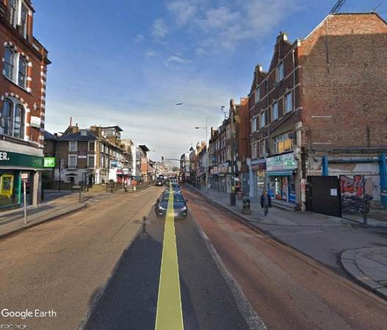 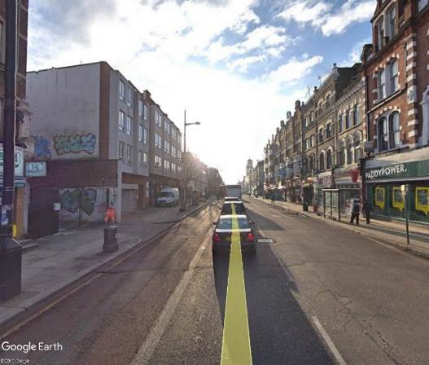

Site location

Looking north from the site entrance Looking south from the site entrance

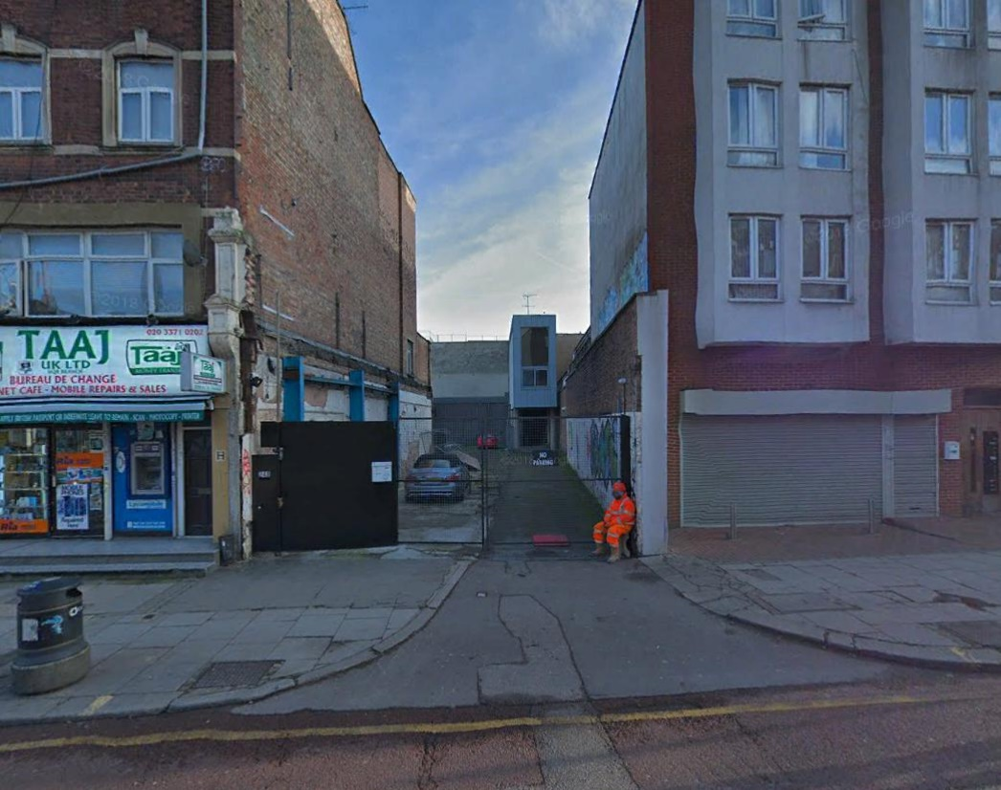

Existing building and site location

b. Please confirm how contractors, delivery companies and visitors will be made aware of the route (to and from the site) and of any on-site restrictions, prior to undertaking journeys.

GPS Projects will contact suppliers, sub-contractors and waste companies, instructing them to use appropriate timings to access the site and communicate this limitation to all of their drivers. Deliveries are to be planned and timings will be as agreed between the delivery contractor and Site Manager. All drivers will be only be permitted to arrive at their allotted time window. If they arrive outside this time, and there is no access onto the loading/delivery location, they will be turned away. This will allow the banksman to be ready for the delivery driver as he approaches site, ensuring minimum disruption on in the immediate streets and to avoid vehicles waiting.

Vehicle Call Up Procedure/Vehicle Holding Areas: Pre-arranged delivery times will be set by the site manager to ensure that there is no more than one delivery vehicle arriving simultaneously. Drivers will be required to contact the site 30 minutes prior to arrival in order to ensure that a space is available for them, with this requirement forming a part of all contract documentation.

**21. Control of site traffic, particularly at peak hours**: “*Clients shall consider other options to plan and control vehicles and reduce peak hour deliveries”* (P20, 3.4.6)

Construction vehicle movements are generally acceptable between 9.30am to 4.30pm on weekdays and between 8.00am and 1.00pm on Saturdays). If there is a school in the vicinity of the site or on the proposed access and/or egress routes, then deliveries must be restricted to between 9.30am and 3pm on weekdays during term time. (Refer to the [*Guide for Contractors Working in Camden*](http://www.camden.gov.uk/ccm/cms-service/download/asset?asset_id=799001)).

A delivery plan should ensure that deliveries arrive at the correct part of site at the correct time. Instructions explaining such a plan should be sent to all suppliers and contractors**.** Consideration should be given to the location of any necessary holding areas for large sites with high volumes of traffic. Vehicles must not wait or circulate on the public highway. Whilst deliveries should be given set times to arrive, dwell and depart, no undue time pressures should be placed upon the driver at any time.

a. Please provide details of the typical sizes of all vehicles and the approximate frequency and times of day when they will need access to the site, for each phase of construction.You should estimate the average daily number of vehicles during each major phase of the work, including their dwell time at the site. High numbers of vehicles per day and/or long dwell times may require vehicle holding procedures.

Owing to the nature of the project, there will be a requirement for some heavy deliveries to the site. The types of construction traffic will be as follows for each phase of the construction process:

**3 Axle Tipper**

This vehicle will be approximately 8.0 metres long, 2.5 metres wide and 3.5 metres high. It is anticipated that up to 5 vehicles per day will access the site during the demolition and excavation phases of the works with a dwell time of 30-40 minutes.

**Concrete Lorries**

This is the largest vehicle that is anticipated to access the site. Concrete vehicles will be approximately 8.3 metres in length with a width of 2.5 metres and a height of 4.0 metres. Deliveries will take place during the structural phase of the programme and it is anticipated that an average of 4-6 vehicles could be expected on the day of pouring. These vehicles will have an average dwell time of 40 minutes.

**Flat-bed Truck/ Panel Van**

These vehicles are typically 7.0 metres long and 2.4 metres wide. Flat-bed vehicles will be used to deliver various materials including scaffolding, steel work, timber, reinforcement, brick and block work, roofing materials, plaster, joinery etc. Deliveries are likely to be expected on average 2 to 3 times per day throughout the works with a typical dwell time of 40 minutes.

**Transit type vans**

These would be up to 6.0 metres in length and 2.0 metres wide and would primarily associated with tradesmen that would be visiting the site during the latter stages of work such as electricians, plasterers and decorators. There could be in the order of 3 to 4 movements per day with a dwell time of 10 to 15 minutes.

b. Please provide details of other developments in the local area or on the route.

We have assessed the local area and the main route to the site and believe that there

are not any current projects of significance that will impact on our works or our works

on theirs. Should other projects come on-line then we will liaise with the main

contractor to coordinate our planning and traffic management is co-ordinated.

As the site is located in close proximity to Kingsgate Primary School, located to the east on Kingsgate Road. It is proposed that delivery and collection times will be restricted to the hours of 9:30 to 15:00 Monday to Friday during term time and 08:00 to 13:00 on Saturdays. Outside of term time, deliveries will be permitted between 09:30 and 16:30 Monday to Friday and between 08:00 and 13:00 on Saturdays.

c. Please outline the system that is to be used to ensure that the correct vehicle attends the correct part of site at the correct time.

The local busy periods are to be avoided. This includes the anticipated busy periods for local School. All deliveries and waste removals are to take place within the following Monday-Friday hours

09:30 – 15:00 during school term time

09:30 – 16:30 outside of school term time

A materials delivery register will be maintained on site with all delivery dates and times being recorded to ensure that only the appropriate number of deliveries only arrived in the allotted slots. Upon the delivery vehicle attending site the date and time will be recorded again the allotted slot for the purpose of good record keeping. Should delivery vehicles arrive outside of the allotted slot this will be recorded, the supplier contacted to find out the reason and to ensure the delivery procedure is adhered to in the future. Should any suppliers be considered to be repeat offenders then an alternative supplier will be sought.

The delivery vehicle will be requested to contact the site before their arrival to ensure

no unforeseen circumstances have arisen and that the delivery can be made. Drivers will be required to contact the site 30 minutes prior to arrival in order to ensure that a space is available for them, with this requirement forming a part of all contract documentation.

d. Please identify the locations of any off-site holding areas (an appropriate location outside the borough may need to be identified, particularly if a large number of delivery vehicles are expected) and any measures that will be taken to ensure the prompt admission of vehicles to site in light of time required for any vehicle/driver compliance checks. Please refer to question 24 if any parking bay suspensions will be required for the holding area.

Due to the nature of the works we do not anticipate the need for any off site holding

areas, with deliveries being managed to avoid large number of deliveries at any given

time.

Delivery times to be agreed with suppliers to avoid any construction site traffic

congestion in the surrounding roads as detailed in 21c above.

e. Please provide details of any other measures designed to reduce the impact of associated traffic (such as the use of [construction material consolidation centres](http://content.tfl.gov.uk/directory-of-london-consolidation-centres.pdf)).

Local Merchants and building suppliers will be used wherever possible to simplify

delivery arrangements and keep the carbon footprint down for the project.

**22. Site access and egress:** “*Clients shall ensure that access to and egress from the site is appropriately managed, clearly marked, understood and clear of obstacles.”* (P18, 3.4.3)

Vehicles entering and leaving the site should be carefully managed, using gates that are clearly marked and free from obstacles. Traffic Marshalls must ensure the safe passage of pedestrians, cyclists and other traffic when vehicles are entering and leaving site, particularly if reversing.

a. Please detail the proposed access and egress routes to and from the site

Vehicles will travel to site via the ‘A’ roads and major roads in the borough, wherever possible, to enter and leave site, ensuring that where possible, residential streets are avoided. Unless where/when it is absolutely unavoidable, the use of residential streets by construction lorries are not tolerated. The site is surrounded by a number of ‘A’ roads and therefore the use of residential streets is unlikely.

Access from the north will take place from the A406 (North Circular Road), south onto the A5 Edgeware Road. Vehicles will travel approximately 2.5 miles through Shoot-Up Hill onto Kilburn High Road, where the site entrance will be located to the left opposite Buckley Road.



Access from the south will take place from the A40 Westway / A501 Marylebone Road and turn north onto A5 Edgeware Road. Vehicles will travel approximately 2 miles through Maida Vale onto Kilburn High Road, where the site entrance will be located to the right opposite Buckley Road.

Access into and egress from site will take place under the control of site banksmen. No vehicles will be permitted to manoeuvre without the assistance of competent banksmen / traffic marshals.

b. Please describe how the access and egress arrangements for construction vehicles will be managed.

Vehicles are not permitted to reverse into or out of site at any time, the vehicles will drive in and will be turned around within the site before leaving in forward gear, this procedure will be maintained throughout of the project duration, every vehicle entering site will be guided by the competent banksman

The banksman will:

* Be dressed in orange high visibility clothing to distinguish him from all other site personnel.
* Be in direct radio communication with the site manager.
* Ensure that that the public have been given right of way on the footpath and pedestrian crossing prior to allowing a vehicle to enter/exit site.
* Control all vehicles in and out of site.
* Ensure the site gates are closed and are secure once the vehicle has passed.
* Ensure that all manoeuvring only takes place when under his control.

A Logistics Coordinator will be expecting the planned deliveries and will manage access, unloading and egress to and from and within the site.

c. Please provide swept path drawings for any tight manoeuvres on vehicle routes to and from the site including proposed access and egress arrangements at the site boundary (if necessary).

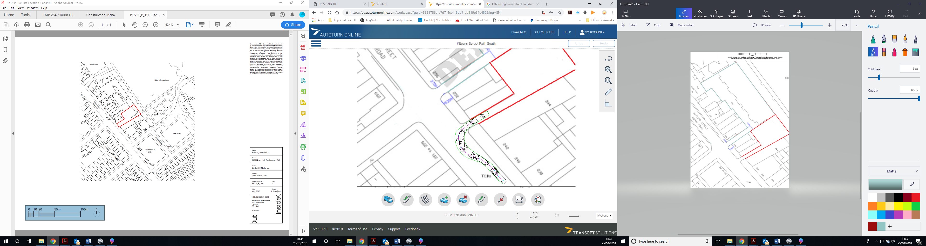

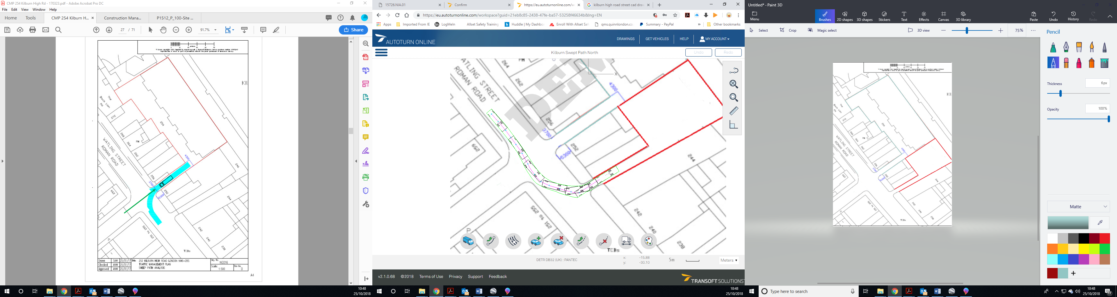

d. Provision of wheel washing facilities should be considered if necessary. If so, please provide details of how this will be managed and any run-off controlled.

In order to prevent the spread of mud from the site to the public highway, wheel washing facilities will be provided and are to be utilised by all drivers of vehicles leaving site. All vehicle drivers are expected to inspect their vehicle for cleanliness prior to leaving site. The Banksman is responsible for ensuring that no vehicle leaves site until the vehicle is suitably clean.

The Site Manager will continually monitor the site entrance and adjacent highway to ensure it remains in a clean, mud-free condition. Where required, the adjacent highway will be washed to remove excess mud and dust.

**23. Vehicle loading and unloading:** *“Clients shall ensure that vehicles are loaded and unloaded on-site as far as is practicable.”* (P19, 3.4.4)

If this is not possible, Traffic Marshalls must ensure the safe passage of pedestrians, cyclists and motor traffic in the street when vehicles are being loaded or unloaded.

Please provide details of the parking and loading arrangements for construction vehicles with regard to servicing and deliveries associated with the site (e.g. delivery of materials and plant, removal of excavated material). This is required as a scaled site plan, showing all points of access and where materials, skips and plant will be stored, and how vehicles will access and egress the site. If loading is to take place off site, please identify where this is due to take place and outline the measures you will take to ensure that loading/unloading is carried out safely. Please outline in question 24 if any parking bay suspensions will be required.

Please refer to the proposed site plan and traffic management diagram included under 22b.

All access and egress to loading/unloading bay where vehicles will be marshalled to the designated area by a Banksman and who will remain in attendance at all times until the materials have been safely unloaded in the designated area before the vehicle is then marshalled off site.

All bulk materials deliveries will be unloaded into the designated storage compound on

Site. This will be via a telehandler or the site crane (once erected) in accordance with the site Lifting Plan

A small telehandler will be used to service the site, as and when required from the storage compound. This will alleviate/significantly reduce the use of larger vehicles within the site area / local roads.

The storage of materials on site will be kept to the minimum with a ‘just in time’

materials delivery procedure being adopted.

The crane installation method will be agreed with the LB Camden prior to proceeding. A meeting with the appropriate representative of Local Authority, crane supplier, Authorised Person and GPS Management will be requested to agree the method and format of installation or if required, mobile crane lifts.

Excavated arisings will be stored and removed from site by muck away grab lorries at regular intervals to avoid large stock piles of arisings accumulating.

A 12 yard skip located in the main site compound to where the tipping skips will be taken. From here the waste materials will be collected by a skip lorry.

**Highway interventions**

**Please note that Temporary Traffic Orders (TTOs) and hoarding/scaffolding licenses may be applied for prior to CMP submission but won’t be granted until the CMP is signed-off.**

**24. Parking bay suspensions and temporary traffic orders**

Please note, parking bay suspensions should only be requested where absolutely necessary. Parking bay suspensions are permitted for a maximum of 6 months, requirement of exclusive access to a bay for longer than 6 months you will be required to obtain [Temporary Traffic Order (TTO)](http://camden.gov.uk/ccm/content/transport-and-streets/traffic-management/temporary-road-restrictions/) for which there is a separate cost.

Please provide details of any proposed parking bay suspensions and TTO’s which would be required to facilitate construction. **Building materials and equipment must not cause obstructions on the highway as per your Considerate Contractors obligations unless the requisite permissions are secured.**

Information regarding parking suspensions can be found [here.](http://www.camden.gov.uk/ccm/navigation/transport-and-streets/parking/parking-bay-suspensions/)

Not Applicable

**25. Scaled drawings of highway works**

Please note that use of the public highway for storage, site accommodation or welfare facilities is at the discretion of the Council and is generally not permitted. If you propose such use you must supply full justification, setting out why it is impossible to allocate space on-site. You must submit a detailed (to-scale) plan showing the impact on the public highway that includes the extent of any hoarding, pedestrian routes, parking bay suspensions and remaining road width for vehicle movements. We prefer not to close footways but if this is unavoidable, you should submit a scaled plan of the proposed diversion route showing key dimensions.

a. Please provide accurate scaled drawings of any highway works necessary to enable construction to take place (e.g. construction of temporary vehicular accesses).

There is already a crossover/access road located at the site entrance and therefore construction of a temporary vehicle access will not be required.

b.Please provide details of all safety signage, barriers and accessibility measures such as ramps and lighting etc.

Only safety signage, barriers and accessibility measures will be provided to the roads/ footpaths as and when required as the works affect the public highway.

Site safety signage will be placed at the main entrance and on approach to the site entrance giving warnings and advice to all road and footpath users.

Chapter 8 barriers will be used as needed to prevent pedestrians from coming into contact with the access to the site as necessary and where pedestrian diversions are required around the site.

Access will be maintained at all times on Kilburn High Road.

**26. Diversions**

Where applicable, please supply details of any diversion, disruption or other anticipated use of the public highway during the construction period (alternatively a plan may be submitted).

No Diversions are required to the public highway apart from potentially during the installation of the site crane. This will be implemented in consultation with LB Camden. We do not consider that any other works will cause excess disruption to the public highway during the construction period.

**27. VRU and pedestrian diversions, scaffolding and hoarding**

Pedestrians and/or cyclist safety must be maintained if diversions are put in place. Vulnerable footway users should also be considered. These include wheelchair users, the elderly, those with walking difficulties, young children, those with prams, the blind and partially sighted. Appropriate ramping must be used if cables, hoses, etc. are run across the footway.

Any work above ground floor level may require a covered walkway adjacent to the site. A licence must be obtained for scaffolding and gantries. The adjoining public highway must be kept clean and free from obstructions. Lighting and signage should be used on temporary structures/skips/hoardings etc.

A secure hoarding will generally be required at the site boundary with a lockable access.

a. Please provide details describing how pedestrian and cyclist safety will be maintained, including any proposed alternative routes (if necessary), and any Traffic Marshall arrangements.

Appropriate signage and barriers will be used to direct cyclists and pedestrians to alternative routes away from any construction works.

The safety of all resident pedestrians or cyclists are paramount and site conditions will be monitored throughout the works and adapted to suit.

All delivery vehicles will report to the site office at the entrance and from there, they will be marshalled to their designated area. All vehicles will abide to the speed limit.

The site manager will ensure the road outside of the site is regularly patrolled (minimum twice daily) to ensure that the adjacent roads and footpaths are clear of any site debris.

We will as part of our sub-contractor procurement process ensure that all subcontractors

and suppliers delivering materials to site follow the conditions outlined in the Standard for Construction Logistics and Cyclist Safety (CLOCS).

b. Please provide details of any temporary structures which would overhang the public highway (e.g. scaffolding, gantries, cranes etc.) and details of hoarding requirements or any other occupation of the public highway.

It is not considered that any temporary structures i.e. scaffolding, gantries, etc.

will overhang the public highway or the estate roads.

Scaffolding will be erected within the sites boundaries and which will be behind the

sites boundary fencing.

Scaffold standards would be protected by Hi-Viz foam sleeves and Heras

fencing/barriers. Solid hoarding panels will be used where the structures are in close

proximity to the road with lighting provided.

Any lifts above doorways will be double boarded with a polythene layer in between

the boards. Scaffolds will be provided with either Monoflex sheeting or netting to any

public areas. Fans will be provided at 1st floor level.

SYMBOL IS FOR INTERNAL USE

**Environment**

To answer these sections please refer to the relevant sections of **Camden’s Minimum Requirements for Building Construction (**[**CMRBC**](http://www.camden.gov.uk/ccm/cms-service/download/asset?asset_id=3257318)**).**

28. Please list all [noisy operations](http://www.camden.gov.uk/ccm/content/environment/environmental-health--consumer-protection/noise/reducing-noise/noise-from-construction-sites.en?page=2)  and the construction method used, and provide details of the times that each of these are due to be carried out.

Demolition and construction work by its nature can cause noise, noise being created

by mechanical plant, cutting, drilling etc. All noisy works will be restricted to the

specified times between 09:00 and 16:00hrs.

However these times will be reviewed specific to the works being carried out and following consultation with Camden and the residents of Kilburn High Road and other neighbouring roads. No noisy operations will be undertaken outside of the standards hours without prior written approval of the Local Authority.

Modern machinery and equipment will be used to minimise noise and vibration.

The works which are considered to be noisy works are:

**Demolition of the existing structure**:

The existing structure will be soft stripped of all fixtures and fittings and loose items of

furniture. A 15 tonne, 360 excavator with a munching attachment will be used to strip the

roof coverings and demolish the main structure building fabric and all waste materials being loaded into skips for removal from site.

Where practicable the ground bearing slabs will be levered from their position and removed from site before being broken up.

Where the concrete slabs are to be broken up on site this will be by means of a pecker attachment on a 15 tonne, 360 excavator, which will ensure the process is carried in a timely fashion minimising the noise and vibration on site. The concrete will then be grubbed up by the 360 excavator with all waste materials being loaded into skips for removal from site.

Communication with neighbouring residents prior to concrete breaking will be undertaken so that the works can be planned and minimise the disturbance to the residents as far as reasonably practicable.

**Reduction of levels and excavations:**

Reductions of levels and excavations will be undertaken with a 5-10 tonne, 360 excavator.

Excavated soils will be heaped on each individual site with materials being removed from

site on a regular basis by muck away lorries.

**Piling:**

Once the levels have been reduced on site crushed concrete will be imported by tipper lorries and a piling mat constructed with a 360 excavator. The preferred method of installing piles will be using the Continuous Flight Auger piling method, which is the quietest form of piling and is a fast and economical technique, with low noise and vibration compared against conventional bored piles and/or driven piles.

**Concrete ground beams and structural slab:**

Following the construction of the piles the pile heads will be broken down. The use of a hydraulic pile breaker will be considered to minimise the noise and vibration associated with breaking down pile heads by the traditional method being hand held breakers. Following this task the structural slab excavations will be undertaken using a 5-10 ton excavator. The ground beams and structural slab concrete will then be cast as one importing concrete via ready mix lorries.

Noise attenuation screening will be used for the above works as deemed necessary to

minimise the noise breakout from the sites.

29. Please confirm when the most recent noise survey was carried out (before any works were carried out) and provide a copy. If a noise survey has not taken place please indicate the date (before any works are being carried out) that the noise survey will be taking place, and agree to provide a copy.

A noise impact assessment was conducted and dated 2nd May 2017 by KP Acoustics. Report 15726.NIA.01 available at <http://camdocs.camden.gov.uk/HPRMWebDrawer/PlanRec?q=recContainer:2017/3206/P>

30. Please provide predictions for [noise](http://www.camden.gov.uk/ccm/content/environment/environmental-health--consumer-protection/noise/reducing-noise/noise-from-construction-sites.en?page=2) and vibration levels throughout the proposed works.

31. Please provide details describing mitigation measures to be incorporated during the construction/[demolition](http://www.camden.gov.uk/ccm/navigation/environment/building-control/demolition/) works to prevent noise and vibration disturbances from the activities on the site, including the actions to be taken in cases where these exceed the predicted levels.

Noise attenuation screening will be used where appropriate and noise monitoring to be carried out at the start and at regular intervals during each task period. Any mobile screens shall have sufficient mass so as to be able to resist the passage of sound across the barrier and to be free of significant holes or gaps between or under any acoustic panels or board materials as far as reasonably practical.

Noise monitoring shall be undertaken using a combination of semi-permanent (continuous) and attended monitoring methods. The locations of the semi-permanent (continuous) and attended monitoring and the frequency of the sampling will be agreed with London Borough of Camden in writing.

Where the measured noise levels are more than 3 dB (A) above the predicted noise levels or in the event of a complaint of noise an investigation shall be carried out to ascertain the cause of the exceedance or the complaint and to check that Best Practicable Means are being used to control the noise in accordance with the steps set out in the application for ‘prior consent’. Noise levels shall be reduced further if it is reasonably practicable to do so.

To minimise noise and vibration transfer , where practicable the ground bearing slabs will be levered from their position and removed from site before being broken up. Where the concrete slabs are to be broken up on site this will be by means of a pecker attachment on a 15 tonne, 360 excavator, which will ensure the process is carried in a timely fashion minimising the noise and vibration on site. The concrete will then be grubbed up by the 360 excavator with all waste materials being loaded into skips for removal from site.

Best Practicable Means (BPM) measures which are to be implemented on site to

mitigate noise, but not limited to, are:

* Carry out compliance real time monitoring of on-site levels to ensure that the agreed noise and vibration limits are adhered to.
* Where reasonably practicable, adopt quiet working methods, using plant with lower noise emissions;
* Where reasonably practicable, adopt working methods that minimise vibration generation;
* Use silenced and well maintained plant conforming with the relevant EU directives relating to noise and vibration;
* Plant, machinery and vehicles to be started sequentially rather than all together;
* Avoid unnecessary revving of engines and switch off when not required;
* Carry out regular inspections of noise mitigation measures to ensure integrity is maintained at all times;
* Provide briefings for all site based personnel so that noise and vibration issues are understood and mitigation measures are adhered to; Manage plant movements to take account of surrounding noise sensitive receptors, as far as it is reasonably practicable;
* Locate plant away from noise and vibration sensitive receptors, where feasible; and
* Minimise drop heights of materials.

32. Please provide evidence that staff have been trained on BS 5228:2009

GPS Projects are aware of the requirements of BS 5228:2009 and with all GPS Managers having attended the Site Managers Safety Training Scheme (SMSTS).

All subcontractors will be vetted for knowledge of BS 5228:2009 and with “Toolbox Talks” being used to inform all site personnel of noise and vibration control.

33. Please provide details on how dust nuisance arising from dusty activities, on site, will be prevented.

The Control of Dust and Emissions During Construction and Demolition SPG will be adhered to prevent dust nuisances arising on site. In addition to the site specific mitigation measures which are to be implemented as identified under section 8.4 of the Air Quality Assessment as prepared by CERC (as provided under section 36), the following philosophy with regard to dust mitigation measures will be also be adopted, where practicable, to prevent, suppress,

contain and manage dust from site activities and minimise disruption or nuisance to

neighbouring occupiers.

Dust will be dealt with using the following hierarchy:

* Prevention
* Suppression
* Containment

Dust will be addressed at source. All work operations where there is a risk of dust will be controlled by wetting-down, the use of extraction equipment or similar. All vehicles removing waste materials will be suitably sheeted or enclosed. A risk assessment for dust is included at the Appendices of the Construction Phase Plan. At all times, GPS Projects will comply with all relevant Environmental Health Legislation and will take a pro-active approach to pollution by way of dust or airborne partials to minimise risk and disturbance to the site operatives, adjacent buildings and the general public

Where machines are provided with suppression covers these will remain closed whilst the machine is in operation. Where it is impossible to reposition a potentially dust producing piece of machinery hoardings and enclosures will be constructed to contain and minimise the potential nuisance.

Liberal amounts of water will be used for dust suppression throughout the works. The runoff from the dust suppression activities will be minimal as most will be absorbed within the masonry arisings. Any excess water will be channelled into the (previously filtered) existing site drainage system. Filters will be installed to the existing drainage system before works begins. The discharge of any water will be managed to prevent contamination of the existing watercourses. All water discharge will be monitored and metered, and all records will be kept on site.

All dust will be controlled in accordance with the GPS Projects Project Dust Risk Assessment

34. Please provide details describing how any significant amounts of dirt or dust that may be spread onto the public highway will be prevented and/or cleaned.

We do not consider that the nature of the works will generate the spread of any significant amount of dirt/dust onto Public highways.

A granular Protectaweb loading bay will be utilised, ensuring that site mud and dust is not transferred onto the public highway via site vehicles’ wheels. This will be incorporated with wheel washing facilities.

All roads adjacent to the site and including the public highway will be swept as necessary using a road sweeper and will be undertaken during times, such as the ground works phase and frame construction phase the sweeper will be attending for three hours per day with a minimum of three entire sweeps for all. A thorough sweep will be made each Friday afternoon prior to the weekend period commencing.

35. Please provide details describing arrangements for monitoring of [noise](http://www.camden.gov.uk/ccm/content/environment/environmental-health--consumer-protection/noise/reducing-noise/noise-from-construction-sites.en?page=2), vibration and dust levels.

See the statements above with regard to noise, vibration and dust levels.

36. Please confirm that a [Risk Assessment](http://www.hse.gov.uk/risk/controlling-risks.htm) has been undertaken at planning application stage in line with the [GLA’s Control of Dust and Emissions Supplementary Planning Guidance](https://www.london.gov.uk/priorities/planning/publications/the-control-of-dust-and-emissions-during-construction-and) (SPG), and the risk level that has been identified, with evidence. Please attach the risk assessment as an appendix if not completed at the planning application stage.

Please see the GPS Projects Project Dust Risk Assessment which identifies the risk levels and identifies the appropriate measures to be applied within the GLA mitigation measures checklist. Air Quality Assessment located at: <http://camdocs.camden.gov.uk/HPRMWebDrawer/Record/6642948/file/document?inline>

Dust Risk Assessment attached below

37. Please confirm that all of the GLA’s ‘highly recommended’ measures from the [SPG](https://www.london.gov.uk/priorities/planning/publications/the-control-of-dust-and-emissions-during-construction-and) document relative to the level of risk identified in question 36 have been addressed by completing the [GLA mitigation measures checklist.](https://www.camden.gov.uk/ccm/content/appendix-to-environment-section-question-37--dust-mitigation-measures.en)

GPS Projects confirm the GLA ‘highly recommended’ measures from the SPG document have been addressed as part of the Air Quality Risk Assessment and the GLA mitigation measures have been addressed as included in section 8.4 of the risk assessment.

38. If the site is a ‘High Risk Site’, 4 real time dust monitors will be required. If the site is a ‘Medium Risk Site’, 2 real time dust monitors will be required. The risk assessment must take account of proximity to sensitive receptors (e.g. schools, care homes etc), as detailed in the [SPG](https://www.london.gov.uk/priorities/planning/publications/the-control-of-dust-and-emissions-during-construction-and). Please confirm the location, number and specification of the monitors in line with the SPG and confirm that these will be installed 3 months prior to the commencement of works, and that real time data and quarterly reports will be provided to the Council detailing any exceedances of the threshold and measures that were implemented to address these.

As identified in the Air Quality Assessment the site is classified as a ‘Medium Risk Site’ GPS Projects will therefore provide and install 2nr. real time dust monitors prior to the works commencing on site and for the duration of the medium risk works and which will monitor levels. Locations of the monitors are to be agreed with LB Camden. Real time data and quarterly reports will be provided to LB Camden detailing any exceedances of the threshold and measures that were implemented to address these.

39. Please provide details about how rodents, including [rats](http://www.camden.gov.uk/ccm/content/environment/environmental-health--consumer-protection/pest-control/about-the-pest-control-service.en), will be prevented from spreading out from the site. You are required to provide information about site inspections carried out and present copies of receipts (if work undertaken).

In accordance with the 222795 CMR and 28 days prior to the demolition of the existing structures GPS Projects will survey the structures to establish the existence of any rodents.

The TRA will also be consulted on the presence of rodents.

If there is evidence of rodents then a qualified British Pest Control Association (BPCA) company will be engaged to eradicate the rodent infestation in accordance with industry working practices. As part of the work by the pest control company method statements will be provided and submitted to LB Camden to demonstrate how the presence of rats has been ascertained and how the destruction / dispersion of rodents will be controlled during deconstruction / construction works.

The existing / new below ground drainage will be sealed during the construction process by the use of pipe bungs and sealed manhole covers to prevent the rodents

from entering the drainage system.

During the works the monitoring for rodents will continue to ensure the sites are kept

free at all time, so far as reasonably practicable, from rodents. Contact details of the specialist pest control company will be kept on site in the event that any termination is required.

The site shall be kept free of food waste as much as possible and wherever practicable, using regular waste removal to reduce the risk of habitable environment for unwanted rodents/attracting rodents to site (pursuant to Pests Act 1949).

40. Please confirm when an asbestos survey was carried out at the site and include the key findings.

A Demolition and Refurbishment Asbestos Survey was undertaken by Salvum on 5th July 2018 Job Ref: J001568. No asbestos containing materials were detected.

41. Complaints often arise from the conduct of builders in an area. Please confirm steps being taken to minimise this e.g. provision of a suitable smoking area, tackling bad language and unnecessary shouting.

An appropriate and area within the site compound behind the office and welfare site will be the designated as a smoking area. No smoking will be permitted on site.

As part of our site rules bad language and unnecessary shouting will not be tolerated by site personnel.

All site personnel will be site inducted and regular “toolbox talks” will be given on site conduct.

All contractors are aware of the requirements and goals set out by the Considerate Constructors Scheme. This is also an element of our site induction process.

42. If you will be using non-road mobile machinery (NRMM) on site with net power between 37kW and 560kW it will be required to meet the standards set out below. The standards are applicable to both variable and constant speed engines and apply for both PM and NOx emissions.

**From 1st September 2015**

**(i) Major Development Sites** – NRMM used on the site of any major development will be required to meet Stage IIIA of EU Directive 97/68/EC

**(ii) Any development site within the Central Activity Zone -** NRMM used on any site within the Central Activity Zone will be required to meet Stage IIIB of EU Directive 97/68/EC

**From 1st September 2020**

**(iii) Any development site -** NRMM used on any site within Greater London will be required to meet Stage IIIB of EU Directive 97/68/EC

**(iv) Any development site within the Central Activity Zone -** NRMM used on any site within the Central Activity Zone will be required to meet Stage IV of EU Directive 97/68/EC

Please provide evidence demonstrating the above requirements will be met by answering the following questions:

1. Construction time period (mm/yy - mm/yy ): 72 weeks from 12th November 2018
2. Is the development within the CAZ? (Y/N): No
3. Will the NRMM with net power between 37kW and 560kW meet the standards outlined above? (Y/N): Yes
4. Please provide evidence to demonstrate that all relevant machinery will be registered on the NRMM Register, including the site name under which it has been registered:

Please confirm that an inventory of all NRMM will be kept on site and that all machinery will be regularly serviced and service logs kept on site for inspection: The Site Manager will be responsible for monitoring and record keeping of any machinery on site.

Please confirm that records will be kept on site which details proof of emission limits, including legible photographs of individual engine plates for all equipment, and that this documentation will be made available to local authority officers as required: The Site Manager will have the appropriate documents and photographs filed on site.

SYMBOL IS FOR INTERNAL USE

**Agreement**

The agreed contents of this Construction Management Plan must be complied with unless otherwise agreed in writing by the Council. This may require the CMP to be revised by the Developer and reapproved by the Council. The project manager shall work with the Council to review this Construction Management Plan if problems arise in relation to the construction of the development. Any future revised plan must be approved by the Council in writing and complied with thereafter.

It should be noted that any agreed Construction Management Plan does not prejudice further agreements that may be required such as road closures or hoarding licences.

**Please notify that council when you intend to start work on site. Please also notify the council when works are approximately 3 months from completion.**

**Signed:** Tulio Novruzov

**Date:** 25 October 2018

**Print Name:** ……………………………………………………..….

**Position:** …………………………………………

Please submit to: [planningobligations@camden.gov.uk](mailto:planningobligations@camden.gov.uk)

End of form.

**SITE DUST RISK ASSESSMENT / METHOD STATEMENT**

|  |  |  |  |  |  |  |  |  |  |  |  |  |  |  |  |  |
| --- | --- | --- | --- | --- | --- | --- | --- | --- | --- | --- | --- | --- | --- | --- | --- | --- |
| |  |  | | --- | --- | | **GPS PROJECTS LTD** | GPS Projects Ltd Unit 10, Victory Park, Trident Close,  Medway City Estate, Rochester, Kent. ME2 4ER  Tel: 01634 299880, Fax: 01634 296539,  Email: [info@gpsprojectsltd.co.uk](mailto:info@gpsprojectsltd.co.uk) |   **RISK ASSESSMENT**  **Hazard/Work Activity Assessed: CONTROL OF DUST DURING SITE SET UP, DEMOLITION AND CONSTRUCTION ACTIVITIES** | | | | | | | | | | | | | | |
| **Location of Workplace:** 246-248 Kilburn High Road, London, NW6 3EY | | | | | | | | |  | | | | | |
| **Foreman who will supervise & monitor the work on site:** Paul Slaughter | | | | | | | | | | | | | | |
| **H = High Risk M = Medium Risk L = Low Risk** | | | **Without**  **Controls** | | | | **With**  **Controls** | | | | | Who may be harmed ***‘*X*’ As appropriate*** | | |
| **HAZARDS** | | | **H** | **M** | **L** | | **H** | **M** | | | **L** | ***Operatives***  ***Other contractors***  ***GPS other staff***  ***Official Visitors***  ***General Public*** | |  |
| 1. INHALATION OF CONTAMINANTS | | | X |  |  | |  | X | | |  |  | |  |
| 2. INGESTION OF CONTAMINANTS | | | X |  |  | |  | X | | |  |  | |  |
| 3. ASPHYXIA | | |  |  | X | |  |  | | | X |  | |  |
| 4. SKIN CONTAMINATION | | |  |  | X | |  |  | | | X |  | |  |
| 5. DUST DAMAGE TO SURROUNDING ENVIRONMENT | | |  | X |  | |  |  | | | X |  | |  |
| **Control Measures**  1. Assessment of work packages to determine those activities that generate dust.  2. COSHH data sheets checked for those materials producing dust, any toxic materials identified, assessment to be made as to, who, what and where work shall be completed.  3. Dust emissions to be minimised and/or contained to boundaries of the construction site, e.g. re-specifying work to eliminate or reduce dust hazards, use exhaust ventilated tools, dampening work before or during cutting and water suppression techniques are to take place. Where damping down cannot be achieved the immediate area is to be enclosed to prevent dust emissions using sheeting or other appropriate materials.  4. Wind blown dust from large, disturbed areas to be reduced by dampening down the surface and where possible, restricting the extent of such hazards. Site boundary to be fully hoarded to minimise dust emission to the surrounding environment.  5. Extra care to be taken when loading materials onto trucks or when excavation is taking place. All vehicles leaving site with waste are to be fully sheeted.  6. All internal dust should be removed after the work has been completed and disposed of correctly.  7. Prohibition of eating and smoking to be enforced in dusty atmospheres, especially where toxins may be present.  8. Adequate means of monitoring/measuring toxic dust to be provided and maximum workplace exposure limits (WELs) to be checked.  9. Vehicle wheels to be washed prior to leaving site. Where required, surrounding streets are to be swept daily and/or as required. | | | | | | | | | | | | | | |
| **Information, Instruction & Training Required**  1. Operatives to be briefed regarding the hazards of dust to their health.  2. Operatives to be briefed regarding PPE and toxic dust. | | | | | | | | | | | | | | |
| **Personal Protective Equipment (PPE)** | | | | | | | | | | | | | | |
| **Hard hat**  **Safety boots**  **Gloves**  **High visibility jacket/ clothing** |  | **Overalls**  **Hearing Protection**  **Eye Protection**  **Dust mask**  **Safety Harness** | | | |  | | | | **Respiratory protection:**  **_______________________**  **_______________________**  **_______________________** | | | |  |
| **Name of person undertaking this risk assessment:**  **Paul Slaughter** | | | | | | | | | | | | | **Date:**  **1st October 2018** | |
| **Signature:** | | | | | | | | | | | | | **Review Date:**  **1st October 2019** | |