**Design and Access Statement**

**Property Address:**

20 Cleveland Street, Fitrovia, London, W1T 4JA

**Areas Impacted:**

Café Front

1. What are the **features** on the existing site?

* Refer Section 6

1. Please provide details of how **access** issues have been addressed

* No changes have been proposed in this regard.

1. Please provide details of the **layout** of proposed development

* The following three changes are requested,
  1. Repainting the exterior to Dark Grey Color
  2. Changing the signage on the front to reflect the name of the new Coffee Shop opening on the premises (Old Restaurant has been closed)
  3. Place a sign in the shop forecourt of no larger than 0.5 square meters

1. Please provide details of the **scale/appearance** of the proposed development

* Signage would be done as per Camden Planning Guidance (CPG1). Refer following photographs for the proposed signage.

Proposed Changes:

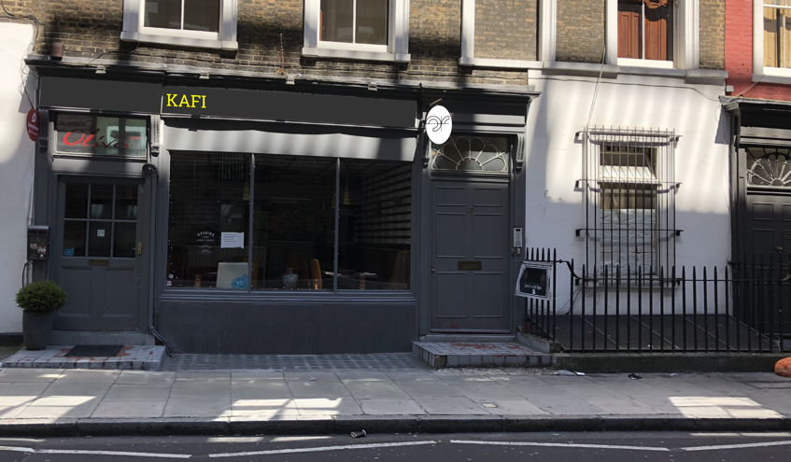

Existing Shopfront:

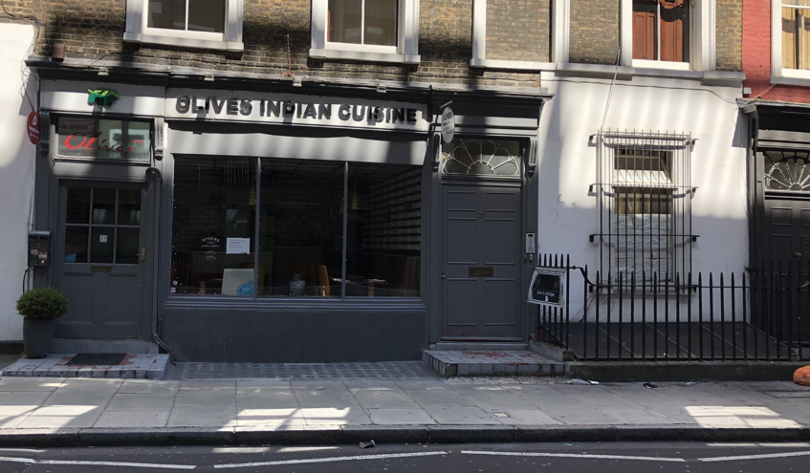

1. Please provide details of the **landscaping** in the proposed development

* None Proposed

1. Please provide details of how **Heritage Assets** issues have been addressed

* Assets affected – Repainting shop exterior including door for the shop entrance. Adding signage on the front.

These changes will add significant improvement as the current paint job is shabbily completed and lot of plaster marks are left. No alterations are proposed to façade except the repaint.

Paint Color: Dark Grey

* Historical Significance - No.20 with extra blind window; bowed wooden shopfront (glazing altered) with enriched entablature, flanked by square-headed house and shop doorways with consoles supporting the entablature; rectangular fanlights (house entrance with radial pattern) and panelled doors (shop door half-glazed). Architraved, recessed window with C20 glazing to right of house door. Architraved, recessed 4-pane sashes. Added stucco cornice. SUBSIDIARY FEATURES: attached cast-iron railings to area.