Campbell Reith Hill LLP,
Friars Court Bridge,
41-45 Blackfriars Road,
London,
SE1 8NZ

November 28th 2018
For the attention of A M Finn and E M Brown

Dear Sirs,

1 and 2 Falkland Mews, London, NW5 2PP

Further to your audit of the Basement Impact Assessment for the above named site dated October 2018, we reply with our amended Reports and details of where you can locate the amendments for your ease of assessment.

Re Audit Discussion:
Your ref:

4.2 Crofts SMS has been revised to read ‘CPG Basements’(2018) and C760.
See BIA Appendix E Structural Report.

4.5 The BIA has been revised to conform with the 3.0m depth of excavation for the basement. The ground movements have also been revised accordingly.

4.8 An additional site plan has been added to the BIA as figure 2B. plus a larger site plan is presented within Appendix F. Croft has clarified Party Wall in Appendix E.

4.9 The ground movements have been revised, see BIA Section 13.4.2 and Section 14.6.

4.11 and 4.12 The ground movement calculations were not hand calculations, but were in line with C760 using the figures 6.8, 6.9 and 6.15 compiled onto the computer and using the wall depth and excavation depth to determine the vertical and horizontal movements. The appropriate equations were then inserted onto an excel spreadsheet to calculate the house slope and maximum deflection ratio. The methodology is described further in Section 14.7 and in Appendix F.

Assessment of surrounding properties was excluded as they all fall within Cat 1 or less. This is justified in Section 14.7 and in Appendix F.

The methodology is a conservative approach, as the methodology in CIRIA 760 is designed for large basements with embedded walls and not for underpins which will exert lower movements.

4.13 This is now included in Crofts Structural report in Appendix E.

We trust our revised reports now answer all your queries and look forward to receiving confirmation of acceptance.

Thank you for your consideration,

Kind Regards,

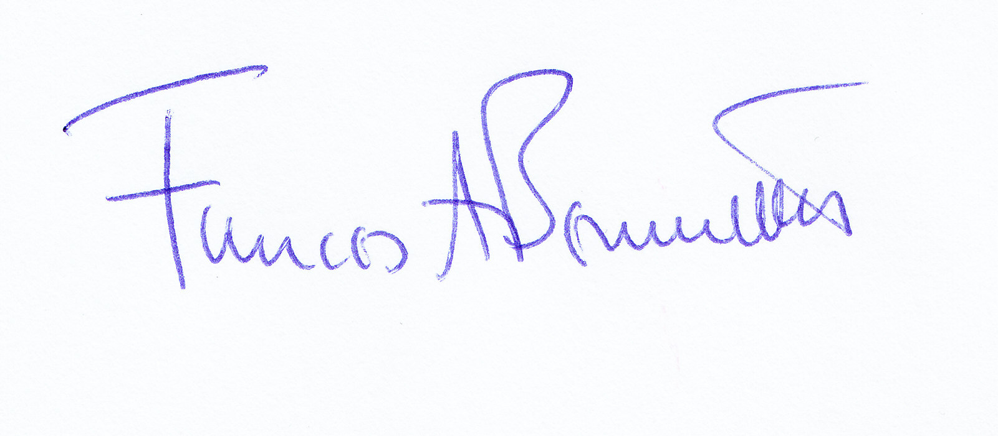

Yours faithfully,
Frances A Bennett
For and on behalf of Ashton Bennett Limited

