**--------------------------------------------------------------------------------------------------------------------Highgate Hill West**

House (6 Highgate Hill West

N6)

Garden Area

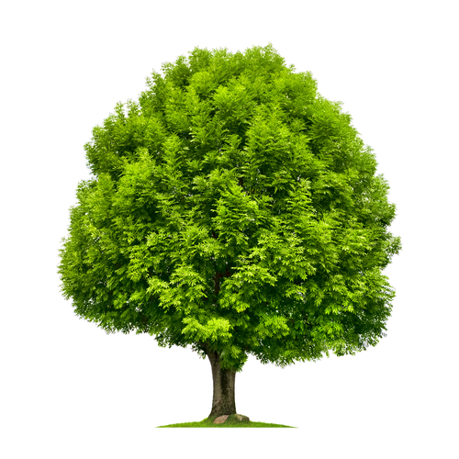

**T1: Willow Tree**