Design & Access Statement | November 2018
Change of use from A1 to A1/A3 ancillary use |  | 246-248 Kentish Town Road  NW5 2AB

- Introduction

This Design and Access Statement is provided to accompany the planning application for a change of use consent for 246-248 Kentish Town Road
NW5 2AB. The document is intended to:
- Meet the local and national validation requirements for planning applications;
- Provide the information necessary to assist the planning officer in determining the application;
- Demonstrate how issues relating to the development have been dealt with;
- Summarise any design principles and concepts that have been applied to the development;
- Explain how the proposed development is a suitable response to the site and its setting; and
- Demonstrate that it can be adequately accessed by prospective users.

In accordance with national guidance; the level of detail in the Design and Access Statement is proportionate to the complexity of the application.

- Site description and history

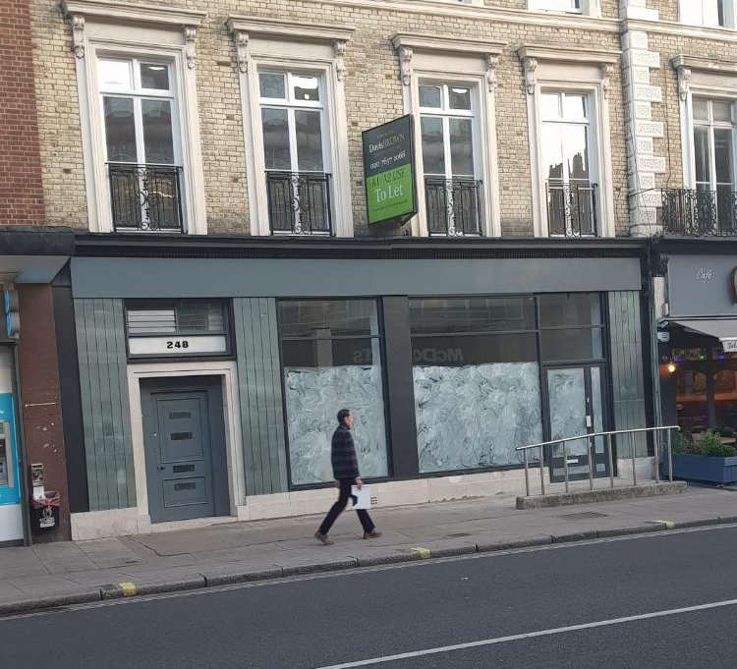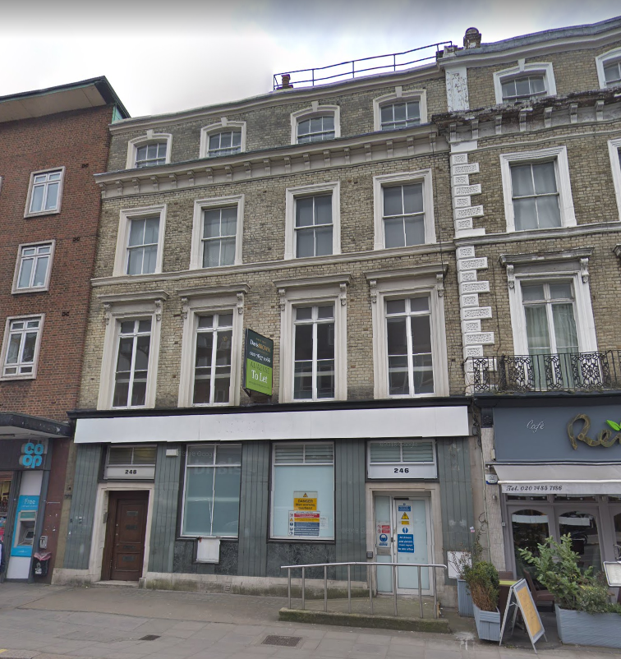
Existing view Previous view

The site is a ground floor (+basement as storage) commercial unit in a busy street of similar commercial units typically in ‘town centre uses’ in use classes A1-A2-A3-A5. The area is a mixed use area of retail, services, eating and drinking establishments. Upper floors are typically residential flats.

The building is a 4 storey + basement building of traditional design of some architectural merit. It has a traditional appearance and materials to the upper floors with the ground floor comprising a modern shopfront which was recently renewed under the planning application 2018/2022/P.

The unit’s last use was a bank branch. This use has ended more than a year ago but the exact date is unknown. The shop is in the market as A1/A2 use since then.

The site is not situated within and the building is not listed.

- The proposal

The development proposal is a change of use at ground floor level from A1 to A1/A3 ancillary use. It will be used as a franchise unit of CREAMS CAFÉ.
The Franchising Company states clearly that they prefer the premises with A3 use. There will not be cooking facilities and any extractor fan or machinery will not be installed.

There will be no external alterations to the building.

- Relevant planning policy

The proposal has been assessed against the NPPF and Camden Local Plan Policy TC4 Town centre uses, Policy E2 Employment premises and sites, and found to be broadly in accordance.

Paragraph 14 of the NPPF confirms that planning applications should be considered in the context of the presumption in favour of sustainable development and, as summarised below, the application fully satisfies this:
- Economic role – the proposal will facilitate business development and provide on-going employment;
- Social role – the proposal will provide a useful eating facility to local residents in an accessible location, complementing the current range of commercial uses available;
- Environmental role – ample professional extraction and ventilation arrangements are already in place which demonstrates the proposal has taken its environmental impact seriously.

The proposal is economic development as defined in the NPPF. The change of use proposal represents sustainable economic growth, enabling a business to operate in a suitable premises. The proposal will enable the employment of members of staff.

5. Access

Access to the premisses will be from the current safe access door onto the street frontage, which will secure disabled access with the existing ramp.

Parking and car access arrangements will remain unchanged from the consented commercial use. There are no on-site parking spaces. The site is served with good public transport links. No intensification of traffic / parking from existing use will therefore result from the proposal from its current commercial use.

It is therefore considered that that there will be no negative access or highways impacts because of the development.

6. Amenity

The cafe’s kitchen will not be an intensive one. It has not been necessary to install an extraction or ventilation system. Internal ventilation will suffice. It is not considered that there will be any detrimental impact on amenity from cooking fumes.

In terms of potential noise from customers, several noise generating uses exist locally in close proximity to residential units including retail and food units and drinking establishments. The hours of use are daytime and no evening or late night use is proposed. The proposed café will be professional and well managed and will be a responsible neighbour. The proposed change of use would therefore not introduce a conflict of uses incongruous to that which already exists in the area.

7. Conclusion
This statement demonstrates that the proposed change of use is in principle in accordance with the development plan and represents sustainable economic development under the NPPF.

The proposed change of use:
- Would not conflict with any policies;
- Would have no adverse material impacts; and
- Would enable sustainable economic development – an underpinning principle of the NPPF.

It is therefore considered that the proposal should be ‘determined under the presumption in favour of sustainable development’ and ‘approved without delay’ as is the NPPF requirement.

