**Brick comparison with existing properties on New End**

**Proposed Brick for use at 29 New End Beckley Dark Red, compared with existing properties**

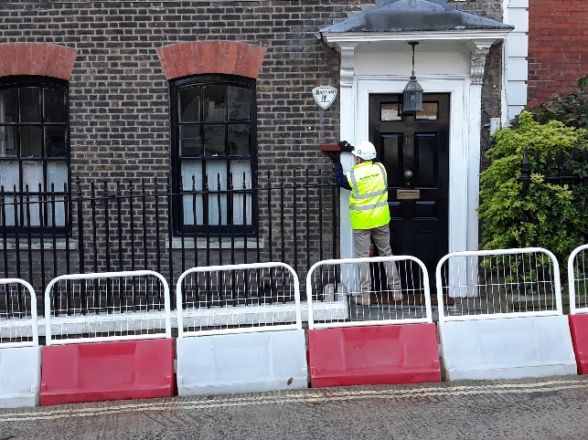

**10 New End**

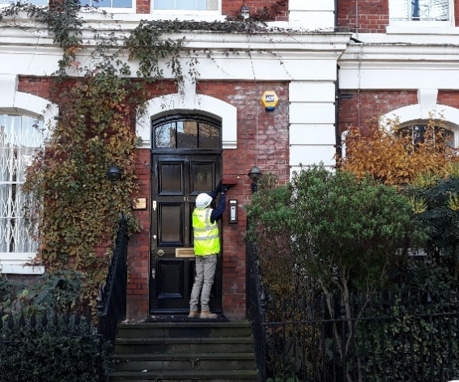

**10 Kendell Hall, New End**

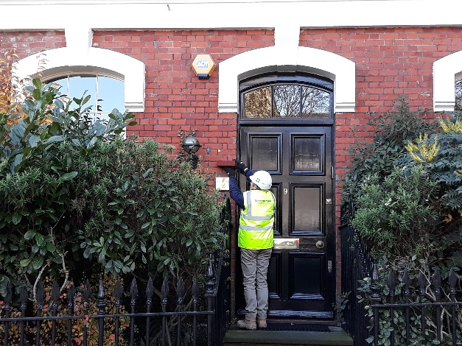

**9 Kendell Hall, New End**

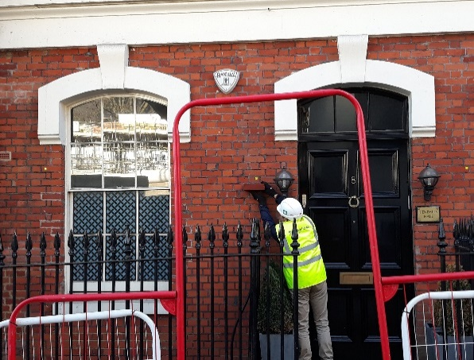

**8 Kendell Hall, New End**

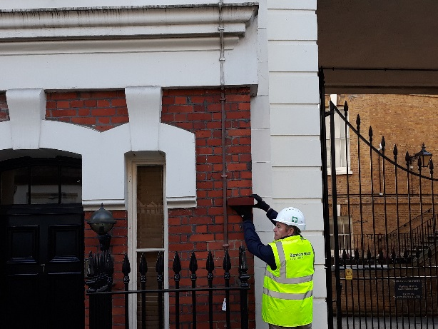

**7 Kendell Hall, New End**

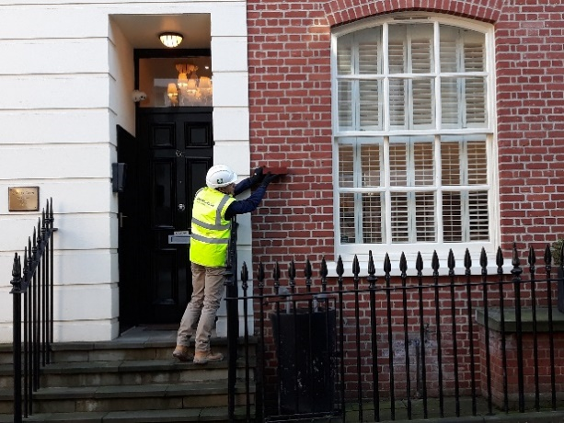

**6c Youngs Court, New End**