* [Menu](https://historicengland.org.uk/listing/the-list/list-entry/1113087)
* [Search](https://historicengland.org.uk/sitesearch)

Top of Form

What are you looking for?



Searching...

Click anywhere to close (ESC)

Bottom of Form

* [Listing](https://historicengland.org.uk/listing/)
  + [Search the List](https://historicengland.org.uk/listing/the-list/)
  + [Enrich the List](https://historicengland.org.uk/listing/enrich-the-list/)
  + [Apply for Listing](https://historicengland.org.uk/listing/apply-for-listing/)
  + [What is Listing?](https://historicengland.org.uk/listing/what-is-designation/)
  + [Listing Guidance](https://historicengland.org.uk/listing/selection-criteria/)
  + [Latest Listings](https://historicengland.org.uk/whats-new/listing/)
* [Advice](https://historicengland.org.uk/advice/)
  + [Advice Finder](https://historicengland.org.uk/advice/find/)
  + [Heritage at Risk](https://historicengland.org.uk/advice/heritage-at-risk/)
  + [Your Home](https://historicengland.org.uk/advice/your-home/)
  + [Technical Guidance](https://historicengland.org.uk/advice/technical-advice/)
  + [Planning](https://historicengland.org.uk/advice/planning/)
  + [Caring for Heritage](https://historicengland.org.uk/advice/caring-for-heritage/)
  + [Constructive Conservation](https://historicengland.org.uk/advice/constructive-conservation/)
  + [Heritage Protection Guide](https://historicengland.org.uk/advice/hpg/)
* [Research](https://historicengland.org.uk/research/)
  + [Our Research Strategy and Agenda](https://historicengland.org.uk/research/agenda/)
  + [Research Methods](https://historicengland.org.uk/research/methods/)
  + [Current Research](https://historicengland.org.uk/research/current/)
  + [Research Results](https://historicengland.org.uk/research/research-results/)
  + [Support & Collaboration](https://historicengland.org.uk/research/support-and-collaboration/)
  + [Inclusive Heritage](https://historicengland.org.uk/research/inclusive-heritage/)
  + [Latest Research](https://historicengland.org.uk/whats-new/research/)
  + [Heritage Counts](https://historicengland.org.uk/research/heritage-counts/)
* [Images & Books](https://historicengland.org.uk/images-books/)
  + [Find Photos](https://historicengland.org.uk/images-books/photos/)
  + [Search All Publications](https://historicengland.org.uk/images-books/publications/)
  + [Buy Books](https://historicengland.org.uk/images-books/books/)
  + [The Historic England Archive](https://historicengland.org.uk/images-books/archive/)
  + [Be an Archive Detective](https://historicengland.org.uk/images-books/archive-mysteries/)
* [Services & Skills](https://historicengland.org.uk/services-skills/)
  + [Education](https://historicengland.org.uk/services-skills/education/)
  + [Grants](https://historicengland.org.uk/services-skills/grants/)
  + [Our Planning Services](https://historicengland.org.uk/services-skills/our-planning-services/)
  + [Training & Skills](https://historicengland.org.uk/services-skills/training-skills/)
  + [Archive Services](https://historicengland.org.uk/services-skills/archive-services/)
  + [Heritage Action Zones](https://historicengland.org.uk/services-skills/heritage-action-zones/)
* [Get Involved](https://historicengland.org.uk/get-involved/)
  + [100 Places](https://historicengland.org.uk/get-involved/100-places/)
  + [Immortalised](https://historicengland.org.uk/get-involved/help-write-history/immortalised/)
  + [HerStories](https://historicengland.org.uk/get-involved/help-write-history/herstories/)
  + [Support Us](https://historicengland.org.uk/get-involved/support-us/)
  + [Volunteer in Heritage](https://historicengland.org.uk/get-involved/volunteer/)
  + [Visit Your Heritage](https://historicengland.org.uk/get-involved/visit/)
  + [Protect Your Heritage](https://historicengland.org.uk/get-involved/protect/)
  + [Help Write History](https://historicengland.org.uk/get-involved/help-write-history/)
  + [Angel Awards](https://historicengland.org.uk/get-involved/angel-awards/)
* [What's New](https://historicengland.org.uk/whats-new/)
  + [News](https://historicengland.org.uk/whats-new/news/)
  + [In Your Area](https://historicengland.org.uk/whats-new/in-your-area/)
  + [Latest Listings](https://historicengland.org.uk/whats-new/listing/)
  + [Latest Research](https://historicengland.org.uk/whats-new/research/)
  + [Heritage Online Debate](https://historicengland.org.uk/whats-new/debate/)
  + [Statements](https://historicengland.org.uk/whats-new/statements/)
  + [Stay Up To Date](https://historicengland.org.uk/whats-new/stay-up-to-date/)
  + [First World War Centenary](https://historicengland.org.uk/whats-new/first-world-war-home-front/)

We use cookies to give you the best possible experience online. By using this website, you consent to cookies being used in accordance with our [Cookie Policy](https://historicengland.org.uk/terms/).

* [Home](https://historicengland.org.uk/)
* [...](https://historicengland.org.uk/listing/the-list/list-entry/1113087)
* [Listing](https://historicengland.org.uk/listing/)
* [Search the List](https://historicengland.org.uk/listing/the-list/)
* List Entry
* [Section Navigation](https://historicengland.org.uk/listing/the-list/list-entry/1113087)
  + [Map Search](https://historicengland.org.uk/listing/the-list/map/)
  + [Advanced Search](https://historicengland.org.uk/listing/the-list/advanced-search/)
  + [Minor Amendments](https://historicengland.org.uk/listing/the-list/minor-amendments/)
  + [Download Listing Data](https://historicengland.org.uk/listing/the-list/data-downloads/)
  + [Non-Listed Sites](https://historicengland.org.uk/listing/the-list/non-listed-sites/)
  + [About The List](https://historicengland.org.uk/listing/the-list/about-the-list/)
  + [Enrich the List](https://historicengland.org.uk/listing/the-list/enrich/)
  + [Understanding List Entries](https://historicengland.org.uk/listing/the-list/understanding-list-entries/)

**NUMBERS 1 AND 2 INCLUDING WALLS TO STREET**

[Be the first to contribute](https://historicengland.org.uk/listing/the-list/list-entry/1113087#contributions)

**Overview**

Heritage Category: Listed Building

Grade: II

List Entry Number: 1113087

Date first listed: 11-Jan-1999

Statutory Address: NUMBERS 1 AND 2 INCLUDING WALLS TO STREET, 1 AND 2, FROGNAL CLOSE

**Map**

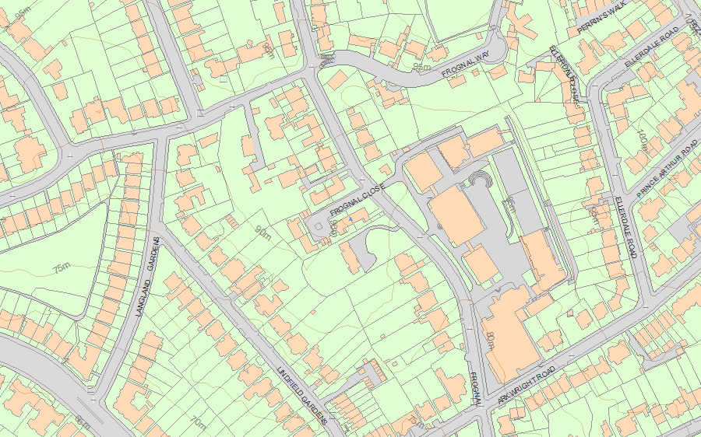© Crown Copyright and database right 2018. All rights reserved. Ordnance Survey Licence number 100024900.  
© British Crown and SeaZone Solutions Limited 2018. All rights reserved. Licence number 102006.006.  
Use of this data is subject to [Terms and Conditions](https://historicengland.org.uk/terms/website-terms-conditions/).

The above map is for quick reference purposes only and may not be to scale. For a copy of the full scale map, please see the attached PDF - [1113087 .pdf](http://mapservices.historicengland.org.uk/printwebservicehle/StatutoryPrint.svc/109538/HLE_A4L_Grade%7CHLE_A3L_Grade.pdf)

The PDF will be generated from our live systems and may take a few minutes to download depending on how busy our servers are. We apologise for this delay.

This copy shows the entry on 12-Nov-2018 at 11:20:44.

**Location**

Statutory Address: NUMBERS 1 AND 2 INCLUDING WALLS TO STREET, 1 AND 2, FROGNAL CLOSE

The building or site itself may lie within the boundary of more than one authority.

County: Greater London Authority

District: Camden (London Borough)

National Grid Reference: TQ 26125 85396

**Summary**

Legacy Record - This information may be included in the List Entry Details.

**Reasons for Designation**

Legacy Record - This information may be included in the List Entry Details.

**History**

Legacy Record - This information may be included in the List Entry Details.

**Details**

CAMDEN  
  
TQ2685SW FROGNAL CLOSE 798-1/37/1778 (South side) Nos.1 AND 2 including walls to street   
  
GV II  
  
Pair of houses. 1937-8. By Ernst L Freud. Narrow buff brick with stone copings, flat roofs. 2 and 3 storeys on sloping site, with slightly raised centre. Upper (second) floor of No.1 set back behind roof terrace. Projecting porches on single piloti, that to No.2 to side. No.2 with original metal casements, those to ground floor of three and four lights with vertical glazing bars, those to upper windows tripartite with horizontal glazing bars in side windows. No.1 has windows of a similar pattern but replaced in aluminium. INTERIORS: not inspected. SUBSIDIARY FEATURES: walls of identical brick stepped as land rises sharply from Frognal are an important part of the composition. Form a symmetrical composition with Nos 5 and 6 opposite (qv). (Architects' Journal: 1 September 1938: London: 374-75).   
  
  
  
Listing NGR: TQ2613785402

**Legacy**

The contents of this record have been generated from a legacy data system.

Legacy System number: 477439

Legacy System: LBS

**Sources**

Books and journals  
'Architects Journal' in 1 September, (1938), 374, 375

**Legal**

This building is listed under the Planning (Listed Buildings and Conservation Areas) Act 1990 as amended for its special architectural or historic interest.

End of official listing