- Menu
- Search

What are you looking for?

Click anywhere to close (ESC)

- Listing
  - Search the List
  - Enrich the List
  - Apply for Listing
  - What is Listing?
  - Listing Guidance
  - Latest Listings
- Advice
  - Your Home
  - Planning
  - Advice Finder
  - Caring for Heritage
  - Technical Guidance
  - Heritage at Risk
  - Constructive Conservation
  - Heritage Protection Guide
- Research
  - Our Research Strategy and Agenda
  - Research Methods
  - Current Research
  - Research Results
  - Support & Collaboration
  - Inclusive Heritage
  - Latest Research
  - Heritage Counts
- Images & Books
  - Find Photos
  - Search All Publications
  - Buy Books
  - The Historic England Archive
  - Be an Archive Detective
- Services & Skills
  - Education
  - Grants
  - Our Planning Services
  - Training & Skills
  - Archive Services
  - Heritage Action Zones
- Get Involved
  - 100 Places
  - Immortalised
  - HerStories
  - Support Us
  - Volunteer in Heritage
  - Visit Your Heritage
  - Protect Your Heritage
  - Help Write History
  - Angel Awards
- What's New
  - News
  - In Your Area
  - Latest Listings
  - Latest Research
  - Heritage Online Debate
  - Statements
  - Stay Up To Date
  - First World War Centenary
We use cookies to give you the best possible experience online. By using this website, you consent to cookies being used in accordance with our Cookie Policy.
- Home
- ...
- Listing
- Search the List
- List Entry
- Section Navigation
  - Map Search
  - Advanced Search
  - Minor Amendments
  - Download Listing Data
  - Non-Listed Sites
  - About The List
  - Enrich the List
  - Understanding List Entries

ALEXANDRA ROAD ESTATE INCLUDING WALLS, RAMPS AND STEPS COMMUNITY CENTRE AND BOILER HOUSE TO ALEXANDRA ROAD ESTATE NUMBERS 1-21 (INCLUDING A AND B TO EACH NUMBER) NUMBERS 4-119 (INCLUDING A AND B TO EACH NUMBER ON SOUTH SIDE, AND A-K TO EACH NUMBER ON NORTH SIDE)
2 contributions

Overview
Heritage Category: Listed Building
Grade: II*
List Entry Number: 1130403
Date first listed: 18-Aug-1993
Date of most recent amendment: 11-Jan-1999
Statutory Address: ALEXANDRA ROAD ESTATE INCLUDING WALLS, RAMPS AND STEPS, ROWLEY WAY
Statutory Address: COMMUNITY CENTRE AND BOILER HOUSE TO ALEXANDRA ROAD ESTATE, ROWLEY WAY
Statutory Address: NUMBERS 1-21 (INCLUDING A AND B TO EACH NUMBER), 1-21, AINSWORTH WAY
Statutory Address: NUMBERS 4-119 (INCLUDING A AND B TO EACH NUMBER ON SOUTH SIDE, AND A-K TO EACH NUMBER ON NORTH SIDE), 4-119, ROWLEY WAY

Map
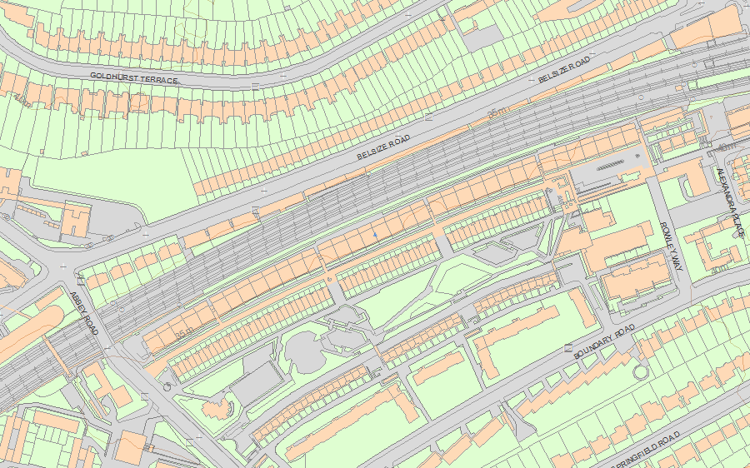© Crown Copyright and database right 2018. All rights reserved. Ordnance Survey Licence number 100024900.
© British Crown and SeaZone Solutions Limited 2018. All rights reserved. Licence number 102006.006.
Use of this data is subject to Terms and Conditions.
The above map is for quick reference purposes only and may not be to scale. For a copy of the full scale map, please see the attached PDF - 1130403 .pdf
The PDF will be generated from our live systems and may take a few minutes to download depending on how busy our servers are. We apologise for this delay.
This copy shows the entry on 01-Nov-2018 at 10:40:14.

Location
Statutory Address: ALEXANDRA ROAD ESTATE INCLUDING WALLS, RAMPS AND STEPS, ROWLEY WAY
Statutory Address: COMMUNITY CENTRE AND BOILER HOUSE TO ALEXANDRA ROAD ESTATE, ROWLEY WAY
Statutory Address: NUMBERS 1-21 (INCLUDING A AND B TO EACH NUMBER), 1-21, AINSWORTH WAY
Statutory Address: NUMBERS 4-119 (INCLUDING A AND B TO EACH NUMBER ON SOUTH SIDE, AND A-K TO EACH NUMBER ON NORTH SIDE), 4-119, ROWLEY WAY
The building or site itself may lie within the boundary of more than one authority.
County: Greater London Authority
District: Camden (London Borough)
National Grid Reference: TQ 26056 83913

Summary
Legacy Record - This information may be included in the List Entry Details.

Reasons for Designation
Legacy Record - This information may be included in the List Entry Details.

History
Legacy Record - This information may be included in the List Entry Details.

Details
CAMDEN
TQ2683NW AINSWORTH WAY 798-1/71/1403 Nos.1-21 (Consecutive) 18/08/93 (including A and B to each number)
II*
See under: Alexandra Road Estate including walls, ramps & steps ROWLEY WAY.
CAMDEN
TQ2683NW ROWLEY WAY 798-1/71/1403 Nos.4-119 (Consecutive) 18/08/93 (incl. A & B to each number on S side, and A-K to each number on N side)
II*
See under: Alexandra Road Estate including walls, ramps & steps ROWLEY WAY.
CAMDEN
TQ2683NW ROWLEY WAY 798-1/71/1403 Community Centre and Boiler House to 18/08/93 Alexandra Road Estate
II*
See under: Alexandra Road Estate including walls, ramps & steps ROWLEY WAY.
CAMDEN
TQ2683NW ROWLEY WAY 798-1/71/1403 Alexandra Road Estate including 18/08/93 walls, ramps & steps (Formerly Listed as: ROWLEY WAY/ AINSWORTH WAY Alexandra Rd Est inc. Rowley Way, Ainsworth Way and walls, ramps, steps)
II*
Includes: Community Centre and Boiler House to Alexandra Road Estate ROWLEY WAY. Includes: Nos.4-119 (incl. A & B to each number on S side, and A-K to each number on N side) ROWLEY WAY. Includes: Nos.1-21 (including A and B to each number) AINSWORTH WAY. Housing estate. Designed 1968; built 1972-78. Designed by Neave Brown of Camden Architects' Department. Site-cast board-marked white, unpainted reinforced concrete. Flat roofs. Three parallel east-west blocks, the northern forming an acoustic wall to shield the estate from the adjacent railway line. The northern pair of blocks facing in towards the pedestrian street Rowley Way, and organised with stepped elevations facing in towards Rowley Way, each level providing private outdoor areas for every home. EXTERIOR: block A is of 7 storeys, Block B of 4 storeys. To the south of Rowley Way are play areas and a public park, separated by concrete walls and banks and by planting into a sequence of small spaces with built-in seating. Attached to the south is Ainsworth Way comprising 3 linked rows of 3-storey terraced houses. Block A, Rowley Way comprises 2-storey, 2-bed flats at the top and 2-storey, 3-bed flats at the bottom with 3 layers of single storey 1-bed flats between. Block B comprises 4 storeys of 2 and 3-bed maisonettes. There are garages beneath Block A and Rowley Way itself, which is paved in red terracotta blocks. Balconies to Blocks A and B have thick reinforced concrete handrails with glass panels beneath; floor to ceiling glazing to Rowley Way with thick dark-stained window frames. Ainsworth Way houses each comprise 1 bay, with paired entrances; top storey set back providing roof terrace with floor to ceiling windows and heavy reinforced concrete balustrade with glass panels beneath. Thick timber windows. Ground floor slightly raised over garages. Community centre is attached to the east of Ainsworth Way and Rowley Way, and has the boiler house below, with its tall 3-shafted metal chimney. The community centre is on 1 level, and of an irregular, triangular plan; horizontal strip windows and roof terrace. To north and west are attached ramps and staircases, including East Bridge and West Bridge. To the west also attached to Ainsworth Way housing is the play area and public park; play areas of irregular shape at several levels, linked by ramps and steps and enclosed and contained by robust board marked concrete walls and planting boxes, often diagonally set, sometimes curved and some with inset seats. INTERIORS not inspected. SUBSIDIARY FEATURES: the 3 blocks which comprise Ainsworth Way are linked by low reinforced concrete walls, enclosing built-in seating areas; there is a further seating area attached to the west of Block B Rowley Way, with a raised circular section paved with granite sets and a lower rectangular section. (Architectural Review: August 1979; Architecture and Urbanism: November 1980; New York Times: 3 December, 1978).
Listing NGR: TQ2605683913

Legacy
The contents of this record have been generated from a legacy data system.
Legacy System number: 477882
Legacy System: LBS

Sources
Books and journals
'New York Times' in 3 December, (1978)
'Architecture and Urbanism' in November, (1980)
'Architectural Review' in August, (1979)

Legal
This building is listed under the Planning (Listed Buildings and Conservation Areas) Act 1990 as amended for its special architectural or historic interest.
End of official listing

