TS_94 |  |  |  | Date: |  | 24/07/2018
262 High Holborn
To: | SHEPPARD ROBSON |  |  |  | From: |  | DARREN ROBERTS
Company: | Synergy Property |  |  |  | Company: |  | ALUMINATE
Copy to: DESIGN TEAM
Submission
PPC Kawneer Capping Sample fo AA100 Ral 9005 Matt (1x Mullion, 2x Transom).
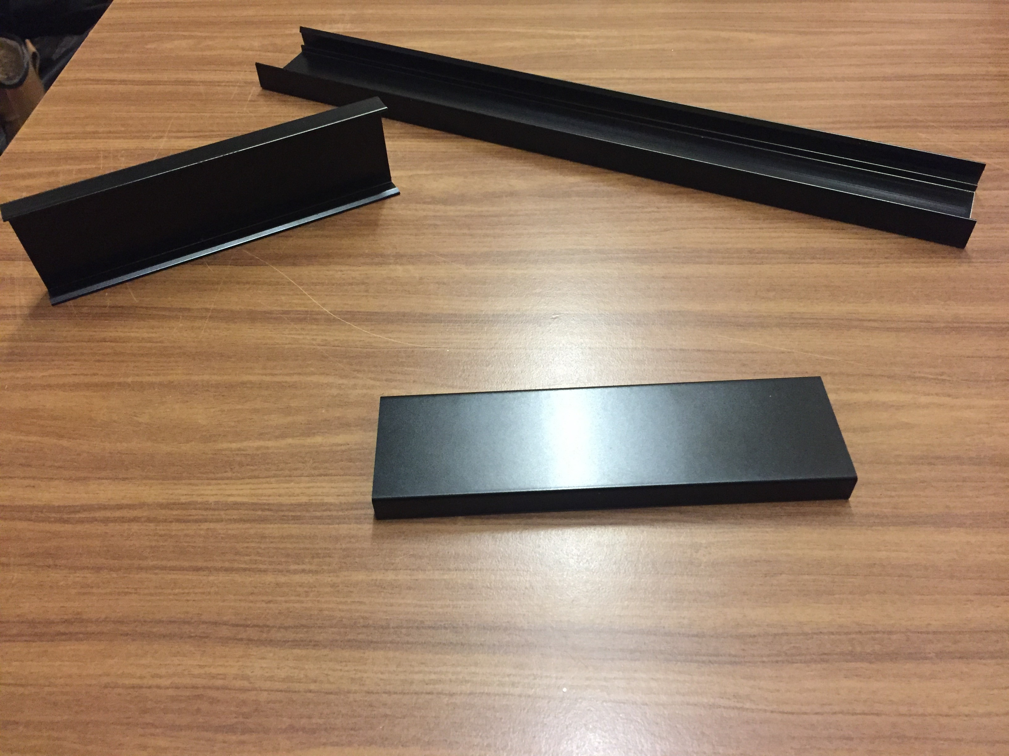

Response required by: 04.08.18
Comments:
Date: |  | Company: | Name: |  |  |  |  | Sign:

