Submittal No: 86 |  | Date: 26/06/2018 | 09/07/2018
262 High Holborn
To: | SHEPPARD ROBSON | From: | ALUMINATE
Copy to: DESIGN TEAM

Submission:

Ikon L502 28 mm glazed in louver 500x500 mm, RAL 7040 Matt

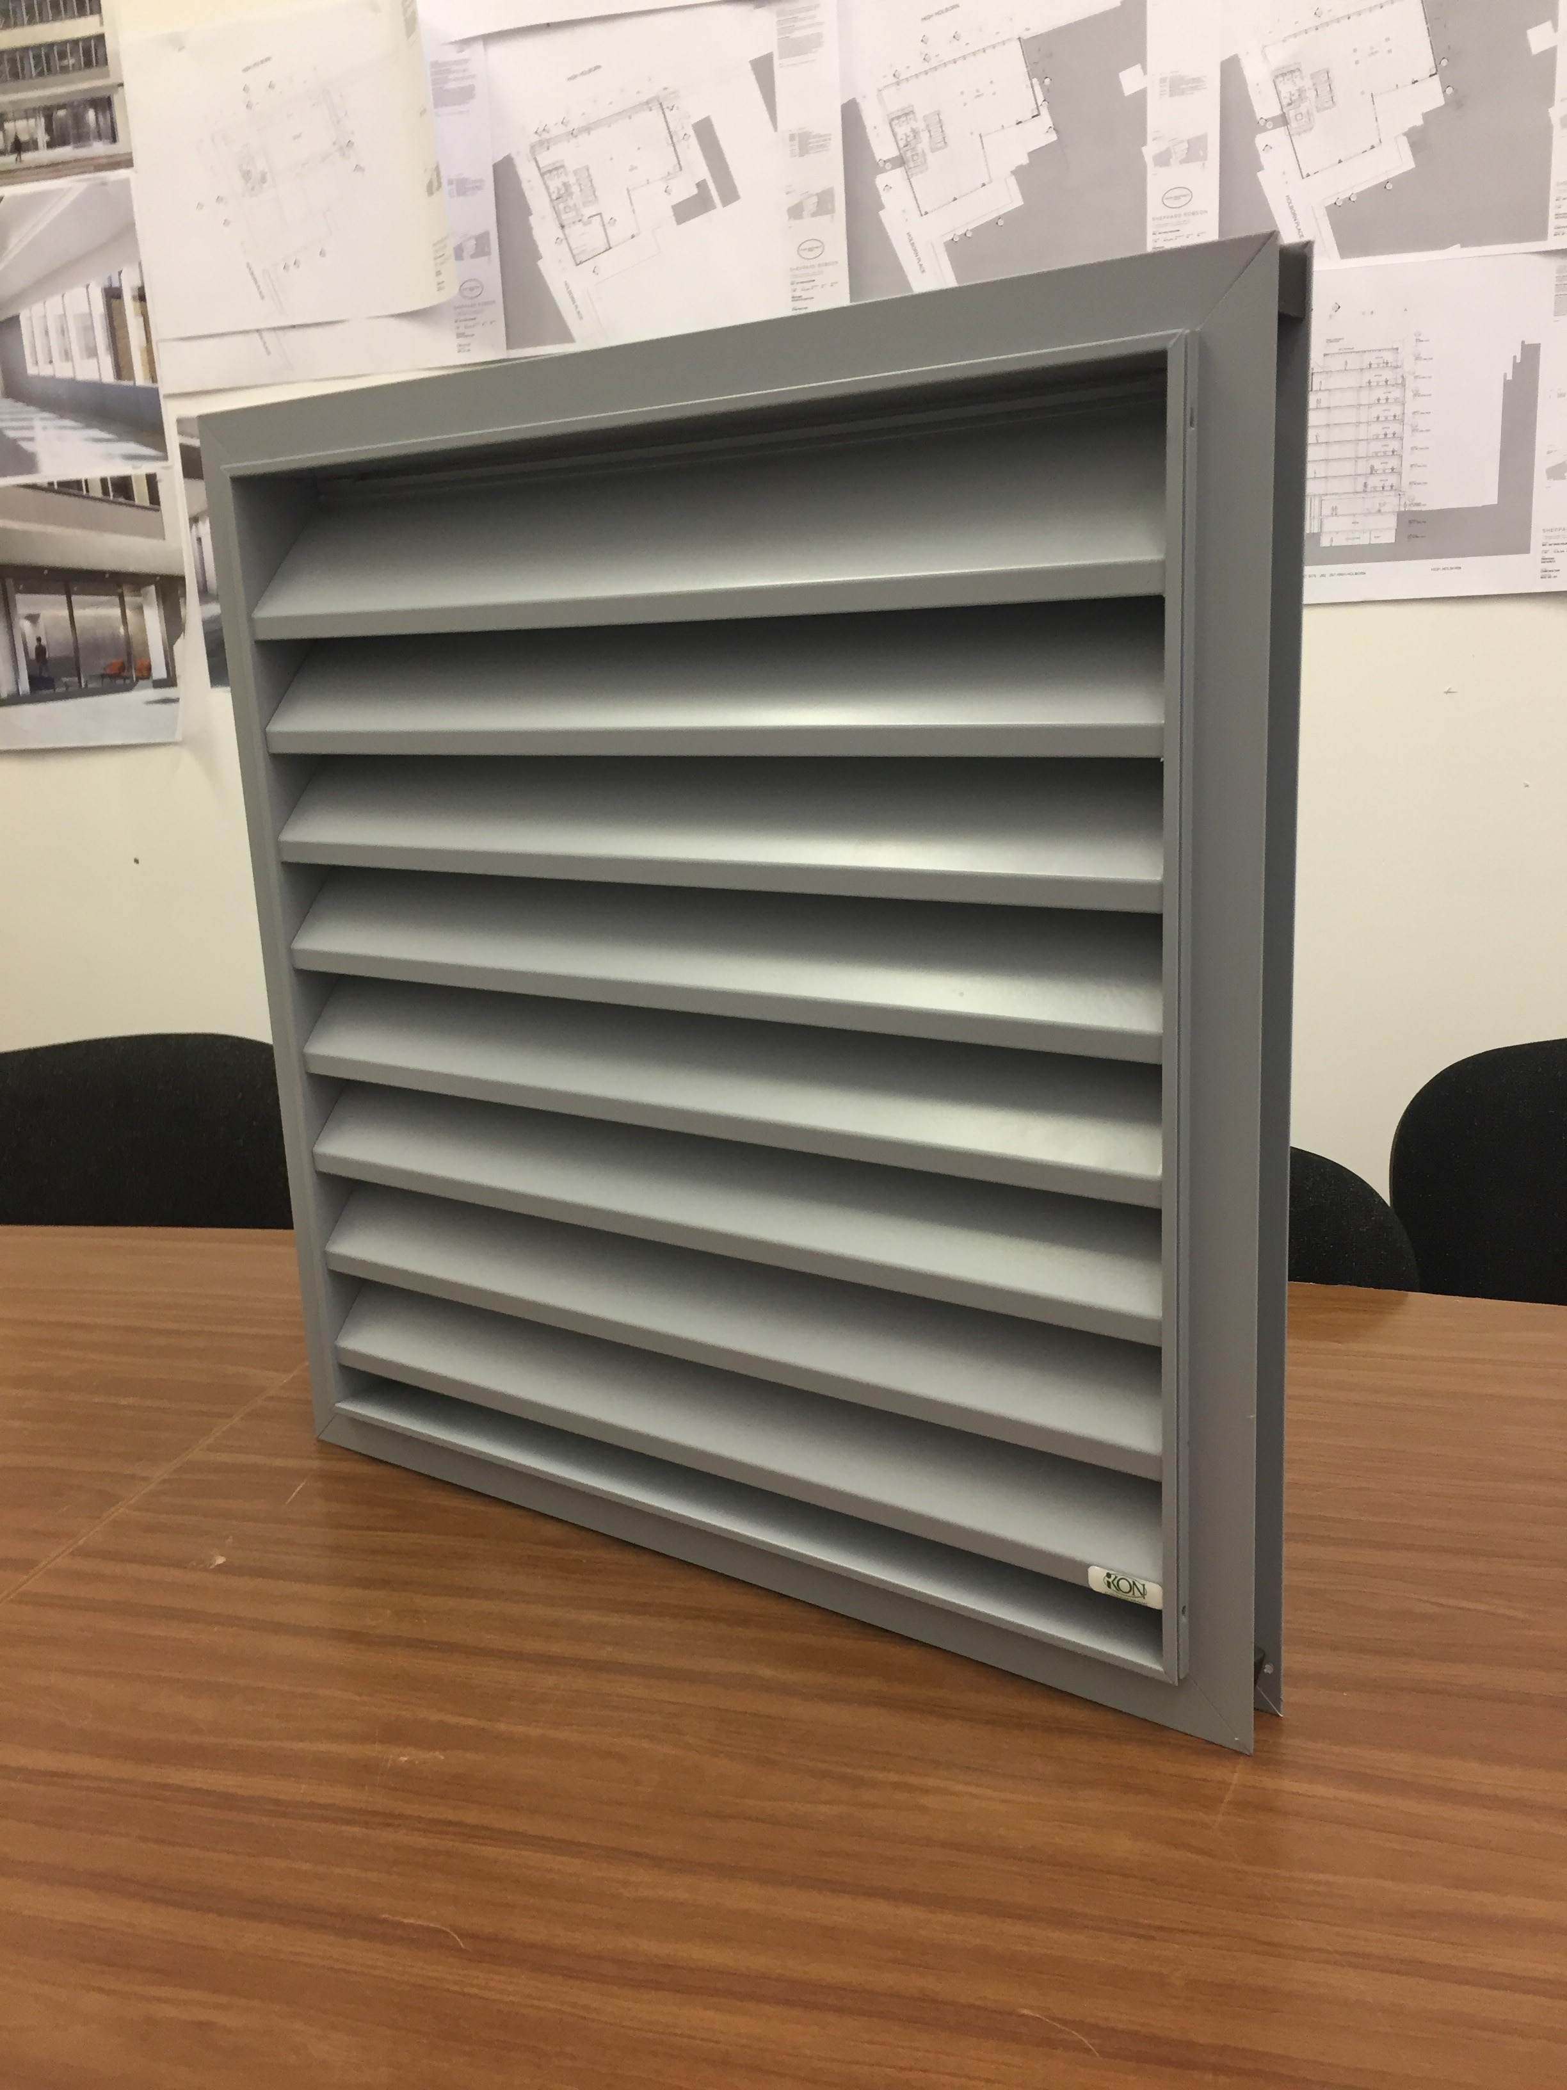

Response Required by: 09/07/2018

Comments:

Date: | Company: | Name: | Sign:

