TS_77 |  |  |  | Date: |  | 27/04/2018
262 High Holborn
To: | Yannis Lekkas |  |  |  | From: |  | Paul Baynham
Company: | Synergy Property |  |  |  | Company: |  | RICHARDSON ROOFING
Copy to: DESIGN TEAM
Sample Submission
A 500mm length sample of the 1.0mm thk PPC Ral 9005 black Wallplank panel.
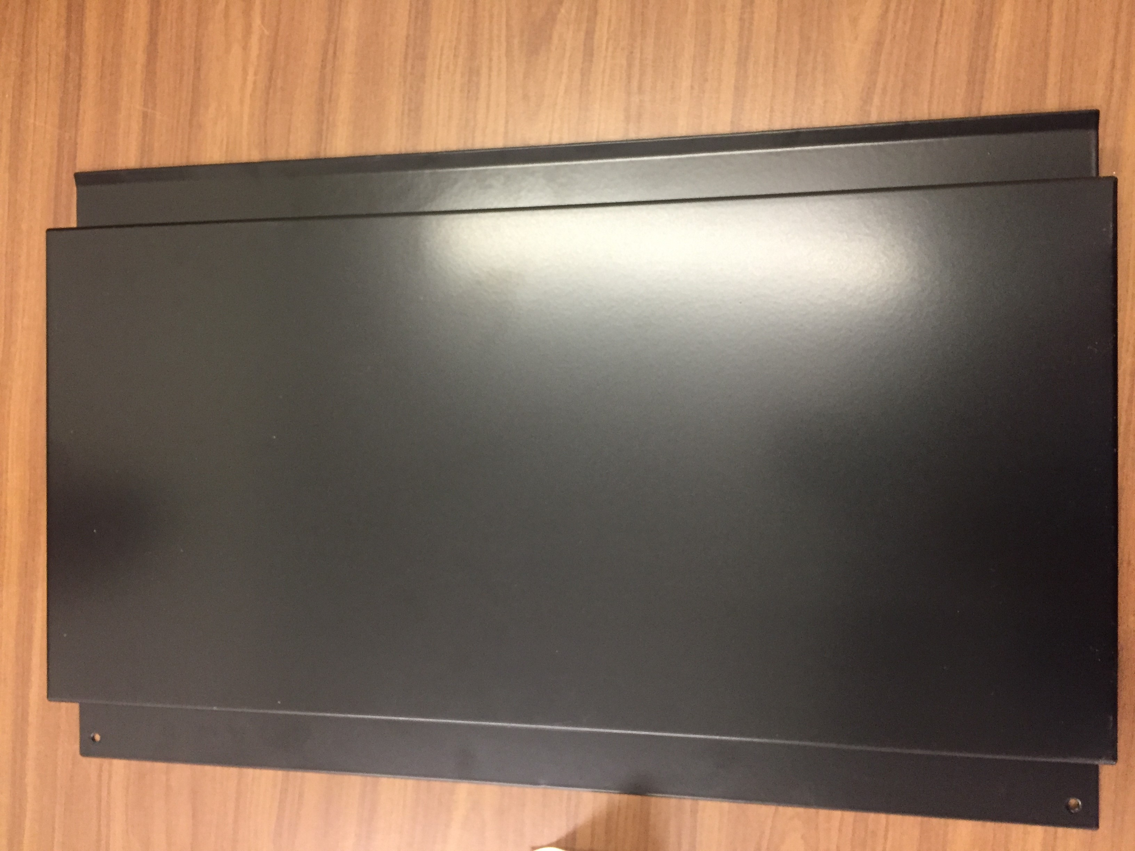

Response required by: 02.05.18
Comments:
Date: |  | Company: | Name: |  |  |  |  | Sign:

