TS_96 |  |  |  | Date: |  | 23/10/2018
262 High Holborn
To: | GEORGE POPPE |  |  |  | From: |  | JAMIE BUCKSEALL
Company: | SHEPPARD ROBSON |  |  |  | Company: |  | HADDONSTONE
Copy to: DESIGN TEAM
Submission:

‘Haddonstone Tecstone 01 Portland’

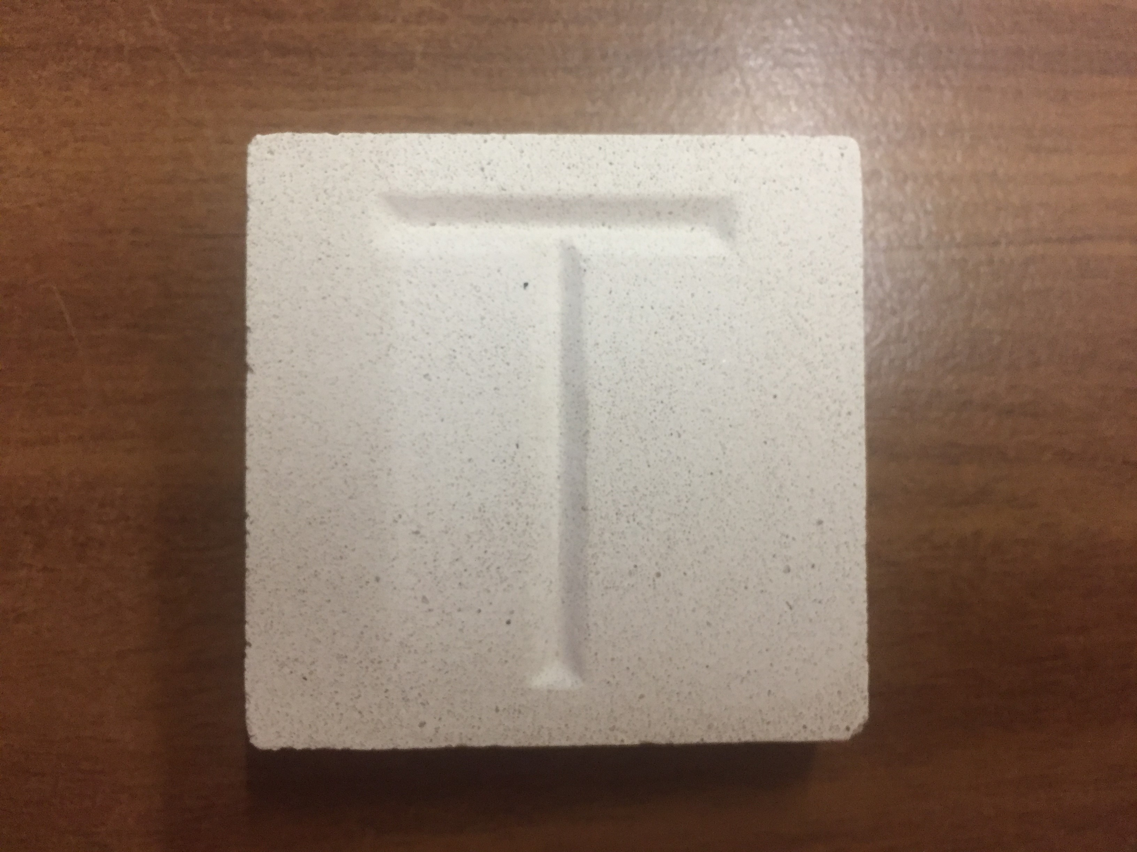

Response required by: 04.11.18
Comments:
Date: |  | Company: | Name: |  |  |  |  | Sign:

