Submittal No: 89 |  | Date: 26/06/2018 | 09/07/2018
262 High Holborn
To: | SHEPPARD ROBSON | From: | ALUMINATE
Copy to: DESIGN TEAM

Submission:

PPC paint sample Ral 7046 Matt.

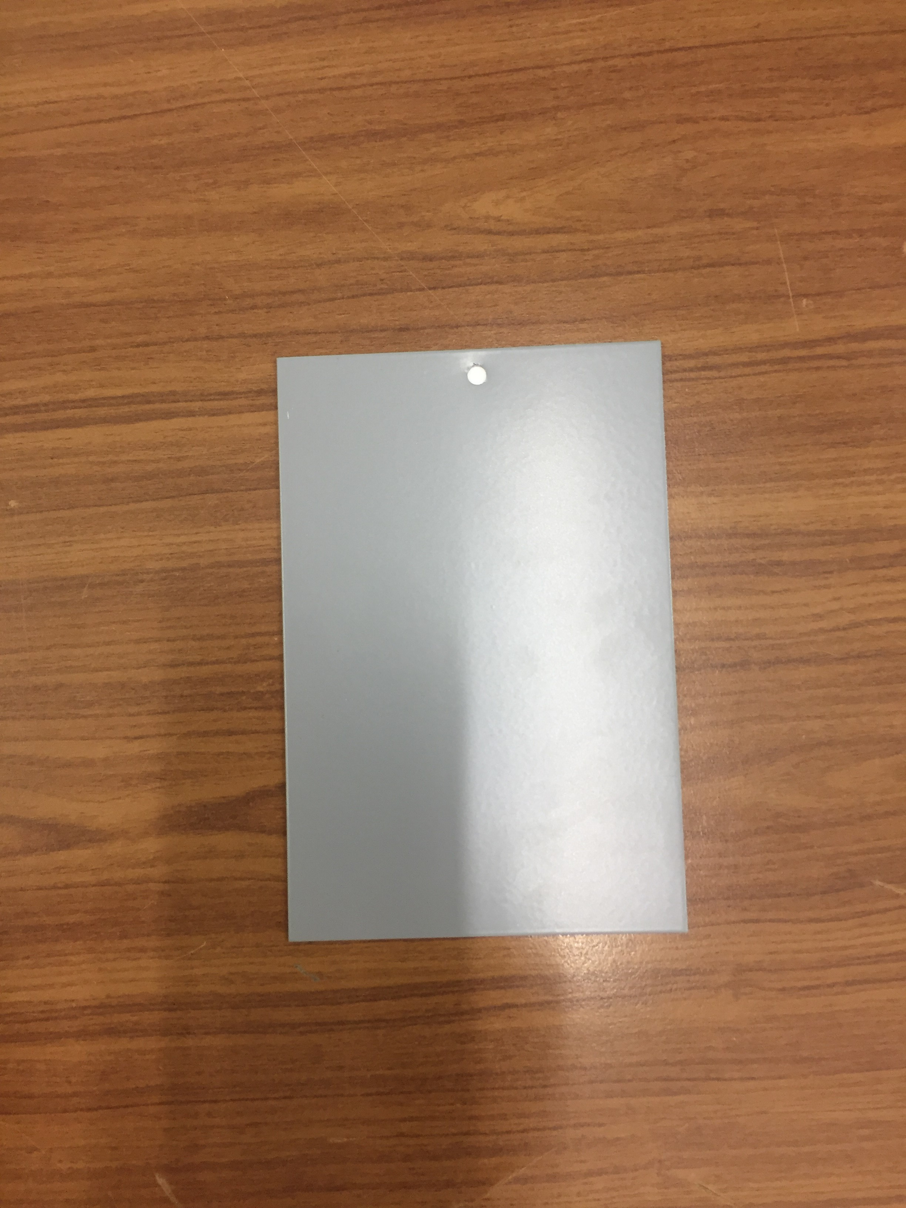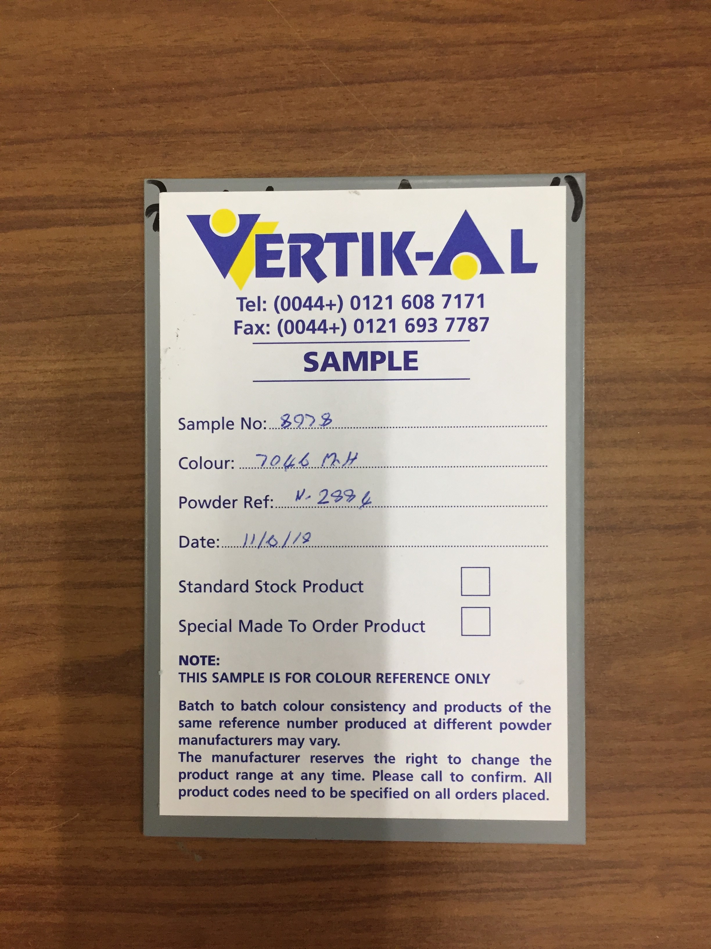

Response Required by: 09/07/2018

Comments:

Date: | Company: | Name: | Sign:

