20. ROBBIE’s HOUSE AT NIGHT

Photo showing Robbie’s temple with candlelight and reflection of trees in the mirror

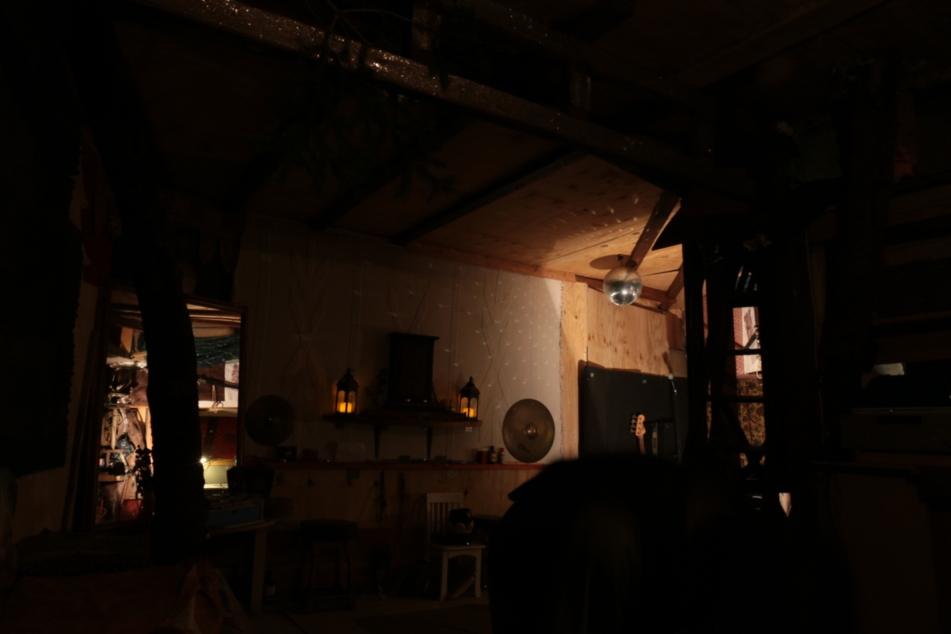

20a. House at Night. Silhouette of house with trees, steps, reflections, temple