19. CARAVAN AND AWNING RIGHT OF ROBBIE’s HOUSE

(See and video 19)

Passing Robbie’s house on the right is Ollie’s caravan and awning. Turning right towards the brick sheds in front of the Vale of Health pond.

The clip ending with Ollie’s awning with Spencer House in the background.

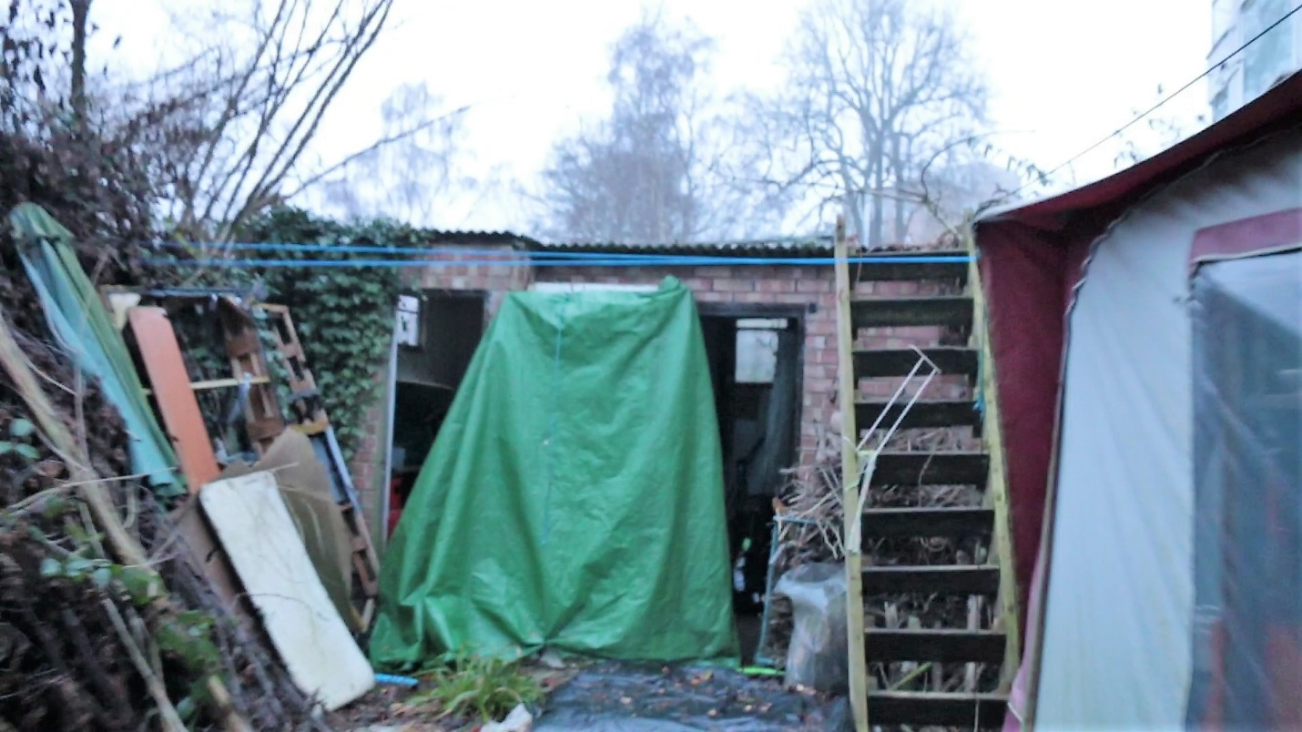

19a Ollies Awning , brick sheds with Spencer House behind to the right

.