18. ENTERING THE SOUTH FAIRGROUND

(See Video 18)

The Video shows the entrance along the site fencing on the corner of Hampstead Heath footpath and road where there is a parked caravan. Passing Joe’s Yurt, the ground covered with fallen leaves and trees bare.

The Cameraman walks towards the gate that leads to corner and sides of Robbie’s house and back door with a triangle warning. Passing Alicia’s caravan to the left.

As he continues along the side of Robbie’s house, see roof top. In front is the green hot dog van (still on property). Note the electric cables connected in a box next to the van

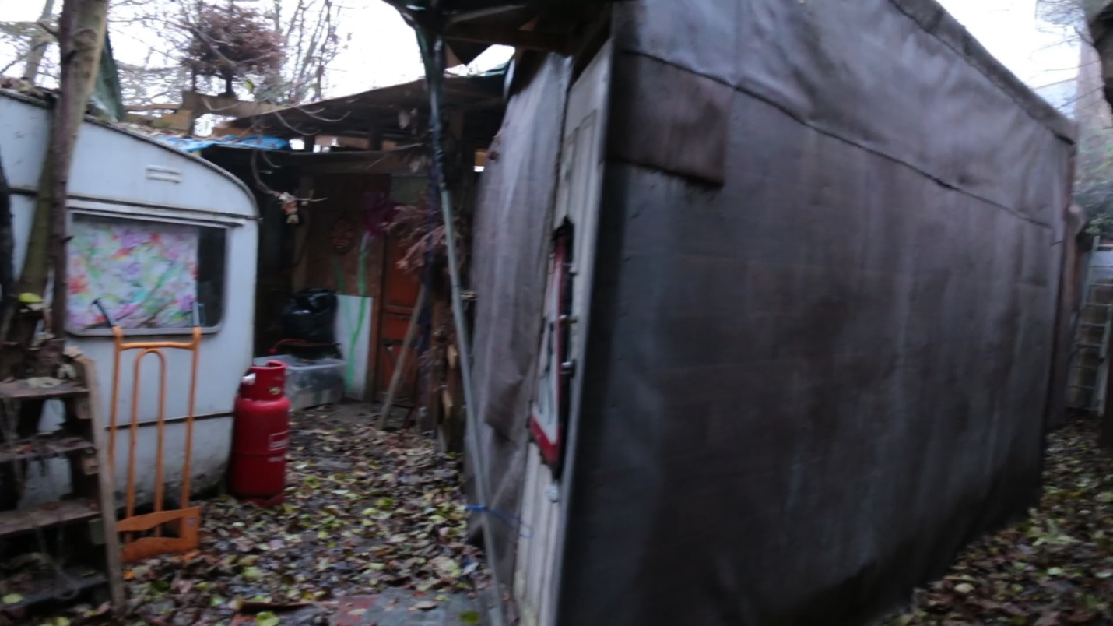

18a Corner, sides, back door to Robbie's House

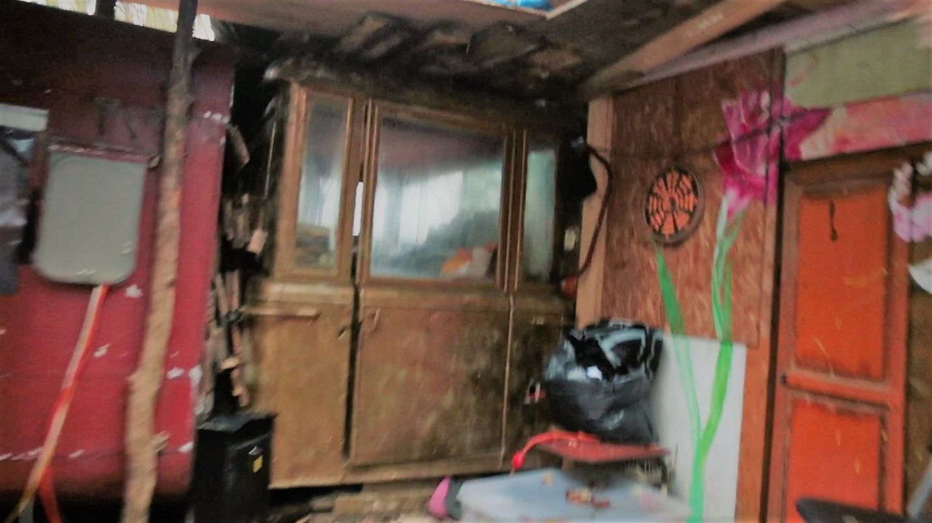

18b Robbie's house on right, centre hot dog van, on left electric box

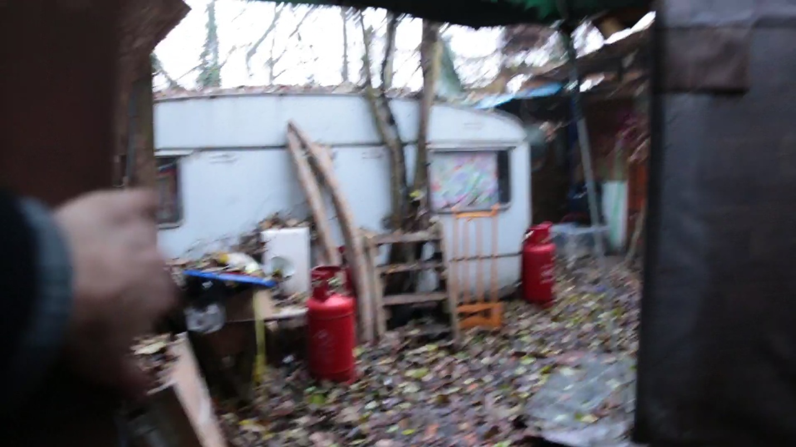

18c Robbie's house on right. Gas bottles in front of Alicia's caravan

.