17. PARTY AT ROBBIE’s HOUSE

(See Videos a, b, c, d, e)

Robbie and guests partying at house. Live music and singing. Numerous electrical instruments in play.

David Southwell, who introduced me to Robbie Litvoi and who I mentioned in my Statutory Declaration (See Exhibit B), who lived next to Robbie for 6 years in a caravan is at the party and seen in the videos. Guests’ sitting around tree inside the house

Robbie playing drums and keyboard. (See video 17c and 17d)

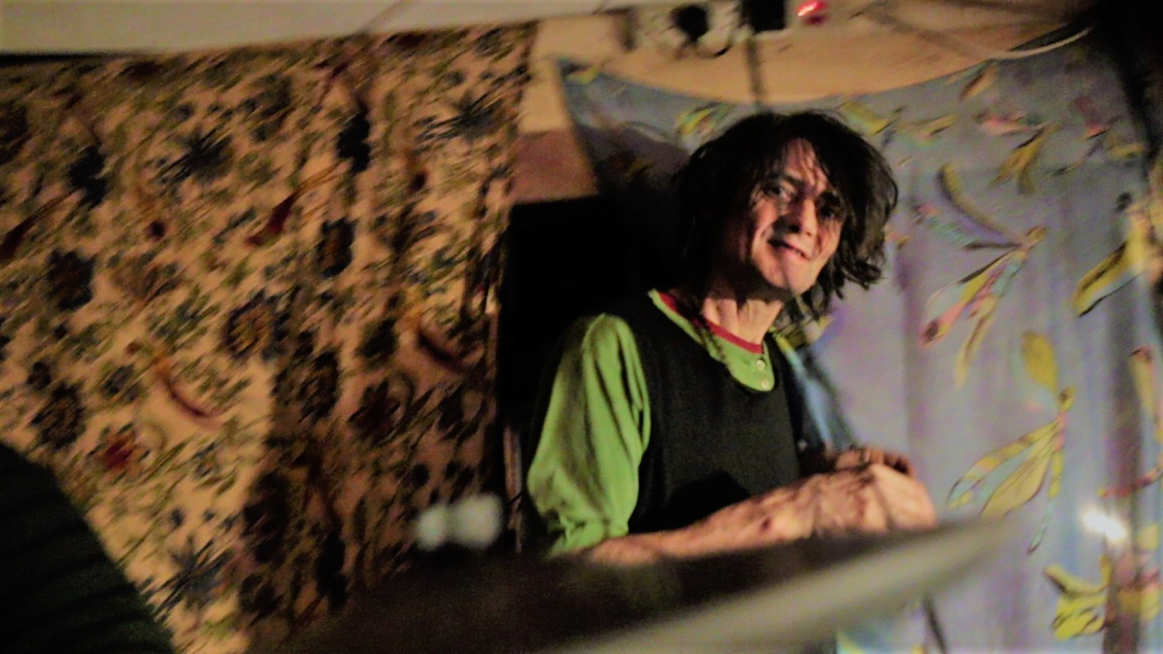

17a Robbie seen exiting bedroom to living room and to his party guests. Electric sockets above his head. (See Video 17b)

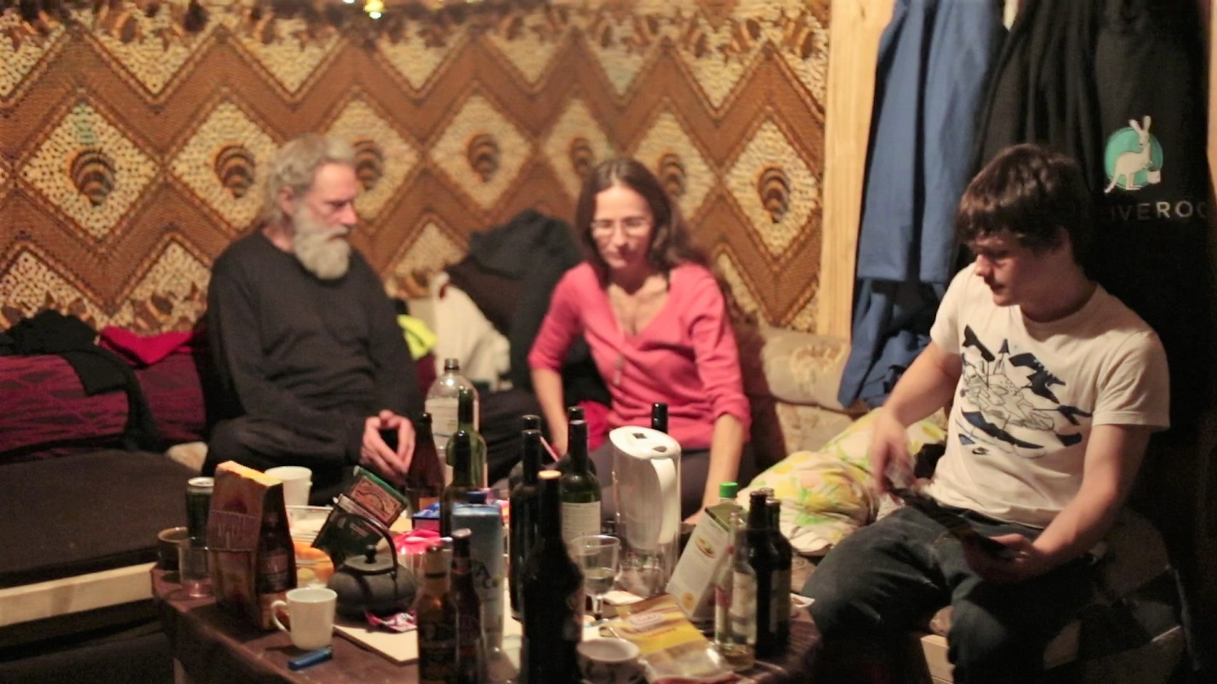

17b. David Southwell , Robbie's neighbor who lived in caravan next to Robbie’s house for 6 years on left of picture at party. (See Video 17e)

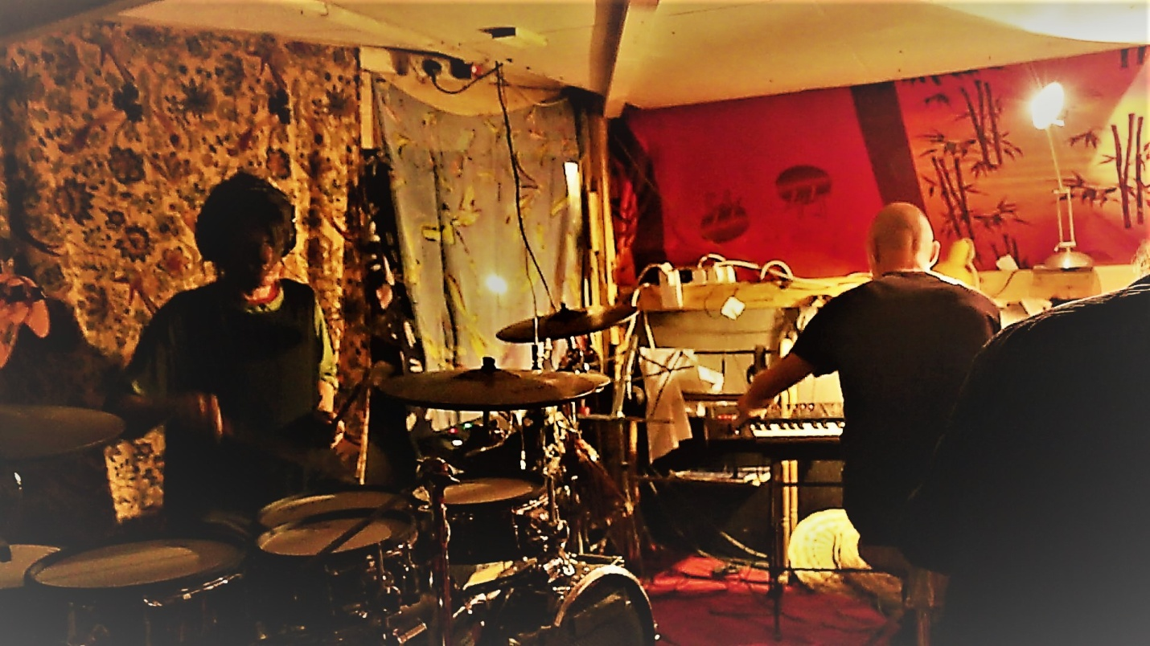

17c. Robbie playing drums on party night (see video 17c)

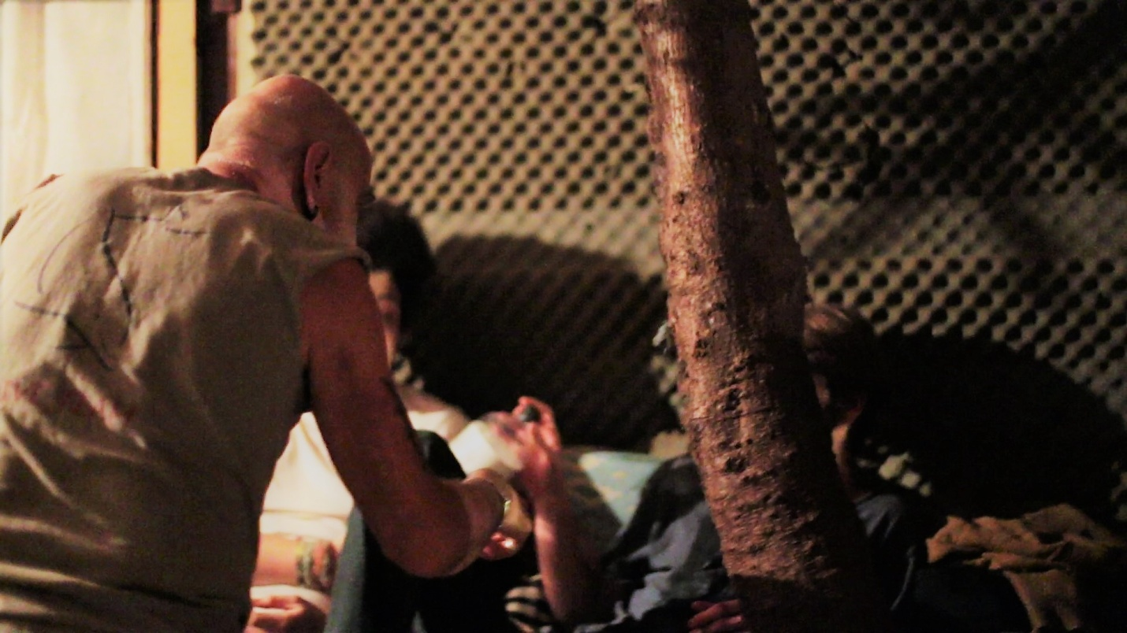

17d. Guests sitting around tree inside party at Robbie’s house (See video 17e)

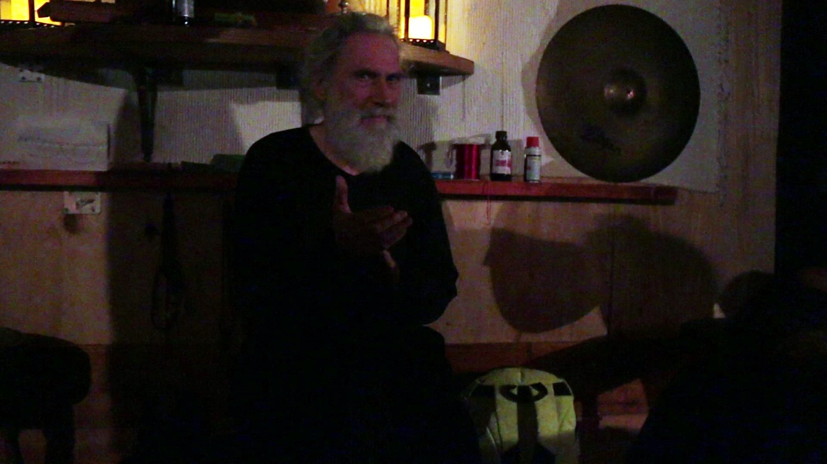

17e David Southwell Sitting in front of Robbie's Buddhist temple at party (See video 17c)