16. ROBBIE AND CATS

Photos showing Robbie holding one of his many cats that he kept to keep vermin out of the house which he talks about in the Camden New Journal (See Exhibit C)

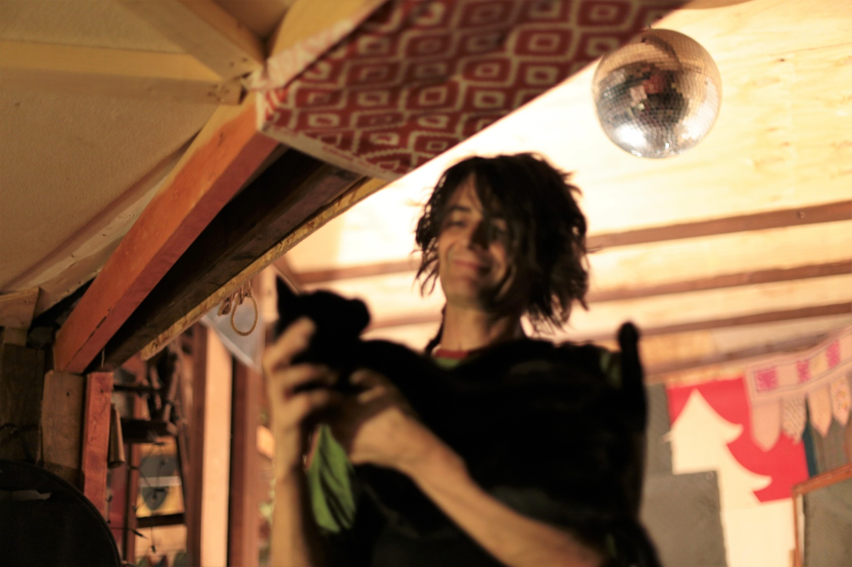

16a Robbie and Cat

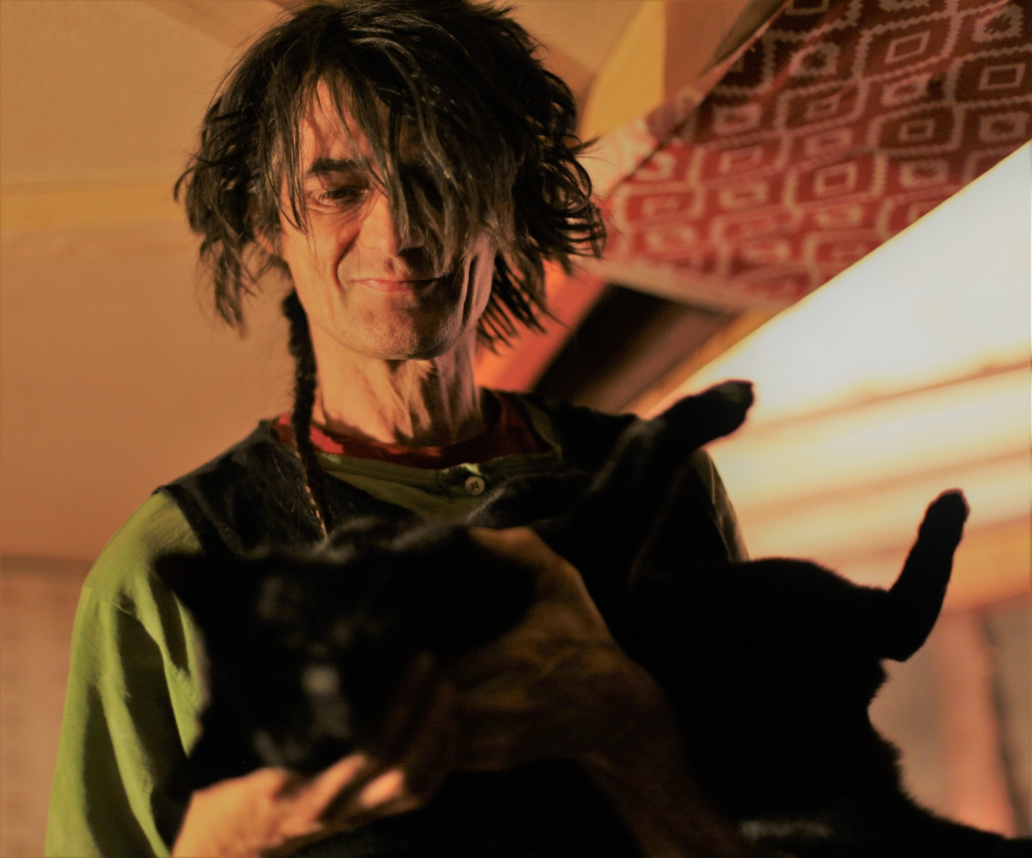

16b Robbie and Cat