15. ROBBIE’s TEMPLE

See Video clips (15a, 15b and 15c)

Robbie described as Buddhist in Camden New Journal (See Exhibit C).

15a Video Clip shows Robbie switching on light for his Buddhist temple. His music area in the background.

15b Video clip showing keyboard synthesizer, electrical sockets on floor. Buddhist temple to the right. The mirror reflecting the tree growing in house.

15c Video Clip showing Robbie’s temple at night, music area at the back behind the steps to upstairs. Robbie talking.

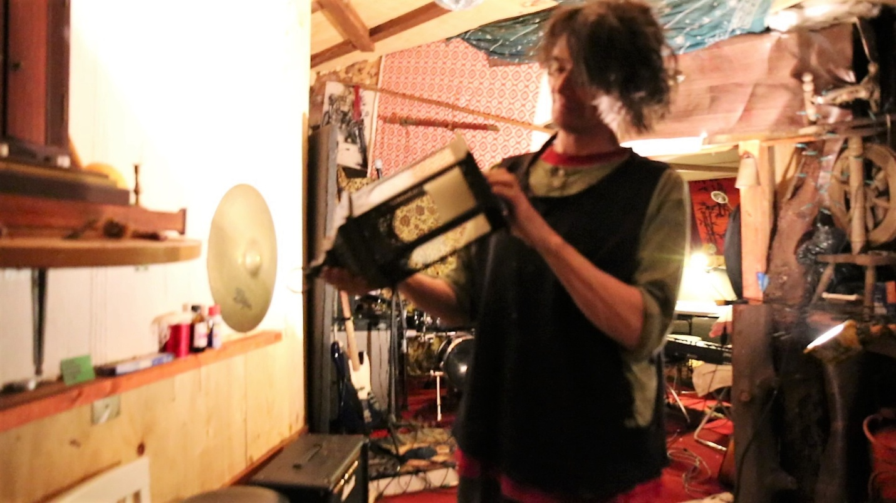

15a Robbie and his buddhist temple to the left with his music room behind him.

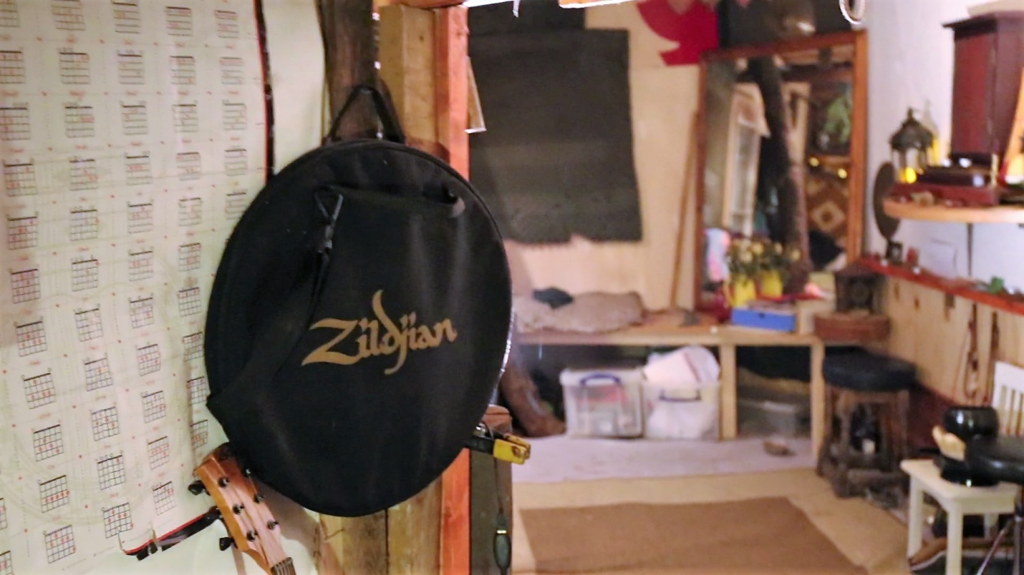

15b Buddhist temple to the right. Tree growing inside house reflected in mirror (See video 15b)

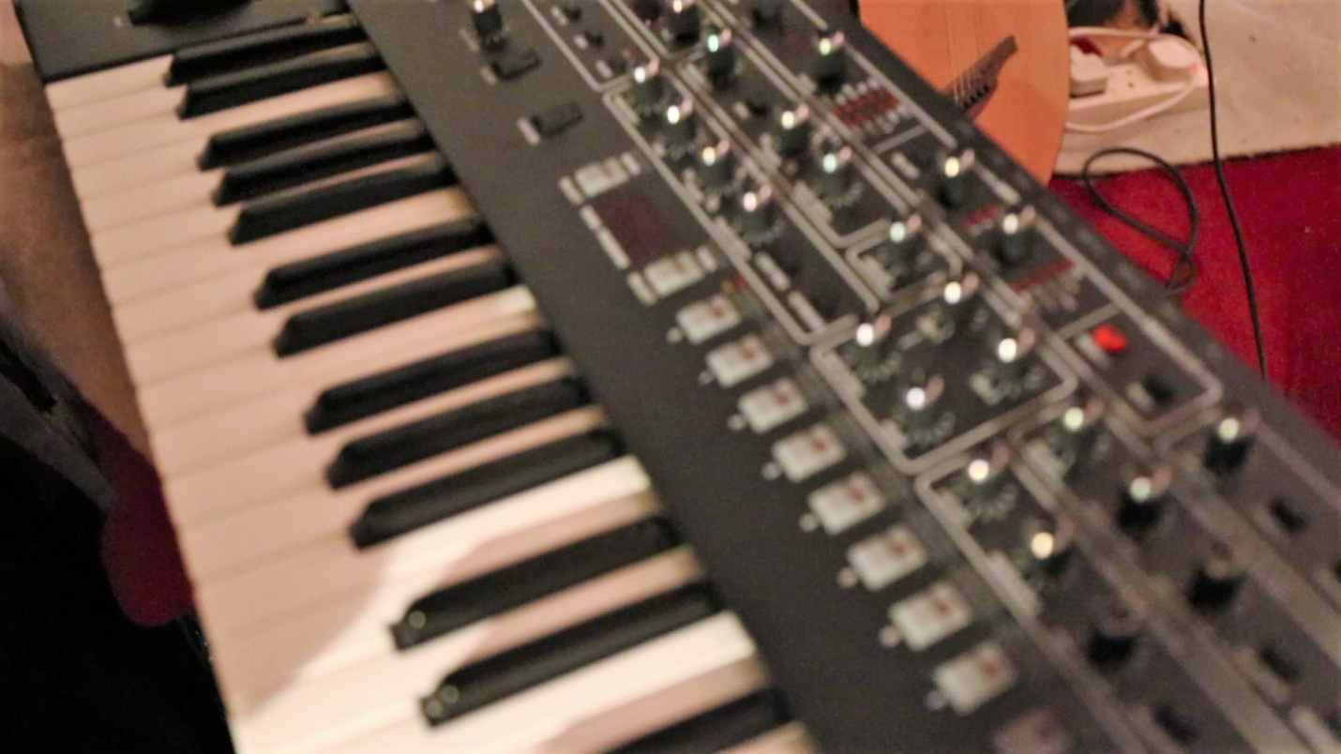

15c Keyboard synthesizer. Electric sockets on floor (See video 15b)