14. ROBBIE’s HOUSE. CEILING AND WALLS PHOTOS

Photos showing beams, cables and lights, shelving with ornaments and framed pictures of Robbie’s cats.

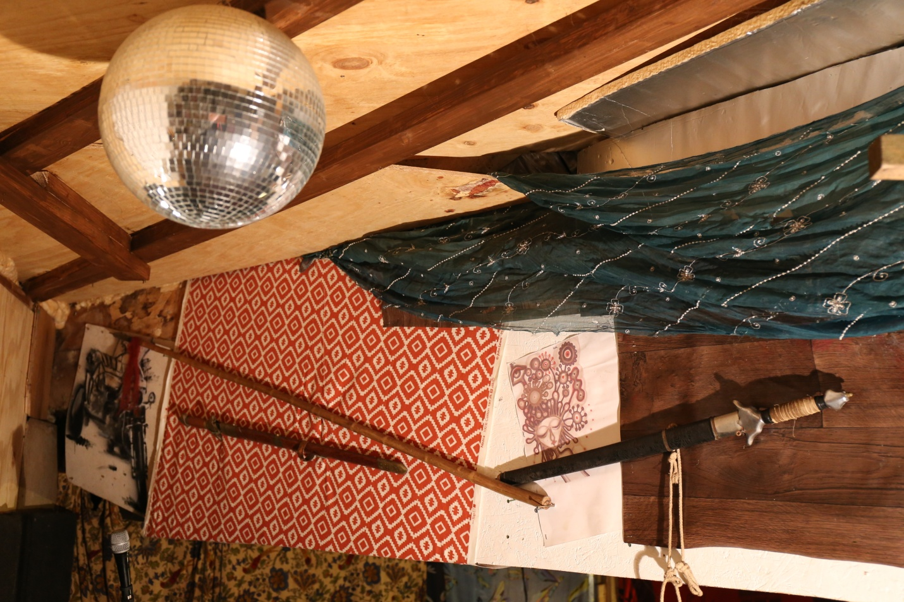

14a Ceiling and walls

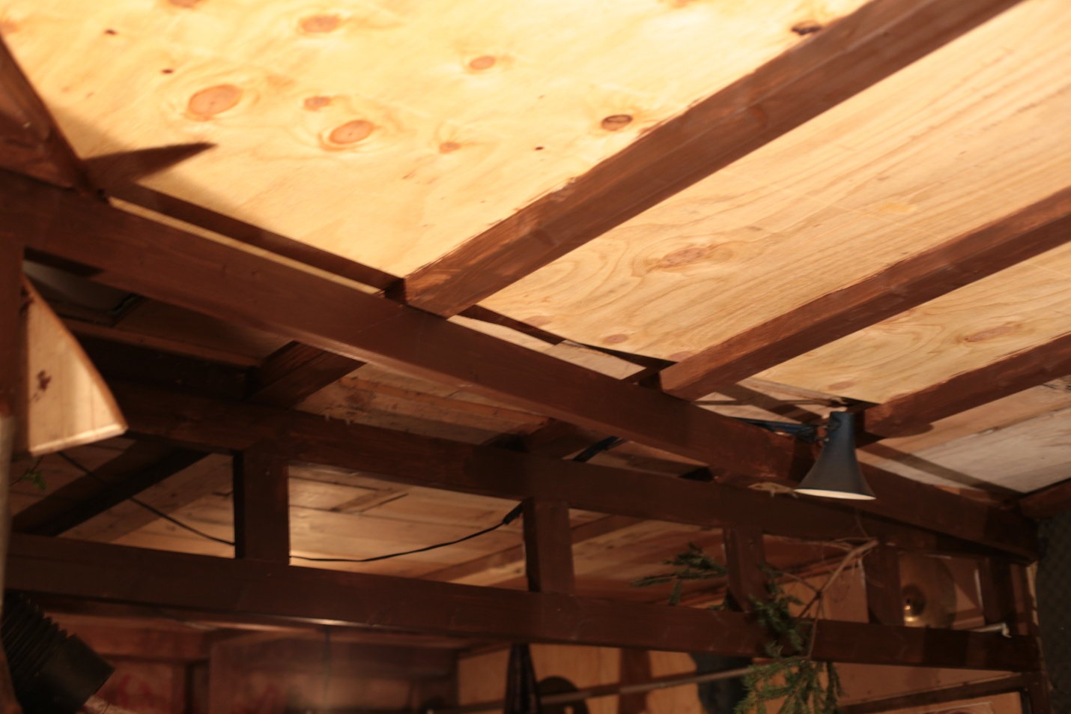

14b Ceiling and light.

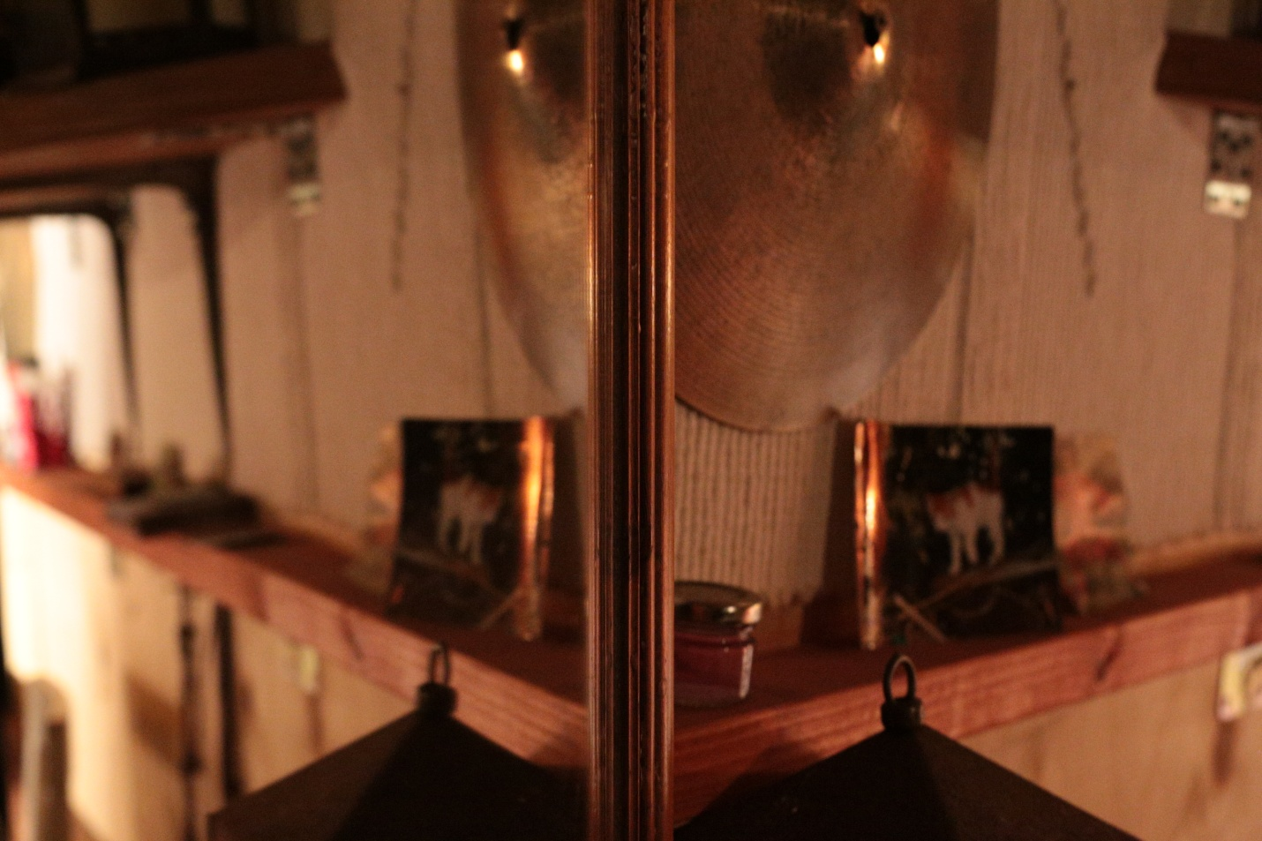

14c Shelving. Framed photo of Robbie’s cat