13. ROBBIE’S MUSIC AREA AND HIM PLAYING MUSIC IN HIS HOUSE

With AMP, lights, ceiling light, fan in background

Musical equipment connected to electrical sockets on the ceiling and side.

Ceiling height particularly lower due to insulation

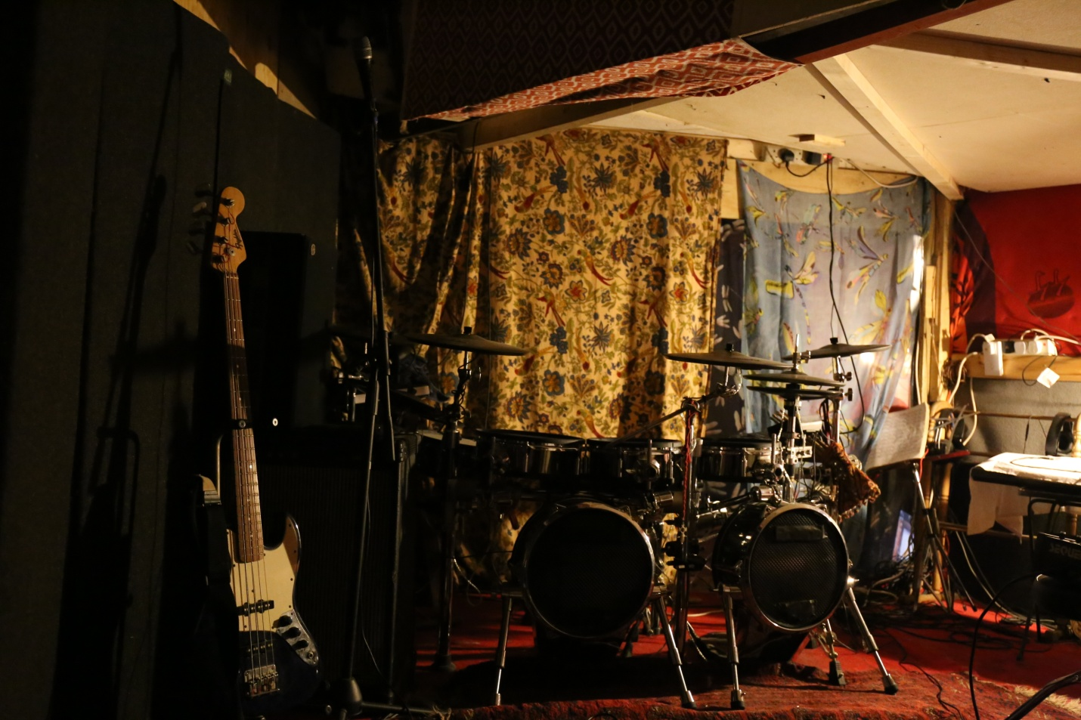

13a Robbie's music room off the sitting room

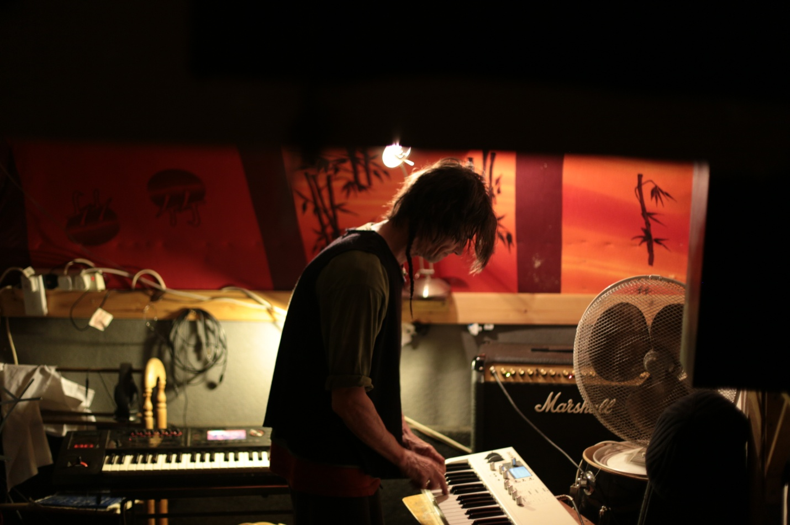

13b Robbie on Keyboard

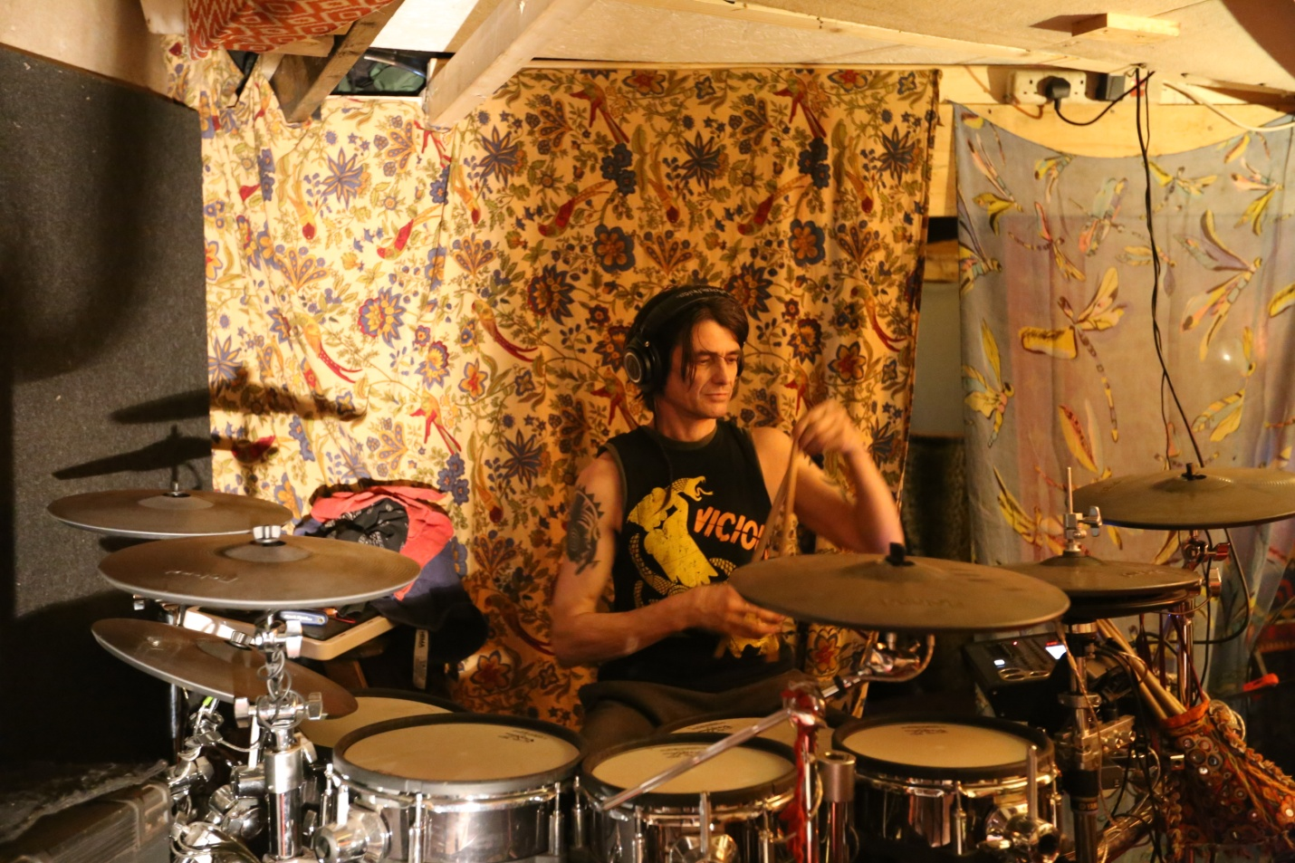

13c Robbie playing drums in music area. Electric Sockets on ceiling