12. ROBBIE AND FRIENDS

Photo showing Robbie standing in front of trees and steps and his friend in the sitting area on the computer. Background shows trees, stereo, computer on side units, and white door to leading kitchen area.

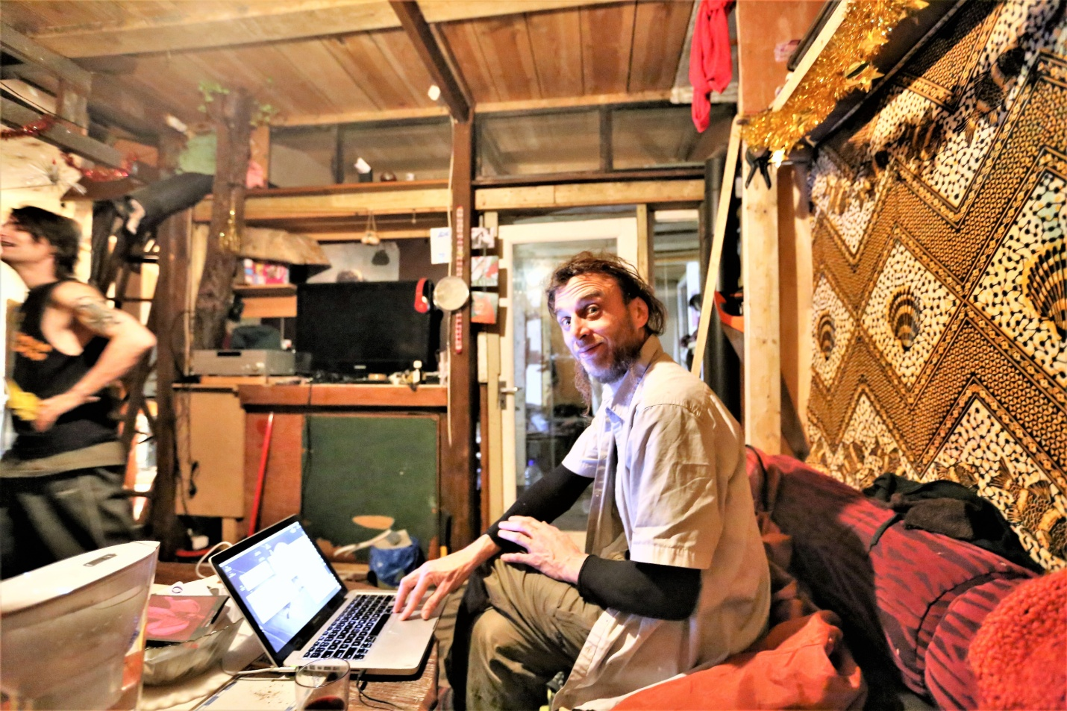

12a Robbie by the steps and trees with friends in living room