11. VISITORS TO ROBBIE’s HOUSE

SEE VIDEOS 11a and 11b

11a Visitor approaching Robbie’s house at night passing Alicia’s caravan on left and the hot dog caravan in front before turning right to enter Robbie’s house. The inside of the house can be seen from the side double glass doors. Including the kitchen on the right with tier of fruit.

11b Visitor walking down the side of Robbie’s house which is on the left passing the fencing on the right which has been removed and the sycamore and goat willow trees that are still there today. Ground covered in leaves. As he turns left along Robbie’s house towards the front entrance in front in view is Spencer House and Heath Villas, Ollie’s caravan awning and the toilet brick sheds. Robbie is greeting morning to the visitor at his front door and the inside of his house with the growing trees, steps can be seen. Robbie exits with chainsaw to front of Vale of Health pond towards the brick sheds passing Ollie’s caravan awning on the right saying he was going to chop wood for the fire.

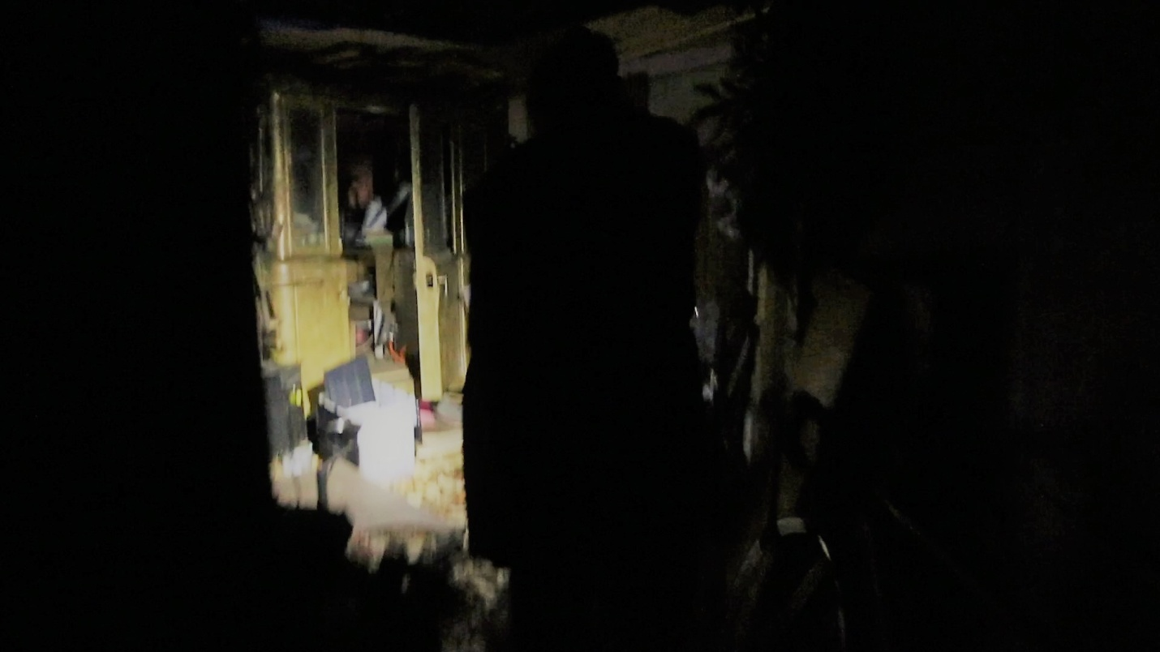

11a Visitor passes Hot dog van before entering Robbie's House (See Video 11a)

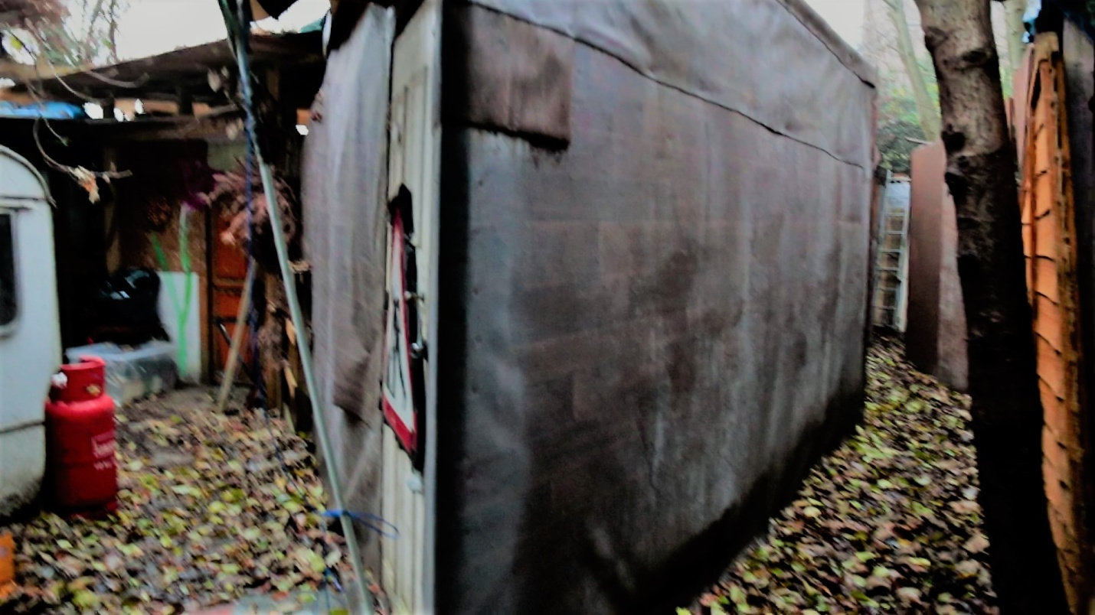

11b Visitor passing sides of Robbie's house. Gas bottle to the left. Sycamore and goat willow trees to the right. Ground covered with leaves. (Video 11b)

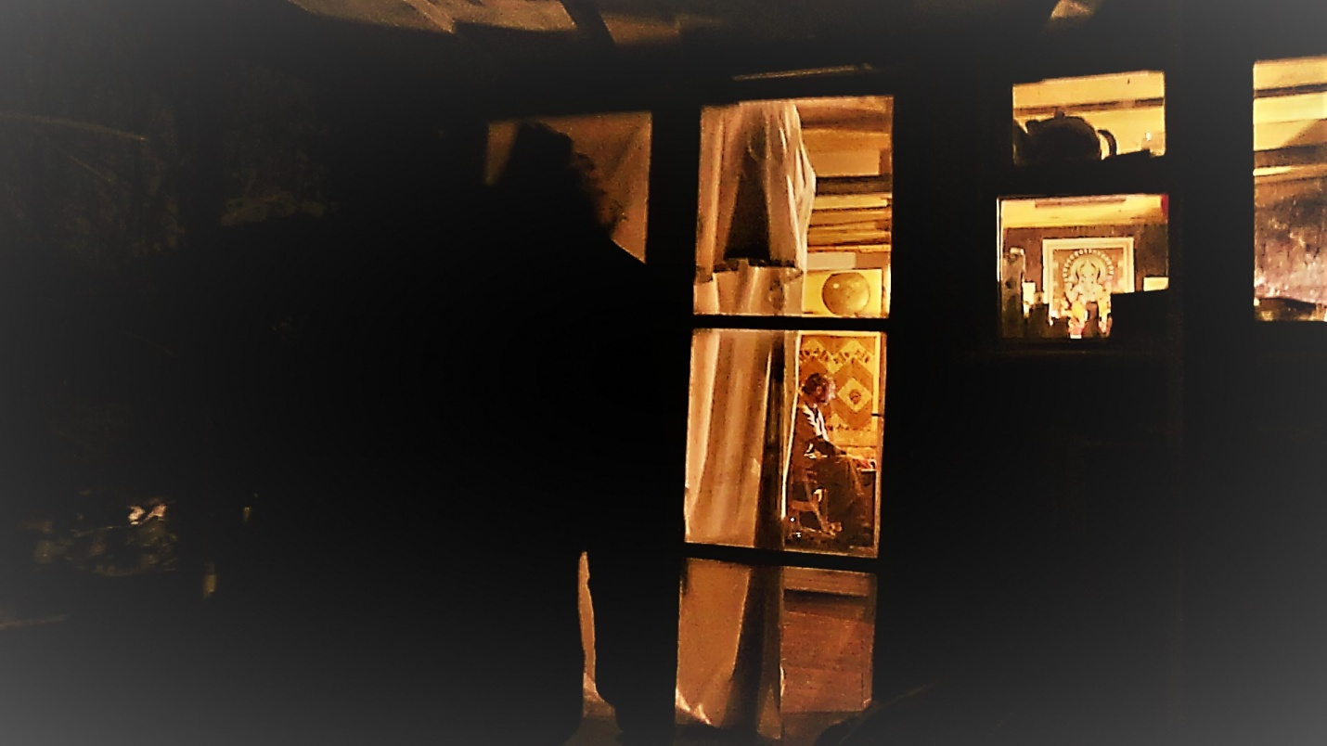

11ai View of inside of Robbie’s house as visitor enters from back door (Video 11a)

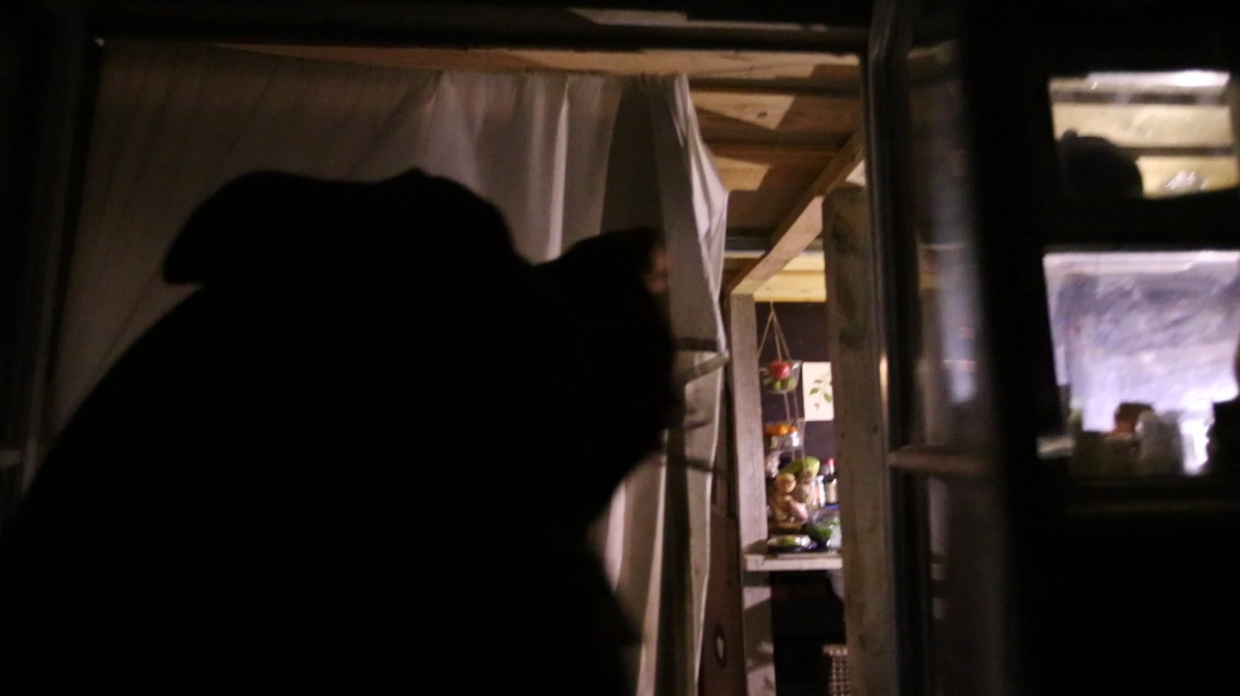

11aii Glimpse of kitchen as visitor enters Robbie's house from back door (Video 11a)

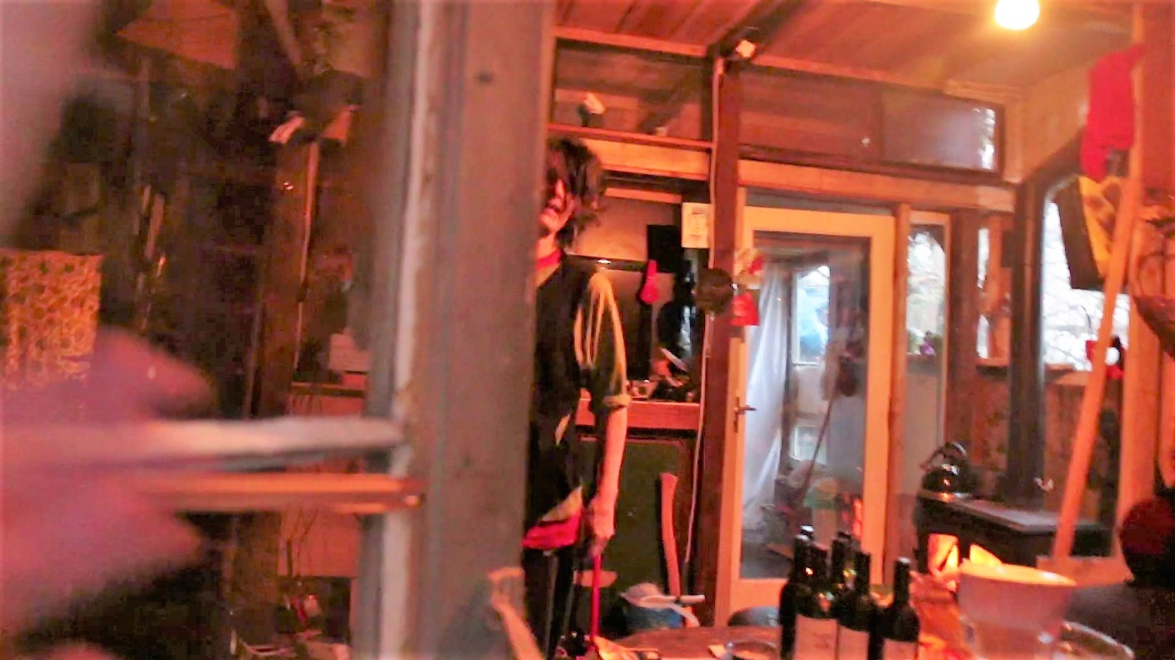

11bi Robbie opening his front door to visitor where the inside of the house can be seen before he steps out to chop wood for the fire (video 11b)

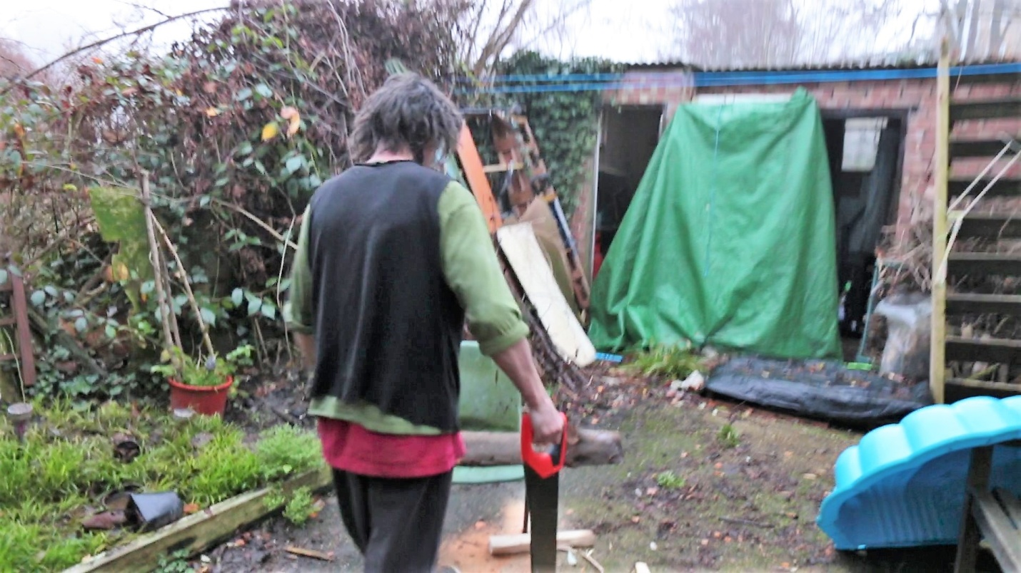

11bii Robbie walking with chainsaw to chop wood towards the brick sheds (See Video 11b)

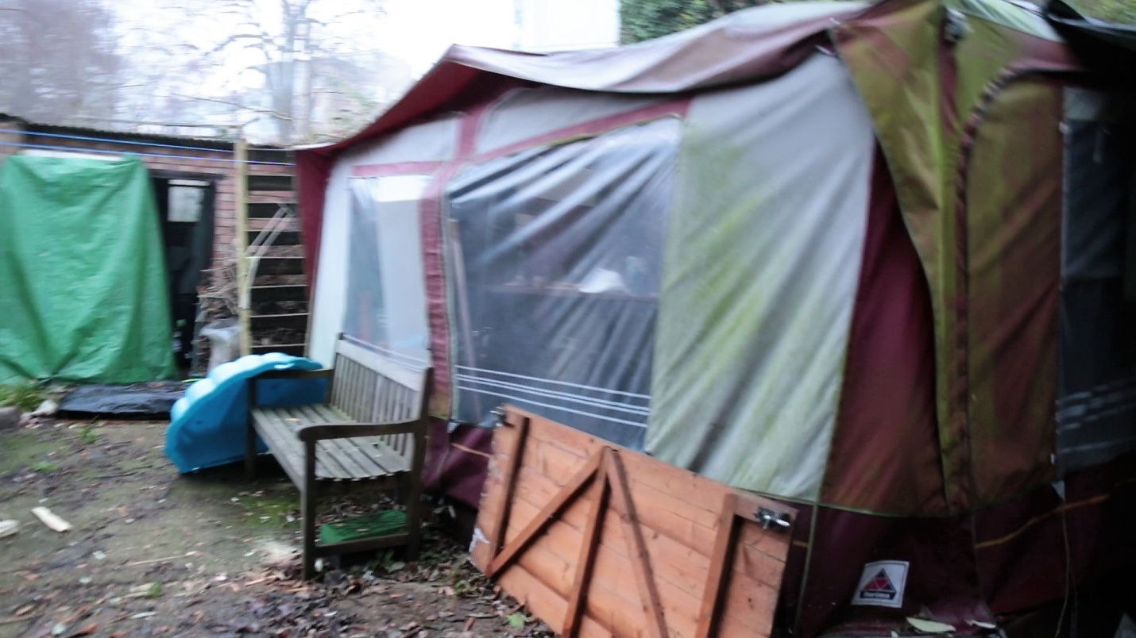

1biii Ollie's caravan awning and brick shed in front to the right as Robbie approaches from his front door(See Video 11b)