10. ROB LIGHTING STOVE

(See Video Clip 10)

As Robbie states he used a gas stove in Camden New Journal

(See Exhibit C)

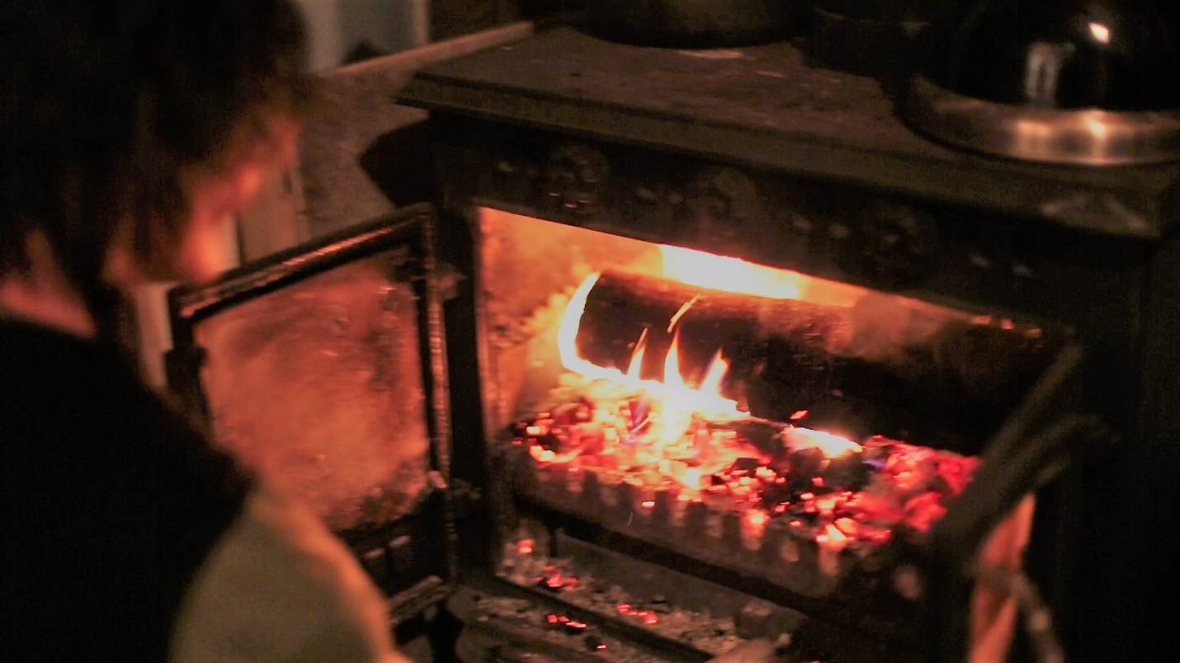

10a Robbie lighting stove