9. Robbie chopping wood for stove.

Robbie’s house to the left with the Sycamore tree and Vale of Health pond behind him.

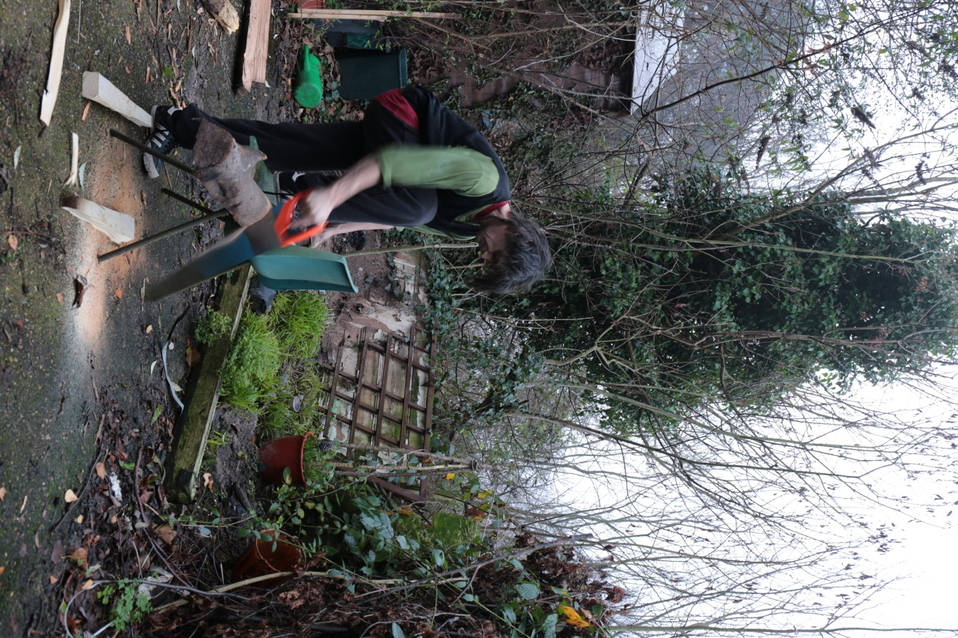

9a Robbie chopping wood in front of his house. Vale of Health pond behind him.

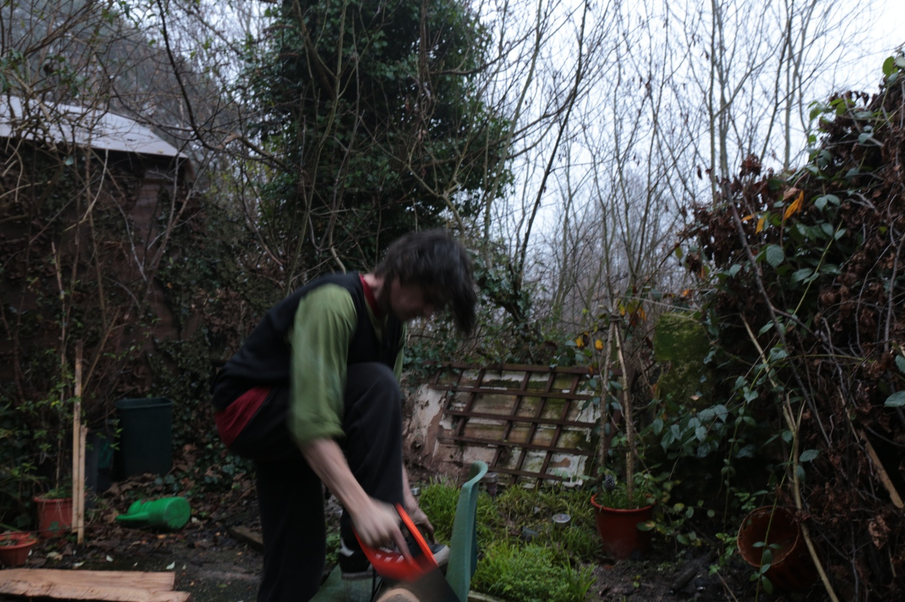

9b Robbie chopping wood in front of his house